Project 2 Part 3

## Project:

* 1. Include name of the team members.

Alan Xu, Jai Bansal

* 1. What is the general status of the project? Describe the roadblocks (if you have any) 3-4 sentences.

As of right now, the project is at a pretty good stage, where we are able to visualize all of the raw data that we are working with on a functional front-end client. Our project has been set up well, as we were careful to consider future functional requirements, and how our code will need to be altered/extended in the future. Now, with the app and database backend set up, we are shifting our focus towards analytics using the data that we have, so that our project actually has meaningful functionality. So far, we have been able to implement a multitude of advanced features (mainly using stored procedures), which will be shown in more detail later in this report. The roadblocks at the moment have to do with version control, while also contending with certain gaps in our individual knowledge (whether that’s in relation to each other or the project itself) that have made it difficult to incorporate some of the advanced features we’ve learned throughout this course.

## Database:

* 1. By this assignment submission date, you should have your decomposition completed with all the tables ready in database. You should have also implemented many of the advanced features. Clearly label the screenshots.
     1. Include the UML screenshot.

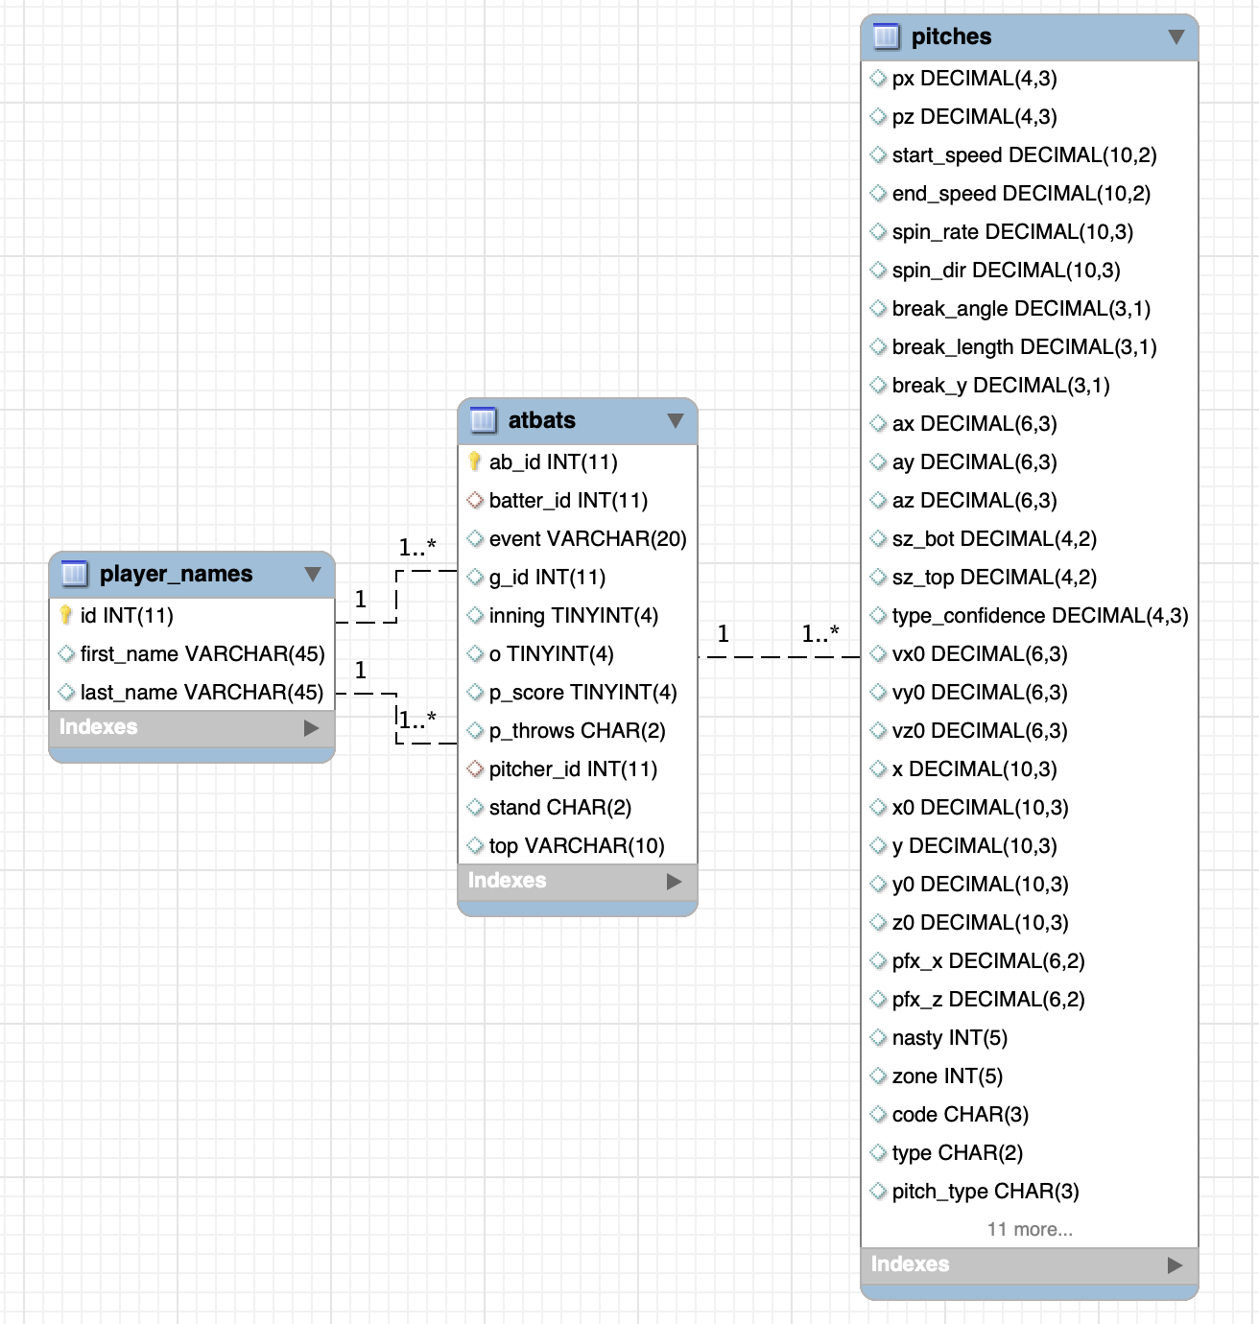

* + 1. Include the screenshots of decomposed tables.

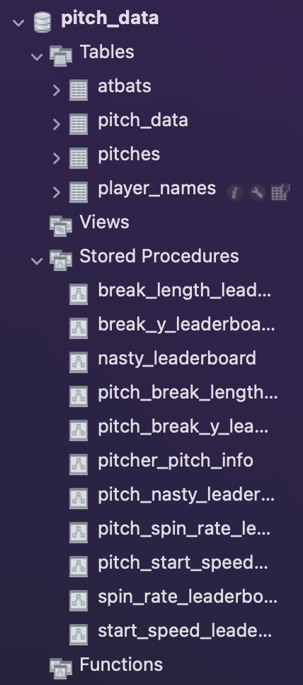

* + 1. Include screenshots of your implementation of some advanced features (Stored procedures, views, triggers etc.)

Below, I included some screenshots of some of the stored procedures we wrote for this component of the project. Basically, what these stored procedures do is take in some parameters (pitch name, pitch type etc) depending on the function and return either a sorted leaderboard of pitchers with that attribute or the information about a specific pitcher. These stored procedures are going to be the backbone of our application, because the most important functionality is going to be users getting to choose different pitchers and attributes and seeing information based on their choices. These stored procedures are then called in our front end – back end connection in Python.

* 1. In terms of percentage how much you think you have completed on database side of the project? Describe the completed work in 2-3 sentences. Describe roadblocks, if any.

We think we are about 75% done with the back end database side of the project. Our decomposition is pretty much done into smaller tables, which was pretty trivial because the data came nicely in a way that was already decomposed. We then wrote a bunch of core stored procedures that will serve as the core functionality for users to filter and look up stats and attributes for their favorite pitchers. We really only have two things left: adding some DML scripts with some triggers that allow users to add/update data (although this isn’t really too practical) and then some more advanced stored procedures that will allow the users more flexibility in searching the database.

## Front end:

* 1. By this assignment submission date, you should have a working interface showing data from the database in live connection. You should also have multiple UI pages. Clearly label the screenshots.
     1. Attach screenshots of the browser showing different UI pages. (At least 2 excluding home page)

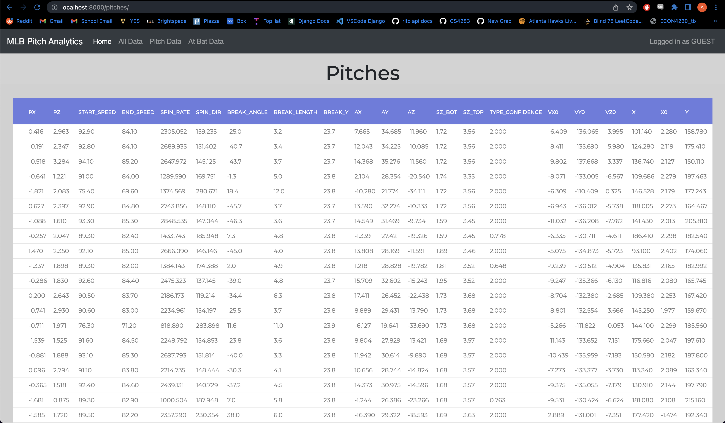

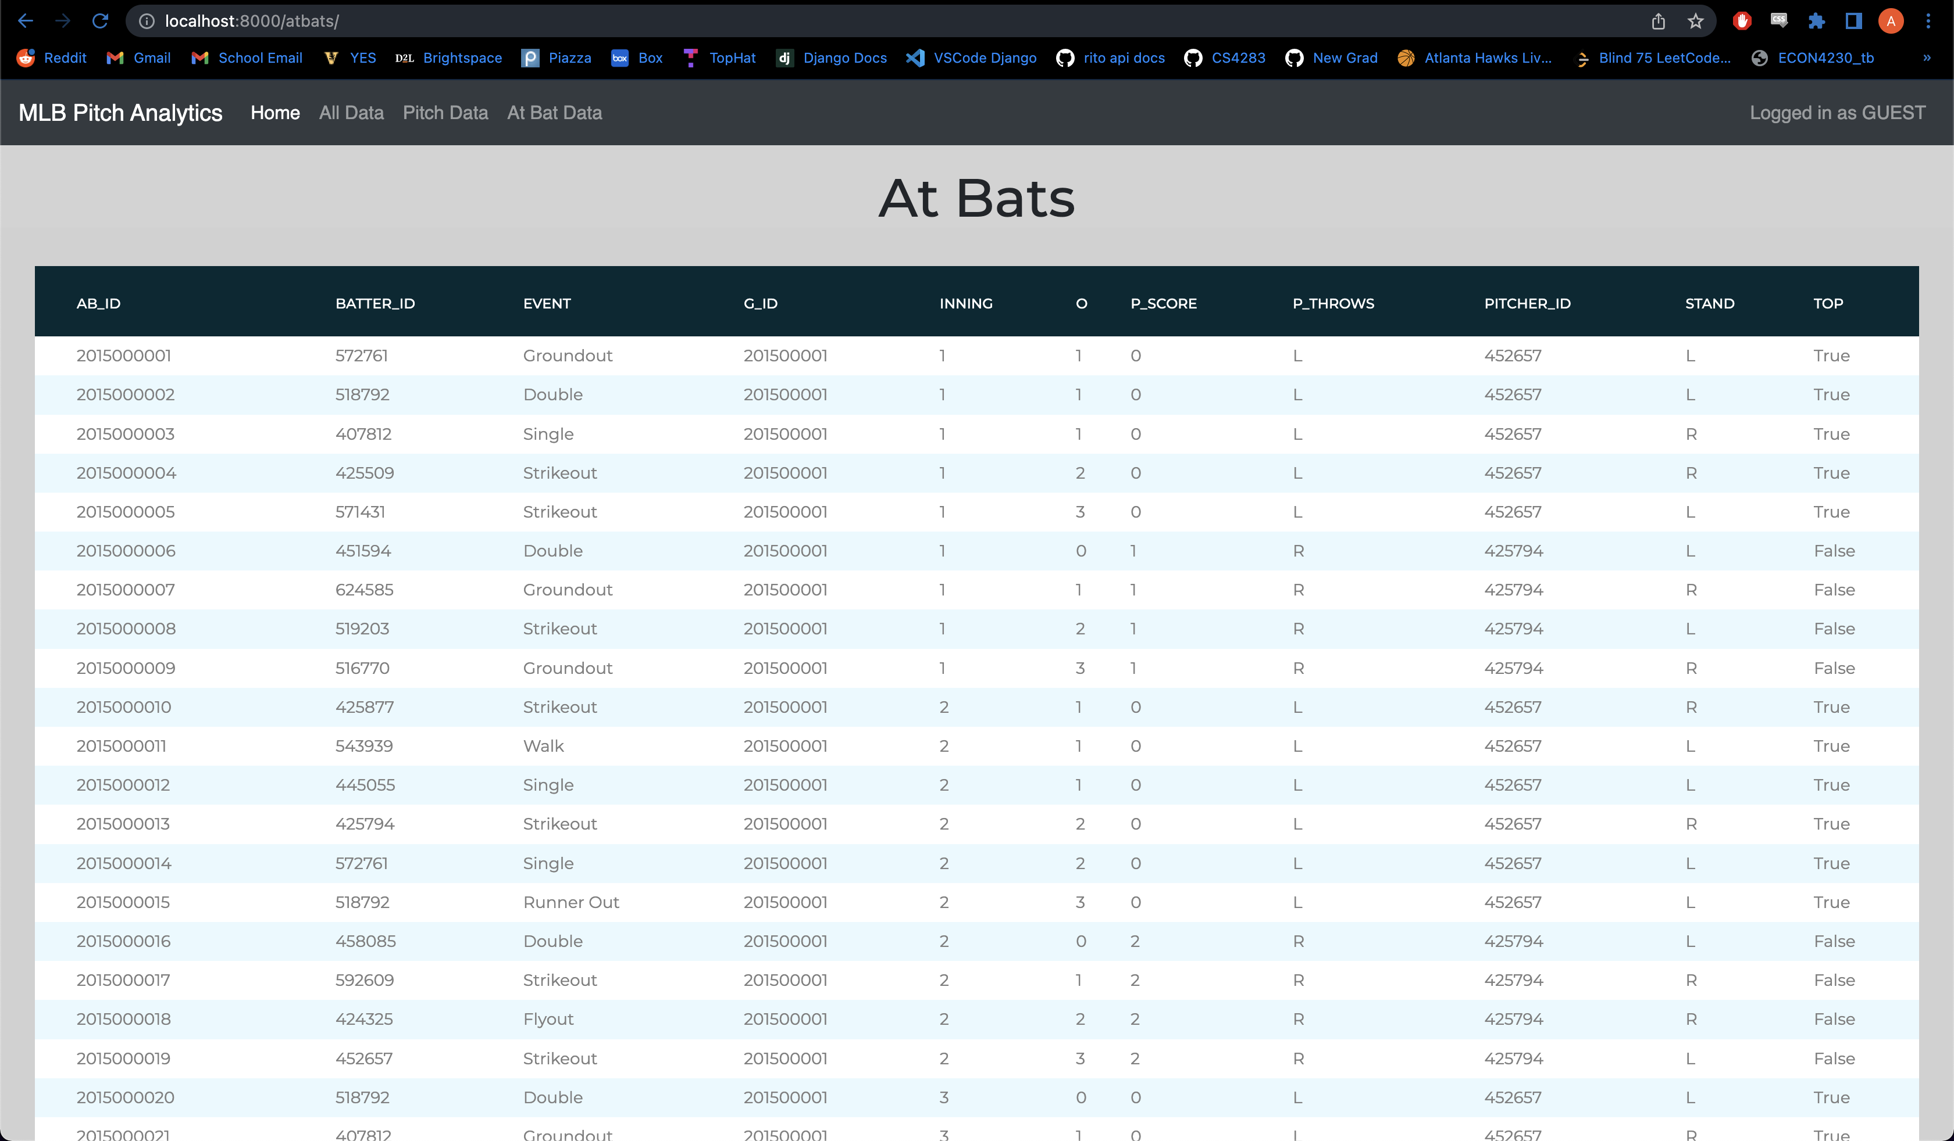

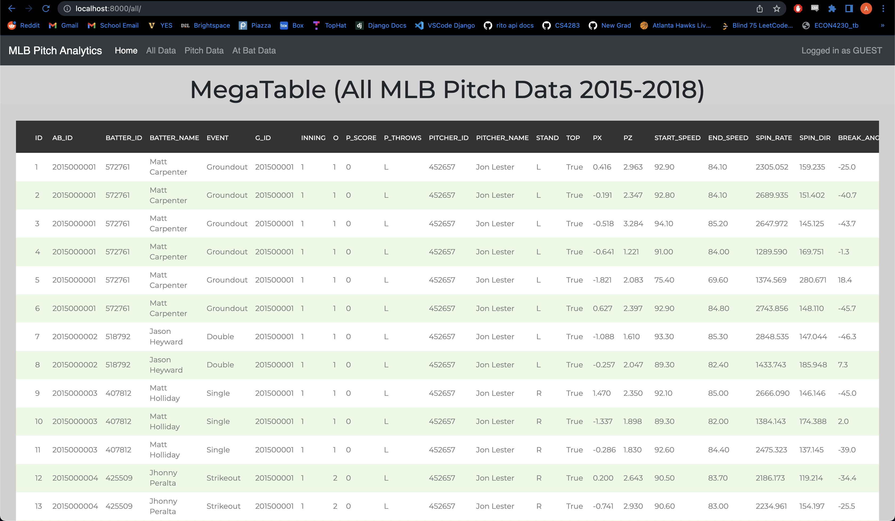

* + 1. Attach screenshots of relevant part of your front-end code showing calls to the database. This can be embedded SQL statements or calls to procedures etc.

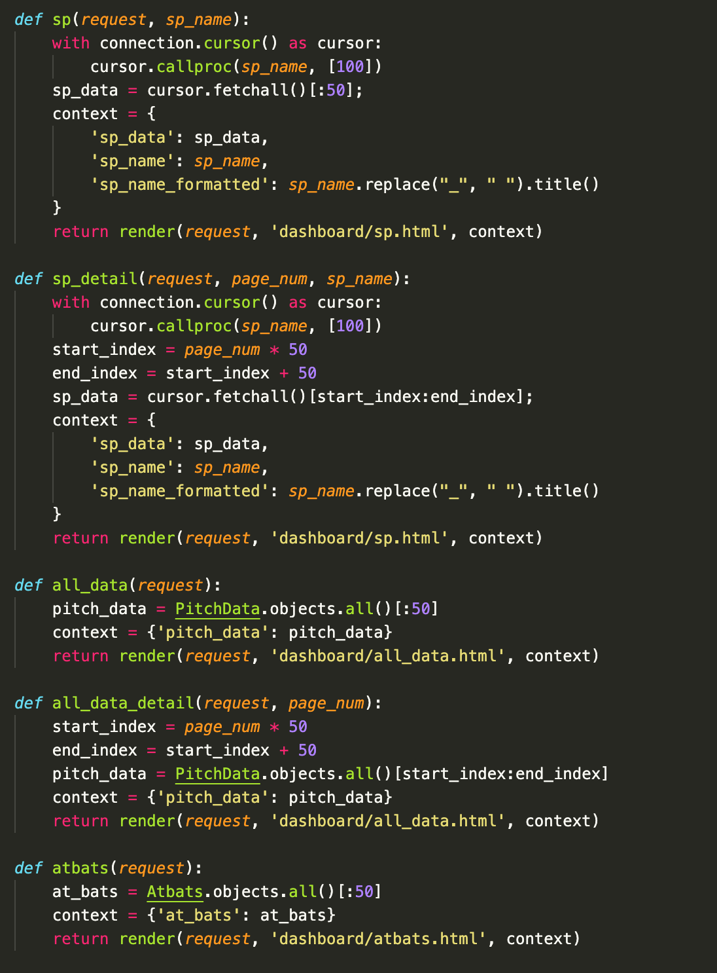Django view functions (query database from the front end)

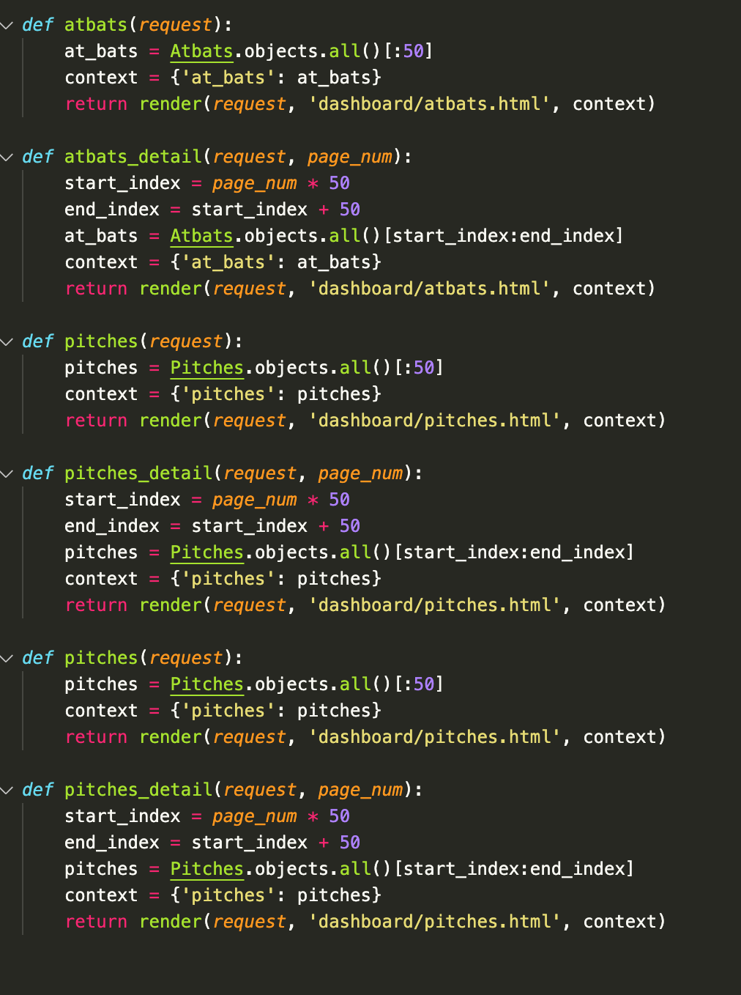

* + 1. Have you implemented any DML components (INSERT, UPDATE, DELETE) yet in your project (Note that you must have DML components in the final version of your project). If yes, include screenshot.

Because we are working with historical (static) data and performing analytics using that data, there is not much actual manipulation that we are doing. Specifically, inserting, updating, or deleting rows from the tables representing our original data sets could possibly affect the accuracy of our analytics. Therefore, as of right now, we have not implemented any DML components. However, we may create some functionality that can allow for new data to be inserted into the existing tables, in which case we would implement INSERT and UPDATE capability.

* 1. What is the status of front-end application? In terms of percentage how much do you think, you have completed on front-end side of the project? Describe what is completed and what is left. 2-3 sentences.

The front-end application is in good shape, as we have written the majority of the code for all of our necessary page templates (useable for all different query result sets). We have also set up routing and navigation, so all compoonents of the application are connected. Because we have not yet completed all of the desired styling and UI functionality (i.e. page navigation, filtering, sorting, etc.), we would say we are about 70% done with the front-end side.

## Report and demo video

* Have you started working on your report? If yes, how much is completed (percentage)

We have not yet begun work on the final report, but we have made sure to maintain documentation of what we have accomplished so that when we get to the report, we will have all the necessary info.

* Which tool you are planning to use to create a demo video of your application?

We will most likely create a screen recording using QuickTime and a voice over using Voice Memos to demo our application.

## Final Submission

* Please read the final project submission grading criteria posted on Brightspace.

# Submission:

Complete this document and save it as pdf. You must submit a PDF file named **p2-part3-lastname1-lastname2.pdf** (For example if I submit this document with John Smith, I would name it p2-part3-singh-smith.pdf). Submit your files on Brightspace.

You must include your name and your partner name in the Brightspace submission text box.

Each member of the team must make the submission of same file.

# Grading:

This Assignment will be graded on the following criteria:

1. Completeness of document.
2. Completeness of required components at this stage of project.
3. Clear evidence of work completed.

*NO grading will be done on file/s sent through email or not uploaded to Brightspace.*