Contents
- Assignment 3

- Best Fit Algorithm 4
2.1 What is Best-Fit in memory allocation 4
2.2 Is Best-Fit really the best option? 5
2.3 Other memory allocation algorithms 6

- Codes 9
  - C language 9
  - C++ language 11
  - Java language 14

- Results 16
  - C language 16
  - C++ language 17
  - Java language 19

- Assignment
The task consists of the following:

Simulate the detail operation for Best Fit Algorithm, including:
1. Algorithm flowchart;
2. Code (can be any language);
3. Output results;
4. A complete report.

The code should include the following requirements:
1. Obtain the number of Processes and obtain number of blocks.
2. Obtain the size of each block and obtain the size each process requests.
3. Order the free blocks with sizes from small -> big.
4. Select the first free memory block that can be allocated using the above definition.
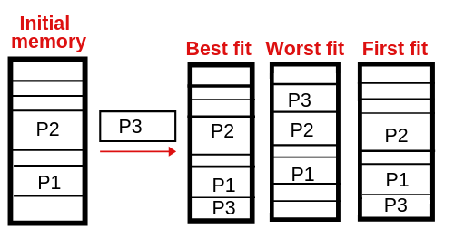

- Best Fit Algorithm
2.1 What is Best-Fit in memory allocation?

The Best Fit Memory Allocation Algorithm allocates the smallest free partition available in the memory that is sufficient enough to hold the process within the system.
It searches the complete memory for available free partitions and allocates the process to the memory partition which is the smallest enough to hold the process.

This is a very slow searching algorithm since it searches a lot of memory spaces to find the best fit memory for the process. Therefore, memory utilization is much better as compared to other memory management algorithms.

Sequence # | Size of the free block
1 | 100 KB
2 | 200 KB
3 | 300 KB
4 | 500 KB
5 | 600 KB

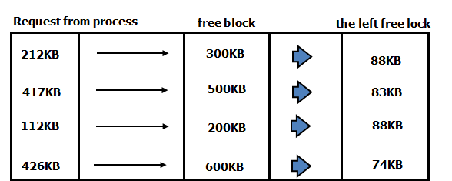
2.2 Is Best-Fit really the best option?

Although, best fit minimizes the wastage space, it consumes a lot of processor time for searching the block which is close to required size. Also, Best-fit may perform poorer than other algorithms in some cases. For example, see below exercise.

Example:
Consider the requests from processes in given order:
- 300K
- 25K
- 125K
- 50K
And there are two blocks of memory available of size:
- 150K
- 350K

Best Fit:
300K is allocated from block of size 350K. 50 is left in the block.
25K is allocated from the remaining 50K block. 25K is left in the block.
125K is allocated from 150 K block. 25K is left in this block also.
50K can’t be allocated even if there is 25K + 25K space available.

First Fit
300K request is allocated from 350K block, 50K is left out.
25K is be allocated from 150K block, 125K is left out.
Then 125K and 50K are allocated to remaining left out partitions.
So the first fit can handle the requests.

2.3 Other memory allocation algorithms

In 2.2 there was already mentioning of first fit memory allocation algorithm. There are a few types of memory allocation algorithms:
- First Fit
- Worst fit
- Buddy's system
- Next fit

First Fit
In the first fit approach is to allocate the first free partition or hole large enough which can accommodate the process. It finishes after finding the first suitable free partition.

Advantage:
This is the fastest algorithm because it searches as little as possible.

Disadvantage:
The remaining unused memory areas left after allocation become waste if it is too smaller. Thus request for larger memory requirement cannot be accomplished.

Worst Fit
In worst fit approach is to locate largest available free portion so that the portion left will be big enough to be useful. It is the reverse of best fit.

Advantage:
It reduces the rate of production of small gaps.

Disadvantage:
If a process requiring larger memory arrives at a later stage then it cannot be accommodated as the largest hole is already split and occupied.

Buddy's System
In a buddy system, sizes of free blocks are in form of integral power of 2. (2, 4, 8, 16, etc., this goes up to the size of memory). When a free block of size 2k is requested, a free block from the list of free blocks of size 2k is allocated. If no free block of size 2k is available, the block of next larger size, 2k+1 is split in two halves called buddies to satisfy the request.

Example:
Let total memory size be 512KB and let a process P1, requires 70KB to be swapped in. As the whole lists are only for powers of 2, 128KB will be big enough. Initially no 128KB is there, nor are blocks 256KB. Thus 512KB block is split into two buddies of 256KB each, one is further split into two 128KB blocks and one of them is allocated to the process. Next P2 requires 35KB. Rounding 35KB up to a power of 2, a 64KB block is required.
So when 128KB block is split into two 64KB buddies. Again a process P3(130KB) will be adjusted in the whole 256KB. After satisfying the request in this way when such block is free, the two blocks/buddies can be recombined to form the twice larger original block when it is second half buddy is also free.
Advantage:
Buddy system is faster. When a block of size 2k is freed, a hole of 2k memory size is searched to check if a merge is possible, whereas in other algorithms the whole list must be searched.

Disadvantage:
It is often become inefficient in terms of memory utilization. As all requests must be rounded up to a power of 2, a 35KB process is allocated to 64KB, thus wasting extra 29KB causing internal fragmentation. There may be holes between the buddies causing external fragmentation.

Next fit
Next fit is a modified version of first fit. It begins as first fit to find a free partition. When called next time it starts searching from where it left off, not from the beginning.

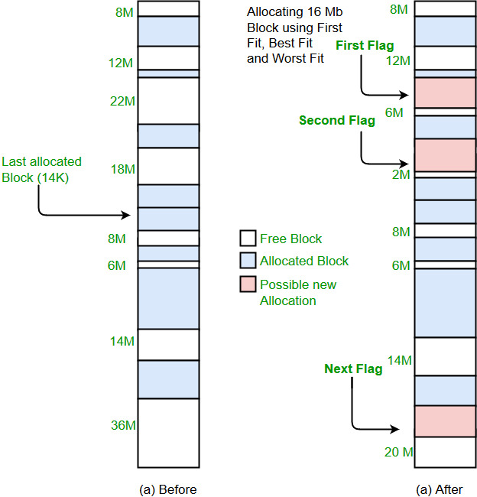
- Codes
3.1 C language

#include<stdio.h>

void main()
{
int fragment[20],b[20],p[20],i,j,nb,np,temp,lowest=9999;
static int barray[20],parray[20];

printf("\n \t\t\tBest Fit Algorithm - C++\n");
printf("\t\t\t========================\n");
printf("\n Enter the number of blocks: ");
scanf("%d",&nb);
printf(" Enter the number of processes: ");
scanf("%d",&np);

printf("\n Enter the size of the blocks:\n");
for(i=1;i<=nb;i++)
{
printf(" Block #%d: ",i);
scanf("%d",&b[i]);
}

printf("\n Enter the size of the processes:\n");
for(i=1;i<=np;i++)
{
printf(" Process #%d: ",i);
scanf("%d",&p[i]);
}

for(i=1;i<=np;i++)
{
for(j=1;j<=nb;j++)
{
if(barray[j]!=1)
{
temp=b[j]-p[i];
if(temp>=0)
if(lowest>temp)
{
parray[i]=j;
lowest=temp;
}
}
}

fragment[i]=lowest;
barray[parray[i]]=1;
lowest=10000;
}

printf("\n Process_no\tProcess_size\tBlock_no\tBlock_size\tFragment");
printf("\n =======================================================================");
for(i=1;i<=np && parray[i]!=0;i++)
printf("\n %d\t\t%d\t\t%d\t\t%d\t\t%d",i,p[i],parray[i],b[parray[i]],fragment[i]);
printf("\n\n\n\n");
}

3.2 C++ language

#include<iostream>
#include <windows.h> // WinApi header

using namespace std;

int main()
{
HANDLE hConsole;
int k;

system("CLS");
hConsole = GetStdHandle(STD_OUTPUT_HANDLE);

int fragment[20],b[20],p[20],i,j,nb,np,temp,lowest=9999;
static int barray[20],parray[20];
k = 14;
SetConsoleTextAttribute(hConsole, k);
cout<< "\n\t\t\t.==========================.";
cout<<"\n\t\t\t| Best Fit Algorithm - C++ |";
cout<<"\n\t\t\t'=========================='";

k = 15;
SetConsoleTextAttribute(hConsole, k);
cout<<"\n\n Number of blocks: ";
k = 10;
SetConsoleTextAttribute(hConsole, k);
cin>>nb;
k = 15;
SetConsoleTextAttribute(hConsole, k);
cout<<" Number of process: ";
k = 10;
SetConsoleTextAttribute(hConsole, k);
cin>>np;

k = 15;
SetConsoleTextAttribute(hConsole, k);
cout<<"\n Size of the blocks: \n";
for(i=1;i<=nb;i++)
{
k = 15;
SetConsoleTextAttribute(hConsole, k);
cout<<" Block #"<<i<<": ";
k = 10;
SetConsoleTextAttribute(hConsole, k);
cin>>b[i];
}

k = 15;
SetConsoleTextAttribute(hConsole, k);
cout<<"\n Size of the processes: \n";
for(i=1;i<=np;i++)
{
k = 15;
SetConsoleTextAttribute(hConsole, k);
cout<<" Process #"<<i<<": ";
k = 10;
SetConsoleTextAttribute(hConsole, k);
cin>>p[i];
}

for(i=1;i<=np;i++)
{
for(j=1;j<=nb;j++)
{
if(barray[j]!=1)
{
temp=b[j]-p[i];
if(temp>=0)
if(lowest>temp)
{
parray[i]=j;
lowest=temp;
}
}
}

fragment[i]=lowest;
barray[parray[i]]=1;
lowest=10000;
}

k = 14;
SetConsoleTextAttribute(hConsole, k);
cout<<"\n Process #\tProcess size\tBlock #\t\tBlock size\tFragment";
cout<<"\n .======================================================================.";
for(i=1;i<=np && parray[i]!=0;i++)
cout<<"\n | "<<i<<"\t\t"<<p[i]<<"\t\t"<<parray[i]<<"\t\t"<<b[parray[i]]<<"\t\t"<<fragment[i]<<"\t|";

cout<<"\n '======================================================================'";
cout<<"\n\n";

k = 15;
SetConsoleTextAttribute(hConsole, k);

cout<<" Student name: Li Qiu\n";
cout<<" Student ID#: 201709130104";

k = 0;
SetConsoleTextAttribute(hConsole, k);

return 0;
}

3.3 Java language

public class bestFit
{
// Method to allocate memory to blocks as per Best fit algorithm
static void bestFit(int blockSize[], int m, int processSize[],
int n, int fragment[], int blockOrder[])
{
// Stores block id of the block allocated to a process
int allocation[] = new int[n];

// Initially no block is assigned to any process
for (int i = 0; i < allocation.length; i++)
allocation[i] = -1;

// pick each process and find suitable blocks according to its size and
// assign it to it
for (int i=0; i<n; i++)
{
// Find the best fit block for current process
int bestIdx = -1;
for (int j=0; j<m; j++)
{
if (blockSize[j] >= processSize[i])
{
if (bestIdx == -1)
bestIdx = j;
else if (blockSize[bestIdx] > blockSize[j])
bestIdx = j;
}
}

// If we could find a block for current process
if (bestIdx != -1)
{
// allocate block j to p[i] process
allocation[i] = bestIdx;

// Reduce available memory in this block
blockSize[bestIdx] -= processSize[i];
}
}
System.out.println("\n Process #\tProcess Size\tBlock #\t\tBlock Size\tFragment");
System.out.println(" =======================================================================");
for (int i = 0; i < n; i++)
{
System.out.print(" " + (i+1) + "\t\t" + processSize[i] + "\t\t");
if (allocation[i] != -1)
System.out.print(allocation[i] + 1);
else
System.out.print("Not Allocated");
System.out.print("\t\t" + blockOrder[i] + "\t\t" + fragment[i]);
System.out.println();
}
}

// Driver Method
public static void main(String[] args)
{
int blockSize[] = {100, 500, 200, 300, 600};
int blockOrder[] = {300, 500, 200, 600};
int processSize[] = {212, 417, 112, 426};
int fragment[] = {88, 83, 88, 174};
int m = blockSize.length;
int n = processSize.length;

System.out.println("\n Block sizes: 100, 500, 200, 300, 600");

bestFit(blockSize, m, processSize, n, fragment, blockOrder);
}
}

- Results
4.1 C language

The results using C code, 5 blocks and 4 processes:
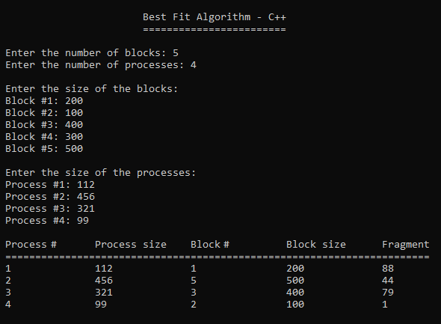

4.2 C++ language

The results using C++ code, 3 blocks and 2 processes:
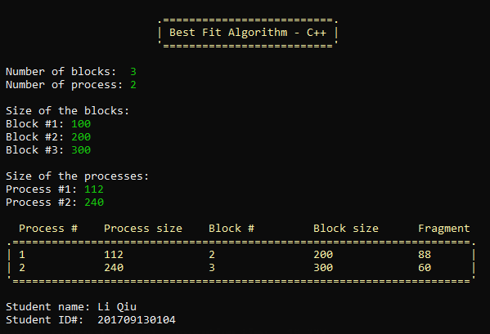

The code is now much easier to read because of the proper use of colors. All the user inputs are green and the output is yellow.
The 112 process size fits in the 200 block size and 88 memory fragments left.
The 240 process size fits in the 300 block size and 60 memory fragments left.

The results using C++ code, 5 blocks and 4 processes.
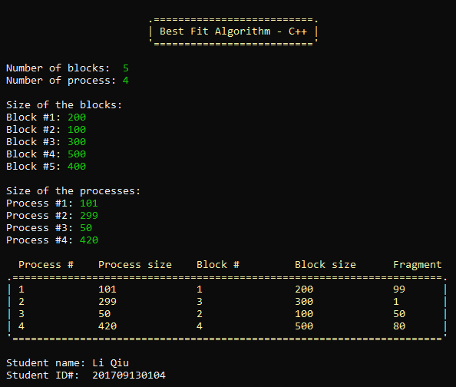

4.3 Java language code

