课程设计安排
按照本文档要求完成课程设计。

时间地点
任课教师另行通知。（学生可自行安排时间来完成任务。）

题目
本次课程设计题目共3道题，每2人一组，需要完成3道题目：（题目说明详见附录）
题目一 | 操作系统内存分配（Best Fit Algorithm）
题目二 | 操作系统页面置换（Belady’s Anomaly in Operating System）
题目三 | 操作系统互斥与同步（Cat-Dog and chocolate）

三、过程安排
- 认真阅读本文档；
- 阅读程序实例，掌握综合程序的结构和设计过程；
- 根据任务，设计具体的算法流程，实现编码；
- 调试和修改自己的程序；
- 书写程序课程设计报告；
- 验收程序。

四、最终需提交材料
在完成课程设计后，将以下所有材料交给课代表。

1 计算机文件：包括题目描述，算法设计，详细编码，测试，以及个人心得体会。
文件统一令名格式： 姓名1_姓名2_班级_课设代号.doc
例如，假设杨和张二人一组，需要递交三份文档，文件名如下：
杨XX_张YY_计算机183_课题1.docx
杨XX_张YY_计算机183_课题2.docx
杨XX_张YY_计算机183_课题3.docx

文档的第一页是封面，需要包含每组二人的个人信息。
文档的第二页开始报告正文。
报告的基本格式，需要符合软件工程的规范，例如，
- 课题设计目的，
- 问题描述，
- 详细设计(至少包括算法流程图等；其它需要的东西，同学们自行调查。)，
- 源代码，
- 测试结果，
- 总结&个人心得体会等。

五、成绩评定方法
课程设计成绩分为五级：优秀、良好、中等、及格、不及格。
（注意，本次实践课设有答辩环节。）

六、作弊处理
凡发现抄袭，抄袭者与被抄袭者皆以零分计入本课程设计成绩并向学院报告；
凡发现课程设计报告或源程序雷同，涉及的全部人员皆以零分计入本课程设计成绩并向学院报告。

附录：题目列表

题目一：操作系统内存分配（Best Fit Algorithm）

What is Best Fit Algorithm?
The Best Fit Memory Allocation Algorithm allocates the smallest free partition available in the memory that is sufficient enough to hold the process within the system.
It searches the complete memory for available free partitions and allocates the process to the memory partition which is the smallest enough to hold the process.
This is a very slow searching algorithm since it searches a lot of memory spaces to find the best fit memory for the process. Therefore, memory utilization is much better as compared to other memory management algorithms.

Sequence No. | Size for free block
1 | 100KB
2 | 200KB
3 | 300KB
4 | 500KB
5 | 600KB
212KB
300KB
88KB
417KB
500KB
83KB
112KB
200KB
88KB
Request from process free block the left free lock
426KB
600KB
74KB

What is Best Fit Memory Management Scheme?
Best fit uses the best memory block based on the Process memory request. In best fit implementation the algorithm first selects the smallest block which can adequately fulfill the memory request by the respective process.
Because of this memory is utilized optimally but as it compares the blocks with the requested memory size it increases the time requirement and hence slower than other methods. It suffers from Internal Fragmentation which simply means that the memory block size is greater than the memory requested by the process, then the free space gets wasted.
Once we encounter a process that requests a memory which is higher than block size we stop the algorithm.
Best Fit Algorithm
- obtain the number of Processes and number of blocks.
- get the size of each block；get the size each process requests.
- order the free block with size from small to big.
- Then select the first free memory block that can be allocated using the above definition.

课题报告要求：
Simulate the detail operation for Best Fit Algorithm, including:
- Algorithm flowchart;
- Code;
- Output result.
- A complete report.

题目二：操作系统页面置换（Belady’s Anomaly in Operating System）

Virtual Memory and Belady’s Anomaly
在先进先出算法(FIFO)——选择装入最早的页面置换的过程中，可以通过链表来表示各页的装入时间先后。FIFO的性能较差，因为较早调入的页往往是经常被访问的页，这些页在FIFO算法下被反复调入和调出，并且有Belady现象。所谓Belady现象是指：采用FIFO算法时，如果对一个进程未分配它所要求的全部页面，有时就会出现分配的页面数增多但缺页率反而提高的异常现象。

Operating systems (OS) use Virtual memory when the programs executed by them need more space than the physical memory can allocate. In the Virtual memory system, all the processes are divided into fixed-sized pages. These pages are loaded into the physical memory using the method of demand paging. Under demand paging, during the execution of a particular process, whenever a page is required, a page fault occurs, and then the required page gets loaded into the memory replacing some other page. The page replacement algorithm specifies the choice of the page which is to be replaced. Now, Belady’s Anomaly is said to occur when the number of page faults increases significantly.

Belady’s Anomaly
The rate of page faults varies directly with the number of frames allocated to the individual process. The increase in the number of frames considerably decreases the number of page faults. However, sometimes reverse action occurs when the increased number of frames results in increased page faults. This exception is known as the Belady’s Anomaly. The occurrence of this exception depends on the page replacement algorithm, which governs the demand paging process. The page replacement algorithms in which Belady’s Anomaly occurs the most includes:
- First In First Out (FIFO)
- Second Chance Algorithm
- Random Page Replacement Algorithm

Belady’s Anomaly Graph
The graph in Fig.1 symbolizes that the number of page faults is inversely proportional to the number of memory frames. In simple terms, when the number of page frames increases, the number of page faults decreases.
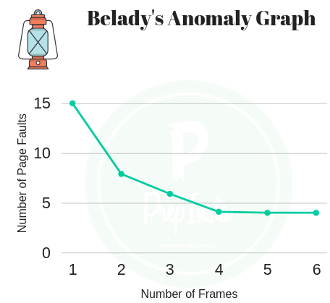

However, when FIFO, second chance algorithm, and Random Page Replacement Algorithm are utilized in demand paging, then Belady’s anomaly is suffered by increased page fault while the expected result should be decrease in the number of page faults. Fig. 2 depicts the graph for Belady’s Anomaly.

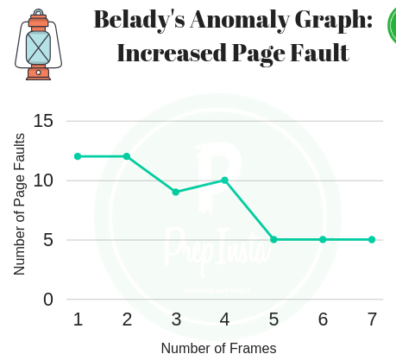

Before solving this example; it will be great if you can understand how to solve the Page Replacement Algorithm

Example of Belady’s Anomaly
Consider the memory with 3 frames, the reference string used in this case be w=dcbadcedcbae

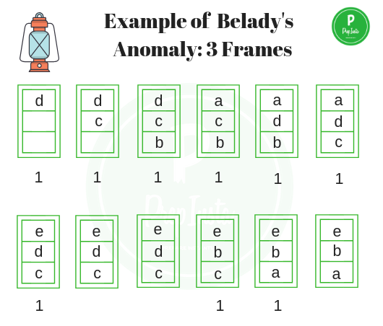

Page faults = 1+1+1+1+1+1+1+1+1 = 9
Consider the memory with 4 frames, the reference string used in this case be w=dcbadcedcbae

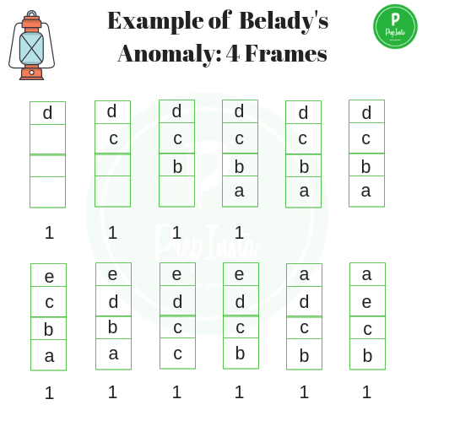
Page Faults = 1+1+1+1+1+1+1+1+1+1 = 10
In the above mentioned case, with the increase in number of frames number of faults increased, displaying Belady’s Anomaly.

How to eliminate Belady’s Anomaly?
Implementing alternative page replacement algorithm helps eliminate Belady’s Anomaly. Use of stack based algorithms, such as Optimal Page Replacement Algorithm and Least Recently Used (LRU) algorithm, can eliminate the issue of increased page faults as these algorithms assign priority to pages. In the example given below LRU is used as page replacement algorithm for string w = 1, 2, 3, 4, 1, 2, 5, 1, 2, 3, 4, 5.
Let the size of memory frame be 3; number of page faults is given by:
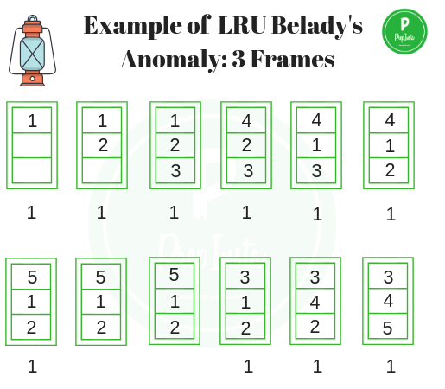
Page Faults = 1+1+1+1+1+1+1+1+1+1= 10
Let the size of memory frame be 4; number of page faults is given by:
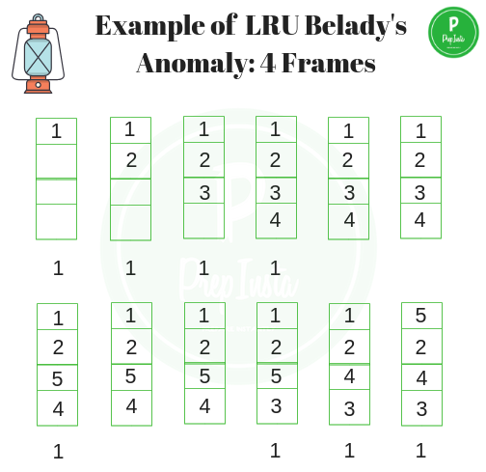
Page Faults = 1+1+1+1+1+1+1+1= 8

报告要求：
Simulate the detail operation for Belady’s Anomaly, including:
- Algorithm flowchart;
- Code（The page replacement algorithm：First In First Out (FIFO)）;
- Output result （should also display the result of Page Faults.）.
- A complete report.

题目三：操作系统互斥与同步（Cat-Dog and chocolate）
房间有一只碗，每次只能放入一个巧克力。丈夫专向碗中放黑巧克力，妻子专向碗中放白巧克力，小狗专等吃碗里的黑巧克力，小猫专等吃碗里的白巧克力。只要碗空则丈夫或妻子都可以向碗放一个巧克力，仅当碗中有自己需要的巧克力时，小狗或小猫可以从碗中取出巧克力
- 实验要求
1..Each time, only one piece of chocolate can be put into the bowl(by husband or wife);
--每次只能放进一块。
2..Each time, only one piece of chocolate can be taken out from the bowl (eaten by a cat or dog).
--每次只能拿出一块。
3..Putting chocolate into the bowl by persons and eating chocolate by pets from the bowl cannot happen simultaneously.
--放进和拿出不能同时发生。
4..only one pet can eat one piece of chocolate at one time (multiple pets cannot eat chocolates simultaneously.).
--在同一时间，只能有一种宠物吃一块。
5..only one person can put a piece of chocolate into the bowl at one time (husband and wife cannot put chocolate into the bowl simultaneously.).
--在同一时间，只能有一个人放进一块。
6.Husband puts black chocolate into the bowl, and wife puts white chocolate into the bowl.
--丈夫放黑色的，妻子放白色的。
7.Dogs wait for eating black chocolate; cats wait for eating white chocolate.
--小狗只吃黑色的，小猫只吃白色的。
报告要求：
Simulate the detail operation for Cat-Dog chocolate, including:
- Algorithm flowchart;
- Code;
- Output result.
- A complete report.

