

**《微型计算机技术及应用》**

**课程设计报告**

专业班级 电子171

小组组别 第五小组

小组成员 陈哲宇 单选迪 冯浚宸

2018 年 7 月 5日

1. **功能简介**

打开系统，按s进入密码界面，显示密码界面，密码为：123，当密码错误时，显示wrong password提示错误，当输入密码正确时，进入另一个界面。

1. **代码简介**

分别运用本学期所学的调颜色，画横线，时间中断等内容，分别写在不同的模块中方便调用。

1. **程序代码**

org 0x8400

jmp start

tip:db 'Password:'

str:db 'Success!!!!!'

str1:db 'Wrong password! Press any key to continue.'

str2:db '123'

start:

mov ax,0b800h

mov es,ax

mov ax,cs

mov ds,ax

mov di,0

call clear

mov di,1020

mov bx,tip

call outtip

mov bx,str2

mov cx,0

jmp pro1

clear:

mov al,' '

mov [es:di],al

inc di

mov ah,05h

mov [es:di],ah

inc di

cmp di,0fa0h

jbe clear

ret

outtip:

mov al,[ds:bx]

mov [es:di],al

inc di

mov ah,05h

mov [es:di],ah

inc di

inc bx

cmp di,1038

jb outtip

ret

pro1:

mov ah,10h

int 16h

cmp al,[ds:bx]

jnz key

mov al,'*'

mov [es:di],al

inc di

mov ah,05h

mov [es:di],ah

inc di

add bx,1

add cx,1

cmp cx,3

jae right

jmp pro1

ret

key:

mov al,'*'

mov [es:di],al

inc di

mov ah,05h

mov [es:di],ah

inc di

mov ah,10h

int 16h

mov di,0

call clear

mov ax,cs

mov ds,ax

mov bx,str1

mov di,1000

jmp errorout

ret

errorout:

mov al,[ds:bx]

mov [es:di],al

add di,1

mov ax,05h

mov [es:di],ax

add di,1

add bx,1

cmp di,1081

jbe errorout

mov ah,10h

int 16h

jmp start

right:

mov ah,10h

int 16h

mov di,0

call clear

mov ax,cs

mov ds,ax

mov bx,str

mov di,1020

jmp 0x8600

ret

org 0x8600

jmp start

chen db '0000000000000000' ;汉字定义'陈单'

db '0000011111000000'

db '0000100000100000'

db '0001000000010000'

db '0001000000010000'

db '0000111111110000'

db '0000001010000000'

db '0000110001100000'

db '1111000000011110'

db '0001000000010000'

db '0001000000010000'

db '0000111111100000'

db '0000010001000000'

db '0000010001000000'

db '0000010001000000'

db '0000000000000000'

dan db '0000000000000000'

db '0000000000000000'

db '0000000000000000'

db '0000000000000000'

db '0000000000000000'

db '0000000000000000'

db '0000000000000000'

db '0000000000000000'

db '0000000000000000'

db '0000000000000000'

db '0011110000000000'

db '0100001000000000'

db '1000000100000000'

db '1000000100000000'

db '0100001000000000'

db '0011110000000000'

start:

MOV AL,0x13

MOV AH,0x00

INT 0x10

mov dx,0x3c8 ;1 颜色定义blue为'1'

mov al,1

out dx,al

mov dx,0x3c9

mov al,0

out dx,al

mov dx,0x3c9

mov al,0

out dx,al

mov dx,0x3c9

mov al,255

out dx,al

mov dx,0x3c9 ;2

mov al,123

out dx,al

mov dx,0x3c9

mov al,121

out dx,al

mov dx,0x3c9

mov al,0

out dx,al

mov dx,0x3c9 ;3

mov al,0

out dx,al

mov dx,0x3c9

mov al,255

out dx,al

mov dx,0x3c9

mov al,0

out dx,al

mov dx,0x3c9 ;4

mov al,255

out dx,al

mov dx,0x3c9

mov al,255

out dx,al

mov dx,0x3c9

mov al,255

out dx,al

mov ax,0xa000

mov es,ax ;初始化

mov ax,0x0

mov ds,ax

call beijing

call xian1

call xian2

call xian3

call xian4

call xian5

call xian6

call xian7

mov di,chen ;16*16

mov bx,0

mov cx,16

mov dx,16

x0: cmp byte[ds:di],'0'

jz out1

mov byte [es:bx],1

out1: inc di

inc bx

dec cx

cmp cx,0

jz x1

jmp x0

x1: sub bx,16

add bx,320

dec dx

cmp dx,0

jz x2

mov cx,16

jmp x0

x2: mov di,dan

mov bx,17

mov cx,16

mov dx,16

x3: cmp byte[ds:di],'0'

jz out2

mov byte [es:bx],1

out2: inc di

inc bx

dec cx

cmp cx,0

jz x4

jmp x3

x4: sub bx,16

add bx,320

dec dx

cmp dx,0

jz exit

mov cx,16

jmp x3

exit: jmp $ ;结束

beijing:

mov di,0

z2: mov byte[es:di],3

inc di

cmp di,64000

jb z2

ret

jmp $

xian1:

mov di, 111

f1: mov cx,0

mov si,cx

mov byte[es:di],4

f2: inc di

inc si

cmp si,320

jb f2

cmp di,11311

jb f1

ret

jmp $

xian2:

mov di,11311

f3: mov byte[es:di],4

inc di

cmp di,11411

jb f3

ret

jmp $

xian3:

mov di, 211

f4: mov cx,0

mov si,cx

mov byte[es:di],4

f5: inc di

inc si

cmp si,320

jb f5

cmp di,11411

jb f4

ret

jmp $

xian4:

mov di,32001

f6: mov byte[es:di],4

inc di

cmp di,32320

jb f6

ret

jmp $

xian5:

mov di, 52910

f7: mov cx,0

mov si,cx

mov byte[es:di],4

f8: inc di

inc si

cmp si,320

jb f8

cmp di,63790

jb f7

ret

jmp $

xian6:

mov di,52910

f9: mov byte[es:di],4

inc di

cmp di,53010

jb f9

ret

jmp $

xian7:

mov di, 53010

f10: mov cx,0

mov si,cx

mov byte[es:di],4

f11: inc di

inc si

cmp si,320

jb f11

cmp di,63890

jb f10

ret

jmp $

1. **测试结果**

初始界面

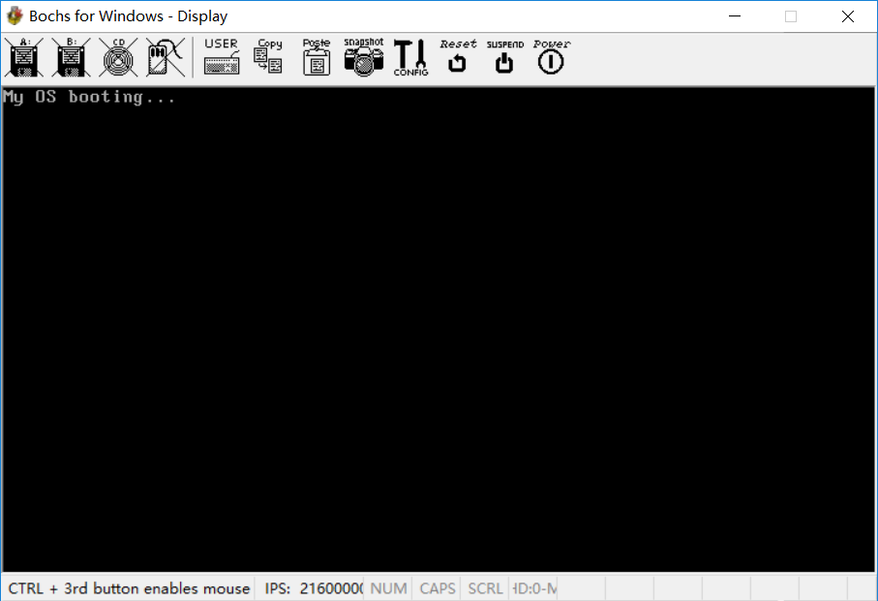

点击S后

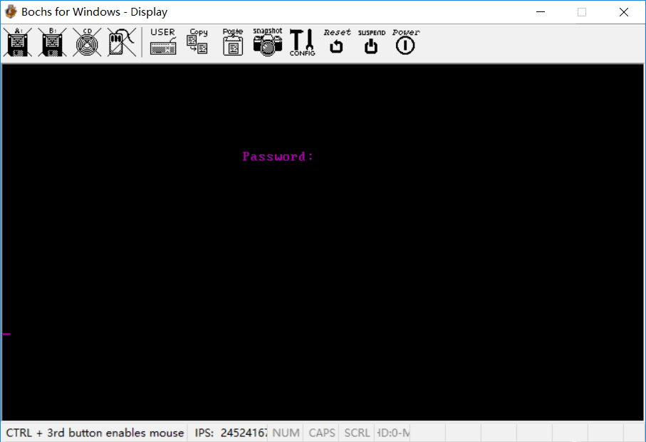

密码错误

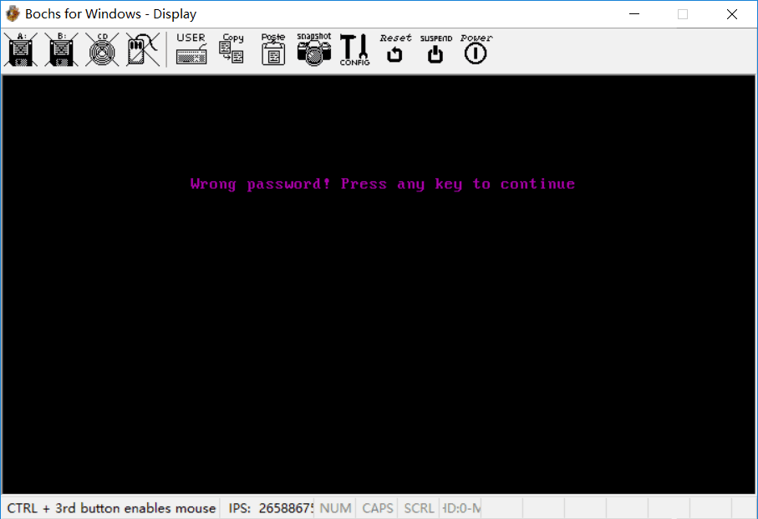

密码正确

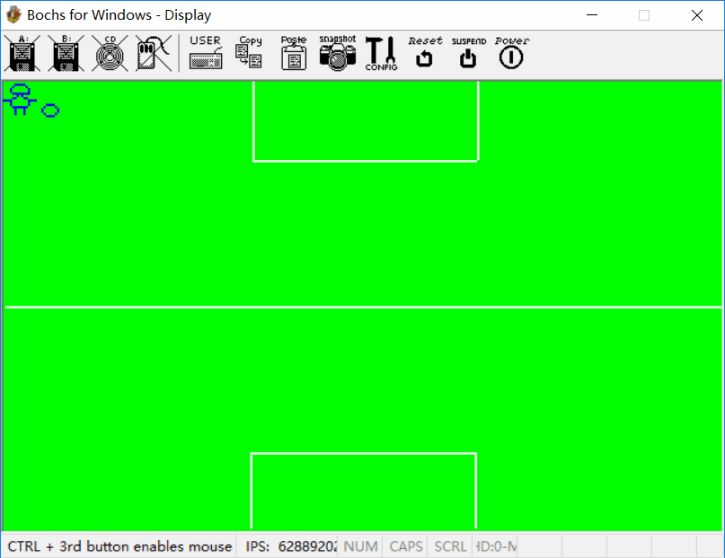

1. **心得体会**

通过这次的实验，我们把这学期学习的调颜色，画横线，时间中断等内容，模块调用进行了一次综合性的运用。让我们对这些知识有了更深的了解。