

**课程作品报告**

**2020-2021学年第一学期**

**课程名称： 微机课程设计**

**学院名称： 信息工程学院**

**专业班级： 计算机183班**

**学生姓名： 邱澳锋、潘伟**

**指导老师： 舒红波**

**2021年1月**

目录

一、 程序总体介绍 2

二、 程序功能模块 3

2.1 登录进入主界面 3

2.2 主界面播放歌曲 5

2.3 Ctrl键的响应 5

2.4 自主输入音频 7

2.5 播放音乐 7

2.6 自主输入音频 9

三、 运用的所学知识 10

3.1 扬声器 10

3.2 键盘中断 11

3.3 界面绘图 12

3.4 按键变色 14

3.5 界面清屏 15

四、 操作实现流程图 16

五、 心得体会 20

六、 附程序代码 21

# 程序总体介绍

渐变式音乐播放的程序，总体框架在于程序输出界面的设计以及音乐如何进行响应按键进行不同的频率播放，首先在界面的设计上用到了自己在之前微机作业上的框架，基于此框架进行修改，所以框架的框图如下：

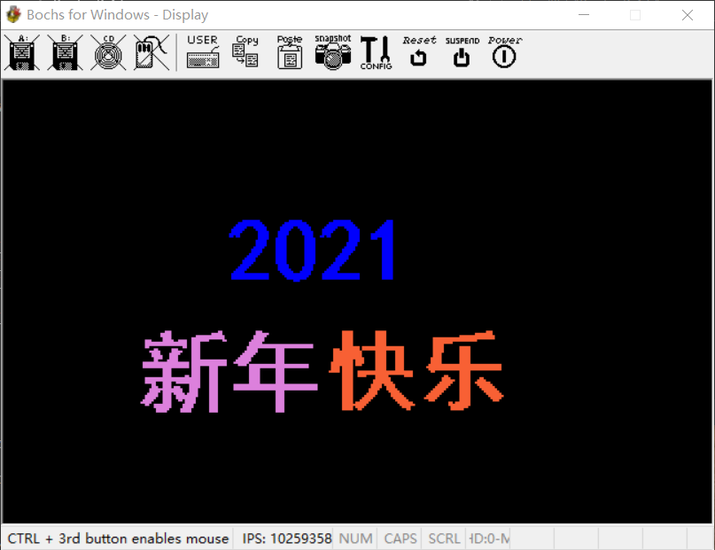

框架的实现用到的是横线（函数名DrawLineHeng）和竖线（函数名DrawLineShu）的调用，横线中的DrawLineHeng定义了ax为横线当前的y值，bx与cx分别定义横线的起始值和终点值，再通过函数中的堆栈操作，将ax，bx，cx压入栈内，每次给bx加1，比较bx与cx的值进行画横线操作；竖线DrawLineShu即定义bx为当前x值，ax与cx为竖线的起始值和终点值，通过每次将ax加320实现画竖线的操作。

响应按键则是通过键盘中断来响应键盘的al值，此处我定义了一个string的数组，用来存放每次按键产生的al值，再来用每个键盘的相应值与string数组中的值进行比较，以此来进行响应键盘。

产生不同的频率在于一个扬声器的使用，通过最后一次实验中的扬声器实验，加上一个延时函数来实现音频的播放，此处用到了一个music和music1的函数，music中就是简单的声音发出的打开和关闭，通过每次不同的bx值，来输入不同的频率以此产生不同的音频，music2函数则是给cx以60000的值来进行每次的dec递减产生延时。

# 程序功能模块

程序可以分为7个基本模块。

## 登录进入主界面

运行进入程序需要点击响应键盘才能进入主界面，进入主界面后有进入的欢迎音乐。

 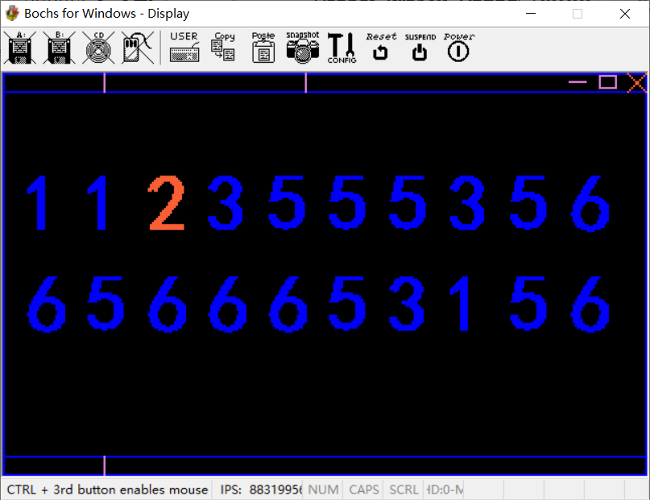

相应代码：

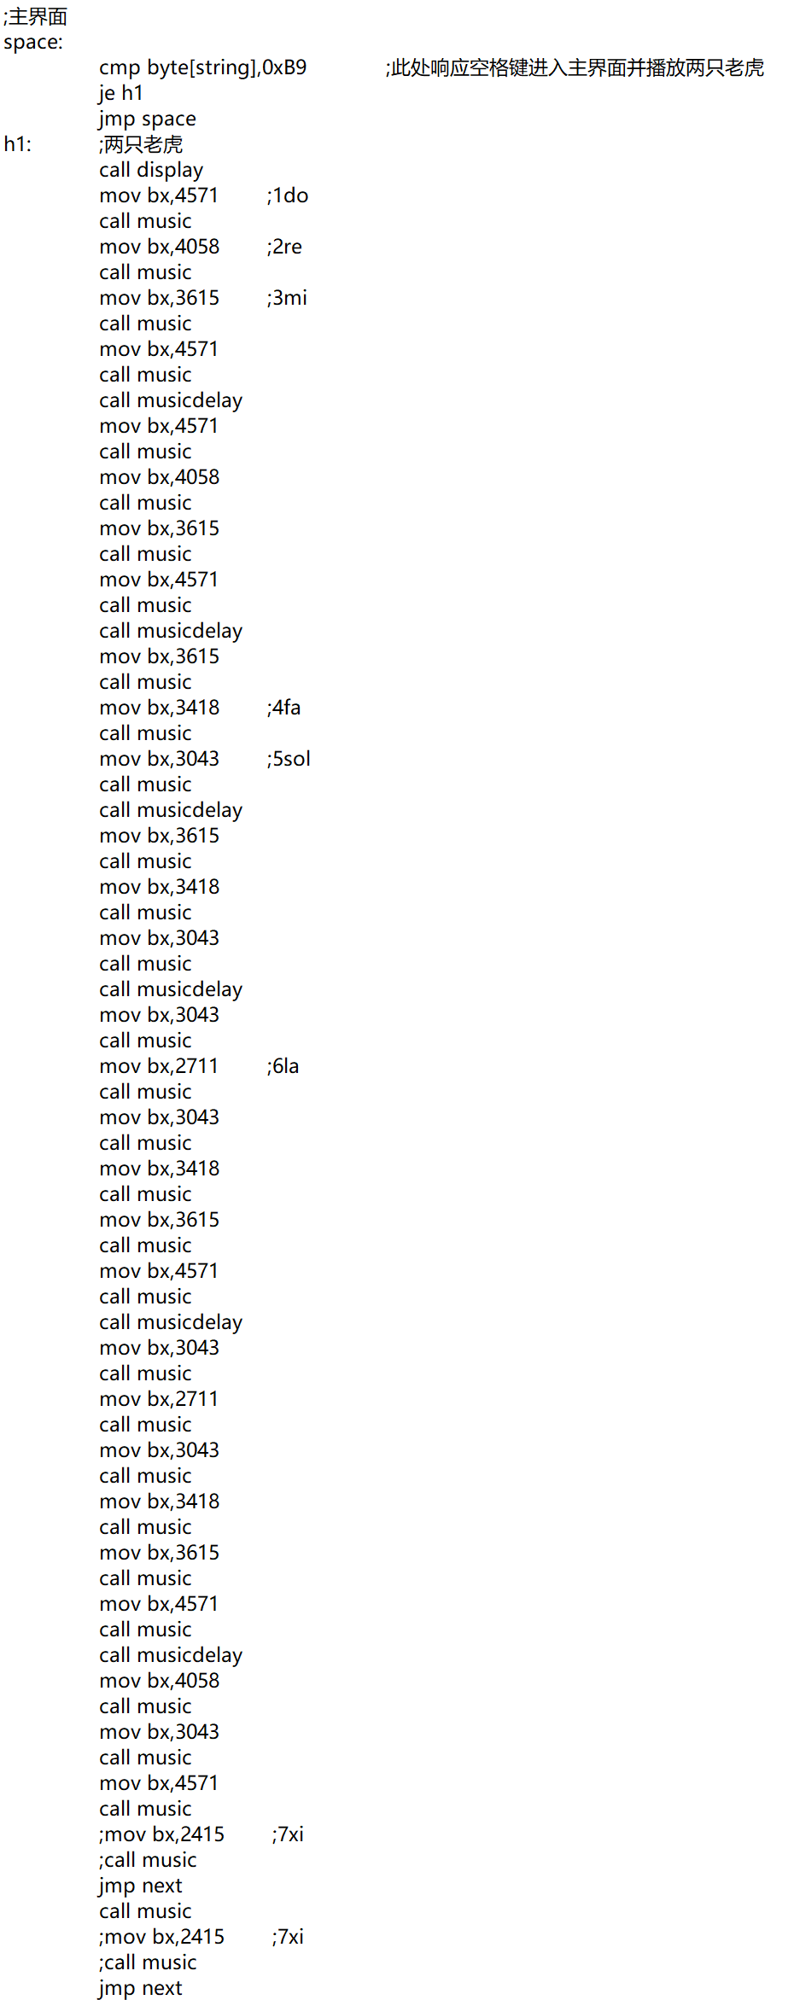

## 主界面变色

主界面点击键盘j键可以进行界面变色。

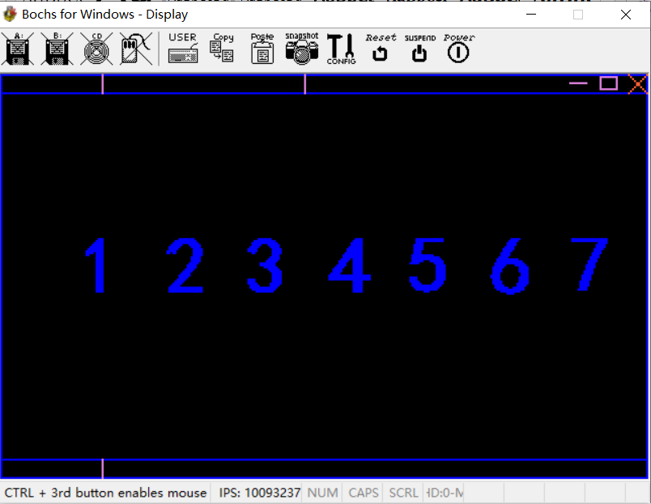 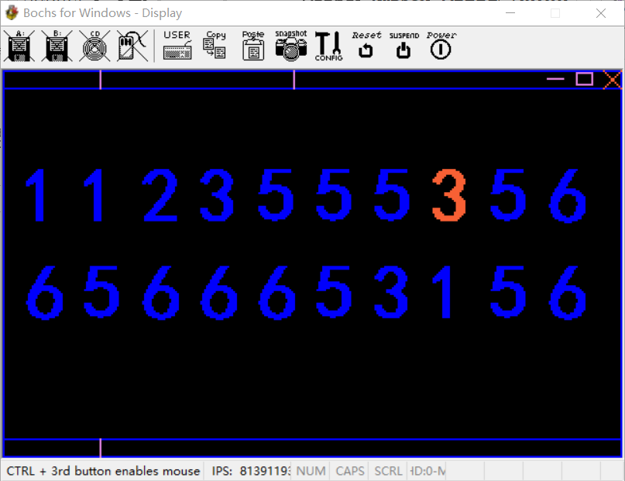

相应代码（je h2）：

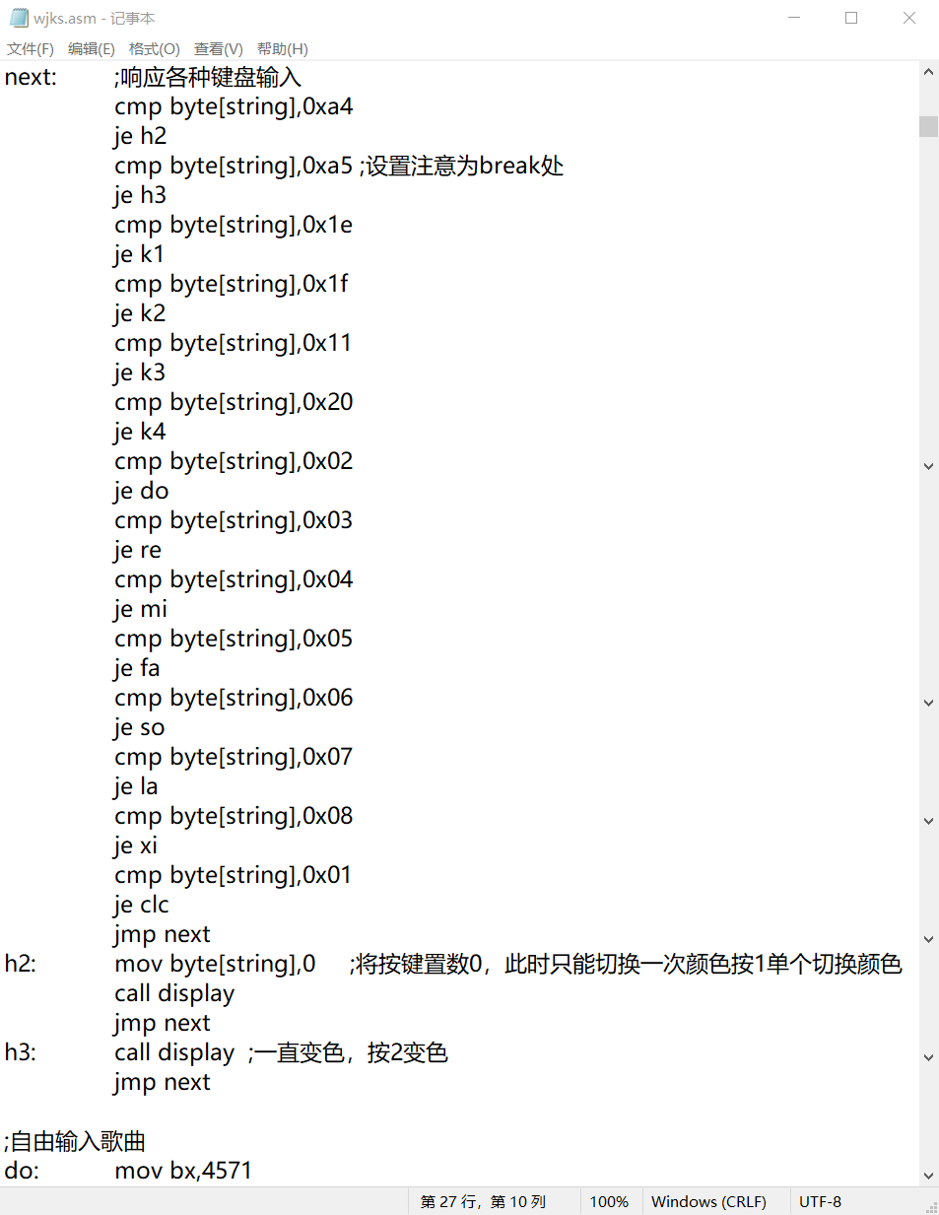

## Ctrl的响应

主界面点击按键space进行音频播放。

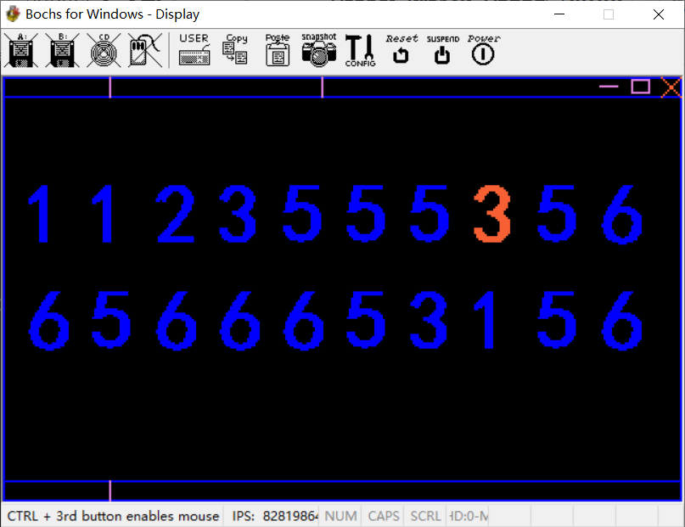

相应代码：

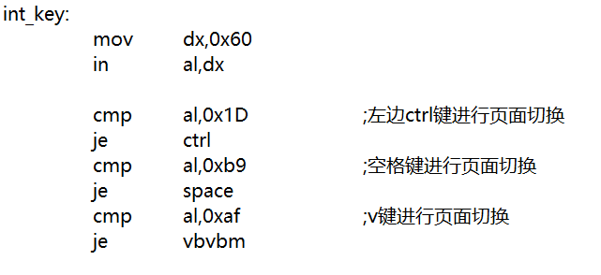

## 响应键盘

按键响应不同的键盘数值。

相应代码：

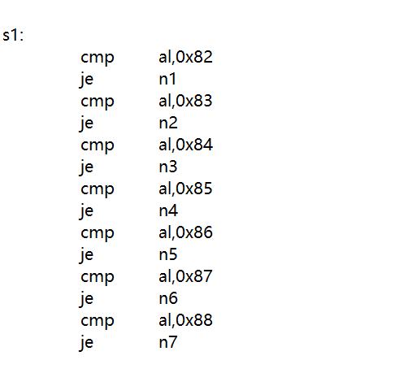

## 播放音乐

通过响应按键调用函数，在函数中给每一个音调用一次music，每次给入一个不同的频率值bx，bx值通过转换得到，由600Hz=1983转换成不同的频率。

当然此处可以改成相应的数组，使代码量降低，但写的时候要调式，避免在数组中难找不同的频率，所以我一个个写出来了。

相应代码（以西海情歌为例）：

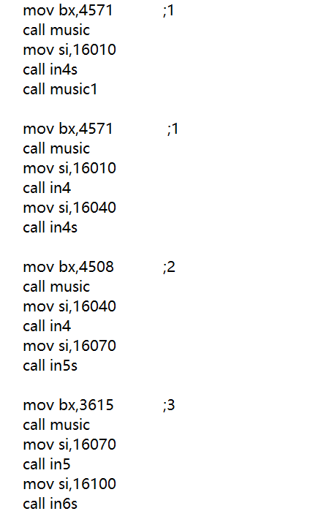

## 自主输入音频

通过按键输入不同的7个音，自主播放音频或音乐。

相应代码：

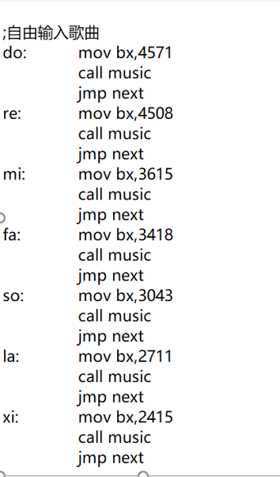

## 退出程序

程序可以通过Esc键退出程序，下次进入程序还需按键space进入。

相应代码:

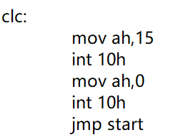

# 运用的所学知识

## 扬声器

music:

call musicdelay

mov al,0xB6

out 43H,al

call sdelay

mov ax,bx

out 42H,al

call sdelay

mov al,ah

out 42H,al

call sdelay

in al,61H;打开

or al,0x03

out 61H,al

call sdelay

call sdelay

call sdelay

call sdelay

call sdelay

in al,61H;关闭

and al,0xFD

out 61H,al

ret

## 键盘中断

mov word[es:0x24],int_key

mov word[es:0x26],0

int_key: ;键盘中断

push ax

push bx

push dx

push es

mov ax,0

mov es,ax

mov dx,0x60

in al,dx

mov [string],al

mov dx,0x20

mov al,0x61

out dx,al

pop es

pop dx

pop bx

pop ax

iret

## 界面绘图

;画横线,ax为此时y值,bx,cx分别为x的当前和结束值

DrawLineHeng:

push ax

push bx

push cx

push dx

mov dx,320

mul dx

add bx,ax

add cx,ax

x1: mov [ds:bx],si

add bx,1

cmp bx,cx

jbe x1 ;小于等于跳

pop dx

pop cx

pop bx

pop ax

ret

;画竖线,bx为x值，ax,cx分别为当前值和结束值

DrawLineShu:

push ax

push bx

push cx

push dx

mov di,ax

mov es,cx

mov dx,320

mul dx

add bx,ax

mov dx,es

x2: mov [ds:bx],si

add bx,320

inc di

cmp di,dx

jbe x2 ;小于等于跳

pop dx

pop cx

pop bx

pop ax

ret

## 按键变色

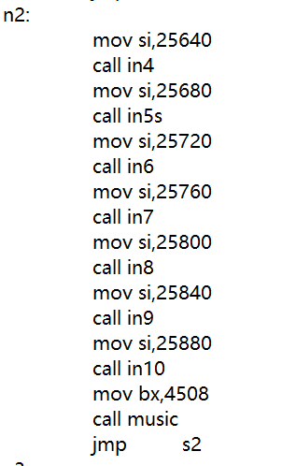

## 界面清屏

clc:

mov ah,15

int 10h

mov ah,0

int 10h

jmp start

# 操作实现流程图

首先经过cmd编辑后的asm文件刷入机器码uboot2.img中，然后在Bochsrc中运行。此处代码已在上述说明。

运行进入页面：

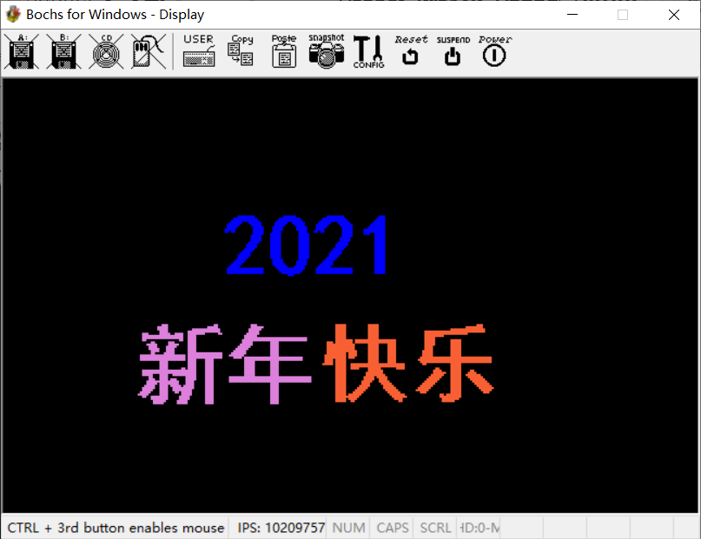

首先点击空格键进入主界面，进入过程中输出音乐音频 西海情歌。

主界面如下所示：

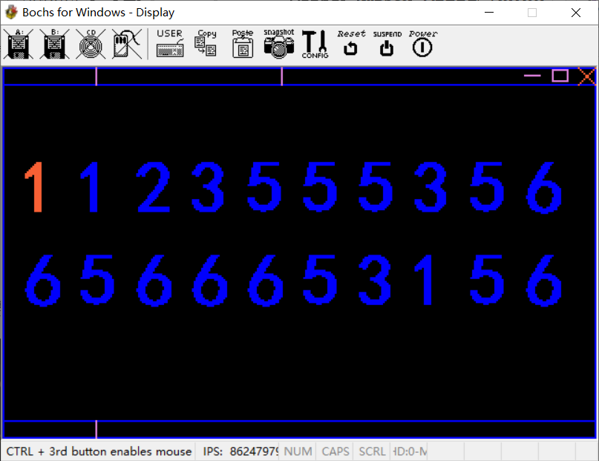

程序设置了V按键响应输出不同的音乐，V为小二郎。

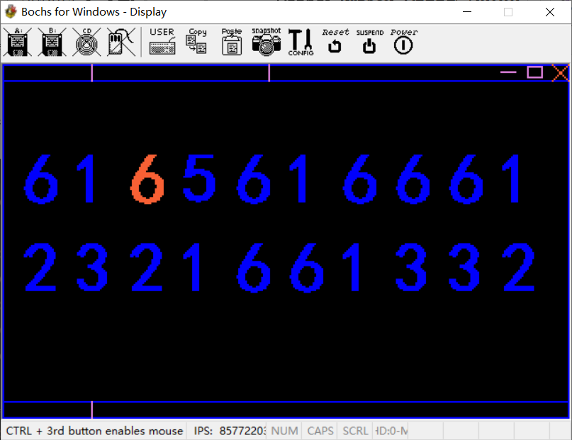

此外按键Ctrl进去自编歌曲，可以自行弹奏歌曲，通过响应1，2，3，4，5，6，7按键实现do，re，mi，fa，so，la，xi七个音，所以说音乐可以添加

。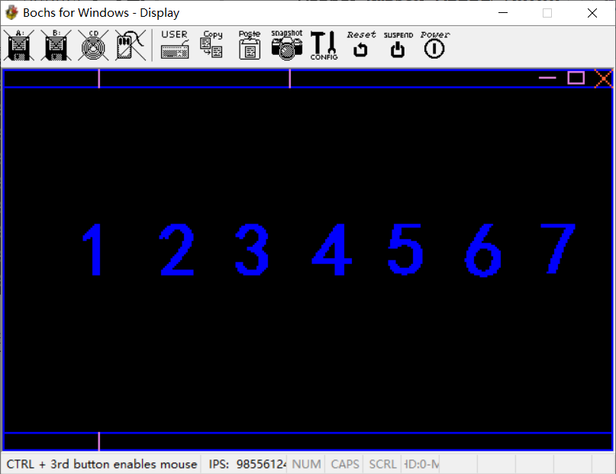

# 心得体会

本次课程设计因为老师没给我们确定的范围，所以对我们来说也是比较开放的，因为之前那一周我们也才上过扬声器的实验，所以对于我们来说，想做一个关于扬声器的课程设计的，扬声器对于微机最大的特点就是可以发出声音，所以我们把目标放在了如何播放音乐上，所以在播放音乐上下了一点功夫，到最后也是可以播放音乐的，之后在主界面加了一些设计，即一些框图，加上了一些颜色的变化，因为这个也是比较简单的，此次设计也是缺少了平时学的一些文字模式下的输出文字，当然文字模式和图像模式两者也是冲突的。最终实现效果，如酷狗音乐的歌词字幕一般，随着音频的播放，界面的字幕也随之渐变。主要利用了，绘图与重绘。

# 附程序代码

org 0x8400

jmp start

color1 db 1,0,0,255

color2 db 2,55,160,55

color3 db 3,190,88,205

string db 0

come1 db 0,0,0,0,0,0,0,0,0,0,0,0,0,0,0,0,0,0,0,0,0,0,0,0,0,0,0,0,0,0,0,0,0,0,0,0,0,0,0,0,0,0,0,0,0,0,0,0,0,0,0,0,0,0,0,0,0,0,0,0,0,0,0,0,0,0,0,0,0,0,0,0,0,0,0,0

db 0,0,0,0,0,0,0,1,1,1,1,1,1,1,1,0,0,0,0,0,0,0,0,0,0,0,0,0,1,1,1,1,1,1,0,0,0,0,0,0,0,0,0,0,0,0,0,0,1,1,1,1,1,1,1,1,0,0,0,0,0,0,0,0,0,0,0,0,0,0,0,0,1,1,1,0

db 0,0,0,0,0,1,1,1,1,1,1,1,1,1,1,1,0,0,0,0,0,0,0,0,0,0,1,1,1,1,1,1,1,1,1,1,0,0,0,0,0,0,0,0,0,0,1,1,1,1,1,1,1,1,1,1,1,0,0,0,0,0,0,0,0,0,0,0,0,0,0,1,1,1,1,0

db 0,0,0,0,1,1,1,1,1,1,1,1,1,1,1,1,1,0,0,0,0,0,0,0,0,1,1,1,1,1,1,1,1,1,1,1,1,0,0,0,0,0,0,0,0,1,1,1,1,1,1,1,1,1,1,1,1,1,0,0,0,0,0,0,0,0,0,0,0,0,1,1,1,1,1,0

db 0,0,0,1,1,1,1,1,1,0,0,0,1,1,1,1,1,1,0,0,0,0,0,0,1,1,1,1,1,1,0,0,1,1,1,1,1,1,0,0,0,0,0,0,1,1,1,1,1,1,0,0,0,1,1,1,1,1,1,0,0,0,0,0,0,0,0,0,0,1,1,1,1,1,1,0

db 0,0,1,1,1,1,1,1,0,0,0,0,0,1,1,1,1,1,0,0,0,0,0,0,1,1,1,1,1,0,0,0,0,1,1,1,1,1,0,0,0,0,0,1,1,1,1,1,1,0,0,0,0,0,1,1,1,1,1,1,0,0,0,0,0,0,0,0,1,1,1,1,1,1,1,0

db 0,0,1,1,1,1,1,0,0,0,0,0,0,0,1,1,1,1,1,0,0,0,0,1,1,1,1,1,0,0,0,0,0,0,1,1,1,1,1,0,0,0,0,1,1,1,1,1,0,0,0,0,0,0,0,1,1,1,1,1,0,0,0,0,0,0,0,1,1,1,1,1,1,1,1,0

db 0,1,1,1,1,1,0,0,0,0,0,0,0,0,1,1,1,1,1,0,0,0,0,1,1,1,1,1,0,0,0,0,0,0,1,1,1,1,1,0,0,0,0,1,1,1,1,0,0,0,0,0,0,0,0,1,1,1,1,1,0,0,0,0,0,1,1,1,1,1,1,1,1,1,1,0

db 0,1,1,0,1,1,0,0,0,0,0,0,0,0,1,1,1,1,1,0,0,0,0,1,1,1,1,0,0,0,0,0,0,0,0,1,1,1,1,0,0,0,1,1,0,1,1,0,0,0,0,0,0,0,0,1,1,1,1,1,0,0,0,0,0,1,1,1,1,1,1,1,1,1,1,0

db 0,0,0,0,0,0,0,0,0,0,0,0,0,0,1,1,1,1,1,0,0,0,1,1,1,1,1,0,0,0,0,0,0,0,0,1,1,1,1,1,0,0,0,0,0,0,0,0,0,0,0,0,0,0,0,1,1,1,1,1,0,0,0,0,0,1,1,1,0,0,1,1,1,1,1,0

db 0,0,0,0,0,0,0,0,0,0,0,0,0,1,1,1,1,1,0,0,0,0,1,1,1,1,1,0,0,0,0,0,0,0,0,1,1,1,1,1,0,0,0,0,0,0,0,0,0,0,0,0,0,0,0,1,1,1,1,1,0,0,0,0,0,0,0,0,0,0,1,1,1,1,1,0

db 0,0,0,0,0,0,0,0,0,0,0,0,0,1,1,1,1,1,0,0,0,0,1,1,1,1,1,0,0,0,0,0,0,0,0,1,1,1,1,1,0,0,0,0,0,0,0,0,0,0,0,0,0,0,1,1,1,1,1,0,0,0,0,0,0,0,0,0,0,0,1,1,1,1,1,0

db 0,0,0,0,0,0,0,0,0,0,0,0,0,1,1,1,1,1,0,0,0,0,1,1,1,1,1,0,0,0,0,0,0,0,0,1,1,1,1,1,0,0,0,0,0,0,0,0,0,0,0,0,0,0,1,1,1,1,1,0,0,0,0,0,0,0,0,0,0,0,1,1,1,1,1,0

db 0,0,0,0,0,0,0,0,0,0,0,0,1,1,1,1,1,0,0,0,0,0,1,1,1,1,1,0,0,0,0,0,0,0,0,1,1,1,1,1,0,0,0,0,0,0,0,0,0,0,0,0,0,1,1,1,1,1,0,0,0,0,0,0,0,0,0,0,0,0,1,1,1,1,1,0

db 0,0,0,0,0,0,0,0,0,0,0,1,1,1,1,1,0,0,0,0,0,0,1,1,1,1,1,0,0,0,0,0,0,0,0,1,1,1,1,1,0,0,0,0,0,0,0,0,0,0,0,0,1,1,1,1,1,1,0,0,0,0,0,0,0,0,0,0,0,0,1,1,1,1,1,0

db 0,0,0,0,0,0,0,0,0,0,0,1,1,1,1,1,0,0,0,0,0,0,1,1,1,1,1,0,0,0,0,0,0,0,0,1,1,1,1,1,0,0,0,0,0,0,0,0,0,0,0,0,1,1,1,1,1,0,0,0,0,0,0,0,0,0,0,0,0,0,1,1,1,1,1,0

db 0,0,0,0,0,0,0,0,0,0,1,1,1,1,1,0,0,0,0,0,0,0,1,1,1,1,1,0,0,0,0,0,0,0,0,1,1,1,1,1,0,0,0,0,0,0,0,0,0,0,0,1,1,1,1,1,0,0,0,0,0,0,0,0,0,0,0,0,0,0,1,1,1,1,1,0

db 0,0,0,0,0,0,0,0,0,1,1,1,1,1,0,0,0,0,0,0,0,0,1,1,1,1,1,0,0,0,0,0,0,0,0,1,1,1,1,1,0,0,0,0,0,0,0,0,0,0,1,1,1,1,1,0,0,0,0,0,0,0,0,0,0,0,0,0,0,0,1,1,1,1,1,0

db 0,0,0,0,0,0,0,0,1,1,1,1,1,0,0,0,0,0,0,0,0,0,1,1,1,1,1,0,0,0,0,0,0,0,0,1,1,1,1,1,0,0,0,0,0,0,0,0,0,1,1,1,1,1,1,0,0,0,0,0,0,0,0,0,0,0,0,0,0,0,1,1,1,1,1,0

db 0,0,0,0,0,0,0,1,1,1,1,1,1,0,0,0,0,0,0,0,0,0,1,1,1,1,1,0,0,0,0,0,0,0,0,1,1,1,1,1,0,0,0,0,0,0,0,0,0,1,1,1,1,1,0,0,0,0,0,0,0,0,0,0,0,0,0,0,0,0,1,1,1,1,1,0

db 0,0,0,0,0,0,0,1,1,1,1,1,0,0,0,0,0,0,0,0,0,0,1,1,1,1,1,0,0,0,0,0,0,0,0,1,1,1,1,1,0,0,0,0,0,0,0,0,1,1,1,1,1,0,0,0,0,0,0,0,0,0,0,0,0,0,0,0,0,0,1,1,1,1,1,0

db 0,0,0,0,0,0,1,1,1,1,1,0,0,0,0,0,0,0,0,0,0,0,0,1,1,1,1,1,0,0,0,0,0,0,0,1,1,1,1,0,0,0,0,0,0,0,0,1,1,1,1,1,0,0,0,0,0,0,0,0,0,0,0,0,0,0,0,0,0,0,1,1,1,1,1,0

db 0,0,0,0,0,1,1,1,1,1,0,0,0,0,0,0,0,0,0,0,0,0,0,1,1,1,1,1,0,0,0,0,0,0,1,1,1,1,1,0,0,0,0,0,0,0,1,1,1,1,1,0,0,0,0,0,0,0,0,0,0,0,0,0,0,0,0,0,0,0,1,1,1,1,1,0

db 0,0,0,0,1,1,1,1,1,0,0,0,0,0,0,0,0,0,0,0,0,0,0,1,1,1,1,1,1,0,0,0,0,0,1,1,1,1,1,0,0,0,0,0,0,1,1,1,1,1,1,0,0,0,0,0,0,0,0,0,0,0,0,0,0,0,0,0,0,0,1,1,1,1,1,0

db 0,0,0,1,1,1,1,1,0,0,0,0,0,0,0,0,0,0,0,0,0,0,0,0,1,1,1,1,1,1,0,0,0,1,1,1,1,1,0,0,0,0,0,0,1,1,1,1,1,1,0,0,0,0,0,0,0,0,0,0,0,0,0,0,0,0,0,0,0,0,1,1,1,1,1,0

db 0,0,1,1,1,1,1,1,1,1,1,1,1,1,1,1,1,1,1,0,0,0,0,0,0,1,1,1,1,1,1,1,1,1,1,1,1,1,0,0,0,0,0,1,1,1,1,1,1,1,1,1,1,1,1,1,1,1,1,1,0,0,0,0,0,0,0,0,0,0,1,1,1,1,1,0

db 0,0,1,1,1,1,1,1,1,1,1,1,1,1,1,1,1,1,1,0,0,0,0,0,0,0,1,1,1,1,1,1,1,1,1,1,1,0,0,0,0,0,0,1,1,1,1,1,1,1,1,1,1,1,1,1,1,1,1,1,0,0,0,0,0,0,0,0,0,0,1,1,1,1,1,0

db 0,0,1,1,1,1,1,1,1,1,1,1,1,1,1,1,1,1,1,0,0,0,0,0,0,0,0,1,1,1,1,1,1,1,1,1,0,0,0,0,0,0,0,1,1,1,1,1,1,1,1,1,1,1,1,1,1,1,1,1,0,0,0,0,0,0,0,0,0,0,1,1,1,1,1,0

db 0,0,0,0,0,0,0,0,0,0,0,0,0,0,0,0,0,0,0,0,0,0,0,0,0,0,0,0,0,0,1,1,1,0,0,0,0,0,0,0,0,0,0,0,0,0,0,0,0,0,0,0,0,0,0,0,0,0,0,0,0,0,0,0,0,0,0,0,0,0,0,0,0,0,0,0

db 0,0,0,0,0,0,0,0,0,0,0,0,0,0,0,0,0,0,0,0,0,0,0,0,0,0,0,0,0,0,0,0,0,0,0,0,0,0,0,0,0,0,0,0,0,0,0,0,0,0,0,0,0,0,0,0,0,0,0,0,0,0,0,0,0,0,0,0,0,0,0,0,0,0,0,0

come2 db 0,0,0,0,0,0,0,0,0,0,0,0,0,0,0,0,0,0,0,0,0,0,0,0,0,0,0,0,0,0,0,0,0,0,0,0,0,0,0,0,0,0,0,0,0,0,0,0,0,0,0,0,0,0,0,0,0,0,0,0,0,0,0,0,0,0,0,0,0,0,0,0,0,0,0,0,0,0,0,0,0,0

db 0,0,0,0,0,0,0,0,0,0,0,0,1,1,1,0,0,0,0,0,0,0,0,0,0,0,0,0,0,0,0,0,0,0,0,0,1,1,0,0,0,0,0,0,0,0,0,0,0,0,0,0,0,1,1,1,0,0,0,0,0,0,0,0,0,0,0,0,0,0,0,0,0,0,0,0,0,0,0,0,0,0

db 0,0,0,0,0,0,0,0,0,0,1,1,1,1,1,0,0,0,0,0,0,0,0,0,0,0,0,0,0,0,0,0,0,1,1,1,1,1,0,0,0,0,0,0,0,0,0,0,0,0,0,0,0,1,1,1,1,1,1,0,0,0,0,0,0,0,0,0,0,0,0,0,0,0,0,0,0,0,0,0,0,0

db 0,0,0,0,0,0,0,0,0,0,1,1,1,1,1,0,0,0,0,0,0,0,0,0,0,0,1,1,1,1,1,1,1,1,1,1,1,1,1,0,0,0,0,0,0,0,0,0,0,0,0,0,1,1,1,1,1,1,0,0,0,0,0,0,0,0,0,0,0,0,0,0,0,0,0,0,0,0,0,0,0,0

db 0,0,0,0,0,0,0,0,0,0,0,1,1,1,1,0,0,0,0,0,0,0,0,0,1,1,1,1,1,1,1,1,1,1,1,1,1,1,1,0,0,0,0,0,0,0,0,0,0,0,0,0,1,1,1,1,1,0,0,0,0,0,0,0,0,0,0,0,0,0,0,0,0,0,0,0,0,0,0,0,0,0

db 0,0,0,1,1,1,0,0,0,0,0,1,1,1,1,1,0,0,1,1,1,1,0,0,1,1,1,1,1,1,1,1,0,0,0,0,0,0,1,1,0,0,0,0,0,0,0,0,0,0,0,1,1,1,1,1,1,0,0,0,0,0,0,0,0,0,0,0,0,0,0,0,0,0,0,0,0,0,0,0,0,0

db 0,0,0,1,1,1,1,1,1,1,1,1,1,1,1,1,1,1,1,1,1,1,0,0,1,1,1,1,0,0,0,0,0,0,0,0,0,0,0,0,0,0,0,0,0,0,0,0,0,0,1,1,1,1,1,1,0,0,0,0,0,0,0,0,0,0,0,0,0,0,0,0,0,0,0,0,0,0,0,0,0,0

db 0,0,0,1,1,1,1,1,1,1,1,1,1,1,1,1,1,1,1,1,1,1,0,0,1,1,1,1,0,0,0,0,0,0,0,0,0,0,0,0,0,0,0,0,0,0,0,0,0,0,1,1,1,1,1,1,1,1,1,1,1,1,1,1,1,1,1,1,1,1,1,1,1,1,1,1,1,1,1,0,0,0

db 0,0,0,1,1,0,0,0,0,0,0,0,0,0,0,0,0,0,0,0,1,1,0,0,1,1,1,1,0,0,0,0,0,0,0,0,0,0,0,0,0,0,0,0,0,0,0,0,0,1,1,1,1,1,1,1,1,1,1,1,1,1,1,1,1,1,1,1,1,1,1,1,1,1,1,1,1,1,1,0,0,0

db 0,0,0,0,0,0,0,1,1,0,0,0,0,0,0,1,1,1,0,0,0,0,0,0,1,1,1,1,0,0,0,0,0,0,0,0,0,0,0,0,0,0,0,0,0,0,0,0,0,1,1,1,1,1,0,0,0,0,0,0,0,0,1,1,1,1,0,0,0,0,0,0,0,0,0,0,0,0,0,0,0,0

db 0,0,0,0,0,1,1,1,1,1,0,0,0,0,0,1,1,1,1,1,0,0,0,0,1,1,1,1,0,0,0,0,0,0,0,0,0,0,0,0,0,0,0,0,0,0,0,0,1,1,1,1,1,1,0,0,0,0,0,0,0,0,1,1,1,1,0,0,0,0,0,0,0,0,0,0,0,0,0,0,0,0

db 0,0,0,0,0,0,1,1,1,1,0,0,0,0,1,1,1,1,1,0,0,0,0,0,1,1,1,1,0,0,0,0,0,0,0,0,0,0,0,0,0,0,0,0,0,0,0,1,1,1,1,1,1,0,0,0,0,0,0,0,0,0,1,1,1,1,0,0,0,0,0,0,0,0,0,0,0,0,0,0,0,0

db 0,0,0,0,0,0,1,1,1,1,1,0,0,0,1,1,1,1,0,0,0,0,0,0,1,1,1,1,0,0,0,0,0,0,0,0,0,0,0,0,0,0,0,0,0,0,1,1,1,1,1,1,0,0,0,0,0,0,0,0,0,0,1,1,1,1,0,0,0,0,0,0,0,0,0,0,0,0,0,0,0,0

db 0,0,0,0,0,0,0,1,1,1,1,0,0,0,1,1,1,1,0,0,0,0,0,0,1,1,1,1,0,0,0,0,0,0,0,0,0,0,0,0,0,0,0,0,0,1,1,1,1,1,1,0,0,0,0,0,0,0,0,0,0,0,1,1,1,1,0,0,0,0,0,0,0,0,0,0,0,0,0,0,0,0

db 0,0,0,0,0,0,0,1,1,0,0,0,0,1,1,1,1,1,0,0,0,0,0,0,1,1,1,1,1,1,1,1,1,1,1,1,1,1,1,1,0,0,0,0,1,1,1,1,1,1,1,0,0,0,0,0,0,0,0,0,0,0,1,1,1,1,0,0,0,0,0,0,0,0,0,0,0,0,0,0,0,0

db 0,0,1,1,1,1,1,1,1,1,1,1,1,1,1,1,1,1,1,1,1,1,1,0,1,1,1,1,1,1,1,1,1,1,1,1,1,1,1,1,0,0,0,1,1,1,1,1,1,1,0,0,0,0,0,0,0,0,0,0,0,0,1,1,1,1,0,0,0,0,0,0,0,0,0,0,0,0,0,0,0,0

db 0,0,1,1,1,1,1,1,1,1,1,1,1,1,1,1,1,1,1,1,1,1,1,0,1,1,1,1,1,1,1,1,1,1,1,1,1,1,1,1,0,0,0,0,0,1,1,1,1,0,1,1,1,1,1,1,1,1,1,1,1,1,1,1,1,1,1,1,1,1,1,1,1,1,1,1,1,0,0,0,0,0

db 0,0,1,1,1,1,1,1,1,1,1,1,1,1,1,1,1,1,1,1,1,1,1,0,1,1,1,1,0,0,0,0,1,1,1,1,0,0,0,0,0,0,0,0,0,0,0,0,0,0,1,1,1,1,1,1,1,1,1,1,1,1,1,1,1,1,1,1,1,1,1,1,1,1,1,1,1,0,0,0,0,0

db 0,0,0,0,0,0,0,0,0,0,0,1,1,1,1,0,0,0,0,0,0,0,0,0,1,1,1,1,0,0,0,0,1,1,1,1,0,0,0,0,0,0,0,0,0,0,0,0,0,0,1,1,1,1,1,0,0,0,0,0,0,0,1,1,1,1,0,0,0,0,0,0,0,0,0,0,0,0,0,0,0,0

db 0,0,0,0,0,0,0,0,0,0,0,1,1,1,1,0,0,0,0,0,0,0,0,0,1,1,1,1,0,0,0,0,1,1,1,1,0,0,0,0,0,0,0,0,0,0,0,0,0,0,1,1,1,1,1,0,0,0,0,0,0,0,1,1,1,1,0,0,0,0,0,0,0,0,0,0,0,0,0,0,0,0

db 0,0,0,0,0,0,0,0,0,0,0,1,1,1,1,0,0,0,0,0,0,0,0,0,1,1,1,1,0,0,0,0,1,1,1,1,0,0,0,0,0,0,0,0,0,0,0,0,0,0,1,1,1,1,1,0,0,0,0,0,0,0,1,1,1,1,0,0,0,0,0,0,0,0,0,0,0,0,0,0,0,0

db 0,0,0,0,0,0,0,0,0,0,0,1,1,1,1,0,0,0,0,0,0,1,1,0,1,1,1,1,0,0,0,0,1,1,1,1,0,0,0,0,0,0,0,0,0,0,0,0,0,0,1,1,1,1,1,0,0,0,0,0,0,0,1,1,1,1,0,0,0,0,0,0,0,0,0,0,0,0,0,0,0,0

db 0,0,0,1,1,1,1,1,1,1,1,1,1,1,1,1,1,1,1,1,1,1,1,1,1,1,1,1,0,0,0,0,1,1,1,1,0,0,0,0,0,0,0,0,0,0,0,0,0,0,1,1,1,1,1,0,0,0,0,0,0,0,1,1,1,1,0,0,0,0,0,0,0,0,0,0,0,0,0,0,0,0

db 0,0,0,1,1,1,1,1,1,1,1,1,1,1,1,1,1,1,1,1,1,1,1,1,1,1,1,1,0,0,0,0,1,1,1,1,0,0,0,0,0,0,0,0,0,0,0,0,0,0,1,1,1,1,1,0,0,0,0,0,0,0,1,1,1,1,0,0,0,0,0,0,0,0,0,0,0,0,0,0,0,0

db 0,0,0,1,1,1,1,1,0,0,0,1,1,1,1,0,0,1,1,1,1,1,1,1,1,1,1,1,0,0,0,0,1,1,1,1,0,0,0,0,0,0,0,0,0,0,0,0,0,0,1,1,1,1,1,0,0,0,0,0,0,0,1,1,1,1,0,0,0,0,0,0,0,0,0,0,0,0,0,0,0,0

db 0,0,0,0,0,0,1,1,0,0,0,1,1,1,1,0,0,0,0,0,0,0,0,1,1,1,1,1,0,0,0,0,1,1,1,1,0,0,0,0,0,0,0,1,1,1,1,1,1,1,1,1,1,1,1,1,1,1,1,1,1,1,1,1,1,1,1,1,1,1,1,1,1,1,1,1,1,1,1,1,1,0

db 0,0,0,0,0,0,1,1,1,0,0,1,1,1,1,0,1,1,1,0,0,0,0,1,1,1,1,1,0,0,0,0,1,1,1,1,0,0,0,0,0,0,0,1,1,1,1,1,1,1,1,1,1,1,1,1,1,1,1,1,1,1,1,1,1,1,1,1,1,1,1,1,1,1,1,1,1,1,1,1,1,0

db 0,0,0,0,0,1,1,1,1,1,1,1,1,1,1,1,1,1,1,1,0,0,0,1,1,1,1,0,0,0,0,0,1,1,1,1,0,0,0,0,0,0,0,1,1,1,1,1,1,1,1,1,1,1,1,1,1,1,1,1,1,1,1,1,1,1,1,1,1,1,1,1,1,1,1,1,1,1,1,1,1,0

db 0,0,0,0,0,1,1,1,1,1,0,1,1,1,1,1,1,1,1,1,0,0,0,1,1,1,1,0,0,0,0,0,1,1,1,1,0,0,0,0,0,0,0,0,0,0,0,0,0,0,0,0,0,0,0,0,0,0,0,0,0,0,1,1,1,1,0,0,0,0,0,0,0,0,0,0,0,0,0,0,0,0

db 0,0,0,0,1,1,1,1,1,0,0,1,1,1,1,0,1,1,1,1,1,0,1,1,1,1,1,0,0,0,0,0,1,1,1,1,0,0,0,0,0,0,0,0,0,0,0,0,0,0,0,0,0,0,0,0,0,0,0,0,0,0,1,1,1,1,0,0,0,0,0,0,0,0,0,0,0,0,0,0,0,0

db 0,0,0,1,1,1,1,1,1,0,0,1,1,1,1,0,0,1,1,1,1,1,1,1,1,1,1,0,0,0,0,0,1,1,1,1,0,0,0,0,0,0,0,0,0,0,0,0,0,0,0,0,0,0,0,0,0,0,0,0,0,0,1,1,1,1,0,0,0,0,0,0,0,0,0,0,0,0,0,0,0,0

db 0,0,0,1,1,1,1,1,0,0,0,1,1,1,1,0,0,1,1,1,1,1,1,1,1,1,0,0,0,0,0,0,1,1,1,1,0,0,0,0,0,0,0,0,0,0,0,0,0,0,0,0,0,0,0,0,0,0,0,0,0,0,1,1,1,1,0,0,0,0,0,0,0,0,0,0,0,0,0,0,0,0

db 0,0,1,1,1,1,1,0,0,0,0,1,1,1,1,0,0,0,1,1,0,1,1,1,1,1,0,0,0,0,0,0,1,1,1,1,0,0,0,0,0,0,0,0,0,0,0,0,0,0,0,0,0,0,0,0,0,0,0,0,0,0,1,1,1,1,0,0,0,0,0,0,0,0,0,0,0,0,0,0,0,0

db 0,1,1,1,1,1,0,0,0,0,0,1,1,1,1,0,0,0,0,0,0,1,1,1,1,1,0,0,0,0,0,0,1,1,1,1,0,0,0,0,0,0,0,0,0,0,0,0,0,0,0,0,0,0,0,0,0,0,0,0,0,0,1,1,1,1,0,0,0,0,0,0,0,0,0,0,0,0,0,0,0,0

db 0,0,0,1,1,0,0,1,1,1,1,1,1,1,1,0,0,0,0,0,1,1,1,1,1,0,0,0,0,0,0,0,1,1,1,1,0,0,0,0,0,0,0,0,0,0,0,0,0,0,0,0,0,0,0,0,0,0,0,0,0,0,1,1,1,1,0,0,0,0,0,0,0,0,0,0,0,0,0,0,0,0

db 0,0,0,0,0,0,0,1,1,1,1,1,1,1,1,0,0,0,0,0,1,1,1,1,1,0,0,0,0,0,0,0,1,1,1,1,0,0,0,0,0,0,0,0,0,0,0,0,0,0,0,0,0,0,0,0,0,0,0,0,0,0,1,1,1,1,0,0,0,0,0,0,0,0,0,0,0,0,0,0,0,0

db 0,0,0,0,0,0,0,0,1,1,1,1,1,1,0,0,0,0,0,1,1,1,1,1,0,0,0,0,0,0,0,0,1,1,1,1,0,0,0,0,0,0,0,0,0,0,0,0,0,0,0,0,0,0,0,0,0,0,0,0,0,0,1,1,1,1,0,0,0,0,0,0,0,0,0,0,0,0,0,0,0,0

db 0,0,0,0,0,0,0,0,1,1,1,1,1,0,0,0,0,0,0,1,1,1,1,1,0,0,0,0,0,0,0,0,1,1,1,1,0,0,0,0,0,0,0,0,0,0,0,0,0,0,0,0,0,0,0,0,0,0,0,0,0,0,1,1,1,1,0,0,0,0,0,0,0,0,0,0,0,0,0,0,0,0

db 0,0,0,0,0,0,0,0,0,0,0,0,0,0,0,0,0,0,0,0,0,0,0,0,0,0,0,0,0,0,0,0,0,0,0,0,0,0,0,0,0,0,0,0,0,0,0,0,0,0,0,0,0,0,0,0,0,0,0,0,0,0,0,0,0,0,0,0,0,0,0,0,0,0,0,0,0,0,0,0,0,0

come3 db 0,0,0,0,0,0,0,0,0,0,0,0,0,0,0,0,0,0,0,0,0,0,0,0,0,0,0,0,0,0,0,0,0,0,0,0,0,0,0,0,0,0,0,0,0,0,0,0,0,0,0,0,0,0,0,0,0,0,0,0,0,0,0,0,0,0,0,0,0,0,0,0,0,0,0,0,0,0,0,0,0

db 0,0,0,0,0,0,0,1,1,1,1,1,0,0,0,0,0,0,0,0,0,0,1,1,1,1,1,0,0,0,0,0,0,0,0,0,0,0,0,0,0,0,0,0,0,0,0,0,0,0,0,0,0,0,0,0,0,0,0,0,0,0,0,0,0,0,0,0,0,0,0,0,1,1,1,0,0,0,0,0,0

db 0,0,0,0,0,0,0,1,1,1,1,1,0,0,0,0,0,0,0,0,0,0,1,1,1,1,1,0,0,0,0,0,0,0,0,0,0,0,0,0,0,0,0,0,0,0,0,0,0,0,0,0,0,0,0,0,0,0,0,0,0,0,0,0,0,0,0,1,1,1,1,1,1,1,1,0,0,0,0,0,0

db 0,0,0,0,0,0,0,1,1,1,1,1,0,0,0,0,0,0,0,0,0,0,1,1,1,1,1,0,0,0,0,0,0,0,0,0,0,0,0,0,0,0,0,0,0,0,0,0,0,0,0,0,0,0,0,0,0,0,0,0,1,1,1,1,1,1,1,1,1,1,1,1,1,1,1,1,0,0,0,0,0

db 0,0,0,0,0,0,0,1,1,1,1,1,0,0,0,0,0,0,0,0,0,0,1,1,1,1,1,0,0,0,0,0,0,0,0,0,0,0,0,0,0,0,0,0,0,0,0,0,1,1,1,1,1,1,1,1,1,1,1,1,1,1,1,1,1,1,1,1,1,1,1,1,1,1,1,1,0,0,0,0,0

db 0,0,0,0,0,0,0,1,1,1,1,1,0,0,0,0,0,0,0,0,0,0,1,1,1,1,1,0,0,0,0,0,0,0,0,0,0,0,0,0,0,0,0,0,0,0,0,0,1,1,1,1,1,1,1,1,1,1,1,1,1,1,1,1,1,1,1,1,0,0,0,0,0,0,0,0,0,0,0,0,0

db 0,0,0,0,0,0,0,1,1,1,1,1,0,0,0,0,0,0,0,0,0,0,1,1,1,1,1,0,0,0,0,0,0,0,0,0,0,0,0,0,0,0,0,0,0,0,0,0,1,1,1,1,1,1,1,1,1,0,0,0,0,0,0,0,0,0,0,0,0,0,0,0,0,0,0,0,0,0,0,0,0

db 0,0,0,0,0,0,0,1,1,1,1,1,0,0,0,0,0,0,0,0,0,0,1,1,1,1,1,0,0,0,0,0,0,0,0,0,0,0,0,0,0,0,0,0,0,0,0,0,1,1,1,1,1,0,0,0,0,0,0,0,0,0,0,0,0,0,0,0,0,0,0,0,0,0,0,0,0,0,0,0,0

db 0,0,0,0,0,0,0,1,1,1,1,1,1,1,1,0,1,1,1,1,1,1,1,1,1,1,1,1,1,1,1,1,1,1,1,0,0,0,0,0,0,0,0,0,0,0,0,0,1,1,1,1,1,0,0,0,0,0,0,0,1,1,1,1,1,0,0,0,0,0,0,0,0,0,0,0,0,0,0,0,0

db 0,0,0,1,1,1,0,1,1,1,1,1,1,1,1,0,1,1,1,1,1,1,1,1,1,1,1,1,1,1,1,1,1,1,1,0,0,0,0,0,0,0,0,0,0,0,0,0,1,1,1,1,1,0,0,0,0,0,0,0,1,1,1,1,1,0,0,0,0,0,0,0,0,0,0,0,0,0,0,0,0

db 0,0,0,1,1,1,1,1,1,1,1,1,1,1,1,1,0,0,0,0,0,0,1,1,1,1,1,0,0,0,0,1,1,1,1,0,0,0,0,0,0,0,0,0,0,0,0,0,1,1,1,1,1,0,0,0,0,0,0,0,1,1,1,1,1,0,0,0,0,0,0,0,0,0,0,0,0,0,0,0,0

db 0,0,0,1,1,1,1,1,1,1,1,1,1,1,1,1,0,0,0,0,0,0,1,1,1,1,1,0,0,0,0,1,1,1,1,0,0,0,0,0,0,0,0,0,0,0,0,0,1,1,1,1,0,0,0,0,0,0,0,0,1,1,1,1,1,0,0,0,0,0,0,0,0,0,0,0,0,0,0,0,0

db 0,0,0,1,1,1,1,1,1,1,1,1,1,1,1,1,0,0,0,0,0,0,1,1,1,1,1,0,0,0,0,1,1,1,1,0,0,0,0,0,0,0,0,0,0,0,0,0,1,1,1,1,0,0,0,0,0,0,0,0,1,1,1,1,1,0,0,0,0,0,0,0,0,0,0,0,0,0,0,0,0

db 0,0,0,1,1,1,1,1,1,1,1,1,1,1,1,1,1,0,0,0,0,0,1,1,1,1,1,0,0,0,0,1,1,1,1,0,0,0,0,0,0,0,0,0,0,0,0,1,1,1,1,1,0,0,0,0,0,0,0,0,1,1,1,1,1,0,0,0,0,0,0,0,0,0,0,0,0,0,0,0,0

db 0,0,0,1,1,1,1,1,1,1,1,1,0,1,1,1,1,0,0,0,0,0,1,1,1,1,1,0,0,0,0,1,1,1,1,0,0,0,0,0,0,0,0,0,0,0,0,1,1,1,1,1,0,0,0,0,0,0,0,0,1,1,1,1,1,0,0,0,0,0,0,0,0,0,0,0,0,0,0,0,0

db 0,0,1,1,1,1,1,1,1,1,1,1,0,1,1,1,1,0,0,0,0,0,1,1,1,1,1,0,0,0,0,1,1,1,1,0,0,0,0,0,0,0,0,0,0,0,0,1,1,1,1,1,0,0,0,0,0,0,0,0,1,1,1,1,1,0,0,0,0,0,0,0,0,0,0,0,0,0,0,0,0

db 0,0,1,1,1,1,1,1,1,1,1,1,0,1,1,1,0,0,0,0,0,0,1,1,1,1,1,0,0,0,0,1,1,1,1,0,0,0,0,0,0,0,0,0,0,0,1,1,1,1,1,1,1,1,1,1,1,1,1,1,1,1,1,1,1,1,1,1,1,1,1,1,1,1,1,1,1,1,1,0,0

db 0,0,1,1,1,1,0,1,1,1,1,1,0,0,0,0,0,0,0,0,0,0,1,1,1,1,1,0,0,0,0,1,1,1,1,0,0,0,0,0,0,0,0,0,0,1,1,1,1,1,1,1,1,1,1,1,1,1,1,1,1,1,1,1,1,1,1,1,1,1,1,1,1,1,1,1,1,1,1,0,0

db 0,0,1,1,1,1,0,1,1,1,1,1,0,0,0,0,0,0,0,0,0,0,1,1,1,1,1,0,0,0,0,1,1,1,1,0,0,0,0,0,0,0,0,0,0,0,1,1,1,1,1,1,1,1,1,1,1,1,1,1,1,1,1,1,1,1,1,1,1,1,1,1,1,1,1,1,1,1,1,0,0

db 0,1,1,1,1,1,0,1,1,1,1,1,0,0,1,1,1,1,1,1,1,1,1,1,1,1,1,1,1,1,1,1,1,1,1,1,1,1,1,0,0,0,0,0,0,0,0,1,1,0,0,0,0,0,0,0,0,0,0,0,1,1,1,1,1,0,0,0,0,0,0,0,0,0,0,0,0,0,0,0,0

db 0,0,0,0,0,0,0,1,1,1,1,1,0,0,1,1,1,1,1,1,1,1,1,1,1,1,1,1,1,1,1,1,1,1,1,1,1,1,1,0,0,0,0,0,0,0,0,0,0,0,0,0,0,0,0,0,0,0,0,0,1,1,1,1,1,0,0,0,0,0,0,0,0,0,0,0,0,0,0,0,0

db 0,0,0,0,0,0,0,1,1,1,1,1,0,0,1,1,1,1,0,0,0,0,1,1,1,1,1,1,0,0,0,0,0,0,0,1,1,1,1,0,0,0,0,0,0,0,0,0,0,0,0,0,0,1,1,0,0,0,0,0,1,1,1,1,1,0,0,0,0,0,0,0,0,0,0,0,0,0,0,0,0

db 0,0,0,0,0,0,0,1,1,1,1,1,0,0,0,0,0,0,0,0,0,0,1,1,1,1,1,1,1,0,0,0,0,0,0,0,0,0,0,0,0,0,0,0,0,0,0,0,0,0,0,0,1,1,1,1,0,0,0,0,1,1,1,1,1,0,0,0,0,1,1,0,0,0,0,0,0,0,0,0,0

db 0,0,0,0,0,0,0,1,1,1,1,1,0,0,0,0,0,0,0,0,0,1,1,1,1,1,1,1,1,0,0,0,0,0,0,0,0,0,0,0,0,0,0,0,0,0,0,0,0,0,0,0,1,1,1,1,1,1,0,0,1,1,1,1,1,0,0,0,1,1,1,1,0,0,0,0,0,0,0,0,0

db 0,0,0,0,0,0,0,1,1,1,1,1,0,0,0,0,0,0,0,0,0,1,1,1,1,1,1,1,1,1,0,0,0,0,0,0,0,0,0,0,0,0,0,0,0,0,0,0,0,0,0,1,1,1,1,1,1,0,0,0,1,1,1,1,1,0,0,1,1,1,1,1,1,1,0,0,0,0,0,0,0

db 0,0,0,0,0,0,0,1,1,1,1,1,0,0,0,0,0,0,0,0,1,1,1,1,1,0,1,1,1,1,1,0,0,0,0,0,0,0,0,0,0,0,0,0,0,0,0,0,0,0,1,1,1,1,1,1,0,0,0,0,1,1,1,1,1,0,0,0,1,1,1,1,1,1,1,0,0,0,0,0,0

db 0,0,0,0,0,0,0,1,1,1,1,1,0,0,0,0,0,0,0,0,1,1,1,1,1,0,0,1,1,1,1,0,0,0,0,0,0,0,0,0,0,0,0,0,0,0,0,0,0,1,1,1,1,1,1,0,0,0,0,0,1,1,1,1,1,0,0,0,0,1,1,1,1,1,1,1,0,0,0,0,0

db 0,0,0,0,0,0,0,1,1,1,1,1,0,0,0,0,0,0,0,1,1,1,1,1,0,0,0,1,1,1,1,1,0,0,0,0,0,0,0,0,0,0,0,0,0,0,0,0,1,1,1,1,1,1,0,0,0,0,0,0,1,1,1,1,1,0,0,0,0,0,1,1,1,1,1,1,1,0,0,0,0

db 0,0,0,0,0,0,0,1,1,1,1,1,0,0,0,0,0,0,0,1,1,1,1,0,0,0,0,0,1,1,1,1,1,0,0,0,0,0,0,0,0,0,0,0,0,0,0,1,1,1,1,1,1,0,0,0,0,0,0,0,1,1,1,1,1,0,0,0,0,0,0,1,1,1,1,1,1,1,0,0,0

db 0,0,0,0,0,0,0,1,1,1,1,1,0,0,0,0,0,0,1,1,1,1,1,0,0,0,0,0,0,1,1,1,1,1,0,0,0,0,0,0,0,0,0,0,0,0,1,1,1,1,1,1,0,0,0,0,0,0,0,0,1,1,1,1,1,0,0,0,0,0,0,0,1,1,1,1,1,1,1,0,0

db 0,0,0,0,0,0,0,1,1,1,1,1,0,0,0,0,0,1,1,1,1,1,0,0,0,0,0,0,0,1,1,1,1,1,1,0,0,0,0,0,0,0,0,0,0,1,1,1,1,1,1,0,0,0,0,0,0,0,0,0,1,1,1,1,1,0,0,0,0,0,0,0,0,1,1,1,1,1,1,1,0

db 0,0,0,0,0,0,0,1,1,1,1,1,0,0,0,0,1,1,1,1,1,0,0,0,0,0,0,0,0,0,1,1,1,1,1,1,0,0,0,0,0,0,0,0,1,1,1,1,1,1,0,0,0,0,0,0,0,0,0,0,1,1,1,1,1,0,0,0,0,0,0,0,0,0,1,1,1,1,1,0,0

db 0,0,0,0,0,0,0,1,1,1,1,1,0,0,0,1,1,1,1,1,0,0,0,0,0,0,0,0,0,0,0,1,1,1,1,1,1,0,0,0,0,0,0,0,0,0,1,1,1,0,0,0,0,0,0,0,0,0,0,0,1,1,1,1,1,0,0,0,0,0,0,0,0,0,0,1,1,1,0,0,0

db 0,0,0,0,0,0,0,1,1,1,1,1,0,1,1,1,1,1,1,0,0,0,0,0,0,0,0,0,0,0,0,0,1,1,1,1,1,1,1,0,0,0,0,0,0,0,0,0,0,0,0,0,0,0,0,1,1,0,1,1,1,1,1,1,1,0,0,0,0,0,0,0,0,0,0,0,0,0,0,0,0

db 0,0,0,0,0,0,0,1,1,1,1,1,1,1,1,1,1,1,0,0,0,0,0,0,0,0,0,0,0,0,0,0,0,1,1,1,1,1,1,1,0,0,0,0,0,0,0,0,0,0,0,0,0,0,0,1,1,1,1,1,1,1,1,1,1,0,0,0,0,0,0,0,0,0,0,0,0,0,0,0,0

db 0,0,0,0,0,0,0,1,1,1,1,1,0,1,1,1,1,0,0,0,0,0,0,0,0,0,0,0,0,0,0,0,0,0,1,1,1,1,0,0,0,0,0,0,0,0,0,0,0,0,0,0,0,0,0,0,1,1,1,1,1,1,1,1,0,0,0,0,0,0,0,0,0,0,0,0,0,0,0,0,0

db 0,0,0,0,0,0,0,1,1,1,1,1,0,0,1,1,0,0,0,0,0,0,0,0,0,0,0,0,0,0,0,0,0,0,0,0,1,1,0,0,0,0,0,0,0,0,0,0,0,0,0,0,0,0,0,0,1,1,1,1,1,1,0,0,0,0,0,0,0,0,0,0,0,0,0,0,0,0,0,0,0

db 0,0,0,0,0,0,0,0,0,0,0,0,0,0,0,0,0,0,0,0,0,0,0,0,0,0,0,0,0,0,0,0,0,0,0,0,0,0,0,0,0,0,0,0,0,0,0,0,0,0,0,0,0,0,0,0,0,0,0,0,0,0,0,0,0,0,0,0,0,0,0,0,0,0,0,0,0,0,0,0,0

number1 db 0,0,0,0,0,0,0,0,0,0,0

db 0,0,0,0,0,0,0,1,1,1,0

db 0,0,0,0,0,0,1,1,1,1,0

db 0,0,0,0,0,1,1,1,1,1,0

db 0,0,0,0,1,1,1,1,1,1,0

db 0,0,0,1,1,1,1,1,1,1,0

db 0,0,1,1,1,1,1,1,1,1,0

db 0,1,1,1,1,1,1,1,1,1,0

db 0,1,1,1,1,0,1,1,1,1,0

db 0,1,1,0,0,0,1,1,1,1,0

db 0,0,0,0,0,0,1,1,1,1,0

db 0,0,0,0,0,0,1,1,1,1,0

db 0,0,0,0,0,0,1,1,1,1,0

db 0,0,0,0,0,0,1,1,1,1,0

db 0,0,0,0,0,0,1,1,1,1,0

db 0,0,0,0,0,0,1,1,1,1,0

db 0,0,0,0,0,0,1,1,1,1,0

db 0,0,0,0,0,0,1,1,1,1,0

db 0,0,0,0,0,0,1,1,1,1,0

db 0,0,0,0,0,0,1,1,1,1,0

db 0,0,0,0,0,0,1,1,1,1,0

db 0,0,0,0,0,0,1,1,1,1,0

db 0,0,0,0,0,0,1,1,1,1,0

db 0,0,0,0,0,0,1,1,1,1,0

db 0,0,0,0,0,0,1,1,1,1,0

db 0,0,0,0,0,0,1,1,1,1,0

db 0,0,0,0,0,0,1,1,1,1,0

db 0,0,0,0,0,0,1,1,1,1,0

db 0,0,0,0,0,0,0,0,0,0,0

number2 db 0,0,0,0,0,0,0,0,0,0,0,0,0,0,0,0,0,0,0,0

db 0,0,0,0,0,0,0,1,1,1,1,1,1,1,1,0,0,0,0,0

db 0,0,0,0,0,1,1,1,1,1,1,1,1,1,1,1,0,0,0,0

db 0,0,0,0,1,1,1,1,1,1,1,1,1,1,1,1,1,0,0,0

db 0,0,0,1,1,1,1,1,1,0,0,0,1,1,1,1,1,1,0,0

db 0,0,1,1,1,1,1,1,0,0,0,0,0,1,1,1,1,1,0,0

db 0,0,1,1,1,1,1,0,0,0,0,0,0,0,1,1,1,1,1,0

db 0,1,1,1,1,1,0,0,0,0,0,0,0,0,1,1,1,1,1,0

db 0,1,1,0,1,1,0,0,0,0,0,0,0,0,1,1,1,1,1,0

db 0,0,0,0,0,0,0,0,0,0,0,0,0,0,1,1,1,1,1,0

db 0,0,0,0,0,0,0,0,0,0,0,0,0,1,1,1,1,1,0,0

db 0,0,0,0,0,0,0,0,0,0,0,0,0,1,1,1,1,1,0,0

db 0,0,0,0,0,0,0,0,0,0,0,0,0,1,1,1,1,1,0,0

db 0,0,0,0,0,0,0,0,0,0,0,0,1,1,1,1,1,0,0,0

db 0,0,0,0,0,0,0,0,0,0,0,1,1,1,1,1,0,0,0,0

db 0,0,0,0,0,0,0,0,0,0,0,1,1,1,1,1,0,0,0,0

db 0,0,0,0,0,0,0,0,0,0,1,1,1,1,1,0,0,0,0,0

db 0,0,0,0,0,0,0,0,0,1,1,1,1,1,0,0,0,0,0,0

db 0,0,0,0,0,0,0,0,1,1,1,1,1,0,0,0,0,0,0,0

db 0,0,0,0,0,0,0,1,1,1,1,1,1,0,0,0,0,0,0,0

db 0,0,0,0,0,0,0,1,1,1,1,1,0,0,0,0,0,0,0,0

db 0,0,0,0,0,0,1,1,1,1,1,0,0,0,0,0,0,0,0,0

db 0,0,0,0,0,1,1,1,1,1,0,0,0,0,0,0,0,0,0,0

db 0,0,0,0,1,1,1,1,1,0,0,0,0,0,0,0,0,0,0,0

db 0,0,0,1,1,1,1,1,0,0,0,0,0,0,0,0,0,0,0,0

db 0,0,1,1,1,1,1,1,1,1,1,1,1,1,1,1,1,1,1,0

db 0,0,1,1,1,1,1,1,1,1,1,1,1,1,1,1,1,1,1,0

db 0,0,1,1,1,1,1,1,1,1,1,1,1,1,1,1,1,1,1,0

db 0,0,0,0,0,0,0,0,0,0,0,0,0,0,0,0,0,0,0,0

number3 db 0,0,0,0,0,0,0,0,0,0,0,0,0,0,0,0,0,0,0

db 0,0,0,0,0,0,1,1,1,1,1,1,1,0,0,0,0,0,0

db 0,0,0,0,1,1,1,1,1,1,1,1,1,1,1,0,0,0,0

db 0,0,0,1,1,1,1,1,1,1,1,1,1,1,1,1,0,0,0

db 0,0,0,1,1,1,1,1,0,0,0,1,1,1,1,1,1,0,0

db 0,0,1,1,1,1,1,0,0,0,0,0,1,1,1,1,1,0,0

db 0,1,1,1,1,1,0,0,0,0,0,0,0,1,1,1,1,1,0

db 0,1,1,1,1,1,0,0,0,0,0,0,0,1,1,1,1,1,0

db 0,0,0,1,1,0,0,0,0,0,0,0,0,1,1,1,1,1,0

db 0,0,0,0,0,0,0,0,0,0,0,0,0,1,1,1,1,0,0

db 0,0,0,0,0,0,0,0,0,0,0,0,1,1,1,1,1,0,0

db 0,0,0,0,0,0,0,0,0,0,0,1,1,1,1,1,1,0,0

db 0,0,0,0,0,0,0,0,0,0,1,1,1,1,1,1,0,0,0

db 0,0,0,0,0,0,0,1,1,1,1,1,1,1,1,0,0,0,0

db 0,0,0,0,0,0,0,1,1,1,1,1,1,1,1,0,0,0,0

db 0,0,0,0,0,0,0,0,0,1,1,1,1,1,1,1,0,0,0

db 0,0,0,0,0,0,0,0,0,0,0,1,1,1,1,1,1,0,0

db 0,0,0,0,0,0,0,0,0,0,0,0,1,1,1,1,1,1,0

db 0,0,0,0,0,0,0,0,0,0,0,0,0,1,1,1,1,1,0

db 0,0,0,0,0,0,0,0,0,0,0,0,0,1,1,1,1,1,0

db 0,0,0,0,0,0,0,0,0,0,0,0,0,1,1,1,1,1,0

db 0,1,1,1,1,0,0,0,0,0,0,0,0,1,1,1,1,1,0

db 0,1,1,1,1,0,0,0,0,0,0,0,0,1,1,1,1,1,0

db 0,1,1,1,1,1,0,0,0,0,0,0,1,1,1,1,1,1,0

db 0,0,1,1,1,1,1,0,0,0,0,0,1,1,1,1,1,0,0

db 0,0,1,1,1,1,1,1,1,1,1,1,1,1,1,1,0,0,0

db 0,0,0,1,1,1,1,1,1,1,1,1,1,1,1,0,0,0,0

db 0,0,0,0,0,1,1,1,1,1,1,1,1,1,0,0,0,0,0

db 0,0,0,0,0,0,0,0,0,0,0,0,0,0,0,0,0,0,0

number4 db 0,0,0,0,0,0,0,0,0,0,0,0,0,0,0,0,0,0,0,0,0,0,0

db 0,0,0,0,0,0,0,0,0,0,0,0,0,0,1,1,1,1,0,0,0,0,0

db 0,0,0,0,0,0,0,0,0,0,0,0,0,1,1,1,1,1,0,0,0,0,0

db 0,0,0,0,0,0,0,0,0,0,0,0,1,1,1,1,1,1,0,0,0,0,0

db 0,0,0,0,0,0,0,0,0,0,0,0,1,1,1,1,1,1,0,0,0,0,0

db 0,0,0,0,0,0,0,0,0,0,0,1,1,1,1,1,1,1,0,0,0,0,0

db 0,0,0,0,0,0,0,0,0,0,1,1,1,1,1,1,1,1,0,0,0,0,0

db 0,0,0,0,0,0,0,0,0,0,1,1,1,1,1,1,1,1,0,0,0,0,0

db 0,0,0,0,0,0,0,0,0,1,1,1,1,1,1,1,1,1,0,0,0,0,0

db 0,0,0,0,0,0,0,0,1,1,1,1,1,1,1,1,1,1,0,0,0,0,0

db 0,0,0,0,0,0,0,0,1,1,1,1,1,1,1,1,1,1,0,0,0,0,0

db 0,0,0,0,0,0,0,1,1,1,1,1,0,1,1,1,1,1,0,0,0,0,0

db 0,0,0,0,0,0,1,1,1,1,1,0,0,1,1,1,1,1,0,0,0,0,0

db 0,0,0,0,0,0,1,1,1,1,0,0,0,1,1,1,1,1,0,0,0,0,0

db 0,0,0,0,0,1,1,1,1,1,0,0,0,1,1,1,1,1,0,0,0,0,0

db 0,0,0,0,1,1,1,1,1,0,0,0,0,1,1,1,1,1,0,0,0,0,0

db 0,0,0,1,1,1,1,1,0,0,0,0,0,1,1,1,1,1,0,0,0,0,0

db 0,0,0,1,1,1,1,1,0,0,0,0,0,1,1,1,1,1,0,0,0,0,0

db 0,0,1,1,1,1,1,0,0,0,0,0,0,1,1,1,1,1,0,0,0,0,0

db 0,1,1,1,1,1,1,1,1,1,1,1,1,1,1,1,1,1,1,1,1,1,0

db 0,1,1,1,1,1,1,1,1,1,1,1,1,1,1,1,1,1,1,1,1,1,0

db 0,1,1,1,1,1,1,1,1,1,1,1,1,1,1,1,1,1,1,1,1,1,0

db 0,0,0,0,0,0,0,0,0,0,0,0,0,1,1,1,1,1,0,0,0,0,0

db 0,0,0,0,0,0,0,0,0,0,0,0,0,1,1,1,1,1,0,0,0,0,0

db 0,0,0,0,0,0,0,0,0,0,0,0,0,1,1,1,1,1,0,0,0,0,0

db 0,0,0,0,0,0,0,0,0,0,0,0,0,1,1,1,1,1,0,0,0,0,0

db 0,0,0,0,0,0,0,0,0,0,0,0,0,1,1,1,1,1,0,0,0,0,0

db 0,0,0,0,0,0,0,0,0,0,0,0,0,1,1,1,1,1,0,0,0,0,0

db 0,0,0,0,0,0,0,0,0,0,0,0,0,0,0,0,0,0,0,0,0,0,0

number5 db 0,0,0,0,0,0,0,0,0,0,0,0,0,0,0,0,0,0,0,0

db 0,0,0,0,1,1,1,1,1,1,1,1,1,1,1,1,1,1,0,0

db 0,0,0,0,1,1,1,1,1,1,1,1,1,1,1,1,1,1,0,0

db 0,0,0,0,1,1,1,1,0,0,0,0,0,0,0,0,0,0,0,0

db 0,0,0,1,1,1,1,1,0,0,0,0,0,0,0,0,0,0,0,0

db 0,0,0,1,1,1,1,1,0,0,0,0,0,0,0,0,0,0,0,0

db 0,0,0,1,1,1,1,1,0,0,0,0,0,0,0,0,0,0,0,0

db 0,0,0,1,1,1,1,0,0,0,0,0,0,0,0,0,0,0,0,0

db 0,0,0,1,1,1,1,0,0,0,0,0,0,0,0,0,0,0,0,0

db 0,0,1,1,1,1,1,1,1,1,1,1,1,0,0,0,0,0,0,0

db 0,0,1,1,1,1,1,1,1,1,1,1,1,1,1,1,0,0,0,0

db 0,0,1,1,1,1,1,1,1,1,1,1,1,1,1,1,1,0,0,0

db 0,0,1,1,1,1,1,1,0,0,0,1,1,1,1,1,1,1,0,0

db 0,1,1,1,1,1,0,0,0,0,0,0,0,1,1,1,1,1,0,0

db 0,0,0,0,0,0,0,0,0,0,0,0,0,0,1,1,1,1,1,0

db 0,0,0,0,0,0,0,0,0,0,0,0,0,0,1,1,1,1,1,0

db 0,0,0,0,0,0,0,0,0,0,0,0,0,0,1,1,1,1,1,0

db 0,0,0,0,0,0,0,0,0,0,0,0,0,0,1,1,1,1,1,0

db 0,0,0,0,0,0,0,0,0,0,0,0,0,0,1,1,1,1,1,0

db 0,0,0,0,0,0,0,0,0,0,0,0,0,0,1,1,1,1,1,0

db 0,1,1,1,1,0,0,0,0,0,0,0,0,0,1,1,1,1,1,0

db 0,1,1,1,1,0,0,0,0,0,0,0,0,0,1,1,1,1,1,0

db 0,1,1,1,1,1,0,0,0,0,0,0,0,1,1,1,1,1,0,0

db 0,0,1,1,1,1,1,0,0,0,0,0,1,1,1,1,1,1,0,0

db 0,0,1,1,1,1,1,1,1,1,1,1,1,1,1,1,1,0,0,0

db 0,0,0,1,1,1,1,1,1,1,1,1,1,1,1,1,0,0,0,0

db 0,0,0,0,1,1,1,1,1,1,1,1,1,1,1,0,0,0,0,0

db 0,0,0,0,0,0,0,0,1,1,1,0,0,0,0,0,0,0,0,0

db 0,0,0,0,0,0,0,0,0,0,0,0,0,0,0,0,0,0,0,0

number6 db 0,0,0,0,0,0,0,0,0,0,0,0,0,0,0,0,0,0,0,0,0

db 0,0,0,0,0,0,0,0,0,0,0,1,1,1,1,1,0,0,0,0,0

db 0,0,0,0,0,0,0,0,0,0,1,1,1,1,1,0,0,0,0,0,0

db 0,0,0,0,0,0,0,0,0,1,1,1,1,1,0,0,0,0,0,0,0

db 0,0,0,0,0,0,0,0,0,1,1,1,1,1,0,0,0,0,0,0,0

db 0,0,0,0,0,0,0,0,1,1,1,1,1,0,0,0,0,0,0,0,0

db 0,0,0,0,0,0,0,1,1,1,1,1,1,0,0,0,0,0,0,0,0

db 0,0,0,0,0,0,0,1,1,1,1,1,0,0,0,0,0,0,0,0,0

db 0,0,0,0,0,0,1,1,1,1,1,0,0,0,0,0,0,0,0,0,0

db 0,0,0,0,0,0,1,1,1,1,1,0,0,0,0,0,0,0,0,0,0

db 0,0,0,0,0,1,1,1,1,1,0,0,0,0,0,0,0,0,0,0,0

db 0,0,0,0,1,1,1,1,1,1,1,1,1,1,1,0,0,0,0,0,0

db 0,0,0,0,1,1,1,1,1,1,1,1,1,1,1,1,1,0,0,0,0

db 0,0,0,1,1,1,1,1,1,1,1,1,1,1,1,1,1,1,0,0,0

db 0,0,0,1,1,1,1,1,1,0,0,0,0,1,1,1,1,1,1,0,0

db 0,0,1,1,1,1,1,1,0,0,0,0,0,0,0,1,1,1,1,1,0

db 0,0,1,1,1,1,1,0,0,0,0,0,0,0,0,1,1,1,1,1,0

db 0,0,1,1,1,1,1,0,0,0,0,0,0,0,0,1,1,1,1,1,0

db 0,0,1,1,1,1,0,0,0,0,0,0,0,0,0,0,1,1,1,1,0

db 0,1,1,1,1,1,0,0,0,0,0,0,0,0,0,0,1,1,1,1,0

db 0,1,1,1,1,1,0,0,0,0,0,0,0,0,0,1,1,1,1,1,0

db 0,0,1,1,1,1,0,0,0,0,0,0,0,0,0,1,1,1,1,1,0

db 0,0,1,1,1,1,1,0,0,0,0,0,0,0,0,1,1,1,1,1,0

db 0,0,1,1,1,1,1,0,0,0,0,0,0,0,1,1,1,1,1,1,0

db 0,0,0,1,1,1,1,1,0,0,0,0,0,0,1,1,1,1,1,0,0

db 0,0,0,1,1,1,1,1,1,1,0,0,1,1,1,1,1,1,0,0,0

db 0,0,0,0,1,1,1,1,1,1,1,1,1,1,1,1,1,1,0,0,0

db 0,0,0,0,0,0,1,1,1,1,1,1,1,1,1,1,0,0,0,0,0

db 0,0,0,0,0,0,0,0,0,1,1,1,1,0,0,0,0,0,0,0,0

db 0,0,0,0,0,0,0,0,0,0,0,0,0,0,0,0,0,0,0,0,0

number7 db 0,0,0,0,0,0,0,0,0,0,0,0,0,0,0,0,0,0,0,0

db 0,1,1,1,1,1,1,1,1,1,1,1,1,1,1,1,1,1,1,0

db 0,1,1,1,1,1,1,1,1,1,1,1,1,1,1,1,1,1,1,0

db 0,0,0,0,0,0,0,0,0,0,0,0,0,0,1,1,1,1,1,0

db 0,0,0,0,0,0,0,0,0,0,0,0,0,1,1,1,1,1,0,0

db 0,0,0,0,0,0,0,0,0,0,0,0,0,1,1,1,1,1,0,0

db 0,0,0,0,0,0,0,0,0,0,0,0,1,1,1,1,1,0,0,0

db 0,0,0,0,0,0,0,0,0,0,0,0,1,1,1,1,0,0,0,0

db 0,0,0,0,0,0,0,0,0,0,0,1,1,1,1,1,0,0,0,0

db 0,0,0,0,0,0,0,0,0,0,0,1,1,1,1,0,0,0,0,0

db 0,0,0,0,0,0,0,0,0,0,1,1,1,1,1,0,0,0,0,0

db 0,0,0,0,0,0,0,0,0,0,1,1,1,1,0,0,0,0,0,0

db 0,0,0,0,0,0,0,0,0,1,1,1,1,1,0,0,0,0,0,0

db 0,0,0,0,0,0,0,0,0,1,1,1,1,0,0,0,0,0,0,0

db 0,0,0,0,0,0,0,0,1,1,1,1,1,0,0,0,0,0,0,0

db 0,0,0,0,0,0,0,0,1,1,1,1,1,0,0,0,0,0,0,0

db 0,0,0,0,0,0,0,0,1,1,1,1,0,0,0,0,0,0,0,0

db 0,0,0,0,0,0,0,1,1,1,1,1,0,0,0,0,0,0,0,0

db 0,0,0,0,0,0,0,1,1,1,1,1,0,0,0,0,0,0,0,0

db 0,0,0,0,0,0,1,1,1,1,1,0,0,0,0,0,0,0,0,0

db 0,0,0,0,0,0,1,1,1,1,1,0,0,0,0,0,0,0,0,0

db 0,0,0,0,0,0,1,1,1,1,1,0,0,0,0,0,0,0,0,0

db 0,0,0,0,0,1,1,1,1,1,0,0,0,0,0,0,0,0,0,0

db 0,0,0,0,0,1,1,1,1,1,0,0,0,0,0,0,0,0,0,0

db 0,0,0,0,0,1,1,1,1,1,0,0,0,0,0,0,0,0,0,0

db 0,0,0,0,0,1,1,1,1,0,0,0,0,0,0,0,0,0,0,0

db 0,0,0,0,1,1,1,1,1,0,0,0,0,0,0,0,0,0,0,0

db 0,0,0,0,0,0,0,0,0,0,0,0,0,0,0,0,0,0,0,0

start:

mov ah,00h

mov al, 13h

int 10h

mov ax,0xa000

mov es,ax

mov si,color1

call dis

mov si,color2

call dis

mov si,color3

call dis

call in1

call in2

call in3

mov ax,0

mov es,ax

cli

mov word[es:0x24],int_key

mov word[es:0x26],0

sti

jmp $

int_key:

mov dx,0x60

in al,dx

cmp al,0x1D ;左边ctrl键进行页面切换

je ctrl

cmp al,0xb9 ;空格键进行页面切换

je space

cmp al,0xaf ;v键进行页面切换

je vbvbm

s1:

cmp al,0x82

je n1

cmp al,0x83

je n2

cmp al,0x84

je n3

cmp al,0x85

je n4

cmp al,0x86

je n5

cmp al,0x87

je n6

cmp al,0x88

je n7

s2:

mov dx,0x20

mov al,0x61

out dx,al

iret

ctrl:

mov ah,00h

mov al,13h

int 10h

mov ax,0x0a000

mov es,ax

mov si,color1

call dis

mov si,color2

call dis

mov si,color3

call dis

mov bx,0

mov cx,319

call x

mov bx,63680

mov cx,63999

call x

mov bx,0

mov cx,63680

call y

mov bx,319

mov cx,63999

call y

mov bx,2880

mov cx,3200

call x

mov bx,50

mov cx,2930

call y1

mov bx,60800

mov cx,61120

call x

mov bx,150

mov cx,3030

call y1

mov bx,60850

mov cx,63730

call y1

mov bx,310

mov cx,3199

call xy

mov bx,319

mov cx,3190

call xy1

mov bx,616

mov cx,624

call x1

mov bx,2536

mov cx,2544

call x1

mov bx,616

mov cx,2536

call y1

mov bx,624

mov cx,2544

call y1

mov bx,1561

mov cx,1569

call x1

mov si,25640

call in4

mov si,25680

call in5

mov si,25720

call in6

mov si,25760

call in7

mov si,25800

call in8

mov si,25840

call in9

mov si,25880

call in10

jmp s2

space:

mov ah,00h

mov al,13h

int 10h

mov ax,0x0a000

mov es,ax

mov si,color1

call dis

mov si,color2

call dis

mov si,color3

call dis

mov bx,0

mov cx,319

call x

mov bx,63680

mov cx,63999

call x

mov bx,0

mov cx,63680

call y

mov bx,319

mov cx,63999

call y

mov bx,2880

mov cx,3200

call x

mov bx,50

mov cx,2930

call y1

mov bx,60800

mov cx,61120

call x

mov bx,150

mov cx,3030

call y1

mov bx,60850

mov cx,63730

call y1

mov bx,310

mov cx,3199

call xy

mov bx,319

mov cx,3190

call xy1

mov bx,616

mov cx,624

call x1

mov bx,2536

mov cx,2544

call x1

mov bx,616

mov cx,2536

call y1

mov bx,624

mov cx,2544

call y1

mov bx,1561

mov cx,1569

call x1

mov si,16010

call in4

mov si,16040

call in4

mov si,16070

call in5

mov si,16100

call in6

mov si,16130

call in8

mov si,16160

call in8

mov si,16190

call in8

mov si,16220

call in6

mov si,16250

call in8

mov si,16280

call in9

mov si,32010

call in9

mov si,32040

call in8

mov si,32070

call in9

mov si,32100

call in9

mov si,32130

call in9

mov si,32160

call in8

mov si,32190

call in6

mov si,32220

call in4

mov si,32250

call in8

mov si,32280

call in9

mov bx,4571 ;1

call music

mov si,16010

call in4s

call music1

mov bx,4571 ;1

call music

mov si,16010

call in4

mov si,16040

call in4s

mov bx,4508 ;2

call music

mov si,16040

call in4

mov si,16070

call in5s

mov bx,3615 ;3

call music

mov si,16070

call in5

mov si,16100

call in6s

mov bx,3043 ;5

call music

mov si,16100

call in6

mov si,16130

call in8s

call music1

mov bx,3043 ;5

call music

mov si,16130

call in8

mov si,16160

call in8s

mov bx,3043 ;5

call music

mov si,16160

call in8

mov si,16190

call in8s

mov bx,3615 ;3

call music

mov si,16190

call in8

mov si,16220

call in6s

mov bx,3043 ;5

call music

mov si,16220

call in6

mov si,16250

call in8s

mov bx,2711 ;6

call music

mov si,16250

call in8

mov si,16280

call in9s

mov bx,2711 ;6

call music

mov si,16280

call in9

mov si,32010

call in9s

mov bx,3043 ;5

call music

mov si,32010

call in9

mov si,32040

call in8s

call music1

mov bx,2711 ;6

call music

mov si,32040

call in8

mov si,32070

call in9s

mov bx,2711 ;6

call music

mov si,32070

call in9

mov si,32100

call in9s

mov bx,2711 ;6

call music

mov si,32100

call in9

mov si,32130

call in9s

call music1

mov bx,3043 ;5

call music

mov si,32130

call in9

mov si,32160

call in8s

mov bx,3615 ;3

call music

mov si,32160

call in8

mov si,32190

call in6s

mov bx,4571 ;1

call music

mov si,32190

call in6

mov si,32220

call in4s

mov bx,3043 ;5

call music

mov si,32220

call in4

mov si,32250

call in8s

call music1

mov bx,2711 ;6

call music

mov si,32250

call in8

mov si,32280

call in9s

call music1

mov si,32280

call in9

jmp s2

vbvbm:

mov ah,00h

mov al,13h

int 10h

mov ax,0x0a000

mov es,ax

mov si,color1

call dis

mov si,color2

call dis

mov si,color3

call dis

mov bx,0

mov cx,319

call x

mov bx,63680

mov cx,63999

call x

mov bx,0

mov cx,63680

call y

mov bx,319

mov cx,63999

call y

mov bx,2880

mov cx,3200

call x

mov bx,50

mov cx,2930

call y1

mov bx,60800

mov cx,61120

call x

mov bx,150

mov cx,3030

call y1

mov bx,60850

mov cx,63730

call y1

mov bx,310

mov cx,3199

call xy

mov bx,319

mov cx,3190

call xy1

mov bx,616

mov cx,624

call x1

mov bx,2536

mov cx,2544

call x1

mov bx,616

mov cx,2536

call y1

mov bx,624

mov cx,2544

call y1

mov bx,1561

mov cx,1569

call x1

mov si,16010

call in9

mov si,16040

call in4

mov si,16070

call in9

mov si,16100

call in8

mov si,16130

call in9

mov si,16160

call in4

mov si,16190

call in9

mov si,16220

call in9

mov si,16250

call in9

mov si,16280

call in4

mov si,32010

call in5

mov si,32040

call in6

mov si,32070

call in5

mov si,32100

call in4

mov si,32130

call in9

mov si,32160

call in9

mov si,32190

call in4

mov si,32220

call in6

mov si,32250

call in6

mov si,32280

call in5

mov bx,2711 ;6

call music

mov si,16010

call in9s

call music1

mov bx,4571 ;1

call music

mov si,16010

call in9

mov si,16040

call in4s

mov bx,2711 ;6

call music

mov si,16040

call in4

mov si,16070

call in9s

mov bx,3043 ;5

call music

mov si,16070

call in9

mov si,16100

call in8s

mov bx,2711 ;6

call music

mov si,16100

call in8

mov si,16130

call in9s

call music1

mov bx,4571 ;1

call music

mov si,16130

call in9

mov si,16160

call in4s

mov bx,2711 ;6

call music

mov si,16160

call in4

mov si,16190

call in9s

mov bx,2711 ;6

call music

mov si,16190

call in9

mov si,16220

call in9s

mov bx,2711 ;6

call music

mov si,16220

call in9

mov si,16250

call in9s

mov bx,4571 ;1

call music

mov si,16250

call in9

mov si,16280

call in4s

mov bx,4508 ;2

call music

mov si,16280

call in4

mov si,32010

call in5s

mov bx,3615 ;3

call music

mov si,32010

call in5

mov si,32040

call in6s

call music1

mov bx,4508 ;2

call music

mov si,32040

call in6

mov si,32070

call in5s

mov bx,4571 ;1

call music

mov si,32070

call in5

mov si,32100

call in4s

mov bx,2711 ;6

call music

mov si,32100

call in4

mov si,32130

call in9s

call music1

mov bx,2711 ;6

call music

mov si,32130

call in9

mov si,32160

call in9s

mov bx,4571 ;1

call music

mov si,32160

call in9

mov si,32190

call in4s

mov bx,3615 ;3

call music

mov si,32190

call in4

mov si,32220

call in6s

mov bx,3615 ;3

call music

mov si,32220

call in6

mov si,32250

call in6s

call music1

mov bx,4508 ;2

call music

mov si,32250

call in6

mov si,32280

call in5s

call music1

mov si,32280

call in5

jmp s2

n1:

mov si,25640

call in4s

mov si,25680

call in5

mov si,25720

call in6

mov si,25760

call in7

mov si,25800

call in8

mov si,25840

call in9

mov si,25880

call in10

mov bx,4571

call music

jmp s2

n2:

mov si,25640

call in4

mov si,25680

call in5s

mov si,25720

call in6

mov si,25760

call in7

mov si,25800

call in8

mov si,25840

call in9

mov si,25880

call in10

mov bx,4508

call music

jmp s2

n3:

mov si,25640

call in4

mov si,25680

call in5

mov si,25720

call in6s

mov si,25760

call in7

mov si,25800

call in8

mov si,25840

call in9

mov si,25880

call in10

mov bx,3615

call music

jmp s2

n4:

mov si,25640

call in4

mov si,25680

call in5

mov si,25720

call in6

mov si,25760

call in7s

mov si,25800

call in8

mov si,25840

call in9

mov si,25880

call in10

mov bx,3418

call music

jmp s2

n5:

mov si,25640

call in4

mov si,25680

call in5

mov si,25720

call in6

mov si,25760

call in7

mov si,25800

call in8s

mov si,25840

call in9

mov si,25880

call in10

mov bx,3043

call music

jmp s2

n6:

mov si,25640

call in4

mov si,25680

call in5

mov si,25720

call in6

mov si,25760

call in7

mov si,25800

call in8

mov si,25840

call in9s

mov si,25880

call in10

mov bx,2711

call music

jmp s2

n7:

mov si,25640

call in4

mov si,25680

call in5

mov si,25720

call in6

mov si,25760

call in7

mov si,25800

call in8

mov si,25840

call in9

mov si,25880

call in10s

mov bx,2415

call music

jmp s2

in1:

mov cx,0

mov bx,0

mov si,19940

push cx

push bx

push si

draw1:

mov al,[ds:come1+bx]

inc cx

inc bx

inc si

cmp al,1

jz x11

cmp cx,76 ;大于76列换行

jz y11

sum1:

cmp bx,2280 ;字符总个数

jb draw1

pop bx

pop cx

pop si

ret

in2:

mov cx,0

mov bx,0

mov si,35900

push cx

push bx

push si

draw2:

mov al,[ds:come2+bx]

inc cx

inc bx

inc si

cmp al,1

jz x22

cmp cx,82 ;大于82列换行

jz y22

sum2:

cmp bx,3198 ;字符总个数

jb draw2

pop bx

pop cx

pop si

ret

in3:

mov cx,0

mov bx,0

mov si,35985

push cx

push bx

push si

draw3:

mov al,[ds:come3+bx]

inc cx

inc bx

inc si

cmp al,1

jz x33

cmp cx,81 ;大于81列换行

jz y33

sum3:

cmp bx,3078 ;字符总个数

jb draw3

pop bx

pop cx

pop si

ret

in4:

mov cx,0

mov bx,0

push cx

push bx

push si

draw4:

mov al,[ds:number1+bx]

inc cx

inc bx

inc si

cmp al,1

jz x44

cmp cx,11 ;大于11列换行

jz y44

sum4:

cmp bx,319 ;字符总个数

jb draw4

pop bx

pop cx

pop si

ret

in5:

mov cx,0

mov bx,0

push cx

push bx

push si

draw5:

mov al,[ds:number2+bx]

inc cx

inc bx

inc si

cmp al,1

jz x55

cmp cx,20 ;大于20列换行

jz y55

sum5:

cmp bx,580 ;字符总个数

jb draw5

pop bx

pop cx

pop si

ret

in6:

mov cx,0

mov bx,0

push cx

push bx

push si

draw6:

mov al,[ds:number3+bx]

inc cx

inc bx

inc si

cmp al,1

jz x66

cmp cx,19 ;大于19列换行

jz y66

sum6:

cmp bx,551 ;字符总个数

jb draw6

pop bx

pop cx

pop si

ret

in7:

mov cx,0

mov bx,0

push cx

push bx

push si

draw7:

mov al,[ds:number4+bx]

inc cx

inc bx

inc si

cmp al,1

jz x77

cmp cx,23 ;大于23列换行

jz y77

sum7:

cmp bx,667 ;字符总个数

jb draw7

pop bx

pop cx

pop si

ret

in8:

mov cx,0

mov bx,0

push cx

push bx

push si

draw8:

mov al,[ds:number5+bx]

inc cx

inc bx

inc si

cmp al,1

jz x88

cmp cx,20 ;大于20列换行

jz y88

sum8:

cmp bx,580 ;字符总个数

jb draw8

pop bx

pop cx

pop si

ret

in9:

mov cx,0

mov bx,0

push cx

push bx

push si

draw9:

mov al,[ds:number6+bx]

inc cx

inc bx

inc si

cmp al,1

jz x99

cmp cx,21 ;大于21列换行

jz y99

sum9:

cmp bx,630 ;字符总个数

jb draw9

pop bx

pop cx

pop si

ret

in10:

mov cx,0

mov bx,0

push cx

push bx

push si

draw10:

mov al,[ds:number7+bx]

inc cx

inc bx

inc si

cmp al,1

jz x10

cmp cx,20 ;大于20列换行

jz y10

sum10:

cmp bx,560 ;字符总个数

jb draw10

pop bx

pop cx

pop si

ret

in4s:

mov cx,0

mov bx,0

push cx

push bx

push si

draw4s:

mov al,[ds:number1+bx]

inc cx

inc bx

inc si

cmp al,1

jz x44s

cmp cx,11 ;大于11列换行

jz y44s

sum4s:

cmp bx,319 ;字符总个数

jb draw4s

pop bx

pop cx

pop si

ret

in5s:

mov cx,0

mov bx,0

push cx

push bx

push si

draw5s:

mov al,[ds:number2+bx]

inc cx

inc bx

inc si

cmp al,1

jz x55s

cmp cx,20 ;大于20列换行

jz y55s

sum5s:

cmp bx,580 ;字符总个数

jb draw5s

pop bx

pop cx

pop si

ret

in6s:

mov cx,0

mov bx,0

push cx

push bx

push si

draw6s:

mov al,[ds:number3+bx]

inc cx

inc bx

inc si

cmp al,1

jz x66s

cmp cx,19 ;大于19列换行

jz y66s

sum6s:

cmp bx,551 ;字符总个数

jb draw6s

pop bx

pop cx

pop si

ret

in7s:

mov cx,0

mov bx,0

push cx

push bx

push si

draw7s:

mov al,[ds:number4+bx]

inc cx

inc bx

inc si

cmp al,1

jz x77s

cmp cx,23 ;大于23列换行

jz y77s

sum7s:

cmp bx,667 ;字符总个数

jb draw7s

pop bx

pop cx

pop si

ret

in8s:

mov cx,0

mov bx,0

push cx

push bx

push si

draw8s:

mov al,[ds:number5+bx]

inc cx

inc bx

inc si

cmp al,1

jz x88s

cmp cx,20 ;大于20列换行

jz y88s

sum8s:

cmp bx,580 ;字符总个数

jb draw8s

pop bx

pop cx

pop si

ret

in9s:

mov cx,0

mov bx,0

push cx

push bx

push si

draw9s:

mov al,[ds:number6+bx]

inc cx

inc bx

inc si

cmp al,1

jz x99s

cmp cx,21 ;大于21列换行

jz y99s

sum9s:

cmp bx,630 ;字符总个数

jb draw9s

pop bx

pop cx

pop si

ret

in10s:

mov cx,0

mov bx,0

push cx

push bx

push si

draw10s:

mov al,[ds:number7+bx]

inc cx

inc bx

inc si

cmp al,1

jz x10s

cmp cx,20 ;大于20列换行

jz y10s

sum10s:

cmp bx,560 ;字符总个数

jb draw10s

pop bx

pop cx

pop si

ret

x11:

mov byte[es:si],1

jmp draw1

ret

y11:

add si,244 ;增加244列到行末

mov cx,0

jmp sum1

ret

x22:

mov byte[es:si],2

jmp draw2

ret

y22:

add si,238 ;增加238列到行末

mov cx,0

jmp sum2

ret

x33:

mov byte[es:si],3

jmp draw3

ret

y33:

add si,239 ;增加239列到行末

mov cx,0

jmp sum3

ret

x44:

mov byte[es:si],1

jmp draw4

ret

y44:

add si,309 ;增加309列到行末

mov cx,0

jmp sum4

ret

x55:

mov byte[es:si],1

jmp draw5

ret

y55:

add si,300 ;增加300列到行末

mov cx,0

jmp sum5

ret

x66:

mov byte[es:si],1

jmp draw6

ret

y66:

add si,301 ;增加301列到行末

mov cx,0

jmp sum6

ret

x77:

mov byte[es:si],1

jmp draw7

ret

y77:

add si,297 ;增加297列到行末

mov cx,0

jmp sum7

ret

x88:

mov byte[es:si],1

jmp draw8

ret

y88:

add si,300 ;增加300列到行末

mov cx,0

jmp sum8

ret

x99:

mov byte[es:si],1

jmp draw9

ret

y99:

add si,299 ;增加299列到行末

mov cx,0

jmp sum9

ret

x10:

mov byte[es:si],1

jmp draw10

ret

y10:

add si,300 ;增加300列到行末

mov cx,0

jmp sum10

ret

x44s:

mov byte[es:si],3

jmp draw4s

ret

y44s:

add si,309 ;增加309列到行末

mov cx,0

jmp sum4s

ret

x55s:

mov byte[es:si],3

jmp draw5s

ret

y55s:

add si,300 ;增加300列到行末

mov cx,0

jmp sum5s

ret

x66s:

mov byte[es:si],3

jmp draw6s

ret

y66s:

add si,301 ;增加301列到行末

mov cx,0

jmp sum6s

ret

x77s:

mov byte[es:si],3

jmp draw7s

ret

y77s:

add si,297 ;增加297列到行末

mov cx,0

jmp sum7s

ret

x88s:

mov byte[es:si],3

jmp draw8s

ret

y88s:

add si,300 ;增加300列到行末

mov cx,0

jmp sum8s

ret

x99s:

mov byte[es:si],3

jmp draw9s

ret

y99s:

add si,299 ;增加299列到行末

mov cx,0

jmp sum9s

ret

x10s:

mov byte[es:si],3

jmp draw10s

ret

y10s:

add si,300 ;增加300列到行末

mov cx,0

jmp sum10s

ret

dis: mov dx,0x3c8

mov al,[si]

out dx,al

mov dx,0x3c9

mov al,[si+1]

out dx,al

mov al,[si+2]

out dx,al

mov al,[si+3]

out dx,al

add si,4

ret

x:

mov byte[es:bx],1

add bx,1

cmp bx,cx

jbe x

ret

y:

mov byte[es:bx],1

add bx,320

cmp bx,cx

jbe y

ret

x1:

mov byte[es:bx],2

add bx,1

cmp bx,cx

jbe x1

ret

y1:

mov byte[es:bx],2

add bx,320

cmp bx,cx

jbe y1

ret

xy:

mov byte[es:bx],3

add bx,321

cmp bx,cx

jbe xy

ret

xy1:

mov byte[es:bx],3

add bx,319

cmp bx,cx

jbe xy1

ret

music:

call music1

mov al,0xB6

out 43H,al

call music2

mov ax,bx

out 42H,al

call music2

mov al,ah

out 42H,al

call music2

in al,61H;打开

or al,0x03

out 61H,al

call music2

call music2

call music2

call music2

call music2

in al,61H;关闭

and al,0xFD

out 61H,al

ret

music1: ;发出声音的延时函数

mov cx,300

x6: cmp cx,0

je x5 ;等于跳出

push cx

mov cx,60000

x4: dec cx

jnz x4 ;结果不为0转

pop cx

dec cx

jmp x6

x5:

ret

music2:

mov cx,0xffff

x7: dec cx

jnz x7

ret