**《微型计算机技术及应用》**

**课程设计报告**

专业班级 计算机183

姓 名 叶锦润

学 号 201805120527

指导老师 舒洪波

2021 年 1 月 17日

目录

程序总体介绍 2

运用到的所学的知识 2

程序代码 2

测试结果 10

心得体会 12

### 程序总体介绍

设计了一个方框的操作界面，按下空格会出现一只小宠物，可以通过WSAD来控制小宠物的上下左右移动。

### 运用到的所学的知识

本次课设，我运用了本学期学习的调颜色、画线以及键盘中断等知识。

### 程序代码

org 0x8400

jmp start

S db 0

J dw 0 ;定义变量

Y_L

db0,0,0,0,0,0,0,0,0,0,0,0,1,1,1,1,1,1,1,1,1,1,0,0,0,0,0,0,0,0,0,0,0,0,0,0,0,0,0

db0,0,0,0,0,0,0,0,0,0,0,0,1,1,1,1,1,1,1,1,1,1,0,0,0,0,0,0,0,0,0,0,0,0,0,0,0,0,0

db0,0,0,0,0,0,0,0,1,1,1,1,0,0,0,0,0,0,0,0,0,0,1,1,1,1,1,1,0,0,0,0,0,0,0,0,0,0,0

db0,0,0,0,0,0,0,0,1,1,1,1,0,0,0,0,0,0,0,0,0,0,1,1,1,1,1,1,0,0,0,0,0,0,0,0,0,0,0

db0,0,0,0,0,0,1,1,0,0,0,0,0,0,0,0,0,0,0,0,0,0,0,0,0,0,0,0,1,1,0,0,0,0,0,0,0,0,0

db0,0,0,0,0,0,1,1,0,0,0,0,0,0,0,0,0,0,0,0,0,0,0,0,0,0,0,0,1,1,0,0,0,0,0,0,0,0,0

db0,0,0,0,1,1,0,0,0,0,1,1,0,0,1,1,0,0,0,0,0,0,0,0,0,0,0,0,0,0,1,1,0,0,0,0,0,0,0

db0,0,0,0,1,1,0,0,0,0,1,1,0,0,1,1,0,0,0,0,0,0,0,0,0,0,0,0,0,0,1,1,0,0,0,0,0,0,0

db 0,0,0,0,1,1,0,0,0,0,1,1,0,0,1,1,0,0,0,0,0,0,0,0,0,0,0,0,0,0,1,1,0,0,0,0,0,0,0

db 0,0,0,0,1,1,0,0,0,0,1,1,0,0,1,1,0,0,0,0,0,0,0,0,0,0,0,0,0,0,1,1,0,0,0,0,0,0,0

db 0,0,1,1,0,0,0,0,0,0,0,0,0,0,0,0,0,0,0,0,0,0,0,0,0,0,0,0,0,0,0,0,1,1,0,0,0,0,0

db 0,0,1,1,0,0,0,0,0,0,0,0,0,0,0,0,0,0,0,0,0,0,0,0,0,0,0,0,0,0,0,0,1,1,0,0,0,0,0

db 0,0,1,1,0,0,0,0,1,1,0,0,1,1,0,0,1,1,1,1,1,1,0,0,1,1,0,0,0,0,0,0,1,1,0,0,0,0,0

db 0,0,1,1,0,0,0,0,1,1,0,0,1,1,0,0,1,1,1,1,1,1,0,0,1,1,0,0,0,0,0,0,1,1,0,0,0,0,0

db 0,0,1,1,0,0,0,0,1,1,1,1,1,1,1,1,1,1,1,1,1,1,0,0,0,0,1,1,0,0,0,0,1,1,0,0,0,0,0

db 0,0,1,1,0,0,0,0,1,1,1,1,1,1,1,1,1,1,1,1,1,1,0,0,0,0,1,1,0,0,0,0,1,1,0,0,0,0,0

db 0,0,1,1,0,0,0,0,1,1,2,2,1,1,2,2,2,2,2,2,1,1,0,0,0,0,0,0,1,1,0,0,1,1,0,0,0,0,0

db 0,0,1,1,0,0,0,0,1,1,2,2,1,1,2,2,2,2,2,2,1,1,0,0,0,0,0,0,1,1,0,0,1,1,1,1,0,0,0

db 0,0,1,1,0,0,0,0,0,0,2,2,2,2,2,2,2,2,2,2,0,0,0,0,0,0,0,0,1,1,0,1,1,1,1,0,0,0,0

db 0,0,1,1,0,0,0,0,0,0,2,2,2,2,2,2,2,2,2,2,0,0,0,0,0,0,0,0,1,1,0,0,1,1,0,0,1,1,0

db 0,0,0,0,1,1,0,0,0,0,0,0,0,0,0,0,0,0,0,0,0,0,0,0,1,1,1,1,0,0,0,0,1,1,0,0,1,1,0

db 0,0,0,0,1,1,0,0,0,0,0,0,0,0,0,0,0,0,0,0,0,0,0,0,1,1,1,1,0,0,0,0,0,0,0,0,1,1,0

db 0,0,0,0,1,1,0,0,0,0,0,0,0,0,0,0,0,0,0,0,0,0,0,0,0,0,0,0,0,0,0,0,0,0,1,1,0,0,0

db 0,0,0,0,1,1,0,0,0,0,0,0,0,0,0,0,0,0,0,0,0,0,0,0,0,0,0,0,0,0,0,0,0,0,1,1,0,0,0

db 0,0,0,0,0,0,1,1,0,0,0,0,0,0,0,0,0,0,0,0,0,0,0,0,0,0,0,0,0,0,1,1,1,1,0,0,0,0,0

db 0,0,0,0,0,0,1,1,0,0,0,0,0,0,0,0,0,0,0,0,0,0,0,0,0,0,0,0,0,0,1,1,1,1,0,0,0,0,0

db 0,0,0,0,0,0,0,0,1,1,1,1,0,0,0,0,0,0,0,0,0,0,0,0,1,1,1,1,1,1,0,0,0,0,0,0,0,0,0

db 0,0,0,0,0,0,0,0,1,1,1,1,0,0,0,0,0,0,0,0,0,0,0,0,1,1,1,1,1,1,0,0,0,0,0,0,0,0,0

db 0,0,0,0,0,0,0,0,0,0,0,0,1,1,1,1,1,1,1,1,1,1,1,1,0,0,0,0,0,0,0,0,0,0,0,0,0,0,0

db 0,0,0,0,0,0,0,0,0,0,0,0,1,1,1,1,1,1,1,1,1,1,1,1,0,0,0,0,0,0,0,0,0,0,0,0,0,0,0

db 0,0,0,0,0,0,0,0,0,0,0,0,0,0,0,0,0,0,0,0,0,0,0,0,0,0,0,0,0,0,0,0,0,0,0,0,0,0,0

;主函数开始

start:

mov al,0x13 ;进入图像模式

mov ah,0x00

int 10h

;***********************

;自定义颜色

;***********************

mov ax,0x0a000

mov es,ax

mov al,128 ;颜色号

mov dx,0x3c8

out dx,al

mov al,0 ;R

mov dx,0x3c9

out dx,al

mov al,231 ;G

mov dx,0x3c9

out dx,al

mov al,52 ;B

mov dx,0x3c9

out dx,al

mov al,129 ;颜色号

mov dx,0x3c8

out dx,al

mov al,255 ;R

mov dx,0x3c9

out dx,al

mov al,172 ;G

mov dx,0x3c9

out dx,al

mov al,203 ;B

mov dx,0x3c9

out dx,al

call huakuang ;画框

mov bx,0

mov cx,0

mov si,0

mov bx,0

sti

mov word [J],0

mov word [ds:0x24],int_key ;开启键盘中断

mov word [ds:0x26],0

jmp $

;主函数结束

;**********************

;画横线

;ax表示横线初始y坐标

;bx表示横线初始x坐标

;cx表示横线长度

;**********************

draw_h:

push ax

push bx

push cx

push dx

mov dx,320

mul dx

add bx,ax

mov dl,128

x1: mov [es:bx],dl ;打点

inc bx

dec cx

jnz x1

pop dx

pop cx

pop bx

pop ax

ret

;**********************

;画竖线

;ax表示竖线初始y坐标

;bx表示竖线初始x坐标

;**********************

draw_s:

push ax

push bx

push cx

push dx

mov dx,320

mul dx

add bx,ax

mov dl,128

x2: mov [es:bx],dl

add bx,320

dec cx

jnz x2

pop dx

pop cx

pop bx

pop ax

ret

;画框

huakuang:

push ax

push bx

push cx

mov ax,5 ;y

mov bx,10 ;x

mov cx,300

call draw_h ;画横线1

mov ax,5 ;y

mov bx,10 ;x

mov cx,190

call draw_s ;画竖线1

mov ax,195 ;y

mov bx,10 ;x

mov cx,300

call draw_h ;画横线2

mov ax,5 ;y

mov bx,310 ;x

mov cx,190

call draw_s ;画竖线2

pop cx

pop bx

pop a

ret

draw_YL:

push ax

push bx

push cx

push si

n: mov al,[ds:Y_L+bx]

inc bx

inc si

inc cx

cmp al,1

jz n1

cmp al,2

jz n4

cmp cx,39 ;一行共40个1或0

jz n2

n3: cmp bx,1209 ;共1209个像素点

jb n ;小于跳

pop si

pop cx

pop bx

pop ax

ret

n1: mov dl,128 ;打蓝色点

mov [es:si],dl

jmp n

n4: mov dl,129 ;打粉色点

mov [es:si],dl

jmp n

n2: add si,281 ;换行

mov cx,0

jmp n3

;***************

;键盘中断

;**************

int_key:

mov dx,0x60

in al,dx

cmp al,0x39

jnz xA ;没摁下就跳

mov si,0

clear5:

cmp si,320*200 ;清屏

ja xk1

mov al,0

mov [es:si],al

inc si

jmp clear5

xk1: call huakuang

mov word[J],1 ;按键按下J=1

mov si,27060 ;初始位置

call draw_YL

;*************************

;按下A幽灵向左移动

;**************************

xA: cmp word[J],0

jz xend ;没有按下空格，就不能移动

cmp al,0x1e ;按键A

jnz xD

dec si

mov [S],si

mov si,0

clear1:

cmp si,320*200

ja xa1

mov al,0

mov [es:si],al

inc si

jmp clear1

xa1:

call huakuang

mov si,[S]

call draw_YL

mov [S],si

;*************************

;按下D幽灵向右移动

;**************************

xD: cmp al,0x20

jnz xW ;按键D

inc si

mov [S],si

mov si,0

clear2:

cmp si,320*200

ja xd1

mov al,0

mov [es:si],al

inc si

jmp clear2

xd1:

call huakuang

mov si,[S]

call draw_YL

mov [S],si

;*************************

;按下W幽灵向上移动

;**************************

xW: cmp al,0x11 ；按键W

jnz xS

sub si,320

mov [S],si

mov si,0

clear3:

cmp si,320*200

ja xw1

mov al,0

mov [es:si],al

inc si

jmp clear3

xw1:

call huakuang

mov si,[S]

call draw_YL

mov [S],si

;************************

;按S幽灵向下移动

;*************************

xS: cmp al,0x1f

jnz xend

add si,320

mov [S],si

mov si,0

clear4: cmp si,320*200

ja xs1

mov al,0

mov [es:si],al

inc si

jmp clear4

xs1:

call huakuang

mov si,[S]

call draw_YL

mov [S],si

xend:

mov dx,0x20

mov al,0x61

out dx,al

iret

### 测试结果

初始界面：

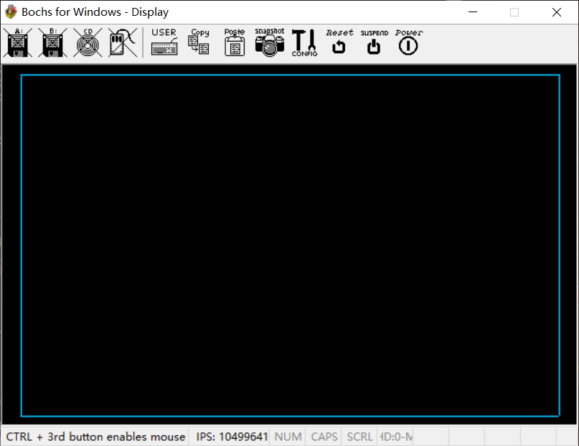

点击空格后：

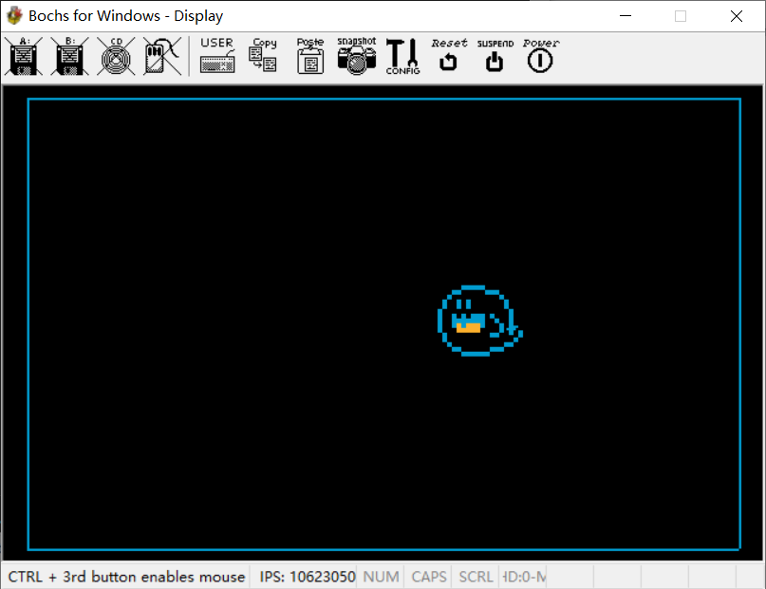

移动位置后：

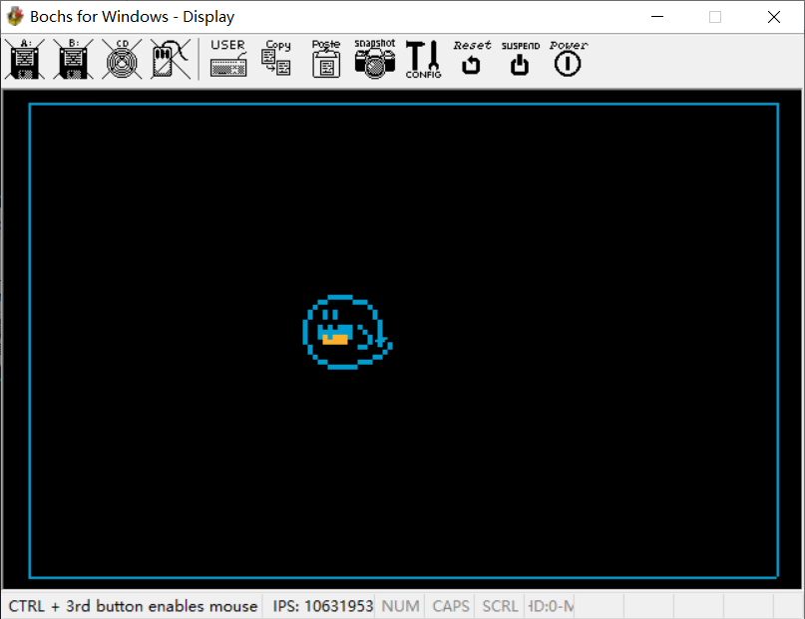

### 心得体会

本次课设，是一次检验我们一学期学期成果的测试，我们要把本学期学到的所有知识汇总起来制作一个功能较完善的程序。在我这次只做课设的过程中，我遇到了不少困难，比如整体的框架怎么设定，宠物的位置怎么确定，如何实现移动功能会比较好等等，都对我造成了一定的困扰，但最终在不断的尝试下还是慢慢完成了。由于这次课设时间比较紧，一些其他功能，例如声音之类的我就没有去制作，这个程序还是有不少可以改进或者说升级的地方，以后还是要继续学习继续做的更好。