

课 程 设 计 报 告

课程名称： 微机系统与接口技术

班 级： 计算机科学与技术183班

学 号： 201805120627

姓 名： 叶俊澎

**2021年1月**

目录

一、程序总体介绍 2

二、 大体功能模块 3

三、 运用到的所学到的知识 3

四、 操作实现流程图 3

五、心得体会 11

六、源代码 11

一、程序总体介绍

该程序是基于nasm汇编语言开发一的一款音乐播放器，一进入程序音乐就会自动开始播放，屏幕的上方会显示歌词，下方会显示日期。可以选择暂停和开始，暂停后音乐、歌词和日期都会暂停，开始后音乐、歌词和日期又会重新开始播放。如果不想看到歌词和日期也可以选择将他们清除。而且该程序还带有背景切换功能。

1. 大体功能模块
2. 音乐播放
3. 歌词显示
4. 日期显示
5. 程序开始
6. 程序暂停
7. 清除屏幕内容
8. 切换背景颜色
9. 运用到的所学到的知识
10. 时钟中断
11. 键盘中断
12. 扬声器
13. 操作实现流程图

1音乐播放

1）最终的音乐播放函数



2）在音乐播放函数里面调用了call_1至call_7系列函数

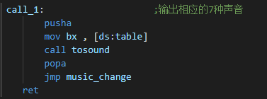

3）call系列函数里面调用声音播放函数

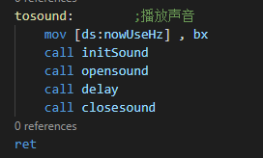

1. 声音播放函数里面调用声音初始化函数和打开关闭扬声器函数

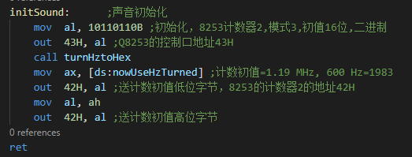

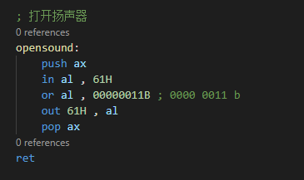

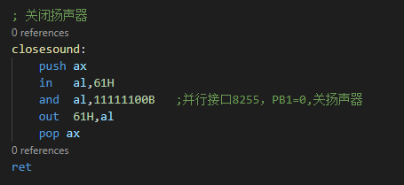

1. 声音初始换函数里面调用频率转化函数

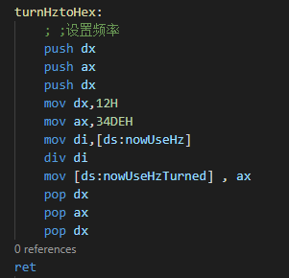

2歌词显示

1. 通过时钟中断来不断调用t0函数

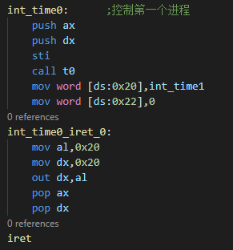

1. 在t0函数里面实现歌词的移动和打印歌词

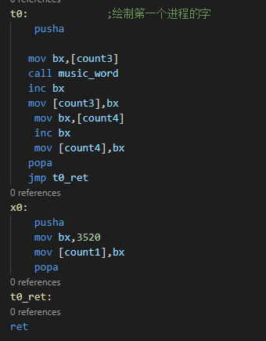

3）歌词打印函数



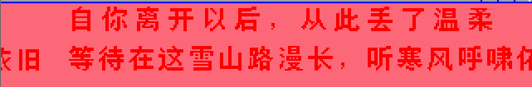

3.日期显示

1）通过时钟中断来不断调用t1函数

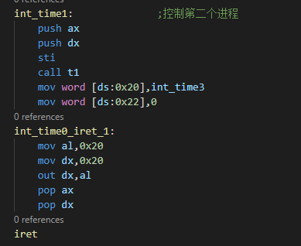

2）在t1函数里实现日期的移动和打印日期

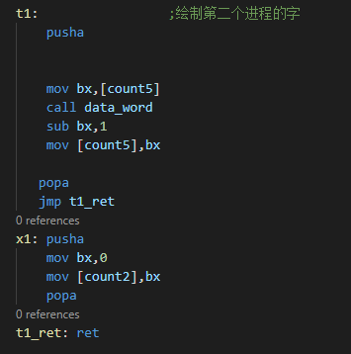

3）打印日期函数





4.程序开始

1）通过键盘中断来实现控制进程开始

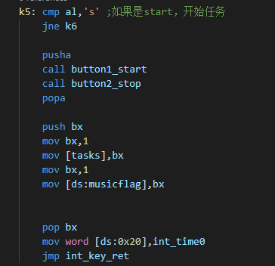

2）button1_start和button2_stop是“开始”“暂停”按钮绘制函数

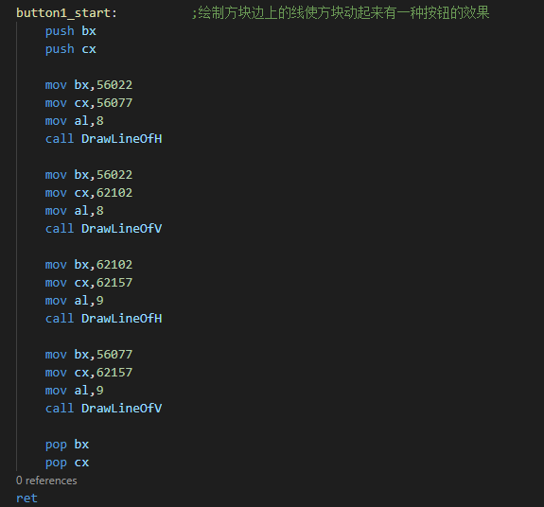

按钮的两种状态



5.程序暂停

1）通过键盘中断来控制进程暂停

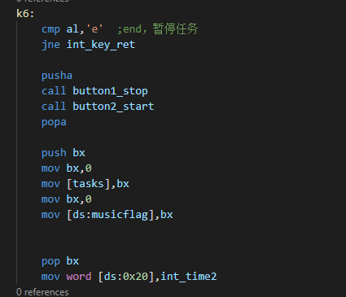

2）时钟中断int_time2是空进程

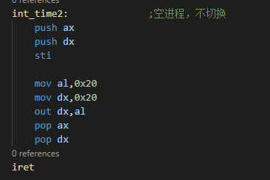

按钮的两种状态



6.清除屏幕内容

1）通过键盘中断来实现

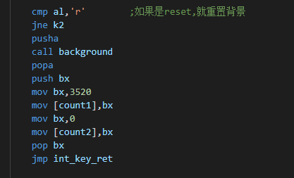

清除前

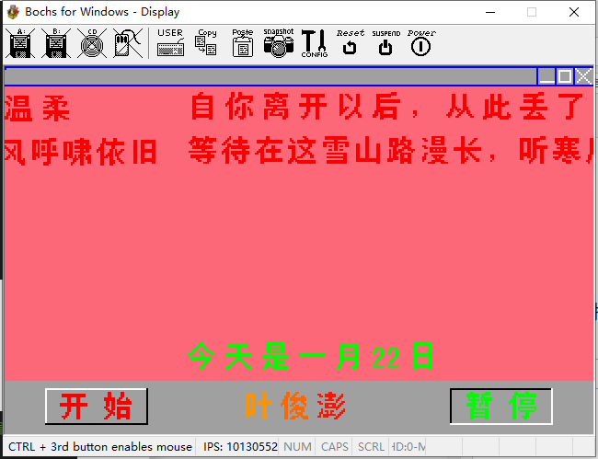

清除后

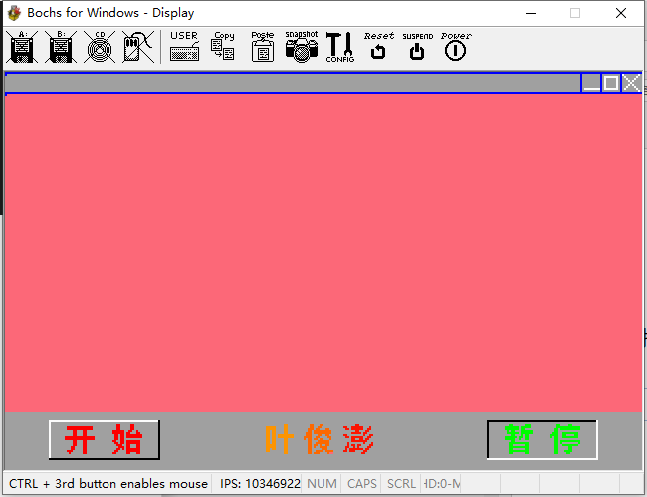

7.切换背景颜色

1）通过键盘中断来实现背景颜色的切换

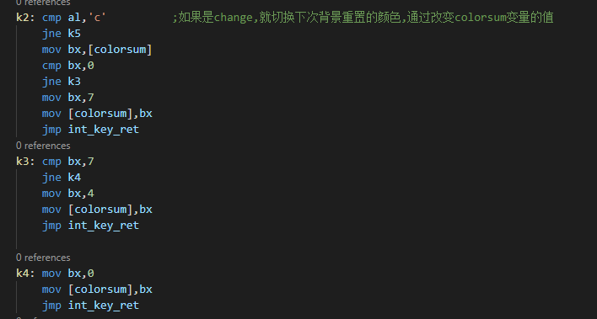

切换前

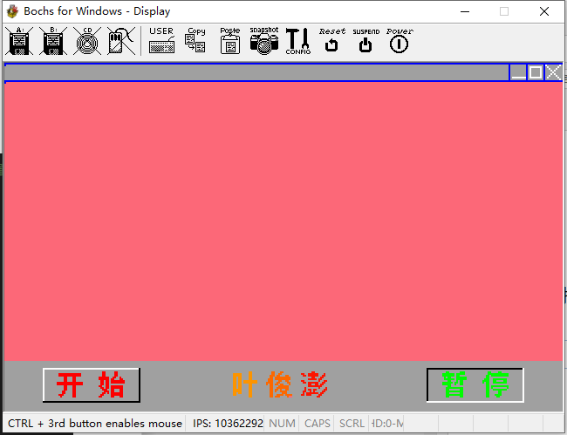

切换后

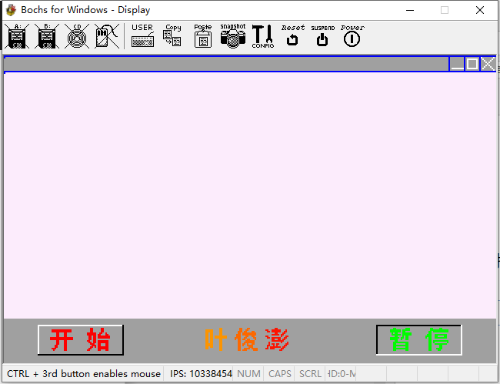

五、心得体会

通过这次课设我不仅巩固了之前所学的知识，而且还明白了一个重要道理，理论与实践相结合是很重要的，只有理论知识是远远不够的，很多事情想想都是很简单的，但当你真正去实现的时候，你就会发现有很多困难，只有把所学的理论知识与实践相结合起来，只有通过不断的实践才能提高自己的实际动手能力和独立思考的能力。

在设计的过程中我也遇到很多问题，毕竟是要把之前学的内容全部整合到一起，整合到一起的过程中就会出现很多问题，但是通过自己查找资料、请教老师和同学，最终这些问题也都被我一一解决了。

通过这一个学期对微机这门课的学习，我理解了很多计算机底层功能实现的原理，老师也很注重实践，经常让我们自己上机动手操作，也正是因为老师的这一行为举动，无形之中帮助了我很多，也让我比较顺利的完成了我的课设。很幸运，碰到了这么一位好老师。

六、源代码

org 0x8400

jmp start

color db 0,255,218,158

db 1,255,0,0

db 2,0,255,0

db 3,0,0,255

db 4,79,79,79

db 5,232,232,232

db 6,0,178,238

db 7,255,187,255

db 8,0,0,0 ;black

db 9,255,255,255 ;white

db 10,255,165,0

db 11,255,154,0

db 12,255,133,0

;所有点阵都是16*20

ye dw 0,0,0,0,0,0,0,0,0,0,0,0,0,0,0,0

dw 0,0,0,0,0,0,0,0,0,0,0,0,0,0,0,0

dw 0,0,0,0,0,0,0,0,0,0,1,1,0,0,0,0

dw 0,1,1,1,1,1,0,0,0,0,1,1,0,0,0,0

dw 0,1,1,1,1,1,0,0,0,0,1,1,0,0,0,0

dw 0,1,1,0,1,1,0,0,0,0,1,1,0,0,0,0

dw 0,1,1,0,1,1,0,0,0,0,1,1,0,0,0,0

dw 0,1,1,0,1,1,0,1,1,1,1,1,1,1,1,0

dw 0,1,1,0,1,1,0,1,1,1,1,1,1,1,1,0

dw 0,1,1,0,1,1,0,0,0,0,1,1,0,0,0,0

dw 0,1,1,0,1,1,0,0,0,0,1,1,0,0,0,0

dw 0,1,1,0,1,1,0,0,0,0,1,1,0,0,0,0

dw 0,1,1,1,1,1,0,0,0,0,1,1,0,0,0,0

dw 0,1,1,1,1,1,0,0,0,0,1,1,0,0,0,0

dw 0,1,1,0,1,1,0,0,0,0,1,1,0,0,0,0

dw 0,1,1,0,0,0,0,0,0,0,1,1,0,0,0,0

dw 0,0,0,0,0,0,0,0,0,0,1,1,0,0,0,0

dw 0,0,0,0,0,0,0,0,0,0,0,0,0,0,0,0

dw 0,0,0,0,0,0,0,0,0,0,0,0,0,0,0,0

dw 0,0,0,0,0,0,0,0,0,0,0,0,0,0,0,0

jun dw 0,0,0,0,0,0,0,0,0,0,0,0,0,0,0,0

dw 0,0,0,0,0,0,0,0,0,0,0,0,0,0,0,0

dw 0,0,0,1,1,0,0,0,1,1,0,0,0,0,0,0

dw 0,0,0,1,1,0,0,1,1,0,0,0,0,0,0,0

dw 0,0,1,1,1,0,1,1,0,0,0,1,1,0,0,0

dw 0,0,1,1,0,1,1,1,1,1,1,1,1,1,0,0

dw 0,1,1,1,0,1,1,1,1,1,1,1,1,1,0,0

dw 0,1,1,1,0,0,0,1,1,0,0,1,1,0,0,0

dw 1,1,1,1,0,0,1,1,0,0,0,0,1,1,0,0

dw 1,0,1,1,0,1,1,0,1,1,0,0,0,1,0,0

dw 0,0,1,1,0,0,0,1,1,1,1,1,1,0,0,0

dw 0,0,1,1,0,0,1,1,1,1,1,1,1,0,0,0

dw 0,0,1,1,0,1,1,0,1,0,0,1,1,0,0,0

dw 0,0,1,1,0,1,0,0,1,1,1,1,0,0,0,0

dw 0,0,1,1,0,0,0,0,0,1,1,1,0,0,0,0

dw 0,0,1,1,0,0,1,1,1,1,0,1,1,1,1,0

dw 0,0,1,1,0,1,1,1,0,0,0,0,1,1,1,0

dw 0,0,0,0,0,0,0,0,0,0,0,0,0,0,0,0

dw 0,0,0,0,0,0,0,0,0,0,0,0,0,0,0,0

dw 0,0,0,0,0,0,0,0,0,0,0,0,0,0,0,0

peng: dw 0,0,0,0,0,0,0,0,0,0,0,0,0,0,0,0

dw 0,0,0,0,0,0,0,0,0,0,0,0,0,0,0,0

dw 0,0,0,0,0,0,1,1,0,0,0,0,0,0,0,0

dw 1,1,0,0,1,1,1,1,1,1,0,0,0,1,0,0

dw 0,1,1,0,1,1,1,1,1,1,0,0,1,1,0,0

dw 0,0,0,0,0,0,1,1,0,0,0,1,1,0,0,0

dw 0,0,0,0,1,1,1,1,1,0,1,1,0,0,0,0

dw 1,1,0,0,0,0,0,0,0,0,1,0,0,1,1,0

dw 0,1,1,0,1,1,1,1,1,1,0,0,1,1,0,0

dw 0,0,0,0,1,1,0,0,1,1,0,1,1,0,0,0

dw 0,0,0,0,1,1,1,1,1,1,1,1,0,0,0,0

dw 0,0,1,0,0,0,0,0,0,0,1,0,0,0,1,0

dw 0,0,1,0,1,1,0,1,1,0,0,0,0,1,1,0

dw 0,1,1,0,0,1,0,1,0,0,0,0,1,1,0,0

dw 0,1,0,1,1,1,1,1,1,1,0,1,1,0,0,0

dw 1,1,0,1,1,1,0,0,0,0,1,1,0,0,0,0

dw 0,0,0,0,0,0,0,0,0,1,1,0,0,0,0,0

dw 0,0,0,0,0,0,0,0,0,0,0,0,0,0,0,0

dw 0,0,0,0,0,0,0,0,0,0,0,0,0,0,0,0

dw 0,0,0,0,0,0,0,0,0,0,0,0,0,0,0,0

kai: dw 0,0,0,0,0,0,0,0,0,0,0,0,0,0,0,0

dw 0,0,0,0,0,0,0,0,0,0,0,0,0,0,0,0

dw 0,0,0,0,0,0,0,0,0,0,0,0,0,0,0,0

dw 0,1,1,1,1,1,1,1,1,1,1,1,1,1,0,0

dw 0,1,1,1,1,1,1,1,1,1,1,1,1,1,0,0

dw 0,0,0,0,1,1,0,0,0,1,1,0,0,0,0,0

dw 0,0,0,0,1,1,0,0,0,1,1,0,0,0,0,0

dw 0,0,0,0,1,1,0,0,0,1,1,0,0,0,0,0

dw 1,1,1,1,1,1,1,1,1,1,1,1,1,1,1,0

dw 1,1,1,1,1,1,1,1,1,1,1,1,1,1,1,0

dw 0,0,0,0,1,1,0,0,0,1,1,0,0,0,0,0

dw 0,0,0,0,1,1,0,0,0,1,1,0,0,0,0,0

dw 0,0,0,0,1,1,0,0,0,1,1,0,0,0,0,0

dw 0,0,0,1,1,0,0,0,0,1,1,0,0,0,0,0

dw 0,0,0,1,1,0,0,0,0,1,1,0,0,0,0,0

dw 0,1,1,1,0,0,0,0,0,1,1,0,0,0,0,0

dw 0,0,1,0,0,0,0,0,0,1,1,0,0,0,0,0

dw 0,0,0,0,0,0,0,0,0,0,0,0,0,0,0,0

dw 0,0,0,0,0,0,0,0,0,0,0,0,0,0,0,0

dw 0,0,0,0,0,0,0,0,0,0,0,0,0,0,0,0

shi: dw 0,0,0,0,0,0,0,0,0,0,0,0,0,0,0,0

dw 0,0,0,0,0,0,0,0,0,0,0,0,0,0,0,0

dw 0,0,1,1,0,0,0,0,0,1,1,0,0,0,0,0

dw 0,0,1,1,0,0,0,0,0,1,1,0,0,0,0,0

dw 0,0,1,1,0,0,0,0,0,1,1,0,0,0,0,0

dw 1,1,1,1,1,1,0,0,1,1,0,0,1,0,0,0

dw 1,1,1,1,1,1,0,1,1,0,0,0,1,1,0,0

dw 0,1,1,0,1,1,0,1,1,1,1,1,1,1,1,0

dw 0,1,1,0,1,1,0,1,1,1,1,1,1,1,1,0

dw 0,1,1,0,1,1,0,0,0,0,0,0,0,0,0,0

dw 1,1,0,0,1,1,0,1,1,1,1,1,1,1,0,0

dw 0,1,1,0,1,1,0,1,1,1,1,1,1,1,0,0

dw 0,0,1,1,1,0,0,1,1,0,0,0,1,1,0,0

dw 0,0,0,1,1,1,0,1,1,0,0,0,1,1,0,0

dw 0,0,1,1,0,1,0,1,1,1,1,1,1,1,0,0

dw 0,1,1,0,0,0,0,1,1,1,1,1,1,1,0,0

dw 1,1,0,0,0,0,0,1,1,0,0,0,1,1,0,0

dw 0,0,0,0,0,0,0,0,0,0,0,0,0,0,0,0

dw 0,0,0,0,0,0,0,0,0,0,0,0,0,0,0,0

dw 0,0,0,0,0,0,0,0,0,0,0,0,0,0,0,0

zan: dw 0,0,0,0,0,0,0,0,0,0,0,0,0,0,0,0

dw 0,0,0,0,0,0,0,0,0,0,0,0,0,0,0,0

dw 0,0,0,1,1,0,0,0,0,0,0,1,1,1,0,0

dw 0,1,1,1,1,1,1,1,0,1,1,1,1,1,0,0

dw 0,1,1,1,1,1,1,1,0,1,1,0,0,0,0,0

dw 0,0,1,0,1,1,0,0,0,1,1,1,1,1,1,0

dw 0,0,1,1,1,1,1,1,0,1,1,1,1,1,1,0

dw 0,0,0,0,1,1,0,0,0,1,0,1,1,0,0,0

dw 0,1,1,1,1,1,1,0,1,1,0,1,1,0,0,0

dw 0,1,1,1,1,1,0,0,1,0,0,1,1,0,0,0

dw 0,0,0,0,1,1,0,0,0,0,0,0,0,0,0,0

dw 0,0,0,1,1,1,1,1,1,1,1,1,1,0,0,0

dw 0,0,0,1,1,0,0,0,0,0,0,1,1,0,0,0

dw 0,0,0,1,1,1,1,1,1,1,1,1,1,0,0,0

dw 0,0,0,1,1,0,0,0,0,0,0,1,1,0,0,0

dw 0,0,0,1,1,1,1,1,1,1,1,1,1,0,0,0

dw 0,0,0,1,1,0,0,0,0,0,0,1,1,0,0,0

dw 0,0,0,0,0,0,0,0,0,0,0,0,0,0,0,0

dw 0,0,0,0,0,0,0,0,0,0,0,0,0,0,0,0

dw 0,0,0,0,0,0,0,0,0,0,0,0,0,0,0,0

ting: dw 0,0,0,0,0,0,0,0,0,0,0,0,0,0,0,0

dw 0,0,0,0,0,0,0,0,0,0,0,0,0,0,0,0

dw 0,0,0,1,1,0,0,0,0,1,1,0,0,0,0,0

dw 0,0,0,1,1,1,1,1,1,1,1,1,1,1,1,0

dw 0,0,1,1,0,1,1,1,1,1,1,1,1,1,1,0

dw 0,0,1,1,0,0,0,0,0,0,0,0,0,0,0,0

dw 0,1,1,1,0,0,1,1,1,1,1,1,1,1,0,0

dw 1,1,1,1,0,0,1,1,0,0,0,0,1,1,0,0

dw 1,0,1,1,0,0,1,1,1,1,1,1,1,1,0,0

dw 0,0,1,1,0,0,0,0,0,0,0,0,0,0,0,0

dw 0,0,1,1,0,1,1,1,1,1,1,1,1,1,1,0

dw 0,0,1,1,0,1,0,0,0,0,0,0,0,0,1,0

dw 0,0,1,1,0,0,1,1,1,1,1,1,1,1,0,0

dw 0,0,1,1,0,0,0,0,0,1,1,0,0,0,0,0

dw 0,0,1,1,0,0,0,0,0,1,1,0,0,0,0,0

dw 0,0,1,1,0,0,0,1,1,1,1,0,0,0,0,0

dw 0,0,1,1,0,0,0,0,1,1,0,0,0,0,0,0

dw 0,0,0,0,0,0,0,0,0,0,0,0,0,0,0,0

dw 0,0,0,0,0,0,0,0,0,0,0,0,0,0,0,0

dw 0,0,0,0,0,0,0,0,0,0,0,0,0,0,0,0

zi: dw 0,0,0,0,0,0,0,0,0,0,0,0,0,0,0,0 ;自

dw 0,0,0,0,0,0,0,0,0,0,0,0,0,0,0,0

dw 0,0,0,0,0,0,1,1,0,0,0,0,0,0,0,0

dw 0,0,0,0,0,1,1,0,0,0,0,0,0,0,0,0

dw 0,0,1,1,1,1,1,1,1,1,1,1,1,0,0,0

dw 0,0,1,1,1,1,1,1,1,1,1,1,1,0,0,0

dw 0,0,1,1,0,0,0,0,0,0,0,1,1,0,0,0

dw 0,0,1,1,0,0,0,0,0,0,0,1,1,0,0,0

dw 0,0,1,1,1,1,1,1,1,1,1,1,1,0,0,0

dw 0,0,1,1,0,0,0,0,0,0,0,1,1,0,0,0

dw 0,0,1,1,0,0,0,0,0,0,0,1,1,0,0,0

dw 0,0,1,1,1,1,1,1,1,1,1,1,1,0,0,0

dw 0,0,1,1,0,0,0,0,0,0,0,1,1,0,0,0

dw 0,0,1,1,0,0,0,0,0,0,0,1,1,0,0,0

dw 0,0,1,1,1,1,1,1,1,1,1,1,1,0,0,0

dw 0,0,1,1,1,1,1,1,1,1,1,1,1,0,0,0

dw 0,0,1,1,0,0,0,0,0,0,0,1,1,0,0,0

dw 0,0,0,0,0,0,0,0,0,0,0,0,0,0,0,0

dw 0,0,0,0,0,0,0,0,0,0,0,0,0,0,0,0

dw 0,0,0,0,0,0,0,0,0,0,0,0,0,0,0,0

ni: dw 0,0,0,0,0,0,0,0,0,0,0,0,0,0,0,0

dw 0,0,0,0,0,0,0,0,0,0,0,0,0,0,0,0

dw 0,0,0,1,1,0,0,1,1,0,0,0,0,0,0,0

dw 0,0,0,1,1,0,0,1,1,0,0,0,0,0,0,0

dw 0,0,0,1,1,0,0,1,1,1,1,1,1,1,1,0

dw 0,0,1,1,0,0,1,1,1,1,1,1,1,1,1,0

dw 0,0,1,1,0,1,1,1,0,0,0,0,0,1,1,0

dw 0,1,1,1,0,1,1,0,0,0,0,0,1,1,0,0

dw 1,1,1,1,0,0,0,0,0,1,1,0,0,0,0,0

dw 1,0,1,1,0,0,0,0,0,1,1,0,0,0,0,0

dw 0,0,1,1,0,0,1,1,0,1,1,0,1,0,0,0

dw 0,0,1,1,0,0,1,1,0,1,1,0,1,1,0,0

dw 0,0,1,1,0,1,1,0,0,1,1,0,0,1,0,0

dw 0,0,1,1,0,1,1,0,0,1,1,0,0,1,1,0

dw 0,0,1,1,0,1,0,0,0,1,1,0,0,1,1,0

dw 0,0,1,1,0,0,0,1,1,1,1,0,0,0,0,0

dw 0,0,1,1,0,0,0,0,1,1,0,0,0,0,0,0

dw 0,0,0,0,0,0,0,0,0,0,0,0,0,0,0,0

dw 0,0,0,0,0,0,0,0,0,0,0,0,0,0,0,0

dw 0,0,0,0,0,0,0,0,0,0,0,0,0,0,0,0

li: dw 0,0,0,0,0,0,0,0,0,0,0,0,0,0,0,0

dw 0,0,0,0,0,0,0,0,0,0,0,0,0,0,0,0

dw 0,0,0,0,0,0,0,1,1,0,0,0,0,0,0,0

dw 0,1,1,1,1,1,1,1,1,1,1,1,1,1,0,0

dw 0,1,1,1,1,1,1,1,1,1,1,1,1,1,0,0

dw 0,0,0,0,0,1,1,0,0,1,1,0,0,0,0,0

dw 0,0,1,1,0,0,1,1,1,0,0,1,1,0,0,0

dw 0,0,1,1,1,1,1,0,1,1,1,1,1,0,0,0

dw 0,0,1,1,0,0,0,0,0,0,0,1,1,0,0,0

dw 0,0,1,1,1,1,1,1,1,1,1,1,1,0,0,0

dw 0,0,0,0,0,0,1,1,0,0,0,0,0,0,0,0

dw 0,1,1,1,1,1,1,1,1,1,1,1,1,1,0,0

dw 0,1,1,0,0,1,1,0,0,0,0,0,1,1,0,0

dw 0,1,1,0,1,1,0,0,0,1,1,0,1,1,0,0

dw 0,1,1,0,1,1,1,1,1,1,1,0,1,1,0,0

dw 0,1,1,0,0,0,0,0,0,0,0,1,1,1,0,0

dw 0,1,1,0,0,0,0,0,0,0,0,1,1,0,0,0

dw 0,0,0,0,0,0,0,0,0,0,0,0,0,0,0,0

dw 0,0,0,0,0,0,0,0,0,0,0,0,0,0,0,0

dw 0,0,0,0,0,0,0,0,0,0,0,0,0,0,0,0

yi: dw 0,0,0,0,0,0,0,0,0,0,0,0,0,0,0,0

dw 0,0,0,0,0,0,0,0,0,0,0,0,0,0,0,0

dw 0,0,0,0,0,0,0,0,0,0,0,0,0,0,0,0

dw 0,0,1,1,0,1,1,0,0,0,0,1,1,0,0,0

dw 0,0,1,1,0,0,1,1,0,0,0,1,1,0,0,0

dw 0,0,1,1,0,0,0,1,1,0,0,1,1,0,0,0

dw 0,0,1,1,0,0,0,0,1,0,0,1,1,0,0,0

dw 0,0,1,1,0,0,0,0,0,0,0,1,1,0,0,0

dw 0,0,1,1,0,0,0,0,0,0,0,1,1,0,0,0

dw 0,0,1,1,0,0,0,0,0,0,0,1,1,0,0,0

dw 0,0,1,1,0,1,1,0,0,0,1,1,0,0,0,0

dw 0,0,1,1,1,1,0,0,0,0,1,1,0,0,0,0

dw 0,0,1,1,1,0,0,0,0,1,1,1,0,0,0,0

dw 0,0,1,1,0,0,0,0,1,1,0,1,1,0,0,0

dw 0,0,1,0,0,0,0,1,1,0,0,0,1,1,0,0

dw 0,0,0,0,0,1,1,1,0,0,0,0,1,1,0,0

dw 0,0,0,0,0,1,1,0,0,0,0,0,0,0,0,0

dw 0,0,0,0,0,0,0,0,0,0,0,0,0,0,0,0

dw 0,0,0,0,0,0,0,0,0,0,0,0,0,0,0,0

dw 0,0,0,0,0,0,0,0,0,0,0,0,0,0,0,0

hou: dw 0,0,0,0,0,0,0,0,0,0,0,0,0,0,0,0

dw 0,0,0,0,0,0,0,0,0,0,0,0,0,0,0,0

dw 0,0,0,0,0,0,0,0,0,0,1,1,1,0,0,0

dw 0,0,1,1,1,1,1,1,1,1,1,1,1,0,0,0

dw 0,0,1,1,1,1,1,1,1,1,0,0,0,0,0,0

dw 0,0,1,1,0,0,0,0,0,0,0,0,0,0,0,0

dw 0,0,1,1,1,1,1,1,1,1,1,1,1,1,1,0

dw 0,0,1,1,1,1,1,1,1,1,1,1,1,1,1,0

dw 0,0,1,1,0,0,0,0,0,0,0,0,0,0,0,0

dw 0,0,1,1,0,0,0,0,0,0,0,0,0,0,0,0

dw 0,0,1,1,1,1,1,1,1,1,1,1,1,0,0,0

dw 0,0,1,1,1,1,1,1,1,1,1,1,1,0,0,0

dw 0,1,1,1,1,1,0,0,0,0,0,1,1,0,0,0

dw 0,1,1,0,1,1,0,0,0,0,0,1,1,0,0,0

dw 1,1,1,0,1,1,1,1,1,1,1,1,1,0,0,0

dw 1,1,0,0,1,1,1,1,1,1,1,1,1,0,0,0

dw 0,0,0,0,1,1,0,0,0,0,0,1,1,0,0,0

dw 0,0,0,0,0,0,0,0,0,0,0,0,0,0,0,0

dw 0,0,0,0,0,0,0,0,0,0,0,0,0,0,0,0

dw 0,0,0,0,0,0,0,0,0,0,0,0,0,0,0,0

douhao: dw 0,0,0,0,0,0,0,0,0,0,0,0,0,0,0,0 ;表示“，”

dw 0,0,0,0,0,0,0,0,0,0,0,0,0,0,0,0

dw 0,0,0,0,0,0,0,0,0,0,0,0,0,0,0,0

dw 0,0,0,0,0,0,0,0,0,0,0,0,0,0,0,0

dw 0,0,0,0,0,0,0,0,0,0,0,0,0,0,0,0

dw 0,0,0,0,0,0,0,0,0,0,0,0,0,0,0,0

dw 0,0,0,0,0,0,0,0,0,0,0,0,0,0,0,0

dw 0,0,0,0,0,0,0,0,0,0,0,0,0,0,0,0

dw 0,0,0,0,0,0,0,0,0,0,0,0,0,0,0,0

dw 0,0,0,0,0,0,0,0,0,0,0,0,0,0,0,0

dw 0,0,0,0,0,0,0,0,0,0,0,0,0,0,0,0

dw 0,0,0,0,0,0,0,0,0,0,0,0,0,0,0,0

dw 0,0,1,1,0,0,0,0,0,0,0,0,0,0,0,0

dw 0,0,1,1,0,0,0,0,0,0,0,0,0,0,0,0

dw 0,0,0,1,0,0,0,0,0,0,0,0,0,0,0,0

dw 0,0,1,0,0,0,0,0,0,0,0,0,0,0,0,0

dw 0,0,0,0,0,0,0,0,0,0,0,0,0,0,0,0

dw 0,0,0,0,0,0,0,0,0,0,0,0,0,0,0,0

dw 0,0,0,0,0,0,0,0,0,0,0,0,0,0,0,0

cong: dw 0,0,0,0,0,0,0,0,0,0,0,0,0,0,0,0

dw 0,0,0,0,0,0,0,0,0,0,0,0,0,0,0,0

dw 0,0,0,0,0,0,0,0,0,0,0,0,0,0,0,0

dw 0,0,0,1,1,0,0,0,0,1,1,0,0,0,0,0

dw 0,0,0,1,1,0,0,0,0,1,1,0,0,0,0,0

dw 0,0,0,1,1,0,0,0,0,1,1,0,0,0,0,0

dw 0,0,0,1,1,0,0,0,0,1,1,0,0,0,0,0

dw 0,0,0,1,1,0,0,0,0,1,1,0,0,0,0,0

dw 0,0,0,1,1,0,0,0,0,1,1,0,0,0,0,0

dw 0,0,0,1,1,0,0,0,0,1,1,0,0,0,0,0

dw 0,0,0,1,1,1,0,0,0,1,1,1,0,0,0,0

dw 0,0,1,1,0,1,1,1,0,1,1,1,0,0,0,0

dw 0,0,1,1,0,0,1,0,1,1,0,1,1,0,0,0

dw 0,1,1,0,0,0,0,1,1,0,0,1,1,0,0,0

dw 1,1,1,0,0,0,1,1,0,0,0,0,1,1,0,0

dw 0,1,0,0,0,1,1,0,0,0,0,0,0,1,1,0

dw 0,0,0,0,0,0,0,0,0,0,0,0,0,0,0,0

dw 0,0,0,0,0,0,0,0,0,0,0,0,0,0,0,0

dw 0,0,0,0,0,0,0,0,0,0,0,0,0,0,0,0

ci: dw 0,0,0,0,0,0,0,0,0,0,0,0,0,0,0,0

dw 0,0,0,0,0,0,0,0,0,0,0,0,0,0,0,0

dw 0,0,0,0,0,0,0,0,0,0,0,0,0,0,0,0

dw 0,0,0,0,1,1,0,0,1,1,0,0,0,0,0,0

dw 0,0,0,0,1,1,0,0,1,1,0,0,0,0,0,0

dw 0,0,0,0,1,1,0,0,1,1,0,0,0,0,0,0

dw 0,1,1,0,1,1,0,0,1,1,0,0,0,0,0,0

dw 0,1,1,0,1,1,1,1,1,1,0,0,1,1,0,0

dw 0,1,1,0,1,1,1,1,1,1,1,1,1,1,0,0

dw 0,1,1,0,1,1,0,0,1,1,1,1,0,0,0,0

dw 0,1,1,0,1,1,0,0,1,1,0,0,0,0,0,0

dw 0,1,1,0,1,1,0,0,1,1,0,0,0,0,0,0

dw 0,1,1,0,1,1,0,0,1,1,0,0,0,0,0,0

dw 0,1,1,0,1,1,1,1,1,1,0,0,0,1,0,0

dw 0,1,1,1,1,1,1,1,1,1,0,0,0,1,1,0

dw 1,1,1,1,1,0,0,0,1,1,1,1,1,1,1,0

dw 1,1,0,0,0,0,0,0,0,1,1,1,1,1,0,0

dw 0,0,0,0,0,0,0,0,0,0,0,0,0,0,0,0

dw 0,0,0,0,0,0,0,0,0,0,0,0,0,0,0,0

dw 0,0,0,0,0,0,0,0,0,0,0,0,0,0,0,0

jiu: dw 0,0,0,0,0,0,0,0,0,0,0,0,0,0,0,0

dw 0,0,0,0,0,0,0,0,0,0,0,0,0,0,0,0

dw 0,0,1,1,0,0,0,0,0,1,1,0,0,0,0,0

dw 0,0,0,1,1,0,0,0,0,1,1,0,1,0,0,0

dw 1,1,1,1,1,1,1,1,0,1,1,0,1,1,0,0

dw 1,1,1,1,1,1,1,1,0,1,1,0,0,1,0,0

dw 0,0,0,0,0,0,0,1,1,1,1,1,1,1,1,0

dw 0,1,1,1,1,1,1,1,1,1,1,1,1,1,1,0

dw 0,1,1,0,0,1,1,0,0,1,0,1,1,0,0,0

dw 0,1,1,1,1,1,1,0,0,1,0,1,1,0,0,0

dw 0,1,1,1,1,1,1,0,0,1,0,1,1,0,0,0

dw 0,0,0,1,1,0,0,0,0,1,0,1,1,0,0,0

dw 0,1,1,1,1,1,1,0,0,1,0,1,1,0,0,0

dw 0,1,0,1,1,0,1,0,1,1,0,1,1,0,0,0

dw 1,1,0,1,1,0,0,0,1,1,0,1,1,0,1,0

dw 0,0,1,1,1,0,0,1,1,0,0,1,1,1,1,0

dw 0,0,1,1,0,0,0,1,0,0,0,0,1,1,0,0

dw 0,0,0,0,0,0,0,0,0,0,0,0,0,0,0,0

dw 0,0,0,0,0,0,0,0,0,0,0,0,0,0,0,0

dw 0,0,0,0,0,0,0,0,0,0,0,0,0,0,0,0

diu: dw 0,0,0,0,0,0,0,0,0,0,0,0,0,0,0,0

dw 0,0,0,0,0,0,0,0,0,0,0,0,0,0,0,0

dw 0,0,0,0,0,0,0,0,0,0,1,1,1,0,0,0

dw 0,0,1,1,1,1,1,1,1,1,1,1,1,0,0,0

dw 0,0,1,1,1,1,1,1,1,1,0,0,0,0,0,0

dw 0,0,0,0,0,0,0,1,1,0,0,0,0,0,0,0

dw 0,0,1,1,1,1,1,1,1,1,1,1,1,0,0,0

dw 0,0,1,1,1,1,1,1,1,1,1,1,1,0,0,0

dw 0,0,0,0,0,0,0,1,1,0,0,0,0,0,0,0

dw 0,0,0,0,0,0,0,1,1,0,0,0,0,0,0,0

dw 1,1,1,1,1,1,1,1,1,1,1,1,1,1,1,0

dw 1,1,1,1,1,1,1,1,1,1,1,1,1,1,1,0

dw 0,0,0,0,0,0,1,1,0,0,0,0,0,0,0,0

dw 0,0,0,0,0,1,1,0,0,1,1,0,0,0,0,0

dw 0,0,0,0,1,1,0,0,0,0,1,1,0,0,0,0

dw 0,0,1,1,1,1,1,1,1,1,1,1,1,0,0,0

dw 0,0,1,1,1,1,1,1,1,1,1,1,1,1,0,0

dw 0,0,0,0,0,0,0,0,0,0,0,0,0,0,0,0

dw 0,0,0,0,0,0,0,0,0,0,0,0,0,0,0,0

dw 0,0,0,0,0,0,0,0,0,0,0,0,0,0,0,0

le: dw 0,0,0,0,0,0,0,0,0,0,0,0,0,0,0,0

dw 0,0,0,0,0,0,0,0,0,0,0,0,0,0,0,0

dw 0,0,0,0,0,0,0,0,0,0,0,0,0,0,0,0

dw 0,1,1,1,1,1,1,1,1,1,1,1,1,1,0,0

dw 0,1,1,1,1,1,1,1,1,1,1,1,1,1,0,0

dw 0,0,0,0,0,0,0,0,0,0,1,1,0,0,0,0

dw 0,0,0,0,0,0,0,0,0,1,1,0,0,0,0,0

dw 0,0,0,0,0,0,0,1,1,1,0,0,0,0,0,0

dw 0,0,0,0,0,0,0,1,1,0,0,0,0,0,0,0

dw 0,0,0,0,0,0,0,1,1,0,0,0,0,0,0,0

dw 0,0,0,0,0,0,0,1,1,0,0,0,0,0,0,0

dw 0,0,0,0,0,0,0,1,1,0,0,0,0,0,0,0

dw 0,0,0,0,0,0,0,1,1,0,0,0,0,0,0,0

dw 0,0,0,0,0,0,0,1,1,0,0,0,0,0,0,0

dw 0,0,0,0,0,0,0,1,1,0,0,0,0,0,0,0

dw 0,0,0,0,0,1,1,1,1,0,0,0,0,0,0,0

dw 0,0,0,0,0,1,1,1,0,0,0,0,0,0,0,0

dw 0,0,0,0,0,0,0,0,0,0,0,0,0,0,0,0

dw 0,0,0,0,0,0,0,0,0,0,0,0,0,0,0,0

dw 0,0,0,0,0,0,0,0,0,0,0,0,0,0,0,0

wen: dw 0,0,0,0,0,0,0,0,0,0,0,0,0,0,0,0

dw 0,0,0,0,0,0,0,0,0,0,0,0,0,0,0,0

dw 0,0,0,0,0,0,0,0,0,0,0,0,0,0,0,0

dw 0,1,1,0,0,1,1,1,1,1,1,1,1,0,0,0

dw 0,0,1,1,0,1,1,1,1,1,1,1,1,0,0,0

dw 0,0,0,1,0,1,1,0,0,0,0,1,1,0,0,0

dw 1,1,0,0,0,1,1,1,1,1,1,1,1,0,0,0

dw 0,1,1,0,0,1,1,0,0,0,0,1,1,0,0,0

dw 0,0,1,0,0,1,1,1,1,1,1,1,1,0,0,0

dw 0,0,0,0,0,0,0,0,0,0,0,0,0,0,0,0

dw 0,0,1,0,1,1,1,1,1,1,1,1,1,1,0,0

dw 0,0,1,0,1,1,1,1,1,1,1,1,1,1,0,0

dw 0,1,1,0,1,1,0,1,0,0,1,0,1,1,0,0

dw 0,1,1,0,1,1,0,1,0,0,1,0,1,1,0,0

dw 1,1,0,0,1,1,0,1,0,0,1,0,1,1,0,0

dw 1,1,0,1,1,1,1,1,1,1,1,1,1,1,1,0

dw 0,0,0,1,1,1,1,1,1,1,1,1,1,1,1,0

dw 0,0,0,0,0,0,0,0,0,0,0,0,0,0,0,0

dw 0,0,0,0,0,0,0,0,0,0,0,0,0,0,0,0

dw 0,0,0,0,0,0,0,0,0,0,0,0,0,0,0,0

rou: dw 0,0,0,0,0,0,0,0,0,0,0,0,0,0,0,0

dw 0,0,0,0,0,0,0,0,0,0,0,0,0,0,0,0

dw 0,0,0,0,0,0,0,0,0,0,0,0,0,0,0,0

dw 0,0,1,1,1,1,1,1,1,1,1,1,0,0,0,0

dw 0,0,0,0,0,1,1,0,0,1,1,0,0,0,0,0

dw 0,0,0,0,0,0,1,1,1,0,0,0,0,0,0,0

dw 0,1,1,1,1,1,1,1,1,1,1,1,1,1,0,0

dw 0,0,0,0,0,1,1,1,1,0,0,0,1,1,0,0

dw 0,0,0,1,1,1,0,1,1,0,0,1,1,0,0,0

dw 0,1,1,1,0,0,1,1,1,0,0,0,0,0,0,0

dw 0,0,0,0,0,0,0,1,1,0,0,0,0,0,0,0

dw 0,1,1,1,1,1,1,1,1,1,1,1,1,1,1,0

dw 0,1,1,1,1,1,1,1,1,1,1,1,1,1,1,0

dw 0,0,0,0,1,1,0,1,1,1,1,0,0,0,0,0

dw 0,0,0,1,1,0,0,1,1,0,1,1,1,0,0,0

dw 0,1,1,1,0,0,0,1,1,0,0,0,1,1,1,0

dw 0,0,0,0,0,0,0,1,1,0,0,0,0,0,0,0

dw 0,0,0,0,0,0,0,0,0,0,0,0,0,0,0,0

dw 0,0,0,0,0,0,0,0,0,0,0,0,0,0,0,0

dw 0,0,0,0,0,0,0,0,0,0,0,0,0,0,0,0

deng: dw 0,0,0,0,0,0,0,0,0,0,0,0,0,0,0,0

dw 0,0,0,0,0,0,0,0,0,0,0,0,0,0,0,0

dw 0,0,1,1,0,0,0,0,0,1,1,0,0,0,0,0

dw 0,0,1,1,1,1,1,1,0,1,1,1,1,1,1,0

dw 0,1,1,1,1,1,1,1,1,1,1,1,1,1,1,0

dw 1,1,1,0,1,1,0,0,1,1,0,1,1,0,0,0

dw 0,1,0,0,1,1,0,1,1,0,0,0,0,0,0,0

dw 0,0,1,1,1,1,1,1,1,1,1,1,1,0,0,0

dw 0,0,1,1,1,1,1,1,1,1,1,1,1,0,0,0

dw 0,0,0,0,0,0,0,1,1,0,0,0,0,0,0,0

dw 1,1,1,1,1,1,1,1,1,1,1,1,1,1,1,0

dw 0,0,0,0,0,0,0,0,0,0,1,1,0,0,0,0

dw 0,1,1,1,1,1,1,1,1,1,1,1,1,1,0,0

dw 0,1,1,1,1,1,1,1,1,1,1,1,1,1,0,0

dw 0,0,0,0,1,1,0,0,0,0,1,1,0,0,0,0

dw 0,0,0,0,0,1,1,0,0,0,1,1,0,0,0,0

dw 0,0,0,0,0,0,0,0,1,1,1,0,0,0,0,0

dw 0,0,0,0,0,0,0,0,0,0,0,0,0,0,0,0

dw 0,0,0,0,0,0,0,0,0,0,0,0,0,0,0,0

dw 0,0,0,0,0,0,0,0,0,0,0,0,0,0,0,0

dai: dw 0,0,0,0,0,0,0,0,0,0,0,0,0,0,0,0

dw 0,0,0,0,0,0,0,0,0,0,0,0,0,0,0,0

dw 0,0,0,0,1,0,0,0,0,1,1,0,0,0,0,0

dw 0,0,0,1,1,0,0,0,0,1,1,0,0,0,0,0

dw 0,0,1,1,0,0,1,1,1,1,1,1,1,1,0,0

dw 0,1,1,0,0,0,1,1,1,1,1,1,1,1,0,0

dw 1,1,0,1,1,0,0,0,0,1,1,0,0,0,0,0

dw 0,0,0,1,1,1,1,1,1,1,1,1,1,1,1,0

dw 0,0,1,1,0,1,1,1,1,1,1,1,1,1,1,0

dw 0,1,1,1,0,0,0,0,0,0,0,1,1,0,0,0

dw 1,1,1,1,0,1,1,1,1,1,1,1,1,1,1,0

dw 1,0,1,1,0,1,1,1,1,1,1,1,1,1,1,0

dw 0,0,1,1,0,0,1,1,0,0,0,1,1,0,0,0

dw 0,0,1,1,0,0,0,1,1,0,0,1,1,0,0,0

dw 0,0,1,1,0,0,0,1,1,0,0,1,1,0,0,0

dw 0,0,1,1,0,0,0,0,0,1,1,1,1,0,0,0

dw 0,0,1,1,0,0,0,0,0,1,1,1,0,0,0,0

dw 0,0,0,0,0,0,0,0,0,0,0,0,0,0,0,0

dw 0,0,0,0,0,0,0,0,0,0,0,0,0,0,0,0

dw 0,0,0,0,0,0,0,0,0,0,0,0,0,0,0,0

zai: dw 0,0,0,0,0,0,0,0,0,0,0,0,0,0,0,0

dw 0,0,0,0,0,0,0,0,0,0,0,0,0,0,0,0

dw 0,0,0,0,0,0,1,1,0,0,0,0,0,0,0,0

dw 0,0,0,0,0,0,1,1,0,0,0,0,0,0,0,0

dw 0,1,1,1,1,1,1,1,1,1,1,1,1,1,1,0

dw 0,1,1,1,1,1,1,1,1,1,1,1,1,1,1,0

dw 0,0,0,0,0,1,1,0,0,0,0,0,0,0,0,0

dw 0,0,0,0,1,1,0,0,0,1,1,0,0,0,0,0

dw 0,0,0,1,1,0,0,0,0,1,1,0,0,0,0,0

dw 0,0,1,1,1,0,1,1,1,1,1,1,1,1,0,0

dw 0,1,1,1,1,0,1,1,1,1,1,1,1,1,0,0

dw 1,1,0,1,1,0,0,0,0,1,1,0,0,0,0,0

dw 0,0,0,1,1,0,0,0,0,1,1,0,0,0,0,0

dw 0,0,0,1,1,0,0,0,0,1,1,0,0,0,0,0

dw 0,0,0,1,1,1,1,1,1,1,1,1,1,1,1,0

dw 0,0,0,1,1,1,1,1,1,1,1,1,1,1,1,0

dw 0,0,0,1,1,0,0,0,0,0,0,0,0,0,0,0

dw 0,0,0,0,0,0,0,0,0,0,0,0,0,0,0,0

dw 0,0,0,0,0,0,0,0,0,0,0,0,0,0,0,0

dw 0,0,0,0,0,0,0,0,0,0,0,0,0,0,0,0

zhe: dw 0,0,0,0,0,0,0,0,0,0,0,0,0,0,0,0

dw 0,0,0,0,0,0,0,0,0,0,0,0,0,0,0,0

dw 0,0,0,0,0,0,0,0,1,1,0,0,0,0,0,0

dw 0,1,0,0,0,0,0,0,0,1,1,0,0,0,0,0

dw 0,1,1,0,0,1,1,1,1,1,1,1,1,1,1,0

dw 0,0,1,1,0,1,1,1,1,1,1,1,1,1,1,0

dw 0,0,0,0,0,0,0,0,0,0,0,1,1,0,0,0

dw 1,1,1,1,0,0,1,1,0,0,0,1,1,0,0,0

dw 1,1,1,1,0,0,0,1,1,0,1,1,0,0,0,0

dw 0,0,1,1,0,0,0,0,1,1,1,0,0,0,0,0

dw 0,0,1,1,0,0,0,0,0,1,1,1,0,0,0,0

dw 0,0,1,1,0,0,0,0,1,1,0,1,1,0,0,0

dw 0,0,1,1,0,0,0,1,1,0,0,0,1,1,0,0

dw 0,0,1,1,0,1,1,1,0,0,0,0,1,1,0,0

dw 0,1,1,1,1,0,0,0,0,0,0,0,0,0,0,0

dw 1,1,1,0,1,1,1,1,1,1,1,1,1,1,1,0

dw 1,1,0,0,0,1,1,1,1,1,1,1,1,1,1,0

dw 0,0,0,0,0,0,0,0,0,0,0,0,0,0,0,0

dw 0,0,0,0,0,0,0,0,0,0,0,0,0,0,0,0

dw 0,0,0,0,0,0,0,0,0,0,0,0,0,0,0,0

xue: dw 0,0,0,0,0,0,0,0,0,0,0,0,0,0,0,0

dw 0,0,0,0,0,0,0,0,0,0,0,0,0,0,0,0

dw 0,0,1,1,1,1,1,1,1,1,1,1,1,1,0,0

dw 0,0,1,1,1,1,1,1,1,1,1,1,1,1,0,0

dw 0,0,0,0,0,0,0,1,1,0,0,0,0,0,0,0

dw 0,1,1,1,1,1,1,1,1,1,1,1,1,1,1,0

dw 0,1,1,0,0,0,0,1,1,0,0,0,0,1,1,0

dw 0,1,1,0,1,1,0,1,1,0,1,1,0,1,1,0

dw 0,0,0,0,0,0,0,1,1,0,0,0,0,0,0,0

dw 0,0,0,0,1,1,0,1,1,0,1,1,0,0,0,0

dw 0,0,0,0,0,0,0,0,0,0,0,0,0,0,0,0

dw 0,0,0,1,1,1,1,1,1,1,1,1,1,1,0,0

dw 0,0,0,0,0,0,0,0,0,0,0,0,1,1,0,0

dw 0,0,0,1,1,1,1,1,1,1,1,1,1,1,0,0

dw 0,0,0,0,0,0,0,0,0,0,0,0,1,1,0,0

dw 0,0,0,1,1,1,1,1,1,1,1,1,1,1,0,0

dw 0,0,0,1,1,1,1,1,1,1,1,1,1,1,0,0

dw 0,0,0,0,0,0,0,0,0,0,0,0,0,0,0,0

dw 0,0,0,0,0,0,0,0,0,0,0,0,0,0,0,0

dw 0,0,0,0,0,0,0,0,0,0,0,0,0,0,0,0

shan: dw 0,0,0,0,0,0,0,0,0,0,0,0,0,0,0,0

dw 0,0,0,0,0,0,0,0,0,0,0,0,0,0,0,0

dw 0,0,0,0,0,0,1,1,0,0,0,0,0,0,0,0

dw 0,0,0,0,0,0,1,1,0,0,0,0,0,0,0,0

dw 0,0,0,0,0,0,1,1,0,0,0,0,0,0,0,0

dw 0,0,0,0,0,0,1,1,0,0,0,0,0,0,0,0

dw 0,1,1,0,0,0,1,1,0,0,0,0,1,1,0,0

dw 0,1,1,0,0,0,1,1,0,0,0,0,1,1,0,0

dw 0,1,1,0,0,0,1,1,0,0,0,0,1,1,0,0

dw 0,1,1,0,0,0,1,1,0,0,0,0,1,1,0,0

dw 0,1,1,0,0,0,1,1,0,0,0,0,1,1,0,0

dw 0,1,1,0,0,0,1,1,0,0,0,0,1,1,0,0

dw 0,1,1,0,0,0,1,1,0,0,0,0,1,1,0,0

dw 0,1,1,0,0,0,1,1,0,0,0,0,1,1,0,0

dw 0,1,1,1,1,1,1,1,1,1,1,1,1,1,0,0

dw 0,1,1,1,1,1,1,1,1,1,1,1,1,1,0,0

dw 0,0,0,0,0,0,0,0,0,0,0,0,1,1,0,0

dw 0,0,0,0,0,0,0,0,0,0,0,0,0,0,0,0

dw 0,0,0,0,0,0,0,0,0,0,0,0,0,0,0,0

dw 0,0,0,0,0,0,0,0,0,0,0,0,0,0,0,0

lu: dw 0,0,0,0,0,0,0,0,0,0,0,0,0,0,0,0

dw 0,0,0,0,0,0,0,0,0,0,0,0,0,0,0,0

dw 0,0,0,0,0,0,0,0,1,1,0,0,0,0,0,0

dw 0,1,1,1,1,1,0,0,1,1,0,0,0,0,0,0

dw 0,1,1,1,1,1,0,1,1,1,1,1,1,0,0,0

dw 0,1,1,0,1,1,0,1,1,0,0,1,1,0,0,0

dw 0,1,1,0,1,1,1,1,1,1,0,1,1,0,0,0

dw 0,1,1,1,1,1,0,0,0,1,1,1,0,0,0,0

dw 0,0,0,1,1,0,0,0,1,1,1,1,1,0,0,0

dw 0,1,0,1,1,0,1,1,1,0,0,1,1,1,1,0

dw 0,1,0,1,1,1,1,1,0,0,0,0,0,1,0,0

dw 0,1,0,1,1,1,0,1,1,1,1,1,1,0,0,0

dw 0,1,0,1,1,0,0,1,1,0,0,1,1,0,0,0

dw 0,1,0,1,1,1,0,1,1,0,0,1,1,0,0,0

dw 1,1,1,1,1,1,0,1,1,1,1,1,1,0,0,0

dw 1,1,1,0,0,0,0,1,1,1,1,1,1,0,0,0

dw 0,0,0,0,0,0,0,1,1,0,0,1,1,0,0,0

dw 0,0,0,0,0,0,0,0,0,0,0,0,0,0,0,0

dw 0,0,0,0,0,0,0,0,0,0,0,0,0,0,0,0

dw 0,0,0,0,0,0,0,0,0,0,0,0,0,0,0,0

man: dw 0,0,0,0,0,0,0,0,0,0,0,0,0,0,0,0

dw 0,0,0,0,0,0,0,0,0,0,0,0,0,0,0,0

dw 0,0,0,0,0,0,1,1,1,1,1,1,1,0,0,0

dw 0,1,1,0,0,0,1,1,0,0,0,1,1,0,0,0

dw 0,0,1,1,0,0,1,1,1,1,1,1,1,0,0,0

dw 0,0,0,0,0,0,1,1,0,0,0,1,1,0,0,0

dw 0,0,0,0,0,0,1,1,1,1,1,1,1,0,0,0

dw 0,1,1,0,0,0,0,0,0,0,0,0,0,0,0,0

dw 0,0,1,1,0,1,1,1,1,1,1,1,1,1,0,0

dw 0,0,0,0,0,1,1,0,1,0,1,0,1,1,0,0

dw 0,0,0,0,0,1,1,1,1,1,1,1,1,1,0,0

dw 0,0,1,1,0,0,0,0,0,0,0,0,0,0,0,0

dw 0,0,1,0,0,0,1,1,1,1,1,1,1,0,0,0

dw 0,1,1,0,0,0,0,1,1,0,1,1,0,0,0,0

dw 0,1,1,0,0,0,0,0,1,1,1,0,0,0,0,0

dw 0,1,0,0,0,0,1,1,1,1,1,1,1,0,0,0

dw 0,0,0,0,1,1,1,1,0,0,0,1,1,1,1,0

dw 0,0,0,0,0,0,0,0,0,0,0,0,0,0,0,0

dw 0,0,0,0,0,0,0,0,0,0,0,0,0,0,0,0

dw 0,0,0,0,0,0,0,0,0,0,0,0,0,0,0,0

chang: dw 0,0,0,0,0,0,0,0,0,0,0,0,0,0,0,0

dw 0,0,0,0,0,0,0,0,0,0,0,0,0,0,0,0

dw 0,0,0,0,1,1,0,0,0,0,0,0,0,0,0,0

dw 0,0,0,0,1,1,0,0,0,0,0,1,1,0,0,0

dw 0,0,0,0,1,1,0,0,0,0,1,1,0,0,0,0

dw 0,0,0,0,1,1,0,0,0,1,1,0,0,0,0,0

dw 0,0,0,0,1,1,0,0,1,1,0,0,0,0,0,0

dw 0,0,0,0,1,1,0,0,0,0,0,0,0,0,0,0

dw 1,1,1,1,1,1,1,1,1,1,1,1,1,1,1,0

dw 1,1,1,1,1,1,1,1,1,1,1,1,1,1,1,0

dw 0,0,0,0,1,1,0,1,1,0,0,0,0,0,0,0

dw 0,0,0,0,1,1,0,0,1,1,0,0,0,0,0,0

dw 0,0,0,0,1,1,0,0,0,1,1,0,0,0,0,0

dw 0,0,0,0,1,1,0,1,0,0,1,1,0,0,0,0

dw 0,0,0,0,1,1,1,1,0,0,0,1,1,1,0,0

dw 0,0,0,0,1,1,1,0,0,0,0,0,1,1,0,0

dw 0,0,0,0,1,1,0,0,0,0,0,0,0,0,0,0

dw 0,0,0,0,0,0,0,0,0,0,0,0,0,0,0,0

dw 0,0,0,0,0,0,0,0,0,0,0,0,0,0,0,0

dw 0,0,0,0,0,0,0,0,0,0,0,0,0,0,0,0

ting1: dw 0,0,0,0,0,0,0,0,0,0,0,0,0,0,0,0

dw 0,0,0,0,0,0,0,0,0,0,0,0,0,0,0,0

dw 0,0,0,0,0,0,0,0,0,0,0,1,1,1,0,0

dw 1,1,1,1,1,1,0,1,1,1,1,1,1,1,0,0

dw 1,1,1,1,1,1,0,1,1,1,1,0,0,0,0,0

dw 1,1,0,0,1,1,0,1,1,0,0,0,0,0,0,0

dw 1,1,0,0,1,1,0,1,1,0,0,0,0,0,0,0

dw 1,1,0,0,1,1,0,1,1,1,1,1,1,1,1,0

dw 1,1,0,0,1,1,0,1,1,1,1,1,1,1,1,0

dw 1,1,0,0,1,1,0,1,1,0,0,1,1,0,0,0

dw 1,1,0,0,1,1,0,1,1,0,0,1,1,0,0,0

dw 1,1,1,1,1,1,0,1,1,0,0,1,1,0,0,0

dw 1,1,1,1,1,1,0,1,1,0,0,1,1,0,0,0

dw 1,1,0,0,1,1,0,1,1,0,0,1,1,0,0,0

dw 1,1,0,0,0,0,1,1,0,0,0,1,1,0,0,0

dw 0,0,0,0,0,1,1,0,0,0,0,1,1,0,0,0

dw 0,0,0,0,0,1,0,0,0,0,0,1,1,0,0,0

dw 0,0,0,0,0,0,0,0,0,0,0,0,0,0,0,0

dw 0,0,0,0,0,0,0,0,0,0,0,0,0,0,0,0

dw 0,0,0,0,0,0,0,0,0,0,0,0,0,0,0,0

han: dw 0,0,0,0,0,0,0,0,0,0,0,0,0,0,0,0

dw 0,0,0,0,0,0,0,0,0,0,0,0,0,0,0,0

dw 0,0,0,0,0,0,1,1,0,0,0,0,0,0,0,0

dw 0,1,1,1,1,1,1,1,1,1,1,1,1,1,0,0

dw 0,1,1,1,1,1,1,1,1,1,1,1,1,1,0,0

dw 0,1,1,0,1,1,0,0,1,1,0,0,1,1,0,0

dw 0,0,1,1,1,1,1,1,1,1,1,1,0,0,0,0

dw 0,0,0,0,1,1,0,0,1,1,0,0,0,0,0,0

dw 0,0,1,1,1,1,1,1,1,1,1,1,1,0,0,0

dw 0,0,0,0,1,1,0,0,1,1,0,0,0,0,0,0

dw 1,1,1,1,1,1,1,1,1,1,1,1,1,1,0,0

dw 1,1,1,1,1,1,1,1,1,1,1,1,1,1,0,0

dw 0,0,0,1,1,0,1,1,0,0,1,1,0,0,0,0

dw 1,1,1,1,0,0,0,1,1,1,0,1,1,1,1,0

dw 0,1,1,0,0,1,1,0,0,0,0,0,1,1,0,0

dw 0,0,0,0,0,1,1,1,1,1,0,0,0,0,0,0

dw 0,0,0,0,0,0,0,1,1,1,0,0,0,0,0,0

dw 0,0,0,0,0,0,0,0,0,0,0,0,0,0,0,0

dw 0,0,0,0,0,0,0,0,0,0,0,0,0,0,0,0

dw 0,0,0,0,0,0,0,0,0,0,0,0,0,0,0,0

feng: dw 0,0,0,0,0,0,0,0,0,0,0,0,0,0,0,0

dw 0,0,0,0,0,0,0,0,0,0,0,0,0,0,0,0

dw 0,0,0,0,0,0,0,0,0,0,0,0,0,0,0,0

dw 0,0,1,1,1,1,1,1,1,1,1,1,1,0,0,0

dw 0,0,1,1,1,1,1,1,1,1,1,1,1,0,0,0

dw 0,0,1,1,0,0,0,0,0,0,0,1,1,0,0,0

dw 0,0,1,1,1,0,0,0,0,1,0,1,1,0,0,0

dw 0,0,1,1,1,1,0,0,0,1,0,1,1,0,0,0

dw 0,0,1,1,0,1,1,0,1,1,0,1,1,0,0,0

dw 0,0,1,1,0,0,1,1,1,0,0,1,1,0,0,0

dw 0,0,1,1,0,0,0,1,1,0,0,1,1,0,0,0

dw 0,0,1,1,0,0,1,0,1,1,0,1,1,0,0,0

dw 0,1,1,0,0,1,1,0,0,1,0,1,1,0,0,0

dw 0,1,1,0,1,1,0,0,0,1,0,1,1,0,1,0

dw 0,1,1,0,0,0,0,0,0,0,0,1,1,1,1,0

dw 1,1,0,0,0,0,0,0,0,0,0,0,1,1,1,0

dw 0,1,0,0,0,0,0,0,0,0,0,0,0,1,1,0

dw 0,0,0,0,0,0,0,0,0,0,0,0,0,0,0,0

dw 0,0,0,0,0,0,0,0,0,0,0,0,0,0,0,0

dw 0,0,0,0,0,0,0,0,0,0,0,0,0,0,0,0

hu: dw 0,0,0,0,0,0,0,0,0,0,0,0,0,0,0,0

dw 0,0,0,0,0,0,0,0,0,0,0,0,0,0,0,0

dw 0,0,0,0,0,0,0,0,0,0,1,1,1,1,0,0

dw 0,1,1,1,1,0,1,1,1,1,1,1,1,1,0,0

dw 0,1,1,1,1,0,1,1,1,1,1,0,0,0,0,0

dw 0,1,1,0,1,0,0,0,0,1,1,0,0,0,0,0

dw 0,1,1,0,1,0,1,1,0,1,1,0,1,1,0,0

dw 0,1,1,0,1,0,1,1,0,1,1,0,1,1,0,0

dw 0,1,1,0,1,0,1,1,0,1,1,0,1,1,0,0

dw 0,1,1,0,1,0,0,0,0,1,1,0,0,0,0,0

dw 0,1,1,1,1,0,1,1,1,1,1,1,1,1,1,0

dw 0,1,1,1,1,0,1,1,1,1,1,1,1,1,1,0

dw 0,1,1,0,1,0,0,0,0,1,1,0,0,0,0,0

dw 0,1,1,0,0,0,0,0,0,1,1,0,0,0,0,0

dw 0,0,0,0,0,0,0,0,0,1,1,0,0,0,0,0

dw 0,0,0,0,0,0,0,1,1,1,1,0,0,0,0,0

dw 0,0,0,0,0,0,0,1,1,1,0,0,0,0,0,0

dw 0,0,0,0,0,0,0,0,0,0,0,0,0,0,0,0

dw 0,0,0,0,0,0,0,0,0,0,0,0,0,0,0,0

dw 0,0,0,0,0,0,0,0,0,0,0,0,0,0,0,0

xiao: dw 0,0,0,0,0,0,0,0,0,0,0,0,0,0,0,0

dw 0,0,0,0,0,0,0,0,0,0,0,0,0,0,0,0

dw 0,0,0,0,0,0,0,0,0,1,1,0,0,0,0,0

dw 0,0,0,0,0,0,1,1,1,1,1,1,1,1,0,0

dw 1,1,1,1,1,0,1,1,1,1,1,1,1,1,0,0

dw 1,1,0,1,1,0,0,0,0,1,1,0,1,1,0,0

dw 1,1,0,1,1,0,1,1,1,1,1,1,1,1,1,0

dw 1,1,0,1,1,0,1,1,1,1,1,1,1,1,1,0

dw 1,1,0,1,1,0,0,0,0,1,1,0,1,1,0,0

dw 1,1,0,1,1,0,1,1,1,1,1,1,1,1,0,0

dw 1,1,0,1,1,0,0,0,0,1,1,0,0,0,0,0

dw 1,1,1,1,1,0,1,0,1,1,1,1,0,1,1,0

dw 1,1,0,1,1,0,1,0,1,1,1,0,1,1,1,0

dw 1,1,0,0,0,1,1,1,0,1,1,0,1,1,1,0

dw 0,0,0,0,0,1,1,0,0,1,1,0,0,1,1,0

dw 0,0,0,0,1,1,0,0,0,1,1,0,0,1,1,0

dw 0,0,0,0,1,0,0,0,0,1,1,0,0,0,0,0

dw 0,0,0,0,0,0,0,0,0,0,0,0,0,0,0,0

dw 0,0,0,0,0,0,0,0,0,0,0,0,0,0,0,0

dw 0,0,0,0,0,0,0,0,0,0,0,0,0,0,0,0

yi1: dw 0,0,0,0,0,0,0,0,0,0,0,0,0,0,0,0

dw 0,0,0,0,0,0,0,0,0,0,0,0,0,0,0,0

dw 0,0,0,1,1,0,0,0,0,1,1,0,0,0,0,0

dw 0,0,0,1,1,0,0,0,0,1,1,0,0,0,0,0

dw 0,0,0,1,1,1,1,1,1,1,1,1,1,1,1,0

dw 0,0,1,1,0,1,1,1,1,1,1,1,1,1,1,0

dw 0,0,1,1,0,0,0,0,1,1,0,0,0,0,0,0

dw 0,1,1,1,0,0,0,0,1,1,0,0,0,0,0,0

dw 1,1,1,1,0,0,0,1,1,0,1,0,0,1,1,0

dw 1,0,1,1,0,0,0,1,1,0,1,0,1,1,0,0

dw 0,0,1,1,0,0,1,1,1,0,1,1,1,0,0,0

dw 0,0,1,1,0,1,1,1,1,0,1,1,0,0,0,0

dw 0,0,1,1,1,1,0,1,1,0,0,1,0,0,0,0

dw 0,0,1,1,0,0,0,1,1,0,0,1,1,0,0,0

dw 0,0,1,1,0,0,0,1,1,1,0,0,1,1,0,0

dw 0,0,1,1,0,0,0,1,1,1,0,0,0,1,1,0

dw 0,0,1,1,0,0,0,1,1,0,0,0,0,0,0,0

dw 0,0,0,0,0,0,0,0,0,0,0,0,0,0,0,0

dw 0,0,0,0,0,0,0,0,0,0,0,0,0,0,0,0

dw 0,0,0,0,0,0,0,0,0,0,0,0,0,0,0,0

jiu1: dw 0,0,0,0,0,0,0,0,0,0,0,0,0,0,0,0

dw 0,0,0,0,0,0,0,0,0,0,0,0,0,0,0,0

dw 0,0,0,0,0,0,0,0,0,0,0,0,0,0,0,0

dw 0,0,1,1,0,0,1,1,1,1,1,1,1,1,0,0

dw 0,0,1,1,0,0,1,1,1,1,1,1,1,1,0,0

dw 0,0,1,1,0,0,1,1,0,0,0,0,1,1,0,0

dw 0,0,1,1,0,0,1,1,0,0,0,0,1,1,0,0

dw 0,0,1,1,0,0,1,1,0,0,0,0,1,1,0,0

dw 0,0,1,1,0,0,1,1,1,1,1,1,1,1,0,0

dw 0,0,1,1,0,0,1,1,1,1,1,1,1,1,0,0

dw 0,0,1,1,0,0,1,1,0,0,0,0,1,1,0,0

dw 0,0,1,1,0,0,1,1,0,0,0,0,1,1,0,0

dw 0,0,1,1,0,0,1,1,0,0,0,0,1,1,0,0

dw 0,0,1,1,0,0,1,1,1,1,1,1,1,1,0,0

dw 0,0,1,1,0,0,1,1,1,1,1,1,1,1,0,0

dw 0,0,1,1,0,0,1,1,0,0,0,0,1,1,0,0

dw 0,0,0,0,0,0,0,0,0,0,0,0,0,0,0,0

dw 0,0,0,0,0,0,0,0,0,0,0,0,0,0,0,0

dw 0,0,0,0,0,0,0,0,0,0,0,0,0,0,0,0

jin: dw 0,0,0,0,0,0,0,0,0,0,0,0,0,0,0,0

dw 0,0,0,0,0,0,0,0,0,0,0,0,0,0,0,0

dw 0,0,0,0,0,0,0,1,1,0,0,0,0,0,0,0

dw 0,0,0,0,0,0,1,1,1,0,0,0,0,0,0,0

dw 0,0,0,0,0,1,1,0,1,1,0,0,0,0,0,0

dw 0,0,0,0,1,1,0,0,0,1,1,0,0,0,0,0

dw 0,0,0,1,1,0,0,0,0,0,1,1,0,0,0,0

dw 0,0,1,1,0,0,1,1,0,0,0,1,1,1,0,0

dw 1,1,1,0,0,0,0,1,1,0,0,0,0,1,1,0

dw 0,1,0,0,0,0,0,0,1,0,0,0,0,0,0,0

dw 0,0,1,1,1,1,1,1,1,1,1,1,1,0,0,0

dw 0,0,1,1,1,1,1,1,1,1,1,1,1,0,0,0

dw 0,0,0,0,0,0,0,0,0,0,1,1,0,0,0,0

dw 0,0,0,0,0,0,0,0,0,1,1,0,0,0,0,0

dw 0,0,0,0,0,0,0,0,1,1,0,0,0,0,0,0

dw 0,0,0,0,0,0,0,1,1,0,0,0,0,0,0,0

dw 0,0,0,0,0,0,0,1,1,0,0,0,0,0,0,0

dw 0,0,0,0,0,0,0,0,0,0,0,0,0,0,0,0

dw 0,0,0,0,0,0,0,0,0,0,0,0,0,0,0,0

dw 0,0,0,0,0,0,0,0,0,0,0,0,0,0,0,0

tian: dw 0,0,0,0,0,0,0,0,0,0,0,0,0,0,0,0

dw 0,0,0,0,0,0,0,0,0,0,0,0,0,0,0,0

dw 0,0,0,0,0,0,0,0,0,0,0,0,0,0,0,0

dw 0,0,1,1,1,1,1,1,1,1,1,1,1,0,0,0

dw 0,0,1,1,1,1,1,1,1,1,1,1,1,0,0,0

dw 0,0,0,0,0,0,0,1,1,0,0,0,0,0,0,0

dw 0,0,0,0,0,0,0,1,1,0,0,0,0,0,0,0

dw 0,0,0,0,0,0,0,1,1,0,0,0,0,0,0,0

dw 0,1,1,1,1,1,1,1,1,1,1,1,1,1,1,0

dw 0,1,1,1,1,1,1,1,1,1,1,1,1,1,1,0

dw 0,0,0,0,0,0,0,1,1,0,0,0,0,0,0,0

dw 0,0,0,0,0,0,1,1,1,1,0,0,0,0,0,0

dw 0,0,0,0,0,1,1,0,0,1,1,0,0,0,0,0

dw 0,0,0,0,1,1,0,0,0,0,1,1,0,0,0,0

dw 0,0,0,1,1,0,0,0,0,0,0,1,1,0,0,0

dw 0,1,1,1,0,0,0,0,0,0,0,0,1,1,1,0

dw 0,1,1,0,0,0,0,0,0,0,0,0,0,1,1,0

dw 0,0,0,0,0,0,0,0,0,0,0,0,0,0,0,0

dw 0,0,0,0,0,0,0,0,0,0,0,0,0,0,0,0

dw 0,0,0,0,0,0,0,0,0,0,0,0,0,0,0,0

shi1: dw 0,0,0,0,0,0,0,0,0,0,0,0,0,0,0,0

dw 0,0,0,0,0,0,0,0,0,0,0,0,0,0,0,0

dw 0,0,0,1,1,1,1,1,1,1,1,1,1,0,0,0

dw 0,0,0,1,1,1,1,1,1,1,1,1,1,0,0,0

dw 0,0,0,1,1,0,0,0,0,0,0,1,1,0,0,0

dw 0,0,0,1,1,1,1,1,1,1,1,1,1,0,0,0

dw 0,0,0,1,1,0,0,0,0,0,0,1,1,0,0,0

dw 0,0,0,1,1,1,1,1,1,1,1,1,1,0,0,0

dw 0,0,0,0,0,0,0,0,0,0,0,0,0,0,0,0

dw 0,1,1,1,1,1,1,1,1,1,1,1,1,1,1,0

dw 0,1,1,1,1,1,1,1,1,1,1,1,1,1,1,0

dw 0,0,0,0,0,0,0,1,1,0,0,0,0,0,0,0

dw 0,0,0,1,1,0,0,1,1,1,1,1,1,0,0,0

dw 0,0,0,1,1,0,0,1,1,1,1,1,1,0,0,0

dw 0,0,1,1,1,1,0,1,1,0,0,0,0,0,0,0

dw 0,0,1,1,0,1,1,1,1,1,1,1,1,1,1,0

dw 0,1,1,0,0,0,0,1,1,1,1,1,1,1,1,0

dw 0,0,0,0,0,0,0,0,0,0,0,0,0,0,0,0

dw 0,0,0,0,0,0,0,0,0,0,0,0,0,0,0,0

dw 0,0,0,0,0,0,0,0,0,0,0,0,0,0,0,0

yi2: dw 0,0,0,0,0,0,0,0,0,0,0,0,0,0,0,0

dw 0,0,0,0,0,0,0,0,0,0,0,0,0,0,0,0

dw 0,0,0,0,0,0,0,0,0,0,0,0,0,0,0,0

dw 0,0,0,0,0,0,0,0,0,0,0,0,0,0,0,0

dw 0,0,0,0,0,0,0,0,0,0,0,0,0,0,0,0

dw 0,0,0,0,0,0,0,0,0,0,0,0,0,0,0,0

dw 0,0,0,0,0,0,0,0,0,0,0,0,0,0,0,0

dw 0,0,0,0,0,0,0,0,0,0,0,0,0,0,0,0

dw 0,1,1,1,1,1,1,1,1,1,1,1,1,1,1,0

dw 0,1,1,1,1,1,1,1,1,1,1,1,1,1,1,0

dw 0,0,0,0,0,0,0,0,0,0,0,0,0,0,0,0

dw 0,0,0,0,0,0,0,0,0,0,0,0,0,0,0,0

dw 0,0,0,0,0,0,0,0,0,0,0,0,0,0,0,0

dw 0,0,0,0,0,0,0,0,0,0,0,0,0,0,0,0

dw 0,0,0,0,0,0,0,0,0,0,0,0,0,0,0,0

dw 0,0,0,0,0,0,0,0,0,0,0,0,0,0,0,0

dw 0,0,0,0,0,0,0,0,0,0,0,0,0,0,0,0

dw 0,0,0,0,0,0,0,0,0,0,0,0,0,0,0,0

dw 0,0,0,0,0,0,0,0,0,0,0,0,0,0,0,0

dw 0,0,0,0,0,0,0,0,0,0,0,0,0,0,0,0

dw 0,0,0,0,0,0,0,0,0,0,0,0,0,0,0,0

yue: dw 0,0,0,0,0,0,0,0,0,0,0,0,0,0,0,0

dw 0,0,0,0,0,0,0,0,0,0,0,0,0,0,0,0

dw 0,0,0,0,0,0,0,0,0,0,0,0,0,0,0,0

dw 0,0,0,1,1,1,1,1,1,1,1,1,1,0,0,0

dw 0,0,0,1,1,1,1,1,1,1,1,1,1,0,0,0

dw 0,0,0,1,1,0,0,0,0,0,0,1,1,0,0,0

dw 0,0,0,1,1,0,0,0,0,0,0,1,1,0,0,0

dw 0,0,0,1,1,1,1,1,1,1,1,1,1,0,0,0

dw 0,0,0,1,1,0,0,0,0,0,0,1,1,0,0,0

dw 0,0,0,1,1,0,0,0,0,0,0,1,1,0,0,0

dw 0,0,0,1,1,1,1,1,1,1,1,1,1,0,0,0

dw 0,0,0,1,1,1,1,1,1,1,1,1,1,0,0,0

dw 0,0,0,1,1,0,0,0,0,0,0,1,1,0,0,0

dw 0,0,0,1,1,0,0,0,0,0,0,1,1,0,0,0

dw 0,0,1,1,0,0,0,0,0,0,0,1,1,0,0,0

dw 0,0,1,1,0,0,0,0,0,1,1,1,1,0,0,0

dw 0,1,1,0,0,0,0,0,0,0,1,1,0,0,0,0

dw 0,0,0,0,0,0,0,0,0,0,0,0,0,0,0,0

dw 0,0,0,0,0,0,0,0,0,0,0,0,0,0,0,0

dw 0,0,0,0,0,0,0,0,0,0,0,0,0,0,0,0

ese: dw 0,0,0,0,0,0,0,0,0,0,0,0,0,0,0,0

dw 0,0,0,0,0,0,0,0,0,0,0,0,0,0,0,0

dw 0,0,0,0,0,0,0,0,0,0,0,0,0,0,0,0

dw 0,0,0,0,0,0,0,0,0,0,0,0,0,0,0,0

dw 0,0,0,0,0,0,0,0,0,0,0,0,0,0,0,0

dw 0,0,1,1,1,1,0,0,0,0,1,1,1,1,0,0

dw 0,0,1,0,0,1,1,0,0,0,1,0,0,1,1,0

dw 0,1,1,0,0,1,1,0,0,1,1,0,0,1,1,0

dw 0,1,0,0,0,1,1,0,0,1,0,0,0,1,1,0

dw 0,0,0,0,0,1,1,0,0,0,0,0,0,1,1,0

dw 0,0,0,0,1,1,0,0,0,0,0,0,1,1,0,0

dw 0,0,0,1,1,0,0,0,0,0,0,1,1,0,0,0

dw 0,0,1,1,0,0,0,0,0,0,1,1,0,0,0,0

dw 0,0,1,0,0,0,0,0,0,0,1,0,0,0,0,0

dw 0,1,0,0,0,0,0,0,0,1,0,0,0,0,0,0

dw 0,1,1,1,1,1,1,0,0,1,1,1,1,1,1,0

dw 0,0,0,0,0,0,0,0,0,0,0,0,0,0,0,0

dw 0,0,0,0,0,0,0,0,0,0,0,0,0,0,0,0

dw 0,0,0,0,0,0,0,0,0,0,0,0,0,0,0,0

ri: dw 0,0,0,0,0,0,0,0,0,0,0,0,0,0,0,0

dw 0,0,0,0,0,0,0,0,0,0,0,0,0,0,0,0

dw 0,0,0,1,1,1,1,1,1,1,1,1,1,0,0,0

dw 0,0,0,1,1,1,1,1,1,1,1,1,1,0,0,0

dw 0,0,0,1,1,0,0,0,0,0,0,1,1,0,0,0

dw 0,0,0,1,1,0,0,0,0,0,0,1,1,0,0,0

dw 0,0,0,1,1,0,0,0,0,0,0,1,1,0,0,0

dw 0,0,0,1,1,0,0,0,0,0,0,1,1,0,0,0

dw 0,0,0,1,1,1,1,1,1,1,1,1,1,0,0,0

dw 0,0,0,1,1,1,1,1,1,1,1,1,1,0,0,0

dw 0,0,0,1,1,0,0,0,0,0,0,1,1,0,0,0

dw 0,0,0,1,1,0,0,0,0,0,0,1,1,0,0,0

dw 0,0,0,1,1,0,0,0,0,0,0,1,1,0,0,0

dw 0,0,0,1,1,0,0,0,0,0,0,1,1,0,0,0

dw 0,0,0,1,1,1,1,1,1,1,1,1,1,0,0,0

dw 0,0,0,1,1,1,1,1,1,1,1,1,1,0,0,0

dw 0,0,0,1,1,0,0,0,0,0,0,1,1,0,0,0

dw 0,0,0,0,0,0,0,0,0,0,0,0,0,0,0,0

dw 0,0,0,0,0,0,0,0,0,0,0,0,0,0,0,0

dw 0,0,0,0,0,0,0,0,0,0,0,0,0,0,0,0

lin: dw 0,0,0,0,0,0,0,0,0,0,0,0,0,0,0,0

dw 0,0,0,0,0,0,0,0,0,0,0,0,0,0,0,0

dw 0,0,0,0,0,0,0,0,0,0,0,0,0,0,0,0

dw 0,0,0,0,0,0,0,0,0,0,0,0,0,0,0,0

dw 0,0,0,0,0,0,0,0,0,0,0,0,0,0,0,0

dw 0,0,0,0,0,0,0,0,0,0,0,0,0,0,0,0

dw 0,0,0,0,0,0,0,0,0,0,0,0,0,0,0,0

dw 0,0,0,0,0,0,0,0,0,0,0,0,0,0,0,0

dw 0,0,0,0,0,0,0,0,0,0,0,0,0,0,0,0

dw 0,0,0,0,0,0,0,0,0,0,0,0,0,0,0,0

dw 0,0,0,0,0,0,0,0,0,0,0,0,0,0,0,0

dw 0,0,0,0,0,0,0,0,0,0,0,0,0,0,0,0

dw 0,0,0,0,0,0,0,0,0,0,0,0,0,0,0,0

dw 0,0,0,0,0,0,0,0,0,0,0,0,0,0,0,0

dw 0,0,0,0,0,0,0,0,0,0,0,0,0,0,0,0

dw 0,0,0,0,0,0,0,0,0,0,0,0,0,0,0,0

dw 0,0,0,0,0,0,0,0,0,0,0,0,0,0,0,0

dw 0,0,0,0,0,0,0,0,0,0,0,0,0,0,0,0

dw 0,0,0,0,0,0,0,0,0,0,0,0,0,0,0,0

dw 0,0,0,0,0,0,0,0,0,0,0,0,0,0,0,0

count1 dd 3520 ;

count2 dd 0 ;

count3 dd 3520 ;歌词第一行一开始的位置

count4 dd 11200 ;歌词第二行的开始位置

count5 dd 47999 ;日期显示的起始位置

count6 dd 0 ;用于刷新第一行歌词

count7 dd 0 ;用于刷新第二行歌词

count8 dd 0 ;用于刷新日期

asctab db 0xff,0x1b,"1234567890-=",08h,09h,"qwertyuiop[]",00h,00h,"asdfghjkl;'",00h,00h,00h,"zxcvbnm,./" ;字母表

colorsum dd 0 ;用于背景的切换

tasks dd 1 ;任务管理器 1表示开始 0表示暂停

musicflag dw 1 ;音乐管理器 1表示开始 0表示暂停

musicsize dw 0

;music

nowUseHz dw 900

nowUseHzTurned dw 0

index db 0 ; 表示当前的标记数

dflag db 0 ; 0 小写 ， 1 大写

table dw 262 ;k1 发 do 的音，261.6HZ

dw 294 ;k2 发 re 的音，293.6HZ

dw 330 ;k3 发 mi 的音，329.6HZ

dw 349 ;k4 发 fa 的音，349.2HZ

dw 392 ;k5 发 sol 的音，392HZ

dw 440 ;k6 发 la 的音，440HZ

dw 494 ;k7 发 si 的音，493.8HZ

; ------------------------------------------------

lovesong: dw 3,5,6,1,6,2,2,1,1,2,3,3,2,2,1,6,6,6,6,3,5,6,1,2,2,2,2,1,2,2,3,3,2,2,1,6,6,6,6,3,5,6,1,6,2,2,1,1,2,3,3,1,1,2,3,5,5,5,3,5,6,6,5,6,6,6,5,3,5,6,6,6,6,6,6,5,3,5,2,2,2,1,6,1,2,2,2,3,5,6,6,5,3,3,3,1,2,5,5,5,3,5,5,6,6,5,6,6,6,5,3,5,6,6,6,6,6,6,5,3,5,3,2,2,2,1,6,1,2,2,2,3,2,1,6,6

start:

mov ah,00h

mov al,13h

int 10h

mov ax,0x0a000 ;往显存(0x0a0000开始)中放入点数据

mov es,ax

pusha

call init_color

call background

popa

;改变时间

mov al,0x34

mov dx,0x43

out dx,al

mov al,0x40

mov dx,0x40

out dx,al

mov al,0x40

mov dx,0x40

out dx,al

cli

mov word [ds:0x20],int_time0 ;

mov word [ds:0x22],0

mov word [ds:0x24],int_key ;按键中断

mov word [ds:0x26],0

sti

jmp $

int_key:sti

mov dx,0x60

in al,dx ; 读入键盘扫描码

cmp al,80h ; 是按键压入码还是释放码

jb k1 ; 是按键压入码则转 k1处理

jmp int_key_ret ; 否则结束中断

k1:

jmp move_on

move_on:

mov ah,0

mov si,ax

mov al,[si+asctab] ;写入字母表

cmp al,'r' ;如果是reset,就重置背景

jne k2

pusha

call background

popa

push bx

mov bx,3520

mov [count1],bx

mov bx,0

mov [count2],bx

pop bx

jmp int_key_ret

k2: cmp al,'c' ;如果是change,就切换下次背景重置的颜色,通过改变colorsum变量的值

jne k5

mov bx,[colorsum]

cmp bx,0

jne k3

mov bx,7

mov [colorsum],bx

jmp int_key_ret

k3: cmp bx,7

jne k4

mov bx,4

mov [colorsum],bx

jmp int_key_ret

k4: mov bx,0

mov [colorsum],bx

jmp int_key_ret

k5: cmp al,'s' ;如果是start，开始任务

jne k6

pusha

call button1_start

call button2_stop

popa

push bx

mov bx,1

mov [tasks],bx

mov bx,1

mov [ds:musicflag],bx

pop bx

mov word [ds:0x20],int_time0

jmp int_key_ret

k6:

cmp al,'e' ;end，暂停任务

jne int_key_ret

pusha

call button1_stop

call button2_start

popa

push bx

mov bx,0

mov [tasks],bx

mov bx,0

mov [ds:musicflag],bx

pop bx

mov word [ds:0x20],int_time2

int_key_ret:;中断返回.

mov al,0x20

mov dx,0x20

out dx,al

iret

int_time0: ;控制第一个进程

push ax

push dx

sti

call t0

mov word [ds:0x20],int_time1

mov word [ds:0x22],0

int_time0_iret_0:

mov al,0x20

mov dx,0x20

out dx,al

pop ax

pop dx

iret

int_time1: ;控制第二个进程

push ax

push dx

sti

call t1

mov word [ds:0x20],int_time3

mov word [ds:0x22],0

int_time0_iret_1:

mov al,0x20

mov dx,0x20

out dx,al

pop ax

pop dx

iret

int_time2: ;空进程，不切换

push ax

push dx

sti

mov al,0x20

mov dx,0x20

out dx,al

pop ax

pop dx

iret

int_time3: ;控制音乐的进程

push ax

push dx

sti

pusha

call playmusic

popa

mov word [ds:0x20],int_time0

mov word [ds:0x22],0

int_time0_iret_3:

mov al,0x20

mov dx,0x20

out dx,al

pop ax

pop dx

iret

t0: ;绘制第一个进程的字

pusha

mov bx,[count3]

call music_word

inc bx

mov [count3],bx

mov bx,[count4]

inc bx

mov [count4],bx

popa

jmp t0_ret

x0:

pusha

mov bx,3520

mov [count1],bx

popa

t0_ret:

ret

t1: ;绘制第二个进程的字

pusha

mov bx,[count5]

call data_word

sub bx,1

mov [count5],bx

popa

jmp t1_ret

x1: pusha

mov bx,0

mov [count2],bx

popa

t1_ret: ret

draw: ;画出汉字点阵的一行

d1: mov cx,0

cmp [di],cx

je draw_close

mov byte[es:bx],al

draw_close:

add di,2

add bx,1

ret

write: ;通过循环和调用draw函数画出整个汉字

mov bp,0 ;一行16个

mov si,0 ;共有20列

back:

cmp si,20

jae run_close

cmp bp,16

jae inc_si

call draw

add bp,1

jmp back

inc_si:

add si,1

sub bp,16

add bx,304

jmp back

run_close:

ret

clear: ;清除汉字点阵最左边的一列

mov si,0 ;一共20行

clear_back: cmp si,20

jae claer_iret

mov dx,[colorsum]

mov byte [es:bx],dl

add bx,320

inc si

jmp clear_back

claer_iret:

ret

smartchange: ;设置颜色

mov dx,0x3c8

mov al,[di]

out dx,al

mov dx,0x3c9

mov al,[di+1]

out dx,al

mov al,[di+2]

out dx,al

mov al,[di+3]

out dx,al

add di,4

ret

;起始位置 x->bx ,y->ax mov bx,***

;终止位置 cx mov cx,***

;色号 al mov al,*

DrawLineOfH: ;水平直线

mov byte[es:bx],al

inc bx

cmp bx,cx

jbe DrawLineOfH

ret

DrawLineOfV: ;竖直线

mov byte[es:bx],al

add bx,320

cmp bx,cx

jbe DrawLineOfV

ret

DrawLineOfRS: ;画右斜线

mov byte[es:bx],al

add bx,321

cmp bx,cx

jbe DrawLineOfRS

ret

DrawLineOfLS: ;画左斜线

mov byte[es:bx],al

add bx,319

cmp bx,cx

jbe DrawLineOfLS

ret

block1: ;画方块

mov si,0;

b:

mov di,0

b1: mov byte [es:bx],5

inc bx

inc di

cmp di,320 ;所画方块的长

jb b1

add bx,0

inc si

cmp si,30 ;所画方块的宽

jb b

ret

block2: ;画方块

mov si,0;

bb:

mov di,0

b2: mov byte [es:bx],5

inc bx

inc di

cmp di,320 ;长

jb b2

add bx,0

inc si

cmp si,10 ;宽

jb bb

ret

block3: ;画方块

mov si,0;

bbb:

mov di,0

b3: mov dx,[colorsum]

mov byte [es:bx],dl

inc bx

inc di

cmp di,320 ;长

jb b3

add bx,0

inc si

cmp si,160 ;宽

jb bbb

ret

block4: ;画方块

mov si,0;

bbbb:

mov di,0

b4: mov byte [es:bx],2

inc bx

inc di

cmp di,32 ;长

jb b4

add bx,0

inc si

cmp si,20 ;宽

jb bbbb

ret

block5: ;画方块

mov si,0;

bbbbb:

mov di,0

b5: mov byte [es:bx],3

inc bx

inc di

cmp di,32 ;长

jb b5

add bx,0

inc si

cmp si,20 ;宽

jb bbbbb

ret

init_color: ;初始化颜色

mov di,color

call smartchange

call smartchange

call smartchange

call smartchange

call smartchange

call smartchange

call smartchange

call smartchange

call smartchange

call smartchange

call smartchange

call smartchange

call smartchange

ret

writename:

;写名字

mov di,kai ;要画的文字

mov al,1

mov bx,56030 ;起始坐标(cx,bx)

call write

mov di,shi

mov al,1

mov bx,56054

call write

mov di,zan

mov al,2

mov bx,56250

call write

mov di,ting

mov al,2

mov bx,56274

call write

mov di,ye

mov al,10

mov bx,56130

call write

mov di,jun

mov al,11

mov bx,56150

call write

mov di,peng

mov al,12

mov bx,56170

call write

ret

button1_start: ;绘制方块边上的线使方块动起来有一种按钮的效果

push bx

push cx

mov bx,56022

mov cx,56077

mov al,8

call DrawLineOfH

mov bx,56022

mov cx,62102

mov al,8

call DrawLineOfV

mov bx,62102

mov cx,62157

mov al,9

call DrawLineOfH

mov bx,56077

mov cx,62157

mov al,9

call DrawLineOfV

pop bx

pop cx

ret

button1_stop:

push bx

push cx

mov bx,56022

mov cx,56077

mov al,9

call DrawLineOfH

mov bx,56022

mov cx,62102

mov al,9

call DrawLineOfV

mov bx,62102

mov cx,62157

mov al,8

call DrawLineOfH

mov bx,56077

mov cx,62157

mov al,8

call DrawLineOfV

pop bx

pop cx

ret

button2_start:

push bx

push cx

mov bx,56242

mov cx,56297

mov al,8

call DrawLineOfH

mov bx,56242

mov cx,62322

mov al,8

call DrawLineOfV

mov bx,62322

mov cx,62377

mov al,9

call DrawLineOfH

mov bx,56297

mov cx,62377

mov al,9

call DrawLineOfV

pop bx

pop cx

ret

button2_stop:

push bx

push cx

mov bx,56242

mov cx,56297

mov al,9

call DrawLineOfH

mov bx,56242

mov cx,62322

mov al,9

call DrawLineOfV

mov bx,62322

mov cx,62377

mov al,8

call DrawLineOfH

mov bx,56297

mov cx,62377

mov al,8

call DrawLineOfV

pop bx

pop cx

ret

background:

;画背景

mov bx,0

call block2

mov bx,54400

call block1

mov bx,3520

call block3

mov bx,[tasks] ;通过tasks变量来判断当前是开始状态还是暂停状态

cmp bx,1

jne cnt2

cnt1:

call button1_start

call button2_stop

jmp draw_lines

cnt2:

call button1_stop

call button2_start

draw_lines:

;外面的边框

mov bx,0

mov cx,320

mov al,3

call DrawLineOfH

mov bx,3200

mov cx,3520

mov al,3

call DrawLineOfH

;边框右边的三个小框

mov bx,299

mov cx,3499

mov al,3

call DrawLineOfV

mov bx,309

mov cx,3509

call DrawLineOfV

mov bx,289

mov cx,3489

call DrawLineOfV

;三个小筐里的内容

mov bx,2851

mov cx,2858

mov al,9

call DrawLineOfH

mov bx,630

mov cx,3199

call DrawLineOfRS

mov bx,638

mov cx,3189

call DrawLineOfLS

mov bx,941

mov cx,947

call DrawLineOfH

mov bx,941

mov cx,2861

call DrawLineOfV

mov bx,2861

mov cx,2867

call DrawLineOfH

mov bx,947

mov cx,2867

call DrawLineOfV

call writename

ret

playmusic: ;播放音乐

mov bx,[ds:musicflag]

cmp bx,0

je music_iret

mov bp,[musicsize]

mov si,bp

mov cx,0

music_choose: ;通过lovesong变量里的数字来输出相应的声音

mov cx,[ds:lovesong+bp]

cmp cx,1

je call_1

cmp cx,2

je call_2

cmp cx,3

je call_3

cmp cx,4

je call_4

cmp cx,5

je call_5

cmp cx,6

je call_6

cmp cx,7

je call_7

music_change:

inc si

mov [musicsize],si

music_iret:

ret

call_1: ;输出相应的7种声音

pusha

mov bx , [ds:table]

call tosound

popa

jmp music_change

ret

call_2:

pusha

mov bx , [ds:table+2]

call tosound

popa

jmp music_change

ret

call_3:

pusha

mov bx , [ds:table+4]

call tosound

popa

jmp music_change

ret

call_4:

pusha

mov bx , [ds:table+6]

call tosound

popa

jmp music_change

ret

call_5:

pusha

mov bx , [ds:table+8]

call tosound

popa

jmp music_change

ret

call_6:

pusha

mov bx , [ds:table+10]

call tosound

popa

jmp music_change

ret

call_7:

pusha

mov bx , [ds:table+12]

call tosound

popa

jmp music_change

ret

tosound: ;播放声音

mov [ds:nowUseHz] , bx

call initSound

call opensound

call delay

call closesound

ret

initSound: ;声音初始化

mov al, 10110110B ;初始化，8253计数器2,模式3,初值16位,二进制

out 43H, al ;Q8253的控制口地址43H

call turnHztoHex

mov ax, [ds:nowUseHzTurned] ;计数初值=1.19 MHz, 600 Hz=1983

out 42H, al ;送计数初值低位字节，8253的计数器2的地址42H

mov al, ah

out 42H, al ;送计数初值高位字节

ret

; 打开扬声器

opensound:

push ax

in al , 61H

or al , 00000011B ; 0000 0011 b

out 61H , al

pop ax

ret

; 关闭扬声器

closesound:

push ax

in al,61H

and al,11111100B ;并行接口8255，PB1=0,关扬声器

out 61H,al

pop ax

ret

; 将 hz 转化为可以使用值

; mubaio

turnHztoHex:

; ;设置频率

push dx

push ax

push dx

mov dx,12H

mov ax,34DEH

mov di,[ds:nowUseHz]

div di

mov [ds:nowUseHzTurned] , ax

pop dx

pop ax

pop dx

ret

delay:

push cx

push ax

push dx

mov cx, 05H

mov dx, 4240H

mov ah, 86H

int 15H

pop cx

pop ax

pop dx

ret

music_word: ;打印歌词

pusha

mov bx,3520

call block3

popa

push bx

mov di,zi

mov al,1

mov bx,[count3]

call write

mov di,ni

mov bx,[count3]

add bx,20

call write

mov di,li

mov bx,[count3]

add bx,40

call write

mov di,kai

mov bx,[count3]

add bx,60

call write

mov di,yi

mov bx,[count3]

add bx,80

call write

mov di,hou

mov bx,[count3]

add bx,100

call write

mov di,douhao

mov bx,[count3]

add bx,120

call write

mov di,cong

mov bx,[count3]

add bx,140

call write

mov di,ci

mov bx,[count3]

add bx,160

call write

mov di,diu

mov bx,[count3]

add bx,180

call write

mov di,le

mov bx,[count3]

add bx,200

call write

mov di,wen

mov bx,[count3]

add bx,220

call write

mov di,rou

mov bx,[count3]

add bx,240

call write

mov bx,[count4]

mov di,deng

pusha

call write

popa

mov di,dai

add bx,18

pusha

call write

popa

mov di,zai

add bx,18

pusha

call write

popa

mov di,zhe

add bx,18

pusha

call write

popa

mov di,xue

add bx,18

pusha

call write

popa

mov di,shan

add bx,18

pusha

call write

popa

mov di,lu

add bx,18

pusha

call write

popa

mov di,man

add bx,18

pusha

call write

popa

mov di,chang

add bx,18

pusha

call write

popa

mov di,douhao

add bx,18

pusha

call write

popa

mov di,ting1

add bx,18

pusha

call write

popa

mov di,han

add bx,18

pusha

call write

popa

mov di,feng

add bx,18

pusha

call write

popa

mov di,hu

add bx,18

pusha

call write

popa

mov di,xiao

add bx,18

pusha

call write

popa

mov di,yi1

add bx,18

pusha

call write

popa

mov di,jiu1

add bx,18

pusha

call write

popa

pop bx

music_word_iret:

ret

data_word: ;打印日期

push bx

mov di,ri

mov al,2

mov bx,[count5]

pusha

call write

popa

mov di,ese

sub bx,20

pusha

call write

popa

mov di,yue

sub bx,20

pusha

call write

popa

mov di,yi2

sub bx,20

pusha

call write

popa

mov di,shi1

sub bx,20

pusha

call write

popa

mov di,tian

sub bx,20

pusha

call write

popa

mov di,jin

sub bx,20

pusha

call write

popa

pop bx

data_word_iret:

ret