ggplot

Jiacheng

2022-11-17

library(knitr)  
library(tidyverse)

## ── Attaching packages ─────────────────────────────────────── tidyverse 1.3.2 ──  
## ✔ ggplot2 3.3.6 ✔ purrr 0.3.4   
## ✔ tibble 3.1.8 ✔ dplyr 1.0.10  
## ✔ tidyr 1.2.1 ✔ stringr 1.4.1   
## ✔ readr 2.1.2 ✔ forcats 0.5.2   
## ── Conflicts ────────────────────────────────────────── tidyverse_conflicts() ──  
## ✖ dplyr::filter() masks stats::filter()  
## ✖ dplyr::lag() masks stats::lag()

library(tsibble)

##   
## Attaching package: 'tsibble'  
##   
## The following objects are masked from 'package:base':  
##   
## intersect, setdiff, union

library(lubridate)

##   
## Attaching package: 'lubridate'  
##   
## The following object is masked from 'package:tsibble':  
##   
## interval  
##   
## The following objects are masked from 'package:base':  
##   
## date, intersect, setdiff, union

#library(sf)  
library(tmap)  
library(terra)

## terra 1.6.17  
##   
## Attaching package: 'terra'  
##   
## The following object is masked from 'package:tidyr':  
##   
## extract  
##   
## The following object is masked from 'package:knitr':  
##   
## spin

library(ceramic)  
library(tsibble)  
library(tsibbledata)  
library(ggHoriPlot)  
library(ggstream)  
library(colorspace)

##   
## Attaching package: 'colorspace'  
##   
## The following object is masked from 'package:terra':  
##   
## RGB

library(ggalluvial)  
library(scales)

##   
## Attaching package: 'scales'  
##   
## The following object is masked from 'package:terra':  
##   
## rescale  
##   
## The following object is masked from 'package:purrr':  
##   
## discard  
##   
## The following object is masked from 'package:readr':  
##   
## col_factor

#read data  
life<-read.csv("/Users/yujiacheng/Desktop/Data_Visualization_Project/life_expectancy_data.csv")  
#rename columns  
colnames(life)[colnames(life)=="Life_expectancy"] <- "life_expectancy"  
colnames(life)[colnames(life)=="Adult_mortality"] <- "adult_mortality"  
colnames(life)[colnames(life)=="Infant_death"] <- "infant_deaths"  
#life

#choose 16 countries from different continents as plot examples  
subset_country <- c("United States",  
 "China",  
 "Australia",  
 "Brazil",  
 "Canada",  
 "South Sudan",  
 "France",  
 "Germany",  
 "India",  
 "Iraq",  
 "Mexico",  
 "New Zealand",  
 "Norway",  
 "Russian Federation",  
 "Chad",  
 "Ethiopia")

#csv with the countries' continent in order to combine the country with its continent  
continent= read.csv("/Users/yujiacheng/Desktop/Data_Visualization_Project/Continents.csv")

#the horizon plot  
  
#according to the range of life expectancy decide the cutpoints  
cutpoints <- seq(35, 85, by = 5)  
#compute the mean of the life expectancy of these 16 countries  
#life %>%  
 #filter(Country %in% subset_country) %>%  
 #summarise(mean_life = mean(life_expectancy, na.rm = TRUE))  
  
life %>%  
 filter(Country %in% subset_country) %>%  
 ggplot() +  
 #origin defined as the mean of the life expectancy of these 16 countries  
 geom_horizon(aes(Year,life_expectancy, fill = ..Cutpoints..), origin = 71.63764,horizonscale = cutpoints) +  
 scale_fill_hcl(palette = 'RdBu') +  
 facet_grid(reorder(Country, -life_expectancy) ~ .) +  
 theme(  
 strip.text.y = element_text(angle = 0),  
 axis.text.y = element_blank(),  
 axis.ticks.y = element_blank()  
 )+  
 ggtitle("Horizon Plot of Life Expectancy") +  
 ylab("Life Expectancy")+  
 theme(plot.title = element_text(hjust = 0.5))

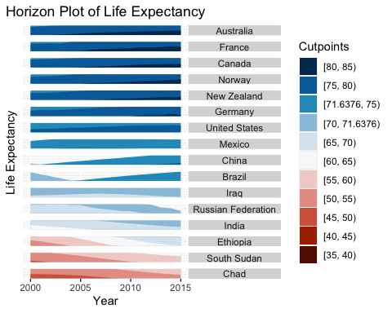

#Line plot is to use faceting with reordering countries by life expectancy  
  
#add a new column to merge continent with each country  
life=merge(continent,life)  
life %>%  
 filter(Country %in% subset_country) %>%  
 ggplot() +  
 #lines' color by different continent  
 geom_line(aes(Year,life_expectancy,color=Continent)) +  
 #facet by different country  
 facet_wrap(~ reorder(Country, -life_expectancy))+  
 labs(color="Continent")+  
 theme_minimal()+  
 ggtitle("Line Plot with Faceting") +  
 ylab("Life Expectancy")+  
 theme(plot.title = element_text(hjust = 0.5))

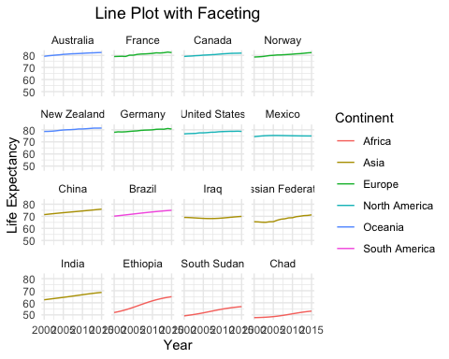

#Segment marks  
  
life %>%  
 filter(Country %in% subset_country) %>%  
 group_by(Country) %>%  
 #'Summarise' finds the minimum and maximum life expectancy restricted to each country  
 summarise(  
 min_life = min(life_expectancy),  
 max_life = max(life_expectancy)  
 )%>%  
 ggplot() +  
 #each bar isn't anchored at 0 due to 'segment' call  
 geom_segment(  
 #reorder the country(y axis) by maximum life expectancy  
 aes(min_life, reorder(Country, max_life), xend = max_life, yend = Country, col = Country),  
 size = 5,  
 ) +  
 labs(x = "Minimum and Maximum Life Expectancy", col = "Country", y = "Country") +  
 xlim(35, 85)+  
 #add country name on each of the segment  
 geom_text(  
 aes(x = min_life, y = reorder(Country, max_life), label = Country),  
 nudge_x = 0.08   
 )+  
 theme_minimal()

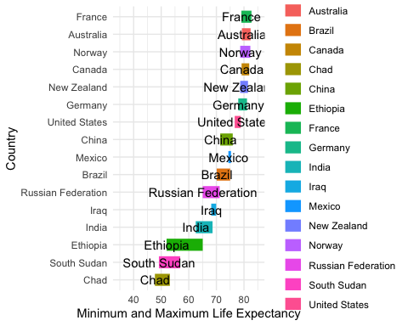

#heatmap with category  
life$category <-cut(life$life_expectancy,breaks=c(-Inf,60,75,Inf),labels=c("45-60","61-75","76-90"))  
life %>%  
 filter(Country %in% subset_country) %>%  
 ggplot() +  
 geom_tile(aes (Year, category, fill = life_expectancy))+  
 scale_x_continuous (expand = c(0, 0))+  
 scale_fill_distiller (direction = 1) +  
 facet_grid(Country ~ .)+  
 theme(strip.text.y = element_text (angle = 0))+  
 labs(y = "Category",fill='Life Expectancy')+  
 ggtitle("Heatmap with Category") +  
 theme(plot.title = element_text(hjust = 0.5))

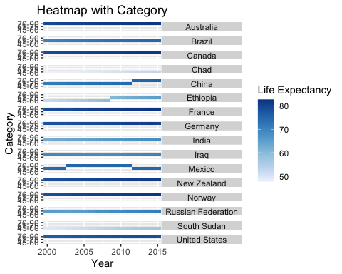

#a heatmap with each country on its own line  
  
life %>%  
 filter(Country %in% subset_country) %>%  
 ggplot() +  
 geom_tile(aes(Year, reorder(Country, life_expectancy), fill = life_expectancy, col = life_expectancy)) +  
 scale_fill_distiller(direction = 1) +  
 scale_x_continuous(expand = c(0, 0))+  
 #scale_x_yearquarter(expand = c(0, 0)) +  
 scale_y_discrete(expand = c(0, 0)) +  
 scale_color_distiller(direction = 1)+  
 labs(y = "Country")+  
 theme_minimal()+  
 ggtitle("Heatmap") +  
 theme(plot.title = element_text(hjust = 0.5))

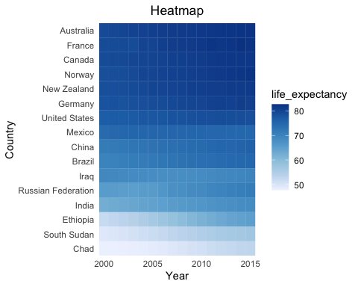

life %>%  
 filter(Country %in% subset_country)%>%  
 ggplot()+  
 geom_line(aes(x=Year, y=life_expectancy, color=Country))+  
 scale_y_continuous(expand = c(0, 0))+  
 scale_x_discrete(expand = c(0, 0)) +  
 theme(legend.position="bottom")+  
 labs(y = "Life Expectancy")+  
 theme_minimal()+  
 ggtitle("Line Plot") +  
 theme(plot.title = element_text(hjust = 0.5))

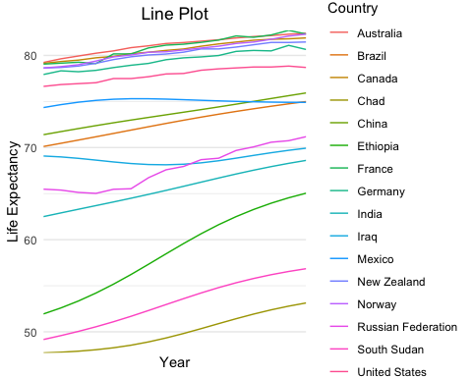

life %>%  
 filter(Country %in% subset_country)%>%  
 ggplot()+  
 geom_alluvium(aes(Year, life_expectancy, fill = Country, alluvium = Country), decreasing = FALSE, alpha = 0.9) +  
 theme(legend.position = "bottom")+  
 theme_minimal()+  
 labs(y = "Life Expectancy")+  
 ggtitle("Line Plot") +  
 theme(plot.title = element_text(hjust = 0.5))

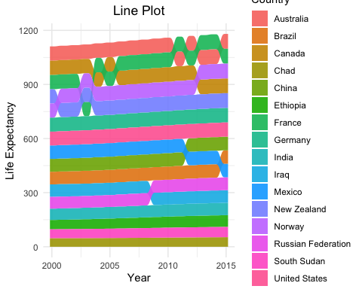

#the stacked area graph  
life=merge(continent,life)  
life %>%  
 filter(Country %in% subset_country) %>%  
 ggplot() +  
 geom_stream(aes(Year, life_expectancy, fill = Country), bw = 1) +  
 facet_wrap(~ Continent, scale = "free_y")+  
 labs(y = "Life Expectancy")+  
 theme_minimal()+  
 ggtitle("Stacked Area Graph") +  
 theme(plot.title = element_text(hjust = 0.5))

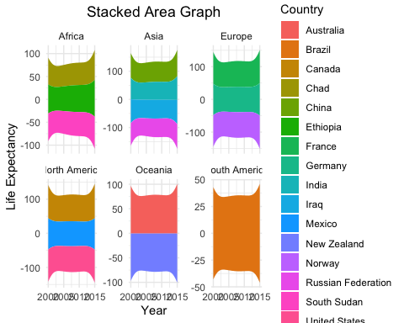

#the alluvial plot to explicitly rank the groups of continents  
life=merge(continent,life)  
life %>%  
 filter(Country %in% subset_country) %>%  
 ggplot() +  
 geom_alluvium(aes(Year, life_expectancy, fill = Country, alluvium = Country), decreasing = FALSE, alpha = 0.9) +  
 facet_wrap(~ Continent, scale = "free_y") +  
 scale_y_continuous(labels = label_number(scale_cut = cut_long_scale()))+  
 labs(y = "Life Expectancy")+  
 theme_minimal()+  
 ggtitle("Alluvial Plot") +  
 theme(plot.title = element_text(hjust = 0.5))

