Exercise 6: Unsupervised learning (word embedding)

Introduction
The hands-on exercise for this week focuses on word embedding and provides an overview of the data structures, and functions relevant for, estimating word vectors for word-embedding analyses.
In this tutorial, you will learn how to:
- Generate word vectors (embeddings) via SVD
- Train a local word embedding model in GloVe
- Visualize and inspect results
- Load and examine pre-trained embeddings
Note: Adapts from tutorials by Chris Bail here and Julia Silge here and Emil Hvitfeldt and Julia Silge here.

Setup
library(tidyverse) # loads dplyr, ggplot2, and others
library(stringr) # to handle text elements
library(tidytext) # includes set of functions useful for manipulating text
library(ggthemes) # to make your plots look nice
library(text2vec) # for word embedding implementation
## Warning: package 'text2vec' was built under R version 4.5.3
library(widyr) # for reshaping the text data
## Warning: package 'widyr' was built under R version 4.5.3
library(RSpectra) # for svd
library(umap) # for dimensionality reduction
## Warning: package 'umap' was built under R version 4.5.3
We begin by reading in the data. These data come from a sample of 1m tweets by elected UK MPs over the period 2017-2019. The data contain just the name of the MP-user, the text of the tweet, and the MP’s party. We then just add an ID variable called “postID.”
twts_sample <- readRDS("data/wordembed/twts_corpus_sample.rds")
#create tweet id
twts_sample$postID <- row.names(twts_sample)
If you’re working on this document from your own computer (“locally”) you can download the tweets sample data in the following way:
twts_sample <- readRDS(gzcon(url("https://github.com/cjbarrie/CTA-ED/blob/main/data/wordembed/twts_corpus_sample.rds?raw=true")))

Word vectors via SVD
We’re going to set about generating a set of word vectors with from our text data. Note that many word embedding applications will use pre-trained embeddings from a much larger corpus, or will generate local embeddings using neural net-based approaches.
Here, we’re instead going to generate a set of embeddings or word vectors by making a series of calculations based on the frequencies with which words appear in different contexts. We will then use a technique called the “Singular Value Decomposition” (SVD). This is a dimensionality reduction technique where the first axis of the resulting composition is designed to capture the most variance, the second the second-most etc…
How do we achieve this?

Implementation
The first thing we need to do is to get our data in the right format to calculate so-called “skip-gram probabilties.” If you go through the code line by the line in the below you will begin to understand what these are.
What’s going on?
Well, we’re first unnesting our tweet data as in previous exercises. But importantly, here, we’re not unnesting to individual tokens but to ngrams of length 6 or, in other words, for postID n with words k indexed by i, we take words i₁ …i₆, then we take words i₂ …i₇. Try just running the first two lines of the code below to see what this means in practice.
After this, we make a unique ID for the particular ngram we create for each postID, and then we make a unique skipgramID for each postID and ngram. And then we unnest the words of each ngram associated with each skipgramID.
You can see the resulting output below.
#create context window with length 6
tidy_skipgrams <- twts_sample %>%
unnest_tokens(ngram, tweet, token = "ngrams", n = 6) %>%
mutate(ngramID = row_number()) %>%
tidyr::unite(skipgramID, postID, ngramID) %>%
unnest_tokens(word, ngram)
head(tidy_skipgrams, n=20)
## # A tibble: 20 × 4
## username party_value skipgramID word
## <chr> <chr> <chr> <chr>
## 1 kirstysnp Scottish National Party 1_1 in
## 2 kirstysnp Scottish National Party 1_1 amongst
## 3 kirstysnp Scottish National Party 1_1 all
## 4 kirstysnp Scottish National Party 1_1 the
## 5 kirstysnp Scottish National Party 1_1 horror
## 6 kirstysnp Scottish National Party 1_1 at
## 7 kirstysnp Scottish National Party 1_2 amongst
## 8 kirstysnp Scottish National Party 1_2 all
## 9 kirstysnp Scottish National Party 1_2 the
## 10 kirstysnp Scottish National Party 1_2 horror
## 11 kirstysnp Scottish National Party 1_2 at
## 12 kirstysnp Scottish National Party 1_2 the
## 13 kirstysnp Scottish National Party 1_3 all
## 14 kirstysnp Scottish National Party 1_3 the
## 15 kirstysnp Scottish National Party 1_3 horror
## 16 kirstysnp Scottish National Party 1_3 at
## 17 kirstysnp Scottish National Party 1_3 the
## 18 kirstysnp Scottish National Party 1_3 notion
## 19 kirstysnp Scottish National Party 1_4 the
## 20 kirstysnp Scottish National Party 1_4 horror
What next?
Well we can now calculate a set of probabilities from our skipgrams. We do so with the pairwise_count() function from the widyr package. Essentially, this function is saying: for each skipgramID count the number of times a word appears with another word for that feature (where the feature is the skipgramID). We set diag to TRUE when we also want to count the number of times a word appears near itself.
The probability we are then calculating is the number of times a word appears with another word denominated by the total number of word pairings across the whole corpus.
#calculate probabilities
skipgram_probs <- tidy_skipgrams %>%
pairwise_count(word, skipgramID, diag = TRUE, sort = TRUE) %>% # diag = T means that we also count when the word appears twice within the window
mutate(p = n / sum(n))
head(skipgram_probs[1000:1020,], n=20)
## # A tibble: 20 × 4
## item1 item2 n p
## <chr> <chr> <dbl> <dbl>
## 1 no to 4100 0.0000531
## 2 vote for 4099 0.0000531
## 3 for vote 4099 0.0000531
## 4 see the 4078 0.0000528
## 5 the see 4078 0.0000528
## 6 having having 4076 0.0000528
## 7 by of 4065 0.0000527
## 8 of by 4065 0.0000527
## 9 this with 4051 0.0000525
## 10 with this 4051 0.0000525
## 11 set set 4050 0.0000525
## 12 right the 4045 0.0000524
## 13 the right 4045 0.0000524
## 14 what the 4044 0.0000524
## 15 going to 4044 0.0000524
## 16 the what 4044 0.0000524
## 17 to going 4044 0.0000524
## 18 evening evening 4035 0.0000523
## 19 get the 4032 0.0000522
## 20 the get 4032 0.0000522
So we see, for example, the words vote and for appear 4099 times together. Denominating that by the total n of word pairings (or sum(skipgram_probs$n)), gives us our probability p.
Okay, now we have our skipgram probabilities we need to get our “unigram probabilities” in order to normalize the skipgram probabilities before applying the singular value decomposition.
What is a “unigram probability”? Well, this is just a technical way of saying: count up all the appearances of a given word in our corpus then divide that by the total number of words in our corpus. And we can do this as such:
#calculate unigram probabilities (used to normalize skipgram probabilities later)
unigram_probs <- twts_sample %>%
unnest_tokens(word, tweet) %>%
count(word, sort = TRUE) %>%
mutate(p = n / sum(n))
Finally, it’s time to normalize our skipgram probabilities.
We take our skipgram probabilities, we filter out word pairings that appear twenty times or less. We rename our words “item1” and “item2,” we merge in the unigram probabilities for both words.
And then we calculate the joint probability as the skipgram probability divided by the unigram probability for the first word in the pairing divided by the unigram probability for the second word in the pairing. This is equivalent to: P(x,y)/P(x)P(y).
In essence, the interpretation of this value is: “do events (words) x and y occur together more often than we would expect if they were independent”?
Once we’ve recovered these normalized probabilities, we can have a look at the joint probabilities for a given item, i.e., word. Here, we look at the word “brexit” and look at those words with the highest value for “p_together.”
Higher values greater than 1 indicate that the words are more likely to appear close to each other; low values less than 1 indicate that they are unlikely to appear close to each other. This, in other words, gives an indication of the association of two words.
#normalize skipgram probabilities
normalized_prob <- skipgram_probs %>%
filter(n > 20) %>% #filter out skipgrams with n <=20
rename(word1 = item1, word2 = item2) %>%
left_join(unigram_probs %>%
select(word1 = word, p1 = p),
by = "word1") %>%
left_join(unigram_probs %>%
select(word2 = word, p2 = p),
by = "word2") %>%
mutate(p_together = p / p1 / p2)
normalized_prob %>%
filter(word1 == "brexit") %>%
arrange(-p_together)
## # A tibble: 1,016 × 7
## word1 word2 n p p1 p2 p_together
## <chr> <chr> <dbl> <dbl> <dbl> <dbl> <dbl>
## 1 brexit scotlandsplaceineurope 37 0.000000479 0.00278 0.00000186 92.6
## 2 brexit preparedness 22 0.000000285 0.00278 0.00000149 68.8
## 3 brexit dividend 176 0.00000228 0.00278 0.0000127 64.8
## 4 brexit brexit 38517 0.000499 0.00278 0.00278 64.6
## 5 brexit softer 50 0.000000648 0.00278 0.00000410 56.9
## 6 brexit botched 129 0.00000167 0.00278 0.0000153 39.4
## 7 brexit impasse 53 0.000000687 0.00278 0.00000820 30.2
## 8 brexit smooth 30 0.000000389 0.00278 0.00000596 23.5
## 9 brexit frustrate 28 0.000000363 0.00278 0.00000559 23.4
## 10 brexit deadlock 120 0.00000155 0.00278 0.0000246 22.8
## # ℹ 1,006 more rows
Using this normalized probabilities, we then calculate the PMI or “Pointwise Mutual Information” value, which is simply the log of the joint probability we calculated above.
Definition time: “PMI is logarithm of the probability of finding two words together, normalized for the probability of finding each of the words alone.”
We then cast our word pairs into a sparse matrix where values correspond to the PMI between two corresponding words.
pmi_matrix <- normalized_prob %>%
mutate(pmi = log10(p_together)) %>%
cast_sparse(word1, word2, pmi)
#remove missing data
pmi_matrix@x[is.na(pmi_matrix@x)] <- 0
#run SVD
pmi_svd <- svds(pmi_matrix, 256)
glimpse(pmi_matrix)
## Formal class 'dgCMatrix' [package "Matrix"] with 6 slots
## ..@ i : int [1:350700] 0 1 2 3 4 5 6 7 8 9 ...
## ..@ p : int [1:21173] 0 7819 14360 20175 25467 29910 34368 39207 43376 46401 ...
## ..@ Dim : int [1:2] 21172 21172
## ..@ Dimnames:List of 2
## .. ..$ : chr [1:21172] "the" "to" "and" "of" ...
## .. ..$ : chr [1:21172] "the" "to" "and" "of" ...
## ..@ x : num [1:350700] 0.65175 -0.01914 -0.00909 0.26939 -0.5246 ...
## ..@ factors : list()
Notice here that we are setting the vector size to equal 256. This just means that we have a vector length of 256 for any given word.
That is, the set of numbers used to represent a word has length limited to 256. This is arbitrary and can be changed. Typically, a size in the low hundreds is chosen when representing a word as a vector.
The word vectors are then taken as the “u” column, or the left-singular vectors, of the SVD.
#next we output the word vectors:
word_vectors <- pmi_svd$u
rownames(word_vectors) <- rownames(pmi_matrix)
dim(word_vectors)
## [1] 21172 256

Exploration
We can define a simple function below to then take our word vector, and find the most similar words, or nearest neighbours, for a given word:
nearest_words <- function(word_vectors, word){
selected_vector = word_vectors[word,]
mult = as.data.frame(word_vectors %*% selected_vector) #dot product of selected word vector and all word vectors
mult %>%
rownames_to_column() %>%
rename(word = rowname,
similarity = V1) %>%
anti_join(get_stopwords(language = "en")) %>%
arrange(-similarity)
}
boris_synonyms <- nearest_words(word_vectors, "boris")
## Joining with `by = join_by(word)`
brexit_synonyms <- nearest_words(word_vectors, "brexit")
## Joining with `by = join_by(word)`
head(boris_synonyms, n=10)
## word similarity
## 1 johnson 0.10309556
## 2 boris 0.09940448
## 3 jeremy 0.04823204
## 4 trust 0.04800155
## 5 corbyn 0.04102031
## 6 farage 0.03973588
## 7 trump 0.03938184
## 8 can.t 0.03533624
## 9 says 0.03324624
## 10 word 0.03267437
head(brexit_synonyms, n=10)
## word similarity
## 1 brexit 0.38737979
## 2 deal 0.15083433
## 3 botched 0.05003683
## 4 tory 0.04377030
## 5 unleash 0.04233445
## 6 impact 0.04139872
## 7 theresa 0.04017608
## 8 approach 0.03970233
## 9 handling 0.03901461
## 10 orderly 0.03897535
#then we can visualize
brexit_synonyms %>%
mutate(selected = "brexit") %>%
bind_rows(boris_synonyms %>%
mutate(selected = "boris")) %>%
group_by(selected) %>%
top_n(15, similarity) %>%
mutate(token = reorder(word, similarity)) %>%
filter(token!=selected) %>%
ggplot(aes(token, similarity, fill = selected)) +
geom_col(show.legend = FALSE) +
facet_wrap(~selected, scales = "free") +
scale_fill_manual(values = c("#336B87", "#2A3132")) +
coord_flip() +
theme_tufte(base_family = "Helvetica")
## Warning in grid.Call(C_stringMetric, as.graphicsAnnot(x$label)): font family
## not found in Windows font database
## Warning in grid.Call(C_stringMetric, as.graphicsAnnot(x$label)): font family
## not found in Windows font database
## Warning in grid.Call.graphics(C_text, as.graphicsAnnot(x$label), x$x, x$y, :
## font family not found in Windows font database
## Warning in grid.Call.graphics(C_text, as.graphicsAnnot(x$label), x$x, x$y, :
## font family not found in Windows font database
## Warning in grid.Call.graphics(C_text, as.graphicsAnnot(x$label), x$x, x$y, :
## font family not found in Windows font database
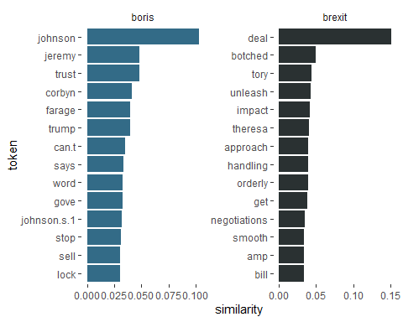

GloVe Embeddings
This section adapts from tutorials by Pedro Rodriguez here and Dmitriy Selivanov here and Wouter van Gils here.

GloVe algorithm
This section is taken from text2vec package page here.
The GloVe algorithm by pennington_glove_2014 consists of the following steps:
- Collect word co-occurence statistics in a form of word co-ocurrence matrix $X$. Each element $X_{ij}$ of such matrix represents how often word i appears in context of word j. Usually we scan our corpus in the following manner: for each term we look for context terms within some area defined by a window_size before the term and a window_size after the term. Also we give less weight for more distant words, usually using this formula:
$$decay=1/offset$$
- Define soft constraints for each word pair:
$$w_{i}^{T}w_{j}+b_{i}+b_{j}=log\left(X_{ij}\right)$$
- Here $w_{i}$ - vector for the main word, $w_{j}$ - vector for the context word, $b_{i}$, $b_{j}$ are scalar biases for the main and context words.
- Define a cost function
$$J=\sum_{i=1}^{V}{\sum_{j=1}^{V}{ }}f\left(X_{ij}\right){\left(w_{i}^{T}w_{j}+b_{i}+b_{j}-logX_{ij}\right)}^{2}$$
- Here $f$ is a weighting function which help us to prevent learning only from extremely common word pairs. The GloVe authors choose the following function:
$$f\left(X_{ij}\right)=\left\{\begin{matrix}{\left(\frac{X_{ij}}{x_{max}}\right)}^{α} & \text{if }X_{ij}<XMAX \\ 1 & \text{otherwise}\end{matrix}\right.$$
How do we go about implementing this algorithm in R?
Let’s first make sure we have loaded the packages we need:
library(text2vec) # for implementation of GloVe algorithm
library(stringr) # to handle text strings
library(umap) # for dimensionality reduction later on
library(RcppParallel) # for parallel processing

Implementation
We then need to set some of the choice parameters of the GloVe model. The first is the window size WINDOW_SIZE, which, as above, is arbitrary but normally set around 6-8. This means we are looking for word context of words up to 6 words around the target word. The image below illustrates this choice parameter for the word “cat” in a given sentence, with increase context window size:
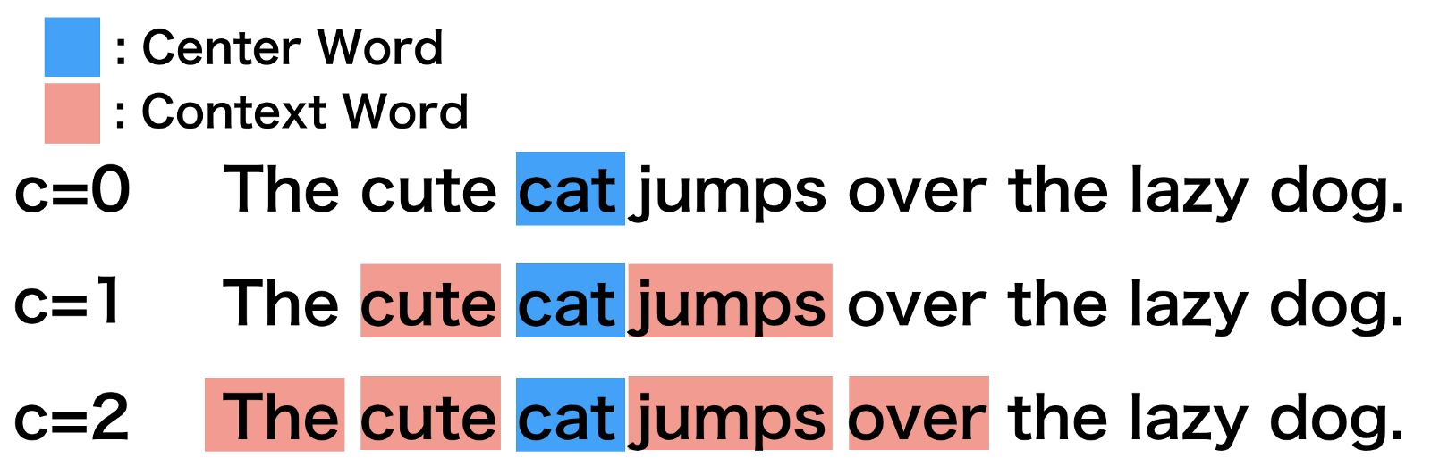
Context window
And this will ultimately be understood in matrix format as:
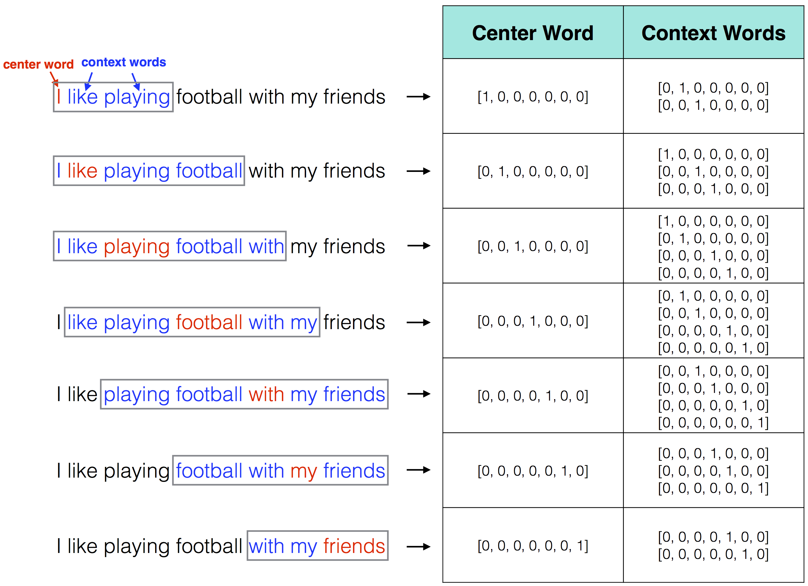
Context window
The iterations parameter ITERS simply sets the maximum number of iterations to allow for model convergence. This number of iterations is relatively high and the model will likely converge before 100 iterations.
The DIM parameter specifies the length of the word vector we want to result (i.e., just as we set a limit of 256 for the SVD approach above). Finally, COUNT_MIN is specifying the minimum count of words that we want to keep. In other words, if a word appears fewer than ten times, it is discarded. Again, this is the same as above where we discarded word pairings that appeared fewer than twenty times.
# ================================ choice parameters
# ================================
WINDOW_SIZE <- 6
DIM <- 300
ITERS <- 100
COUNT_MIN <- 10
We next “shuffle” our text. This just means we are randomly reordering the character vector of tweets.
# shuffle text
set.seed(42L)
text <- sample(twts_sample$tweet)
We then create a list object, tokenizing the text of each tweet within each item of the list. After this, we create the vocabulary object needed to implement the GloVe algorithm. We do this by creating an “itoken” object with itoken() and then creating a vocabulary with create_vocabulary. We then remove words that do not exceed our specified threshold above with prune_vocabulary().
# ================================ create vocab ================================
tokens <- space_tokenizer(text)
it <- itoken(tokens, progressbar = FALSE)
vocab <- create_vocabulary(it)
vocab_pruned <- prune_vocabulary(vocab, term_count_min = COUNT_MIN) # keep only words that meet count threshold
Next up we vectorize our vocabulary and create our term co-occurrence matrix. Again, this is similar to the above where we created a matrix of PMIs for each of the word pairings in our corpus.
# ================================ create term co-occurrence matrix
# ================================
vectorizer <- vocab_vectorizer(vocab_pruned)
tcm <- create_tcm(it, vectorizer, skip_grams_window = WINDOW_SIZE, skip_grams_window_context = "symmetric",
weights = rep(1, WINDOW_SIZE))
Then we set our final model parameters, learning rate and fit the model. This whole process will take some time. To save time when working through this tutorial, you may also download the resulting embedding from the Github repo linked a little further below.
# ================================ set model parameters
# ================================
glove <- GlobalVectors$new(rank = DIM, x_max = 100, learning_rate = 0.05)
# ================================ fit model ================================
word_vectors_main <- glove$fit_transform(tcm, n_iter = ITERS, convergence_tol = 0.001,
n_threads = RcppParallel::defaultNumThreads())
Finally, we get the resulting word embedding and save it as a .rds file.
# ================================ get output ================================
word_vectors_context <- glove$components
glove_embedding <- word_vectors_main + t(word_vectors_context) # word vectors
# ================================ save ================================
saveRDS(glove_embedding, file = "local_glove.rds")
To save time when working through this tutorial, you may also download the resulting embedding from the Github repo with:
url <- "https://github.com/cjbarrie/CTA-ED/blob/main/data/wordembed/local_glove.rds?raw=true"
glove_embedding <- readRDS(url(url, method="libcurl"))

Visualization
How do we explore these embeddings? Well, imagine that our embeddings will look something not dissimilar to this visualization of another embedding here. In other words, we are talking about something that doesn’t lend itself to projection in 2D space!
But…
All hope is not lost, space travellers. A smart technique by @mcinnes_umap_2020 linked here describes a way to reduce the dimensionality of such embedding layers using what is called “Uniform Manifold Approximation and Projection.” How do we do this? Well, happily, with the umap package it is pretty straightforward!
# GloVe dimension reduction
glove_umap <- umap(glove_embedding, n_components = 2, metric = "cosine", n_neighbors = 25, min_dist = 0.1, spread=2)
Why is this helpful? Well, for a number of reasons, but it is particularly helpful here for visualizing our embeddings in two-dimensional space.
# Put results in a dataframe for ggplot
df_glove_umap <- as.data.frame(glove_umap[["layout"]])
# Add the labels of the words to the dataframe
df_glove_umap$word <- rownames(df_glove_umap)
colnames(df_glove_umap) <- c("UMAP1", "UMAP2", "word")
# Plot the UMAP dimensions
ggplot(df_glove_umap) +
geom_point(aes(x = UMAP1, y = UMAP2), colour = 'blue', size = 0.05) +
ggplot2::annotate("rect", xmin = -3, xmax = -2, ymin = 5, ymax = 7,alpha = .2) +
labs(title = "GloVe word embedding in 2D using UMAP")
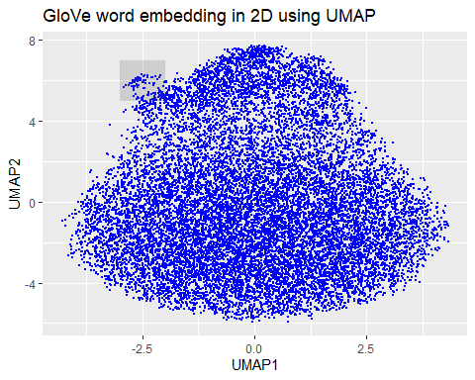
# Plot the shaded part of the GloVe word embedding with labels
ggplot(df_glove_umap[df_glove_umap$UMAP1 < -2.5 & df_glove_umap$UMAP1 > -3 & df_glove_umap$UMAP2 > 5 & df_glove_umap$UMAP2 < 6.5,]) +
geom_point(aes(x = UMAP1, y = UMAP2), colour = 'blue', size = 2) +
geom_text(aes(UMAP1, UMAP2, label = word), size = 2.5, vjust=-1, hjust=0) +
labs(title = "GloVe word embedding in 2D using UMAP - partial view") +
theme(plot.title = element_text(hjust = .5, size = 14))
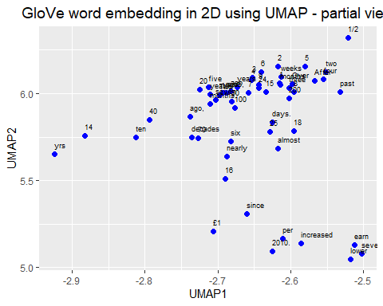
# Plot the word embedding of words that are related for the GloVe model
word <- glove_embedding["economy",, drop = FALSE]
cos_sim = sim2(x = glove_embedding, y = word, method = "cosine", norm = "l2")
select <- data.frame(rownames(as.data.frame(head(sort(cos_sim[,1], decreasing = TRUE), 25))))
colnames(select) <- "word"
selected_words <- df_glove_umap %>%
inner_join(y=select, by= "word")
#The ggplot visual for GloVe
ggplot(selected_words, aes(x = UMAP1, y = UMAP2)) +
geom_point(show.legend = FALSE) +
geom_text(aes(UMAP1, UMAP2, label = word), show.legend = FALSE, size = 2.5, vjust=-1.5, hjust=0) +
labs(title = "GloVe word embedding of words related to 'economy'") +
theme(plot.title = element_text(hjust = .5, size = 14))
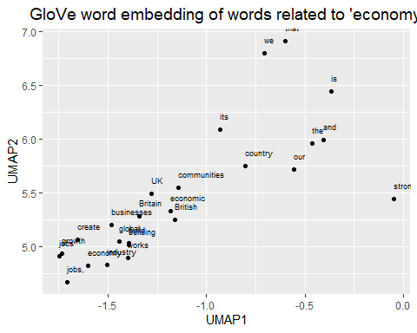
We can see, here, then that our embeddings seem to make sense. We zoomed in first on that little outgrowth of our 2D mapping, which seemed to correspond to numbers and number words. Then we looked at words around “economy” and we see other related terms like “growth” and “jobs.”

Exercises
- Inspect and visualize the nearest neighbour synonyms of other relevant words in the tweets corpus
female_synonyms <- nearest_words(word_vectors, "female")
## Joining with `by = join_by(word)`
male_synonyms <- nearest_words(word_vectors, "male")
## Joining with `by = join_by(word)`
head(female_synonyms, n=10)
## word similarity
## 1 first 0.06927018
## 2 female 0.06441228
## 3 rate 0.04863032
## 4 employment 0.04772731
## 5 mps 0.03819039
## 6 record 0.03798679
## 7 mp 0.03519267
## 8 sikh 0.03408724
## 9 minister 0.03196007
## 10 ever 0.02547385
head(male_synonyms, n=10)
## word similarity
## 1 violence 0.028962514
## 2 sexual 0.016269552
## 3 abuse 0.014881383
## 4 domestic 0.014550979
## 5 harassment 0.012397670
## 6 survivors 0.011556372
## 7 victims 0.011110875
## 8 fleeing 0.009745282
## 9 elimination 0.009306707
## 10 youth 0.009256478
#then we can visualize
male_synonyms %>%
mutate(selected = "male") %>%
bind_rows(female_synonyms %>%
mutate(selected = "female")) %>%
group_by(selected) %>%
top_n(15, similarity) %>%
mutate(token = reorder(word, similarity)) %>%
filter(token!=selected) %>%
ggplot(aes(token, similarity, fill = selected)) +
geom_col(show.legend = FALSE) +
facet_wrap(~selected, scales = "free") +
scale_fill_manual(values = c("purple4", "#2A3132")) +
coord_flip() +
theme_tufte(base_family = "Helvetica")
## Warning in grid.Call(C_textBounds, as.graphicsAnnot(x$label), x$x, x$y, : font
## family not found in Windows font database
## Warning in grid.Call(C_textBounds, as.graphicsAnnot(x$label), x$x, x$y, : font
## family not found in Windows font database
## Warning in grid.Call.graphics(C_text, as.graphicsAnnot(x$label), x$x, x$y, :
## font family not found in Windows font database
## Warning in grid.Call.graphics(C_text, as.graphicsAnnot(x$label), x$x, x$y, :
## font family not found in Windows font database
## Warning in grid.Call.graphics(C_text, as.graphicsAnnot(x$label), x$x, x$y, :
## font family not found in Windows font database
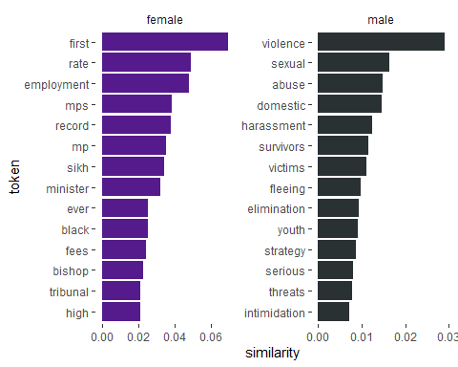
The plots show an evident difference between the words most associated with “female” and those associated with “male”. The words appearing with female do not indicate a specific single topic, while the words appearing with male tend to have close relations to violence and delinquent behavior.
- Identify another region of interest in the GloVe-trained model and visualize
ggplot(df_glove_umap[df_glove_umap$UMAP1 < -1 & df_glove_umap$UMAP1 > -1.5 & df_glove_umap$UMAP2 > 6 & df_glove_umap$UMAP2 < 7.5,]) +
geom_point(aes(x = UMAP1, y = UMAP2), colour = 'blue', size = 2) +
geom_text(aes(UMAP1, UMAP2, label = word), size = 2.5, vjust=-1, hjust=0) +
labs(title = "GloVe word embedding in 2D using UMAP - partial view") +
theme(plot.title = element_text(hjust = .5, size = 14))
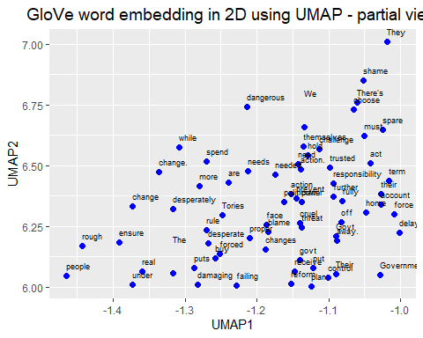
This region in the GloVe-trained model tends to be connected with the governments’ action towards certain issues, as the words “change”, “reform” and “action” have the tendency to cluster together.

