Keynote Speaker 1

Application of motor in electric vehicle

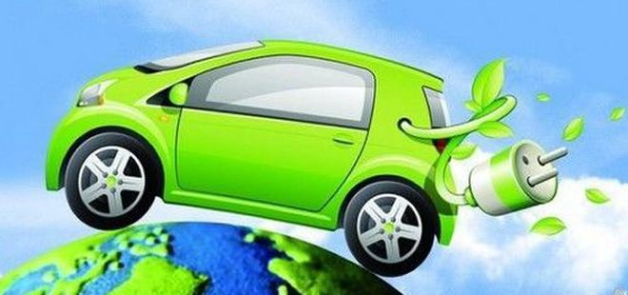

1. **Introduction of the Keynote Speaker:**

**Professor Wu for Southeast University**

|  |  |
| --- | --- |
| Fields | *Design and analysis of new energy power generation system;  *Motor system design and drive control of pure electric / hybrid vehicles. |
| Educational background | *BS degree in Harbin Institute of Technology;  *PhD in Hanyang University; |
| Achievements | *Published over 80 academic papers;  *Participated in well-known international academic conferences and made academic reports;  * Undertook many major scientific research projects |

Good afternoon, ladies and gentlemen. Today , it’s my great honor to stand here and deliver my keynote speech. My topic is Application of motors in elecric vehicle: Current status, challenges and prospects

My speech consists of 3 parts:

First, I will introduce two kinds of motors currently used in electric vehicle

Second, I will talk about the challenges for new electric vehicle motor.

Third, I want to look forward to the future development of electric vehicles motor.

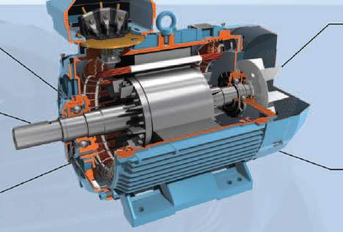

**2、Current status**

Nowadays, there are mainly two kinds of drive motor for electric vehicle in the market, one is asynchronous motor(AM), the other is permanent magnet synchronous motor(PMSM).

The stator and rotor of synchronous motor rotate at the same speed . However, for asynchronous motor, there is speed difference between stator and rotor. So, there are great differences between the two motors in structure and performance.

This table shows the differences between the two motors. As you can see,

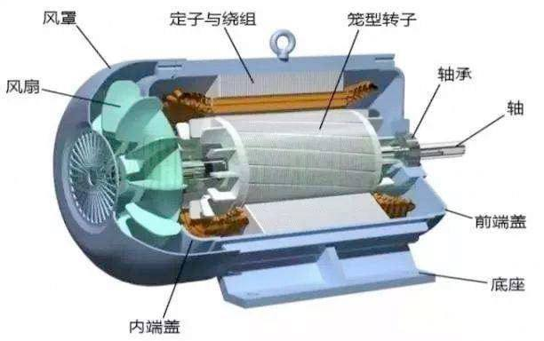

Asynchronous motor

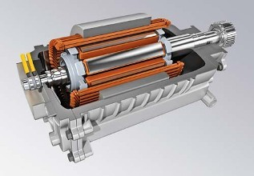

Permanent magnet synchronous motor

Comparison between AM and PMSM

|  |  |  |
| --- | --- | --- |
| Type | AM | PMSM |
| Advantages | *Low manufacturing cost  *High reliability  *Simple structure | *Light weight,  *Small volume,  *High efficiency  *Reliable operation |
| Disadvantages | *Low efficiency at low speed  *Difficult to control under complex working conditions. | *Complex structure  *High cost |

In the market, automobile manufacturers choose motors according to their product positioning.

For example, Tesla chooses AM, mainly focusing on its characteristics of high efficiency under high-speed working condition, which fits Tesla's high-end, high-speed and high endurance product positioning.

But, BYD chooses PMSM, mainly focusing on its reliable operation, good speed regulation and high power density, which in line with its brand positioning suitable for mass consumption.

**3、Challenges**

As the core part of electric vehicles, the motor and its drive system should not only meet the need of the performance of the basic electric drive, but also meet the need of a series of inherent requirements of electric vehicle itself.

Therefore, motors are facing the following challenges:

1. Motors should have good electromagnetic compatibility, moisture resistance, high temperature resistance so that it can adapt to harsh environment.
2. Motors are required to meet the requirements of quick start, braking, climbing, acceleration, frequent start and stop.
3. Motors need reduce the torque noise in the state of high frequency switch so that it can reduce the noise pollution to the surrounding environment.
4. Optimize the design of motors, reduce the loss, ensure the reasonable cost, and facilitate the maintenance and repair in the future.

**4、Prospect**

The motor industry is developing at full speed.

In order to meet the needs of electric vehicles, the development direction of motors is: smaller volume, higher efficiency, high reliability, lower cost and simpler structure.

I have strong faith that the development of electric vehicle motors will continue to move forward rapidly and form a complete industrial chain.