Keynote speaker

Application of motor in new energy industry

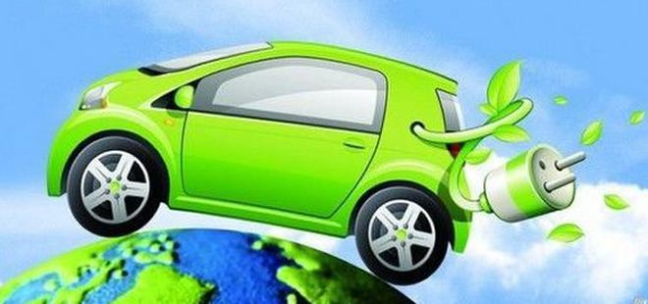

**1、Introduction of the Keynote Speaker: Professor Wu Xie**

|  |  |
| --- | --- |
| Fields | *Design and analysis of new energy power generation system;  *Motor system design and drive control of pure electric / hybrid vehicles. |
| Educational background | *BS degree in Harbin Institute of Technology;  *PhD in Hanyang University; |
| Achievements | *Published over 80 academic papers;  *Participated in well-known international academic conferences and made academic reports;  * Undertook many major scientific research projects |

**2、Background**

With the global energy shortage and the increasing environmental pollution, Traditional fuel vehicles need to be eliminated.

In the global scope, the development of new energy vehicles has formed a consensus, the transformation of traditional fuel vehicles to new energy vehicles is imperative.

Electric vehicle consists of battery, electric control and motor. I will introduce the motor in electric vehicle here.

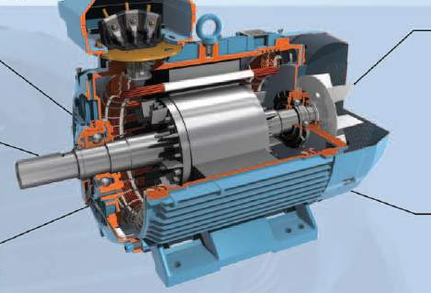

**3、Current status**

At present, there are two main types of drive motor systems for electric vehicles in the market, one is asynchronous motor(AM), the other is permanent magnet synchronous motor(PMSM).

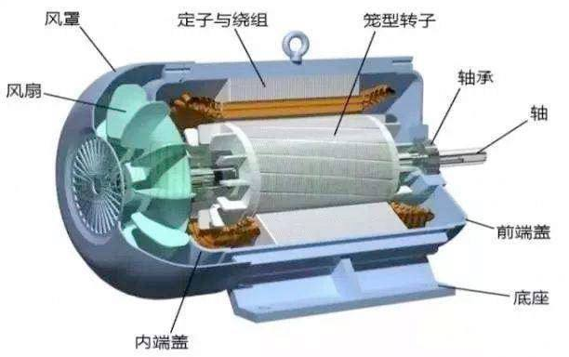

Asynchronous motor

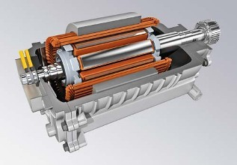

Permanent magnet synchronous motor

Comparison between AM and PMSM

|  |  |  |
| --- | --- | --- |
| Type | AM | PMSM |
| Advantages | *Low manufacturing cost  *High reliability  *Simple structure | *Light weight,  *Small volume,  *High efficiency  *Reliable operation |
| Disadvantages | *Lower efficiency at low speed  *It is difficult to control under complex working conditions. | *Complex structure  *High cost |

**4、Examples**

Nowadays, all major vehicle enterprises in the world are actively distributing new energy market, comprehensively promoting new energy strategic process and accelerating the implementation of industry.

For example,

**BMW** started the second stage layout of electrification;

**Audi** launched the strategy of "Audi. Vorsprung. 2025.";

**Mercedes Benz** launched case strategy- new energy planning;

**Toyota** launched Challenge planning for R & D and popularization of electric vehicles;

**Volkswagen** launched the Roadmap E electrification strategy;

**Ford** company launched China's electrification strategy.

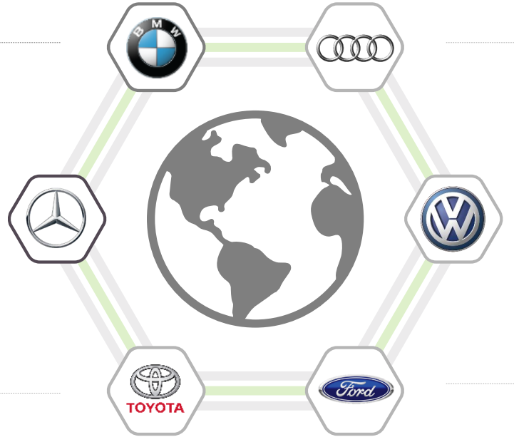

**5、Challenges**

As the core part of the electric vehicle, the motor and its drive system should not only meet the need of the performance of the basic electric drive, but also meet the need of a series of inherent requirements of the electric vehicle itself.

Therefore, electric motors for electric vehicles are facing the following challenges:

1. The motor has good electromagnetic compatibility, moisture resistance, high temperature resistance, high reliability, and can adapt to harsh environment.
2. The motor is required to meet the requirements of quick start, braking, climbing, acceleration, frequent start and stop below the base speed.
3. It is required that the motor can reduce the torque noise of motor pulsation and motor control in the state of high frequency switch so that it can reduce the noise pollution to the surrounding environment.
4. Optimize the design of the motor, reduce the loss, ensure the reasonable cost, and facilitate the maintenance and repair in the future.

**6、Prospect**

We should have faith in the fact that the development of new energy industry will continue to move forward rapidly and form a relatively complete industrial chain. We should also believe that the application prospect of motor in electric vehicles is bright. In order to meet the needs of the development of new energy industry, the development direction of motor for electric vehicles should be: smaller volume, higher efficiency, high reliability, lower cost, simpler structure.