CSE 5524 HW5

**Problem 1**

T = 1, all the pair-wise differences are black.

T = 0.5, all the pair-wise differences are black.

T = 0.25, we could start to see the motion

T = 0.125, we could see more white area

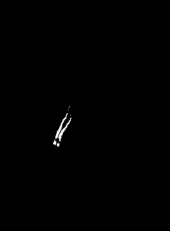

T = graythresh

Discussion: After median filter the image, the above images are among 21 difference images for each threshold value. As we decrease the threshold value, we could see more motion area. The final threshold value I chose is computed from graythresh.

**Problem 2**

MEI MHI

Nvals for MEI after normalization

0.4118 0.0862 0.1297 0.0717 0.1291 0.0270 0.0114

Nvals for MHI after normalization

0.4684 0.2973 0.0863 0.1287 0.1600 0.0292 0.0205

Observations: The result seems to be plausible since as the earlier movements’ color is lighter than the latter movements’ color.

**Problem 3**

Here is the two created images:

Here is the vector field of the motion on the first image

Observations: The result is what I expected since we are moving the box 1 pixel right and 1 pixel down. Then vector field shows the exact right direction. The flows on the up and bottom side are pointing downward and flows on the left and right side are pointing right. The flow on the upper left and bottom right corners are pointing 45 degree to the bottom right. The flow on the upper right and bottom left are pointing right and down respectively.