Action for Change

Bethany Smith, Henry Tan, Xuechun Wang

Neighborhood Rescue of America Week 3: Fundraising

Proposal – Grant

**Funder**: The Morris & Gwendolyn Cafritz Foundation

<http://www.cafritzfoundation.org/apply>

**Summary**: The Morris & Gwendolyn Cafritz Foundation seeks to provide grants geared toward “improving the quality of life for residents of the Washington, DC area.” The Foundation was established in 1948 and has awarded $194 million to almost 1000 organizations in the last decade.

**Project Areas**: They have three focus areas:

* Arts and Humanities
  + Includes any kind of art form.
  + Gives specific attention to how “access to the Arts and Humanities for diverse populations is created and how unique opportunities are provided for all ages to engage.”
* Education
  + Covers education initiatives at all levels, from early childhood to graduate school, including literacy and GED prep programs.
  + Looks for initiatives to improve students’ academic success.
* Community Services
  + Community development – focused on affordable housing, reducing homelessness and increasing housing stability.
  + Children, Youth and Families – focus on improving academic performance of youth, skill development and employment opportunities for older youth, developing trusting adult-child relationships and connecting with community.
  + Justice – focus on increasing access to justice for low-income individuals, assistance to victims of violence and recidivism reduction for formerly incarcerated individuals.
* Health and Wellness
  + Supports community-based nonprofit health centers, programs to increase access to health foods and resources for improving health behaviors.
* Environment
  + Focus on improving the environment and public awareness of environmental impacts.

The Foundation’s overarching goal is improvement of the lives of individuals living in the DC area. While there is some language that indicates they mostly offer grants to DC-area service organizations, they have also awarded grants to some advocacy (e.g. Coalition for Smarter Growth) and community investment (e.g. Greater Washington Community Foundation) organizations.

I believe Neighborhood Rescue’s unique community turnaround program could appeal to them. They have a “particular emphasis on vulnerable and underserved individuals” They are also looking for organizations that “work towards systemic change, which addresses all levels of, and all who are affected by, the issue” and “employ effective partnering and show cultural competence in engaging effectively with communities and people of various cultures and socio-economic backgrounds.” These emphases are very much in line with NRA’s work and a persuasive grant proposal emphasizing these components could be effective.

Of the focus areas listed above, I think that Community Services is the best fit for NRA’s broad-reaching efforts. NRA has a particular interest in improving outcomes for children (Children, Youth and Families) and also in reducing crime (Justice).

**Application Procedures:**

* Determine Eligibility – Organization must:
  + Be an IRS-registered, tax-exempt, 501(c)(3) organization with a non-private foundation status of 509(a)(1) or 509(a)(2).
  + Serve residents of the District of Columbia, Prince George’s or Montgomery Counties in Maryland, or Arlington or Fairfax Counties or the cities of Falls Church or Alexandria in Virginia.
  + Be requesting grant money for general operating or program support rather than special events (e.g., dinner tables, galas), endowments or an individual.
  + Fall under one or more of our program area Funding Priorities including: Arts and Humanities, Community Services, Education and Health & Environment.
  + Have not applied for a grant with this organization in the last 12 months.
  + Not have the current grant being applied for overlap with a previous one.
* Submit an application (see Appendix for application template)
  + Deadlines:
    - March 1
    - July 1
    - November 1
  + Applications must be submitted through online application system
  + During the review process, Foundation staff will occasionally need to meet with prospective applicants. The review and funding process generally takes 4-6 months.
  + Upon approval, grantees submit interim and final reports through the online system.

**Funding Amount:** Various amounts. Of the 52 Community Development grants they listed on their website, the lowest grant amount was $20,000 and the highest was $220,000. The average was $45,865, while the median and mode were both $35,000.

Appendix I: Application Organization and Project Narrative

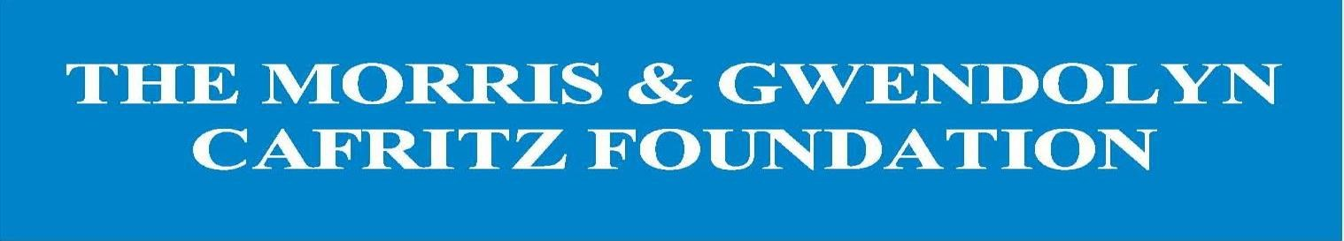

*The narrative section of the application will generally run 8-10*

*pages in length, double-spaced with 12-point font and 1-inch margins.*

*This does* ***not*** *include the required attachments.*

***Note****: The online application has individual text boxes that coincide with the numbered questions below.*

**Organization Narrative**

1. Describe your organization’s history and mission. Include significant milestones and key accomplishments.

1. Describe your organization’s current activities, projects or programs.

1. Describe the results achieved during the past twelve months.

1. Describe the results you are committed to achieving during the grant period and how you will demonstrate your success. Share qualitative and/or quantitative information.

1. Describe the results you are hoping to achieve over the next three years.

1. Describe your organization’s most significant collaborations and partnerships with other organizations in the same field and geographic area.

1. What makes your organization different from other groups doing similar work?

1. Explain how the population you serve is involved in the work of the organization, and/or how client feedback is collected and incorporated.

1. Briefly describe the Board of Director’s role in relation to leadership and staff, including how members are recruited and selected and how they carry out their responsibility for financial and programmatic oversight and fundraising. Indicate the percentage of directors who make monetary contributions.

1. Describe any significant staff or Board changes that have occurred within the past twelve months or are expected to take place in the coming year.



If this application is for general operating support, do **not** submit a project narrative.

*The project narrative is part of the approximately 8-10 page total.*

*Note: Project Requests do* ***not*** *include Capital Requests. If you have a capital project, please contact the Foundation for advice.*

**Project Narrative**

1. What problem/need does this project address?

1. What is your organization’s proposed solution to this problem/need, and how will it be implemented?

1. What evidence will prove the success of this project?

1. What results are you committed to achieving during the grant period?

1. Is this a new project? If so, how was the approach developed and why? If not, what has been accomplished so far?

1. If this project extends beyond the grant period, what is the timeline for the entire project?

1. Are there partners that are working with you on this project? If so, who are they, why did your organization choose to work with them and what are their roles? What is your organization’s unique contribution?

Appendix II: Financial Reports

Financial Attachments Instructions

Submit attachments as PDF files. For instructions on how to convert Word documents or Excel speadsheets to PDF files, click here.

FOR ALL REQUESTS: Please include the following information, regardless of the dollar amount of the grant request. Use footnotes to explain in greater detail anticipated surpluses and deficits, unusual revenue or expense items, and major variations from previous years.

For the previous fiscal year:

* Organizational budget versus actuals, including revenue and expenses

For the current fiscal year:

* Organizational budget versus actuals, including revenue and expenses
* Organizational year-to-date Statement of Financial Position (Balance Sheet)
* Organizational year-to-date Statement of Activities (Income Statement)

For the next fiscal year, if available:

* Organizational projected or proposed budget, including revenues and expenses (A draft is acceptable, but please indicate if it has not yet been approved by the Board of Directors.)

Funding Sources:

* List specific amounts requested from foundations, corporations, governments and other funding sources, as well as the status of those requests (received, pending or committed)
* For pending requests, please indicate the expected notification date, if available

RECOMMENDED BUDGET EXPENSE CATEGORIES: The categories listed below are suggestions for developing a budget. Include the total amount for each category. Not all categories may be applicable to your organization or request.

1. Salaries (total salary budget, number of positions, and note whether full- or part-time)

2. Payroll Taxes

3. Fringe Benefits

4. Consultants and Professional Fees [please itemize type(s) of consultant(s) and fees]

5. Travel

6. Equipment

7. Supplies

8. Printing and Copying

9. Telephone and Fax

10. Postage and Delivery

11. Rent and Utilities

12. Maintenance

13. Technology (this can include hardware/software capital spending, maintenance, and/or training)

14. Evaluation

15. In-kind expenses

16. Reserves

17. Other (specify)

18. Total Expenses

RECOMMENDED BUDGET REVENUE CATEGORIES: The categories listed below are suggestions for developing a budget. Include the total amount for each category. Not all categories may be applicable to your organization or request.

1. Federal/State/Local Government [specify what agency, department or source(s)]

2. Foundations (identify each by name)

3. Corporations (list each by name)

4. United Way/Combined Federal Campaign and/or other workplace giving

5. Individual Donors

6. Earned Revenue (delineate whether events, product or publication sales, program fees or other)

7. Membership Fees

8. In-Kind Support (donated goods, services, equipment, non-cash items or volunteer hours)

9. Other (specify)

10. Total Revenue

FOR PROJECT REQUESTS, PLEASE ALSO INCLUDE THE FOLLOWING: This section is for local organizations requesting funds for specific activities or national organizations seeking general or project support for work conducted in, and benefitting residents of, the Washington, DC, metropolitan area (Note to national organizations: please frame the funding request as project support for the local efforts.):

For the previous fiscal year, or 12-month project period:

* Project budget versus actuals, including revenue and expenses

For the current fiscal year, or 12-month project period:

* Project budget versus actuals, including revenue and expenses

For the next fiscal year, or 12-month project period, if available:

* Project projected or proposed budget, including revenues and expenses (A draft is acceptable, but please indicate if it has not yet been approved by the Board of Directors.)

Project Funding Sources:

* List specific amounts requested from foundations, corporations, governments and other funding sources, as well as the status of those requests (received, pending or committed)
* For pending requests, please indicate the expected notification date, if available

NOTE: For developing a project budget, see the recommended budget categories and instructions above.

Appendix III: Attachments Checklist

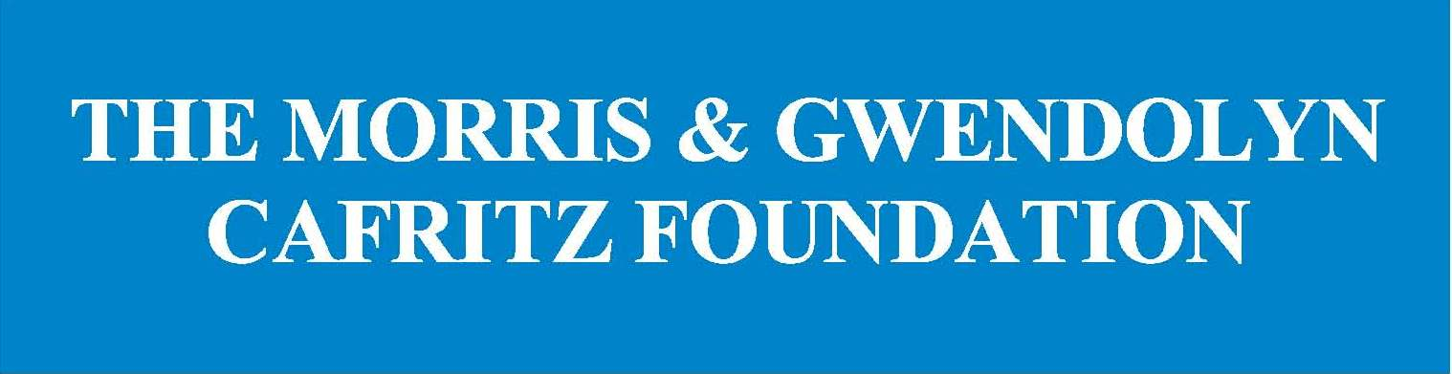

**Checklist for Attachments**

*We require all attachments as* ***PDF documents*** *to ensure proper*

*formatting and readability during our review process.*

*For instructions on how to convert Word documents*

*or Excel spreadsheets to PDF files,* [*click here*](https://acrobat.adobe.com/us/en/acrobat/how-to/word-excel-ppt-to-pdf-converter.html)*.*

Previous Fiscal Year Organization Budget: Organizational budget versus actuals,

including revenue and expenses

Previous Fiscal Year Statement of Financial Position (Balance Sheet)

Current Fiscal Year Organization Budget: Organizational budget versus actuals,

including revenue and expenses

Year-To-Date Statement of Financial Position (Balance Sheet)

Year-To-Date Statement of Activities (Income Statement)

Next Fiscal Year Organization Budget: Organizational projected or proposed

budget, including revenues and expenses, if available (A draft is acceptable, but

please note if it has not yet been approved by the Board of Directors.)

Current Fiscal Year Organization Funding Sources: All Organization Funding Sources

for this funding request (foundations, corporations, governments, etc.), including

Amount, Source and Status (received, pending or committed)

Audit: If your organization has an audit, provide the most recent copy

990: Provide a copy of your most recent Form 990

Organizational Chart

Staff Biographies: Short biographies of staff and volunteers essential to the success of

this request

Board List: List of Board Members, Terms and Affiliations

Memoranda of Understanding (MOU): An example of a current MOU or Memoranda

of Agreement with other organizations for each distinct collaborative or cooperative

set of activities, if applicable

Additional Support Documents: Any additional documents not already listed,

including budget narratives, recent letters of support from partner organizations or

other materials, as appropriate

**If you are requesting project support, please include the following additional documents:**

Previous Fiscal Year or 12-Month Project Period Project Budget: Project budget versus

actuals, including revenue and expenses

Current Fiscal Year or 12-Month Project Period Project Budget: Project budget versus

actuals, including revenue and expenses

Next Fiscal Year or 12-Month Project Period Project Budget: Project projected

or proposed budget, including revenues and expenses, if available (A draft is

acceptable, but please note if it has not yet been approved by the Board of

Directors)

Project Funding Sources: All Project Funding Sources for this funding request

(e.g., foundations, corporations, government, etc.), including Amount, Source and

Status (received, pending or committed)

Uploading Attachments

1. Choose which attachment you are uploading from the drop down menu:
   1. * **EACH** Required attachment must be selected and uploaded separately in order to submit your full grant application*
      1. If you are unable to submit a Required attachment, please upload a document stating the reason in its place

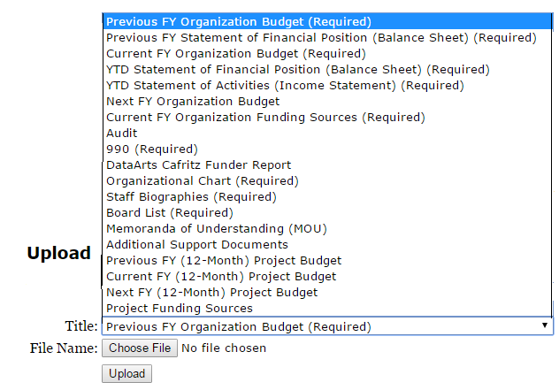

1. Choose the Corresponding file (on your computer)

