Assignment FOUR — Content providers

*Xuefan Wu*

**Part 1: Book Store**

**.contracts.BookContract class**

Defines AUTHORITY, CONTENT_URI, CONTENT_PATH and column names

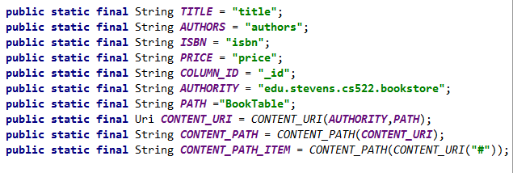

Defines getter (Cursor) and putter (ContentValues) operations

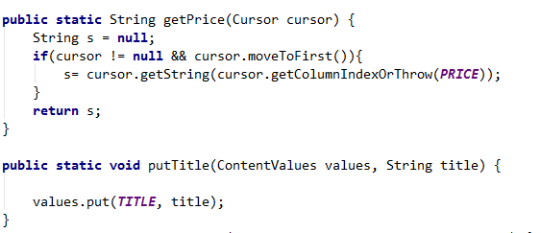

**.entities.Book entity class**

Book(Cursor) constructor

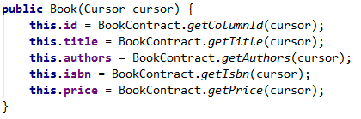

writeToProvider(ContentValues) method

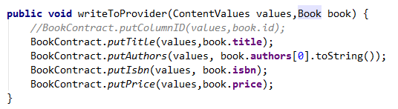

**.providers.BookProvider class**

Literals as before, CREATE_DATABASE follows spec, and is constructed using

column names from contract

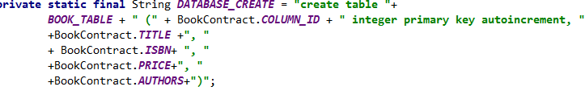

Use of SQLiteOpenHelper (subclass) to create/open database

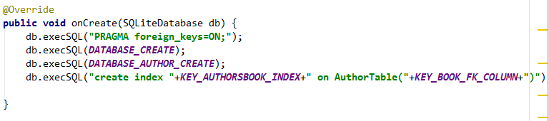

query, insert, delete implemented, insert and delete implement notifyChange(), query sets notify listener in cursor

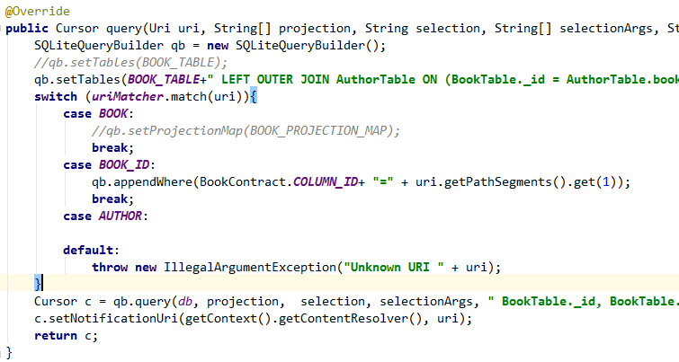

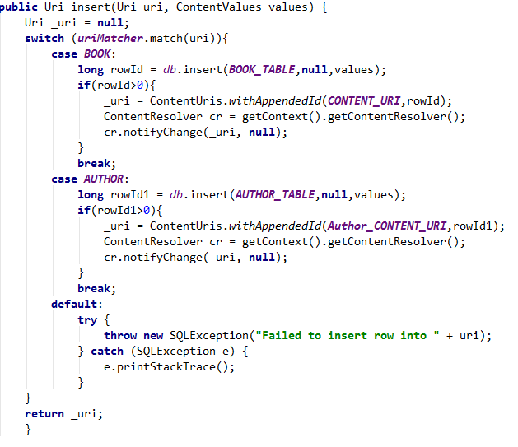

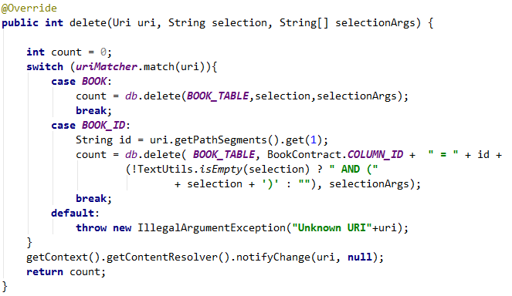

Authors in separate table in database, use of join and aggregation (GROUP-BY

with GROUP-CONCAT) to return authors in query





**BookstoreWithContentProvider:**

Main activity uses loader manager for queries, callbacks are defined as methods

in the main activity



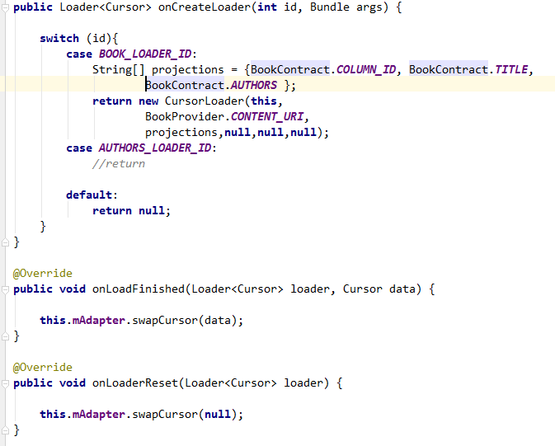

Main activity supports deletion of multiple books using multi-selection CAB



Use of custom cursor adapter to display first author only in main activity

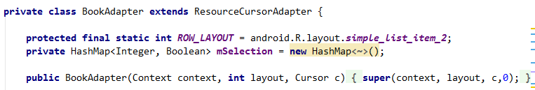

**BookstoreWithEntityManager:**

AsyncContentResolver class derives from AsyncQueryHandler

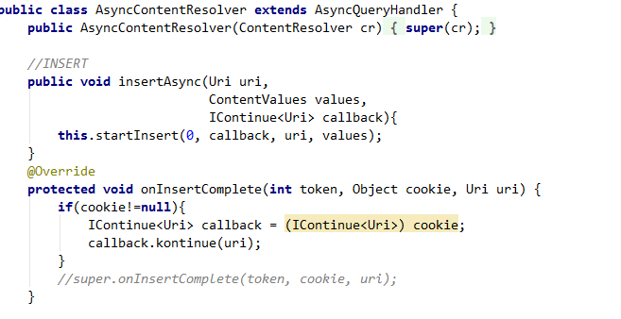

SimpleQueryBuilder uses AsyncContentResolver

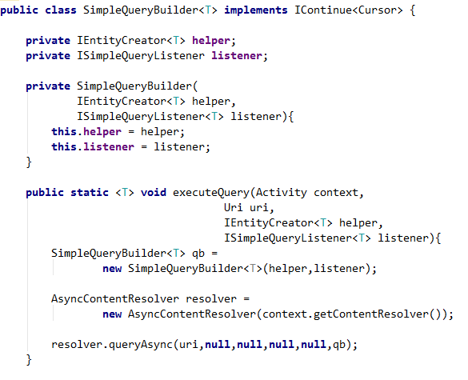

QueryBuilder uses LoaderManager

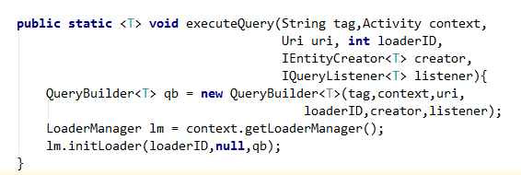

BookstoreManager used to access data, uses all three of the classes defined above,

AsyncContentResolver used in BookstoreManager for asynchronous insert/update

