**EverEdu Mobile Client Manual Testing Plan**

Login in

In the login page, you are able to log in with correct email and password.

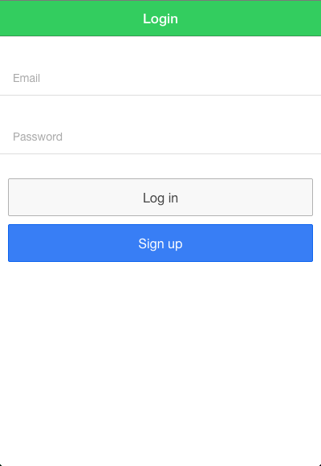

If you have not got an account yet, you can click “Sign up” button to register a new account with your email address and password. Then click “Create Account”

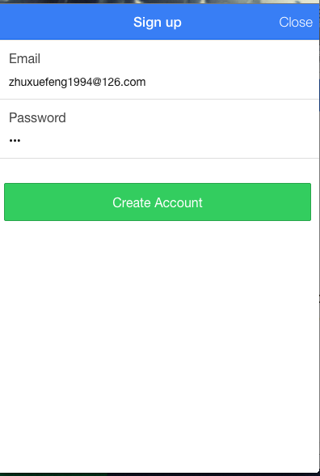

If there is any issue with the sign up, such as existing email, wrong format, an error alert will pop up.

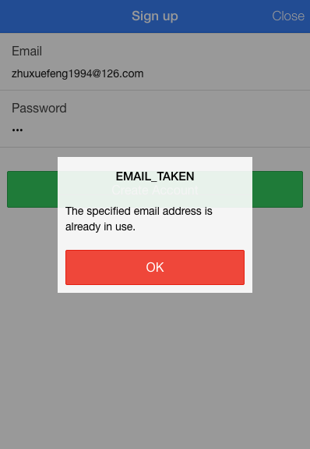

Otherwise, a message will show you that you have successfully created an account.

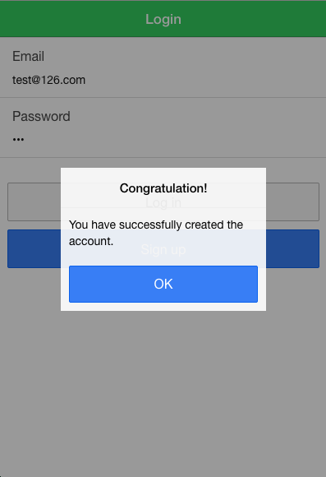

After registering a new account, you can log in with it.

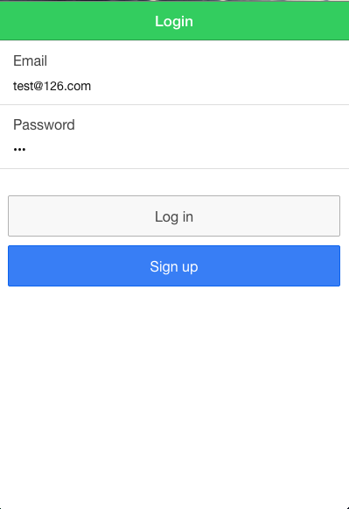

Curse List

If you are first time login into EverEdu, you will be required to enter your name information. After enter the name. It will appear in Firebase

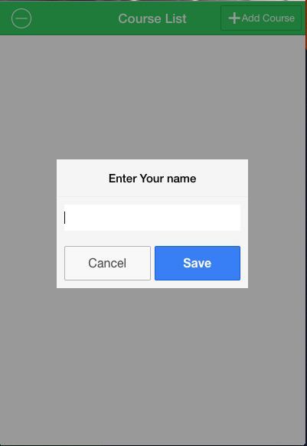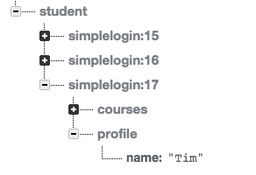

After you login, you will see a list of courses you are in

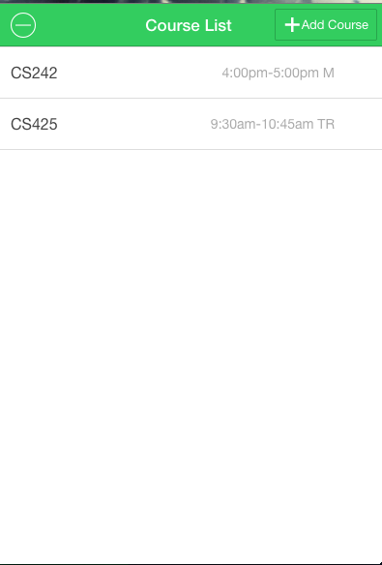

You can click the “Add Course” button on the top right to search and add new course

If the course number does not exist, an error alert will pop up

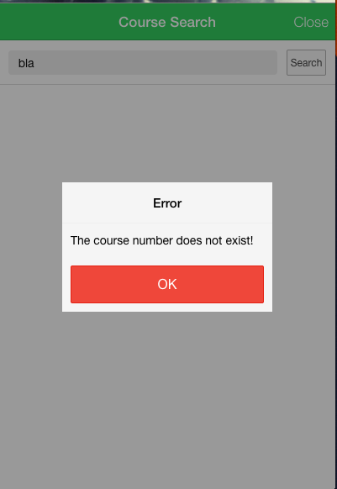

Otherwise, you will see

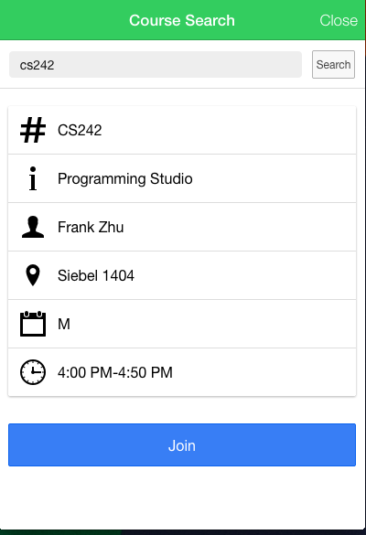

After checking the course detail information, you can click “Join” to add the course to courses list. And the course will also appear in Firebase



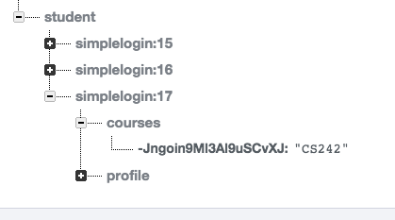

Click the top left button to remove unwanted courses

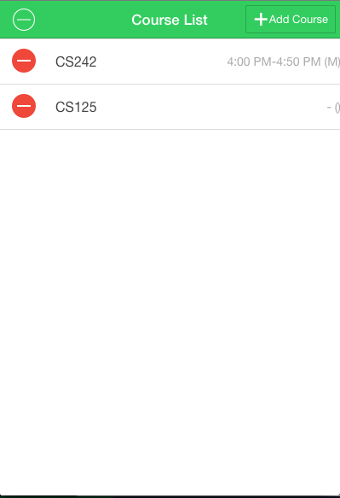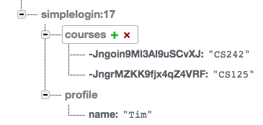

Click the red minus button to remove specific course. The course in the Firebase also will disappear.

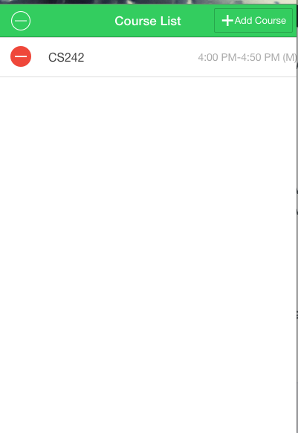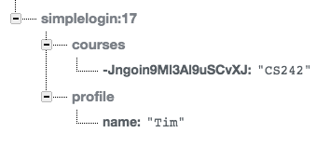

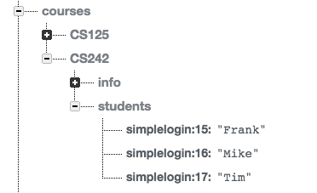

Click the left top button to return back normal list

Course Info

Click on specific course to enter its section. The default page will be the course information page. At course information page, you can see the announcement the instructor made and course description.

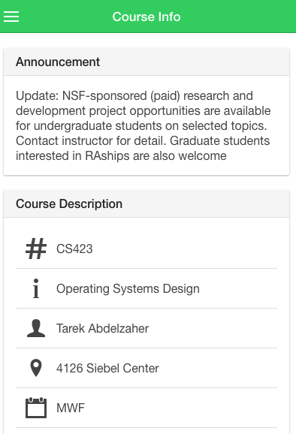

Click the left top button to see the menu. You can click each item to enter specific page

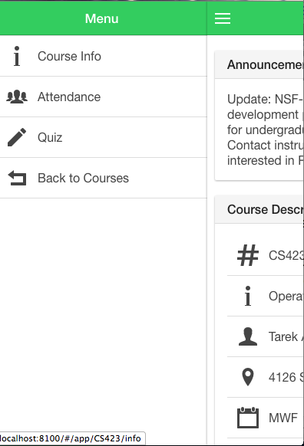

Attendance

In the attendance page, you can see your past attendance records.

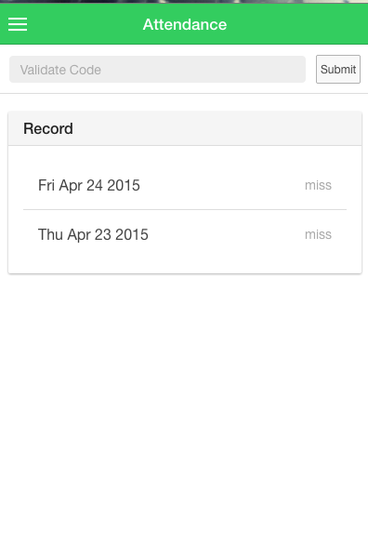

You can enter the verify code for the lecture in order to mark the attendance for the lecture

If the instructor does not turn on attendance or the validate code is wrong, you will see an error alert

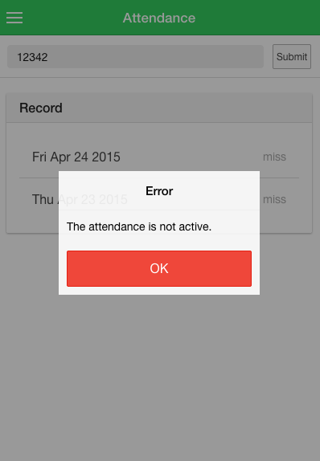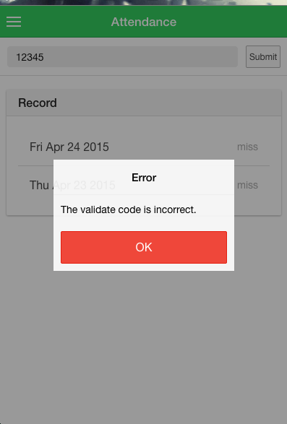

Otherwise, you will see the record showing attend. The record will also appear in Firebase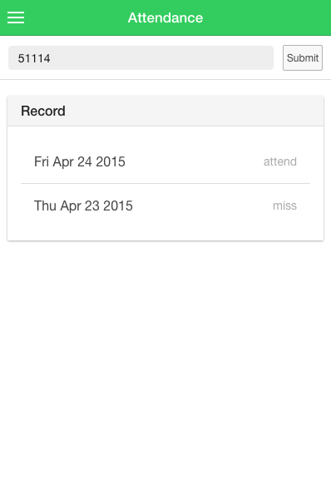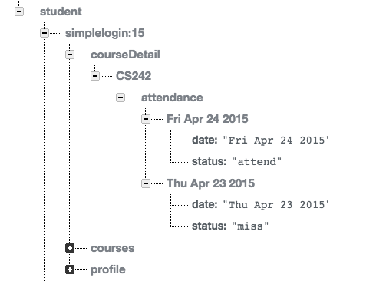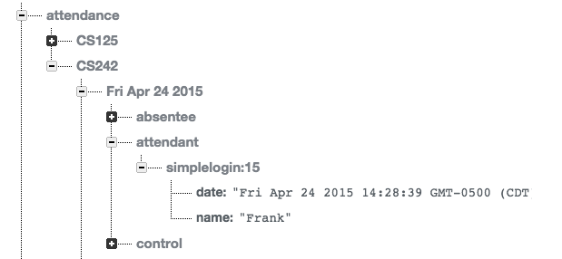

Quiz

At the quiz page, you are able to see the current quiz and completed quiz. Current Quiz has a list of quizzes in progress. Completed Quiz has a list of past quizzes

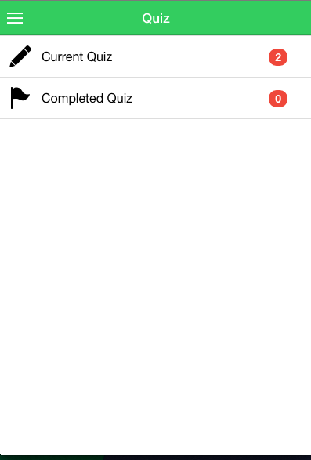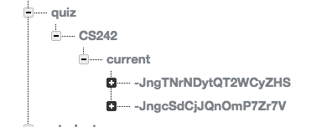

Click on either Current Quiz or Completed Quiz, you can see a list of quiz questions

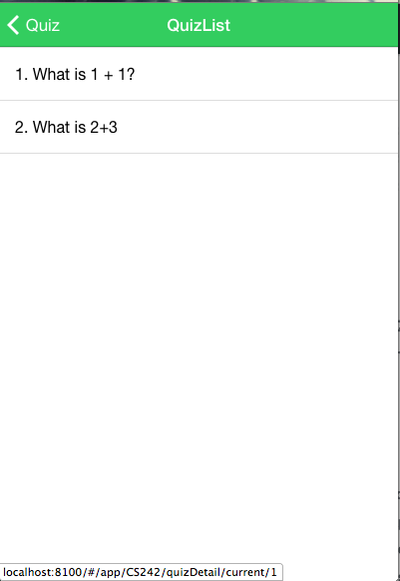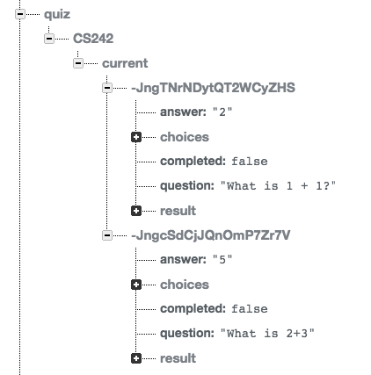

Click on a specific question, you are able to see the detail of the question.

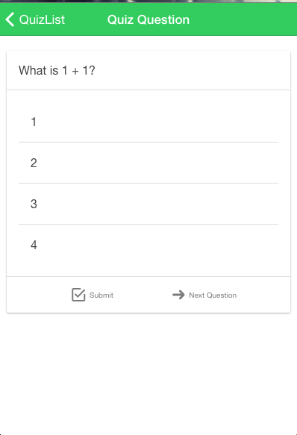

After making the selection, you can click “Submit” button to submit selection. The result in the Firebase will be updated. You will automatically lead to next question. Or you can skip current question and click “Next Question” to go to next question directly.

