**EverEdu Instructor Client Manual Testing Plan**

Login in

In the login page, you can log in with your email and password.

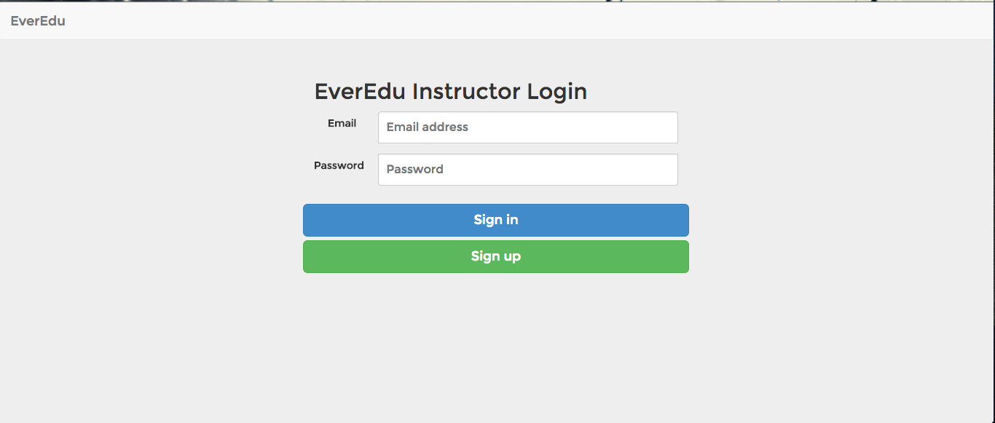

If you do not have an account, you can click “Sign up” button to register a new account. After entering the email and password, then click “Create New Account”

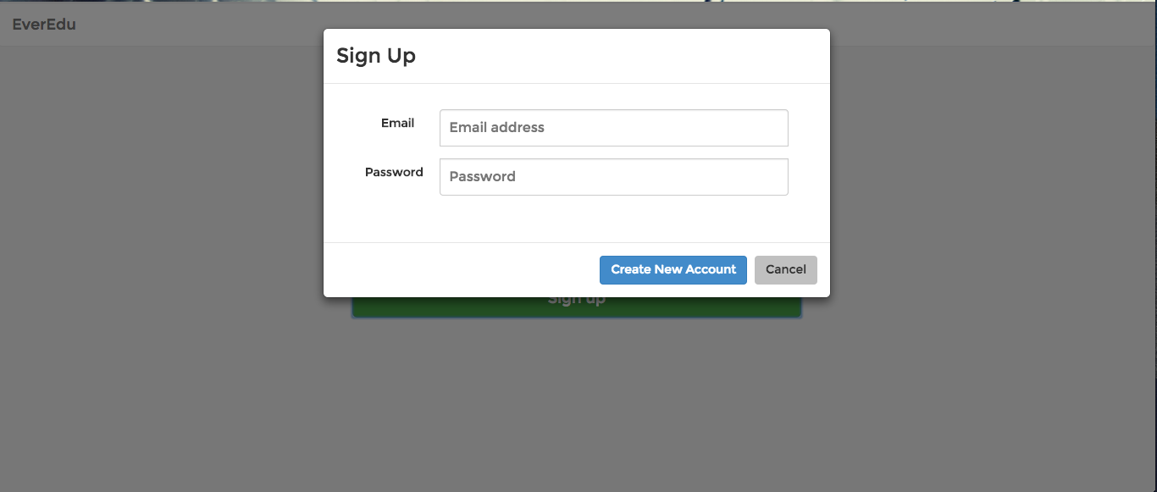

If there is any issue with the sign up, such as existing email, wrong format, an error alert will pop up.

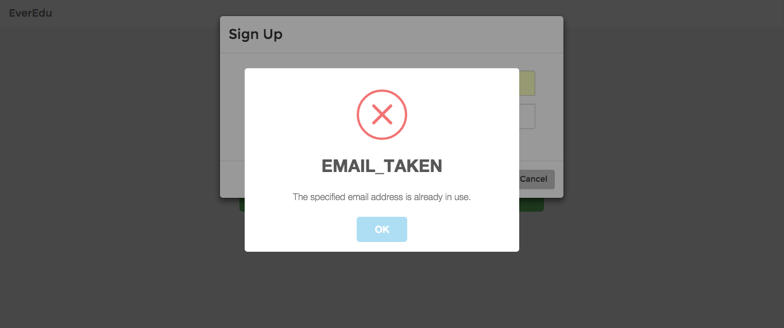

After creating a new account, you can log in with your new account.

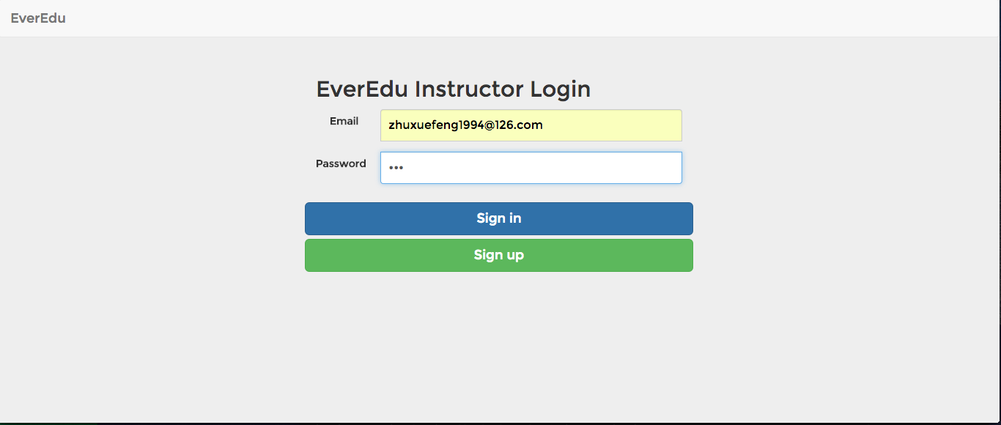

User Profile and Course List

After you login, you will see a list of courses, which are managed by you, on the left sidebar, and your personal profile on the right section

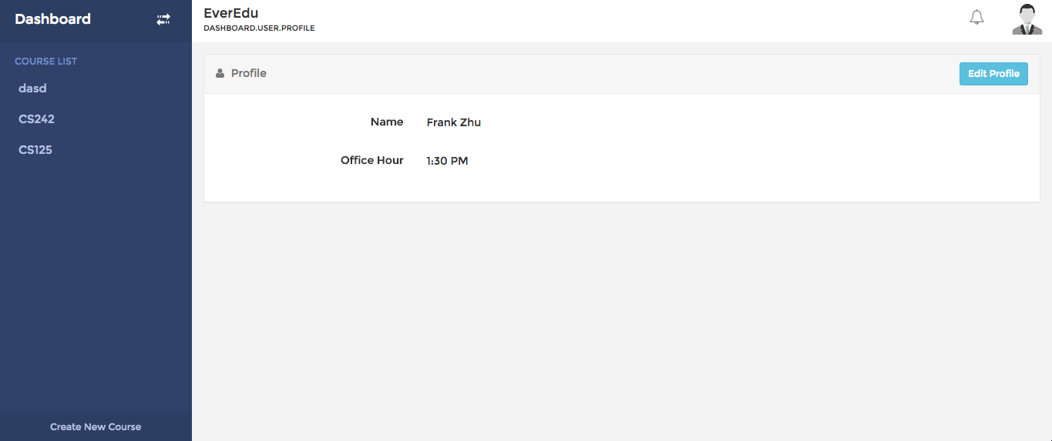

This is data for instructor profile in Firebase

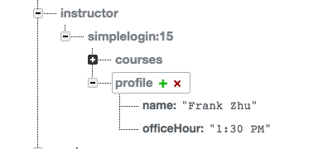

You can click the “Create New Course” button on the left bottom to create a new course

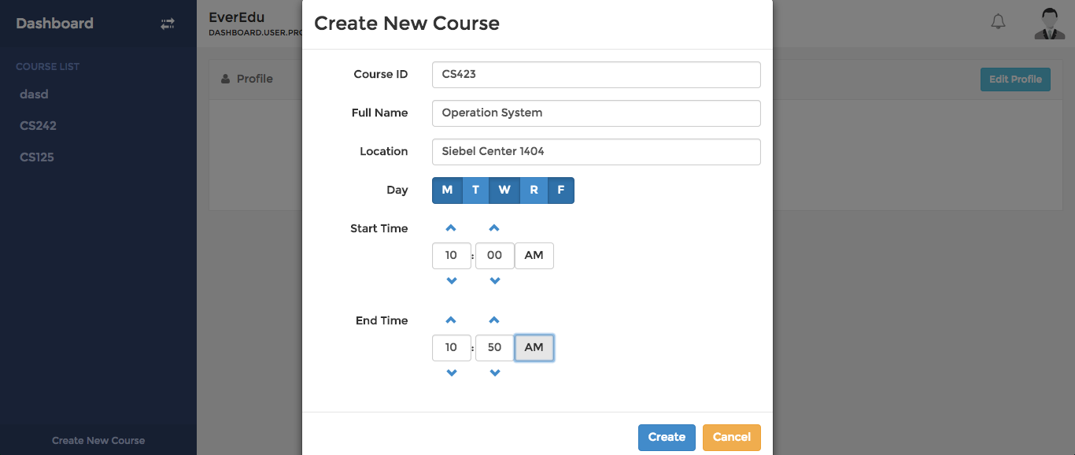

After filtering out the required information, you can click “Create” button to create the course, and the new course will appear in the left course list.

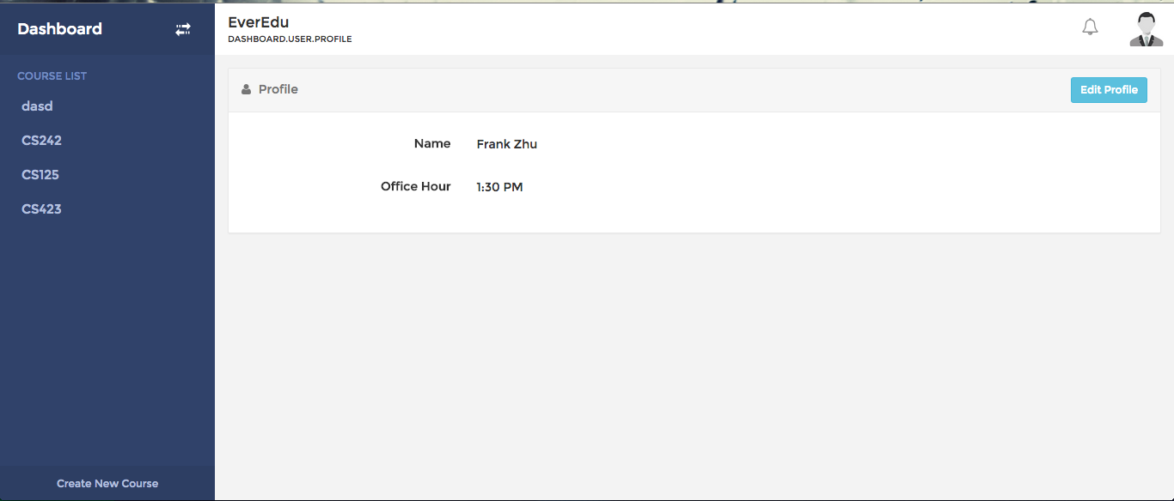

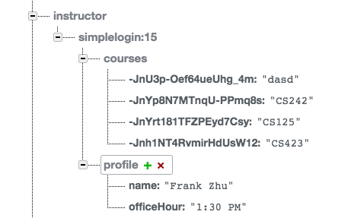

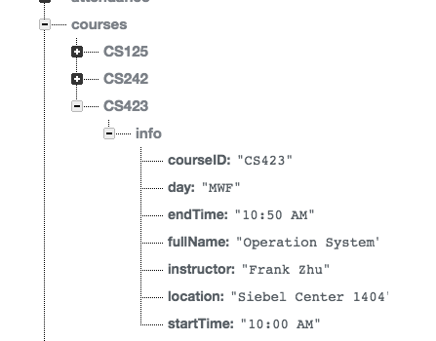

You can edit user profile by clicking the “Edit Profile” button on the right of the Profile panel

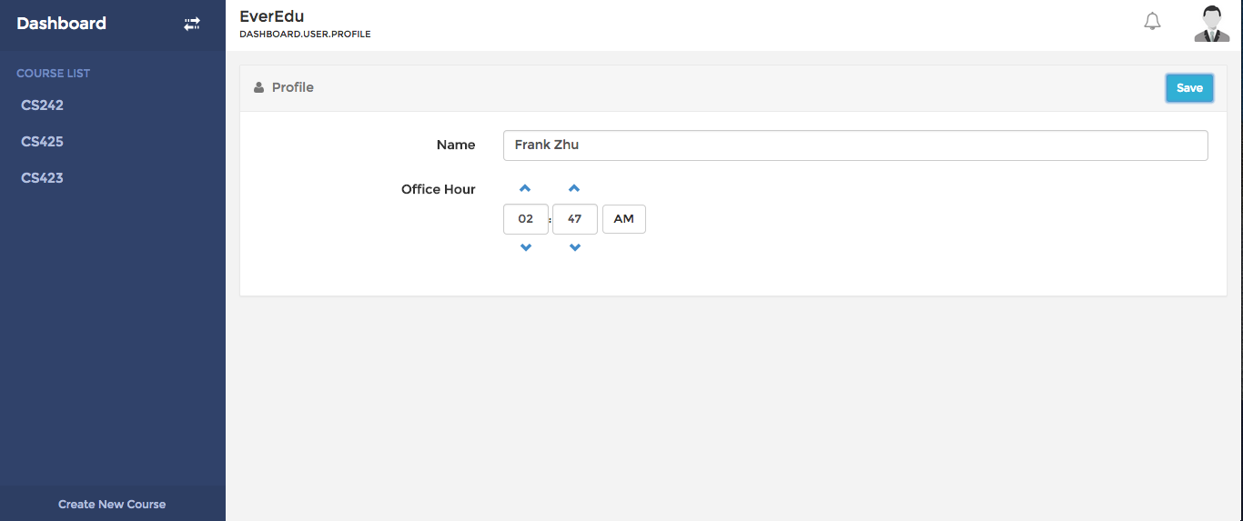

After making changes, click “Save” to save result

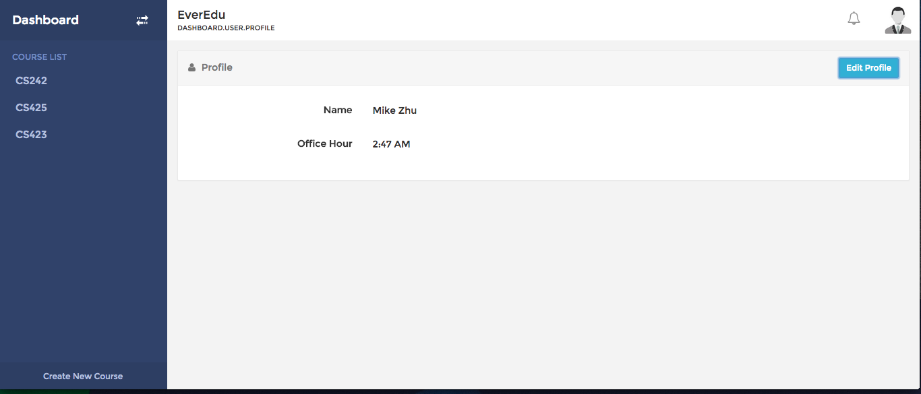

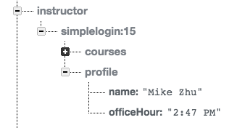

Course Info

Click on specific course to enter course menu. The default page will be the course info page. At course info page, you can view and edit the announcement and course description.

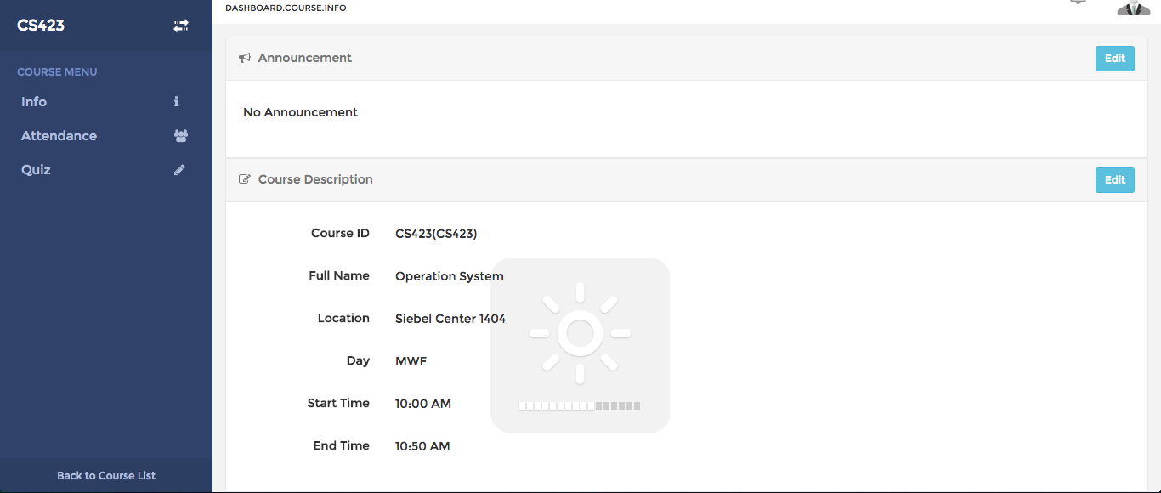

Same as editing profile, you can click the “Edit” button to edit corresponding section

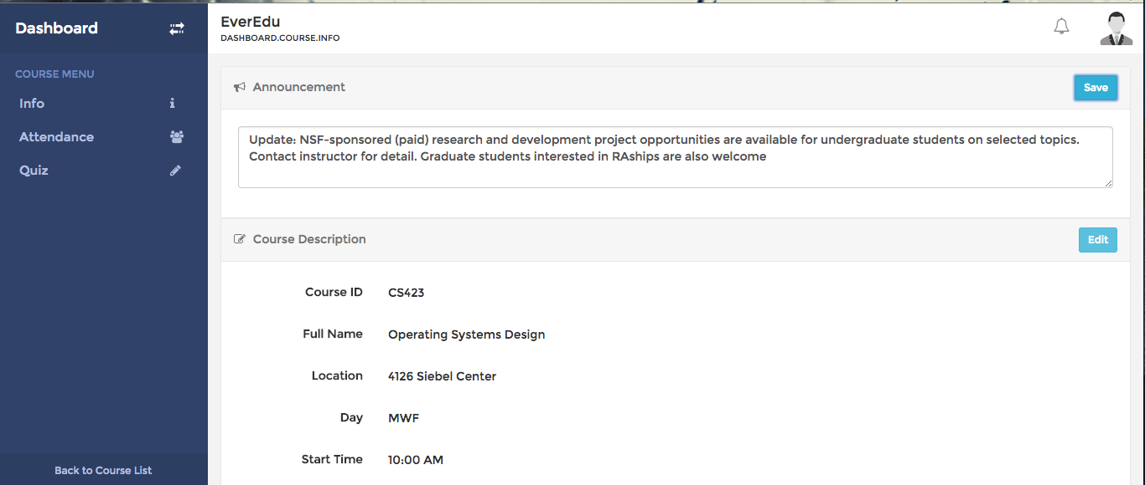

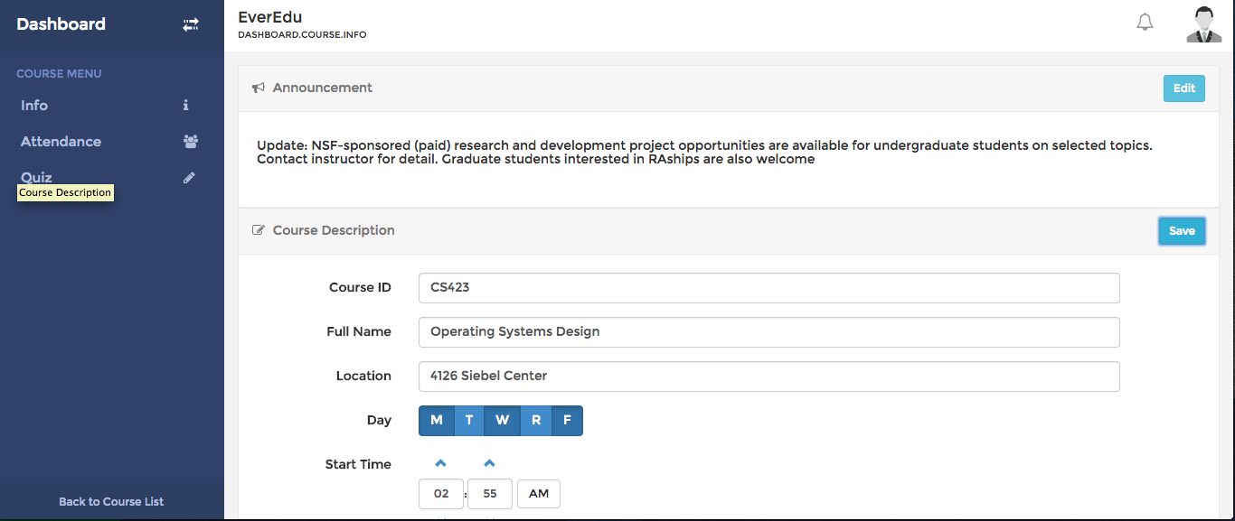

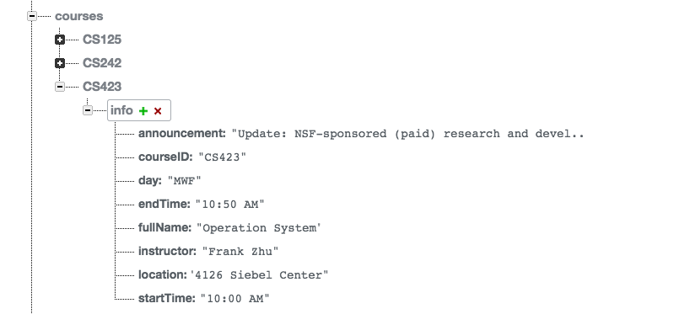

Attendance

In the attendance page, you can see four sections: attendance control, attendance statistics, attendant list, and absentee list.

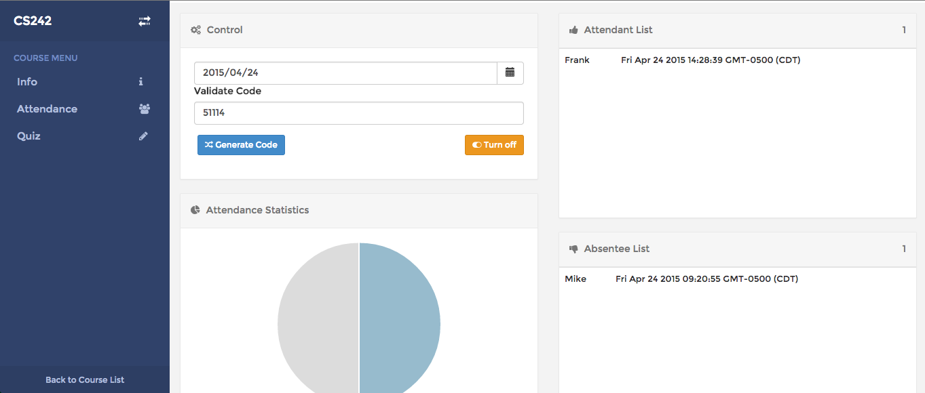

In the Control Panel, you can select specific date for attendance record. You also can click “Generate Code” button to generate validate code for student to take attendance. The “turn on/off” can used to control either accept attendance or not at this moment.

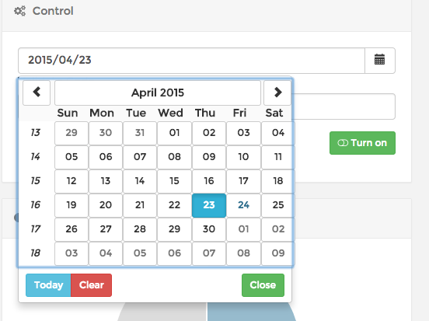

If you turn on status of attendace without generating code, you will get an alert

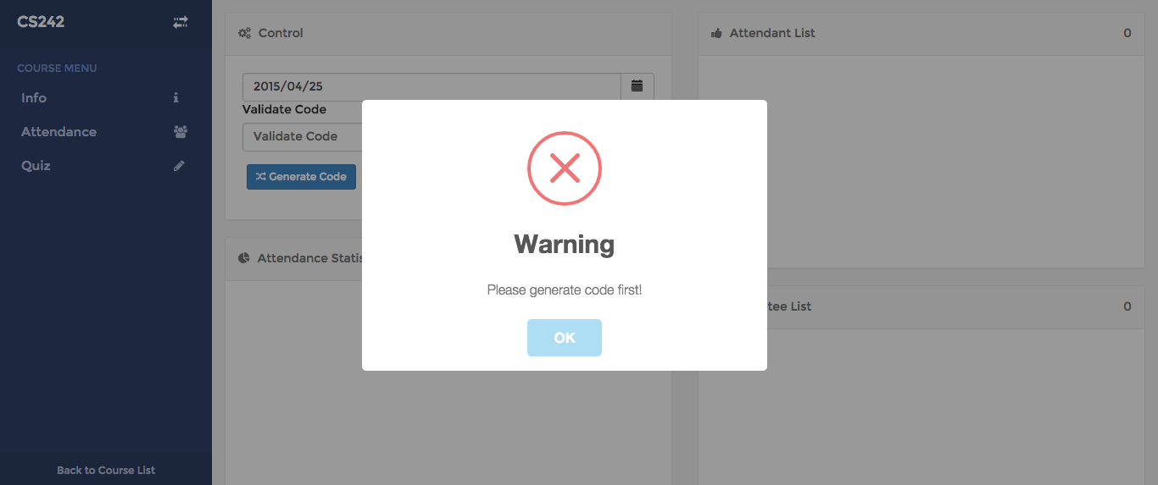

Otherwise, you can begin to collection attendance record. Initially, all students enrolled in the class will be in the absentee list. This view will automatically update while students are taking attendance.

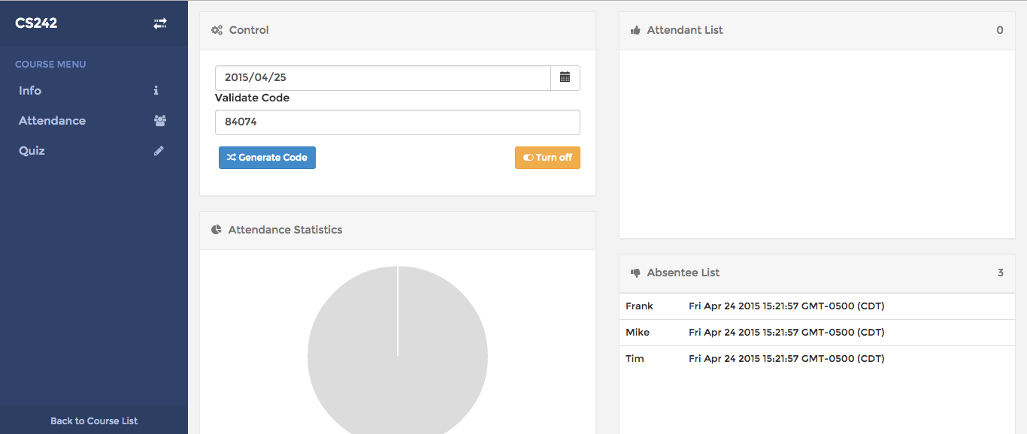

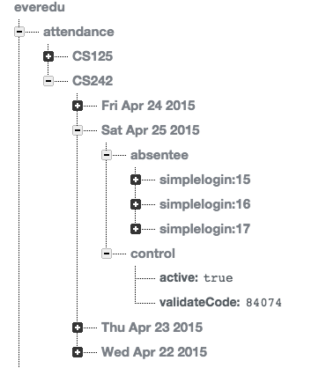

Quiz

In the Quiz view, you can see two sections initially, current quiz and completed quiz.

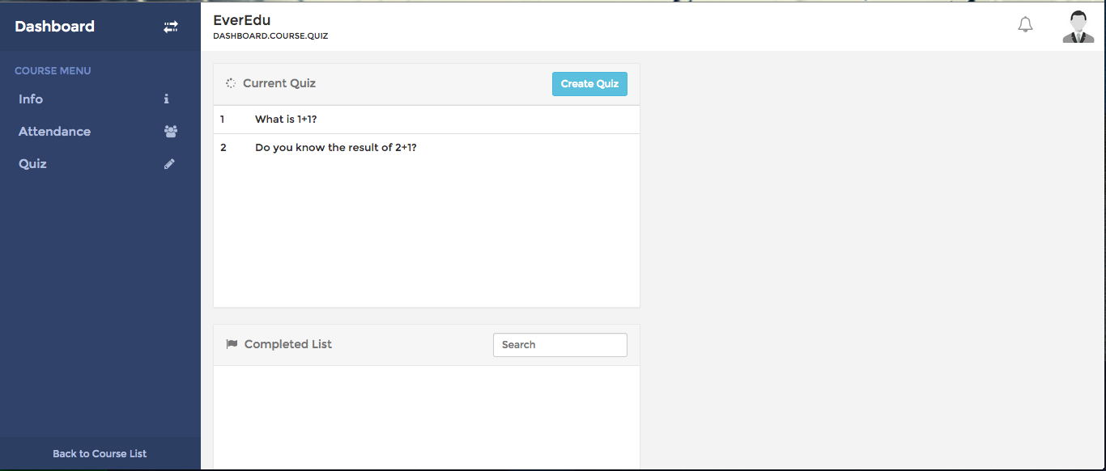

You can click “Create Quiz” button to add new quiz to current quiz list. You need to enter the question for the quiz. To add choices for the quiz question, hit “Enter” key or click “Add Choice” button. Ask put choices, you can click the radio button to mark the right answer. Click “Create”, and the new quiz will appear in the current quiz list.

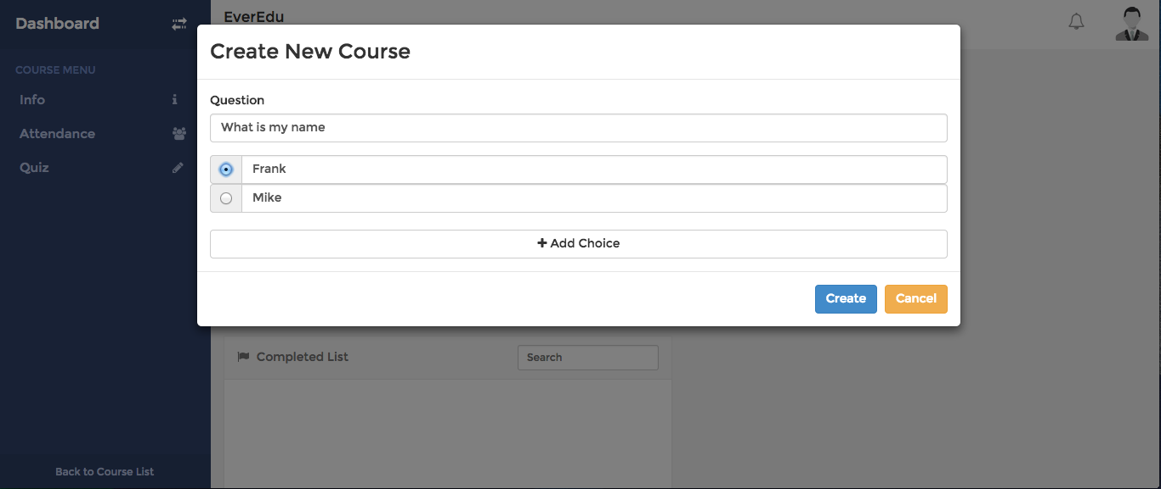

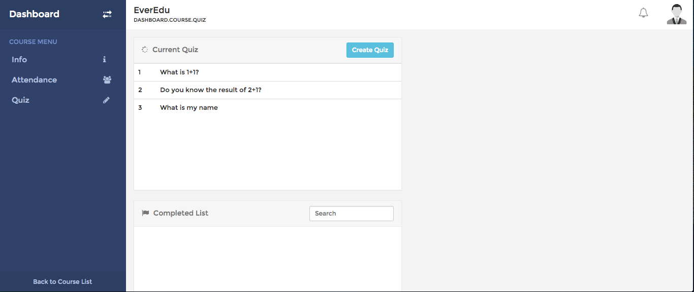

You can click on specific quiz question to see detail, including question itself and students’ performance.

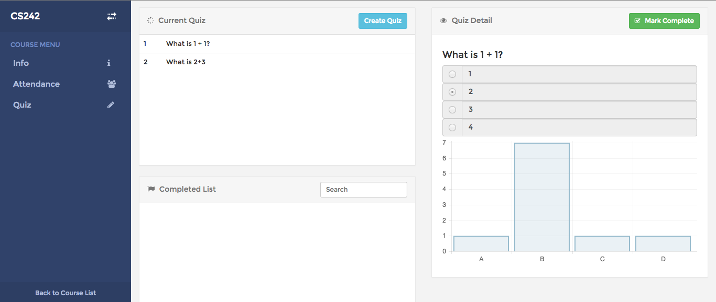

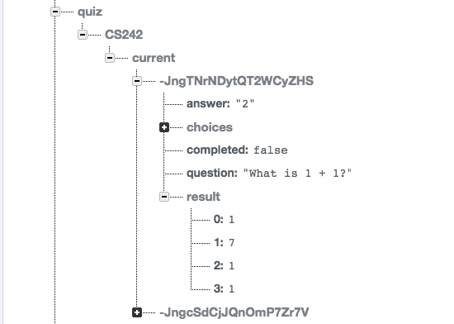

Click the button on the right top of Quiz Detail panel, you can mark the quiz as completed or uncompleted, and the quiz question will also be put into the corresponding quiz list.

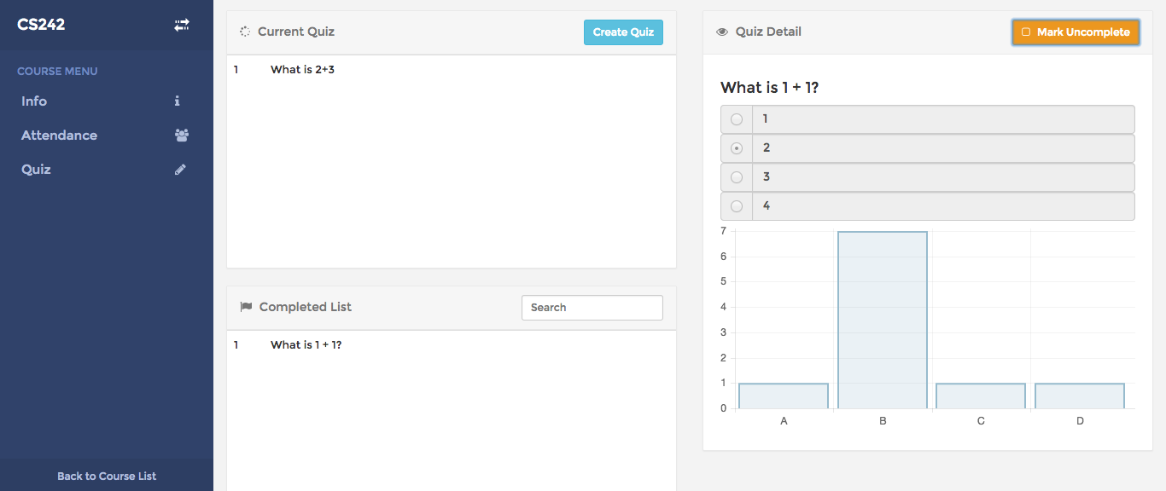

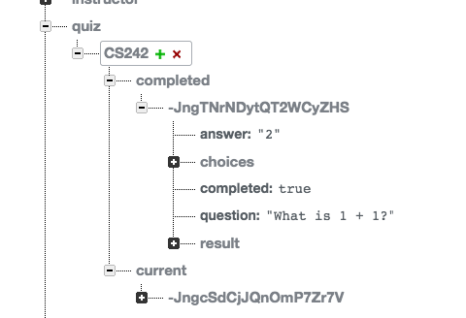

You can search quiz question using the search box at the right corner of completed quiz.

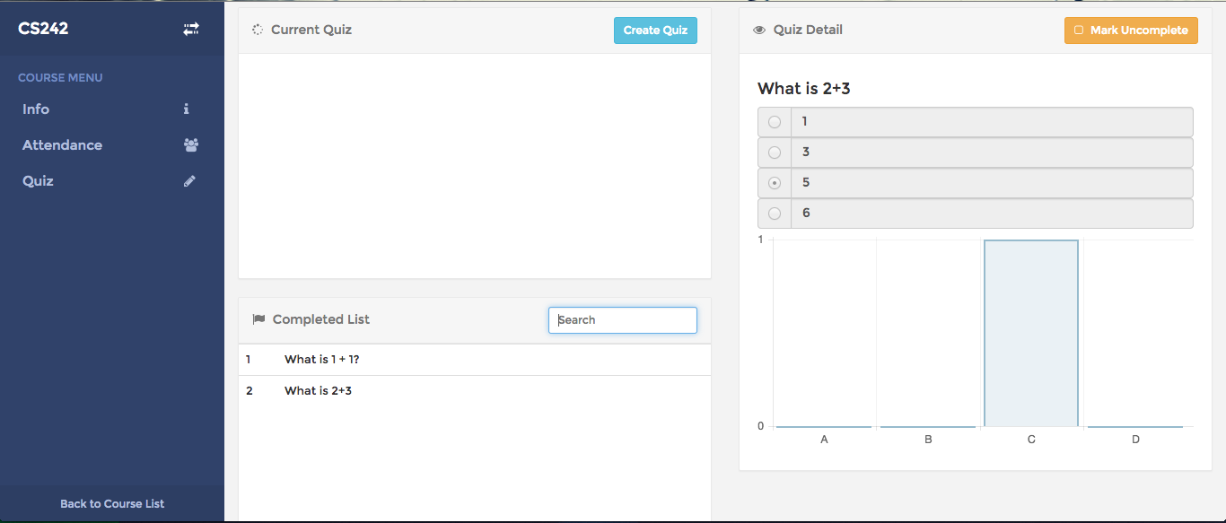

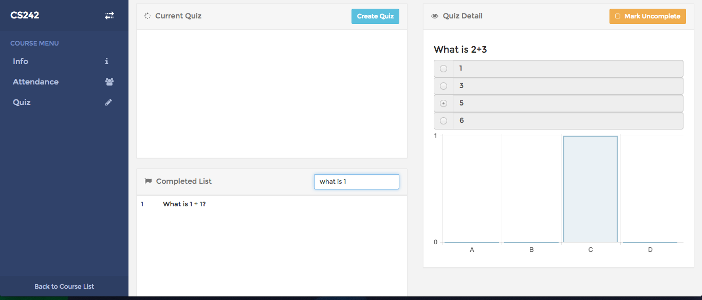

Presentation

EverEdu allows students to present from it smart phone and project the video on instructor’s client.

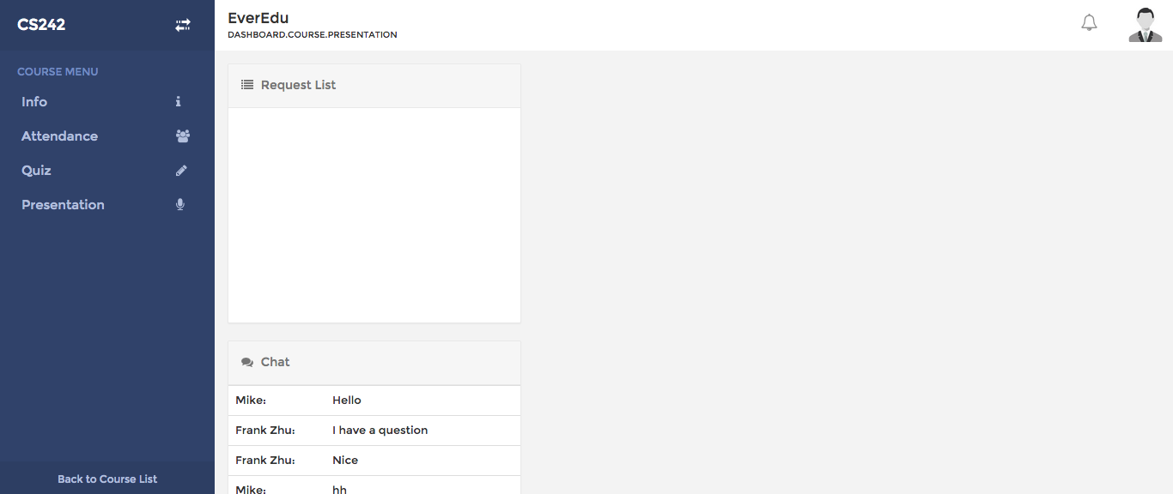

After Students submit presentation request, you are able to view these requests in Request List Widget. You can perform two actions for items in the request list: accept request or delete request.

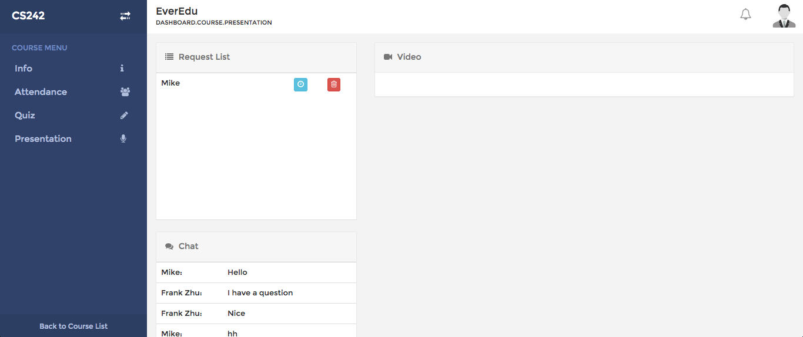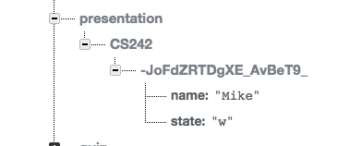

If you accept students’ requests, the students are able to present. Their video will show up at right side in Video Widget.

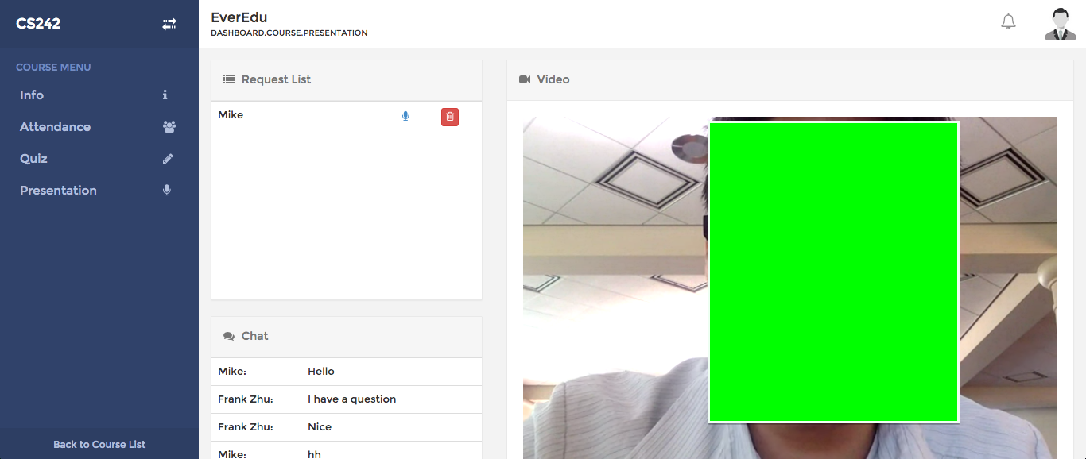

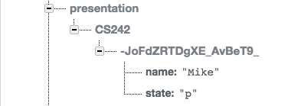

If you delete the request while students are presenting, the video will be shut down.

Chat

In the same view of presentation, the instructor can also communicate with student in side the chat room.

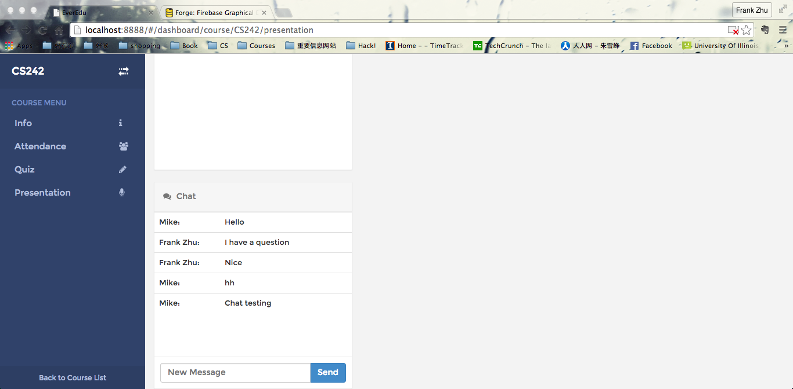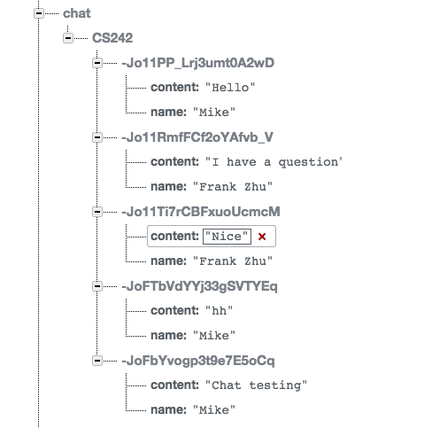

You can enter your message at bottom input field and click “Send” button to send the message

