Eggshell Home Builder (Final Project)

Requirements Document:

**Advanced Database Management:** December 9, 2013

(Group 3)

Gummoe, Benjamin

Malavia, Sonal

Shaw, Katarina

Zhai, Xuefeng

Eggshell home builder need to build a database for their website to provide more information to buyers and to make it easier for them to choose houses and select options and manage the business.

The database should keep information about the following groups of people: customers, sales agent, project manager, crew manager, construction worker.

For the subdivision, it should has 3 or 4 styles of houses. Each style has a slight different exterior, called elevation. Customers could choose one elevation when they purchase a house. The style includes floor plans and description of rooms. A specific house style usually has already been assigned to each lot of a subdivision.  Also, a map of the subdivision should be included in the database. Buyers would also want to know the school district for subdivision.

When purchasing a house, buyers could decide what options they would like for the house. Eggshell only offer limited number of options and the options belongs to several category. The buyers usually should decide what options they want before the beginning of the construction of their houses. And there are seven stages in the construction of a house, if customers change their mind about the options after the construction begins, the builders would charge additional costs for making changes after certain stages.

If a customer selects an option that is allocated for a stage beyond the current stage of the construction project for the house, that selection will not be allowed. If a customer selects an option for a stage that is too far past the current construction stage, that will also not be allowed. An option selected for a stage that is one increment past the construction stage will be added, but with a markup.

The project manager tracks the progress of each house and evaluates the work crews in terms of the progress. The project manager is also responsible for updating the construction progress. The project should have several tasks of each stages and an estimated end date.

Besides, the information about the contract of the sales of a house should be stored in the database.

A number of reports and procedures have been developed to support these transactions.

The first report demonstrates which project managers have been assigned to which construction projects. The output is included below: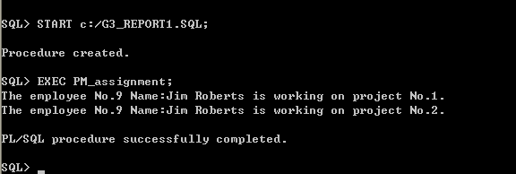

The next report identifies the status of current construction projects and the houses that are associated with them.

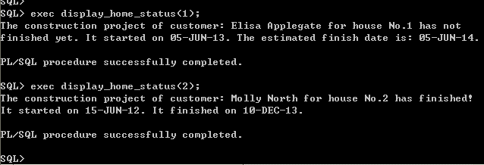

The first procedure, ‘display_home_status’ displays a report on a given customer’s house. When a user inputs the ID of the house, the procedure will report whether the project is finished or not. If it is not finished, it will report the estimated finish date.

The second procedure, ‘pm_assignment’, generates a report of the assignment of the project manager. It shows which projects each project managers is working on.