Table 1-1 Parameters in the typical building

|  |  |  |  |  |
| --- | --- | --- | --- | --- |
| **Building length** | **building width** | **Elevator exit width** | **Elevator length** | **Elevator width** |
| 56m | 56m | 2m | 3m | 3m |

Table 1-2 Parameters in the typical building

|  |  |  |  |  |
| --- | --- | --- | --- | --- |
| **Floor height** | **Room exit width** | **Horizontal length of stairs** | **Number of Floors** |  |
| 5m | 3m | 3m | 100 |  |

Table 2-1 Personnel parameters

|  |  |  |  |  |
| --- | --- | --- | --- | --- |
| **Personnel behavior** | **Evacuation mode** | **Number of people per floor** | **Number of adult males** | **Number of adult females** |
| Elevator or staircase | Steering | 300 | 150 | 150 |

Table 2-2 Personnel parameters

|  |  |  |  |  |
| --- | --- | --- | --- | --- |
| **Speed(man)** | **Shoulder width(man)** | **Height(man)** | **Reduction Factor(man)** | **Acceleration Time(man)** |
| 1.2m/s | 42.92cm | 1.82m | 0.7 | 1.1s |

Table 2-3 Personnel parameters

|  |  |  |  |  |
| --- | --- | --- | --- | --- |
| **Speed(woman)** | **Shoulder width(woman)** | **Height(woman)** | **Reduction Factor(woman)** | **Acceleration Time(woman)** |
| 1.0m/s | 39.35cm | 1.65m | 0.7 | 1.1s |

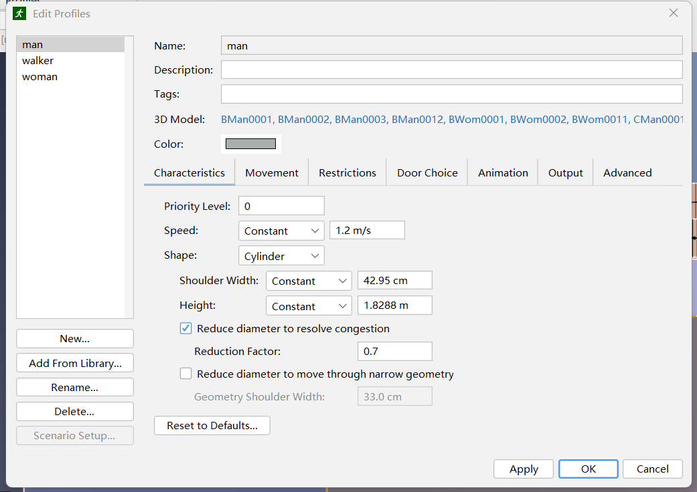

Fig. 1-1 Personnel parameter setting for men

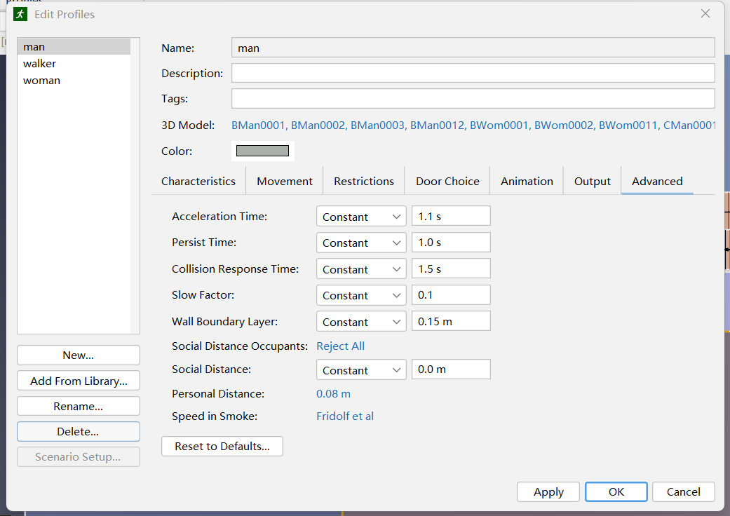

Fig. 1-2 Personnel parameter setting for men

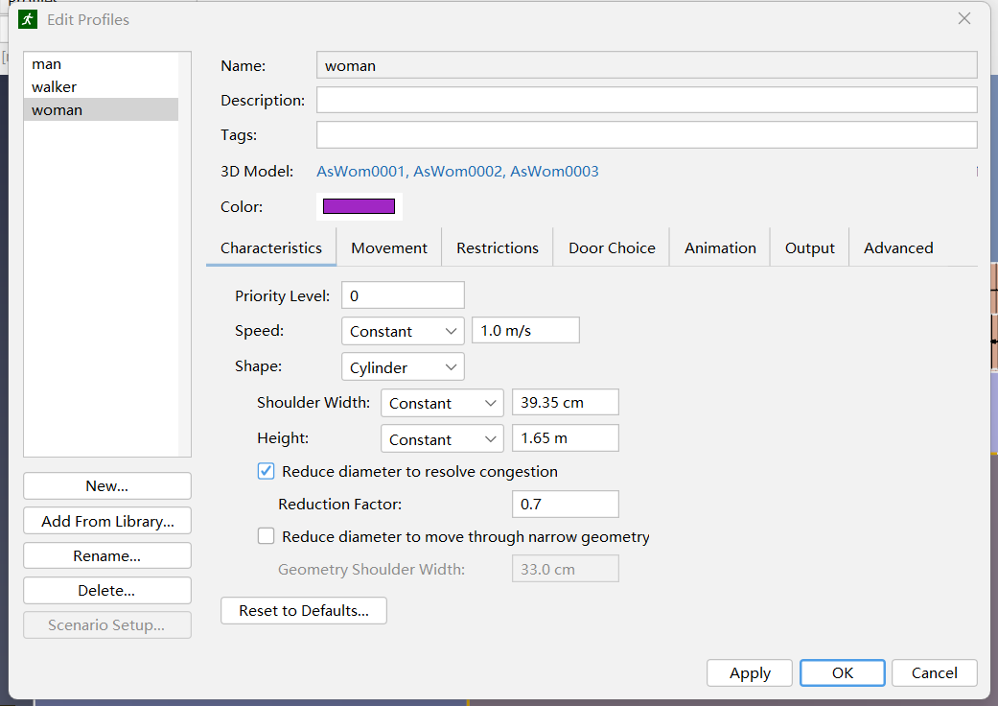

Fig. 1-3 Personnel parameter setting for women

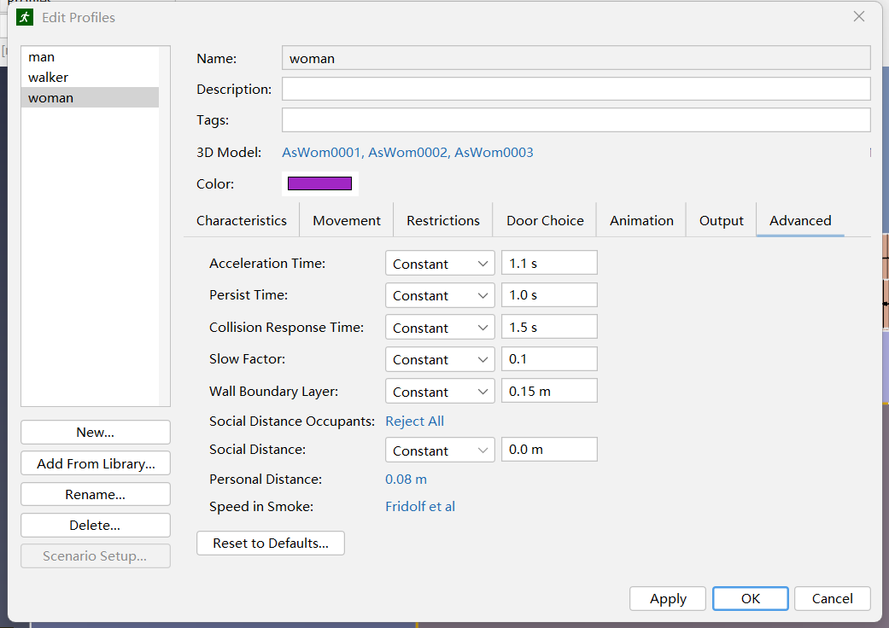

Fig. 1-4 Personnel parameter setting for women