**Reflection**

**User Interface bugs (3)**

1. #10 Help and Documentation

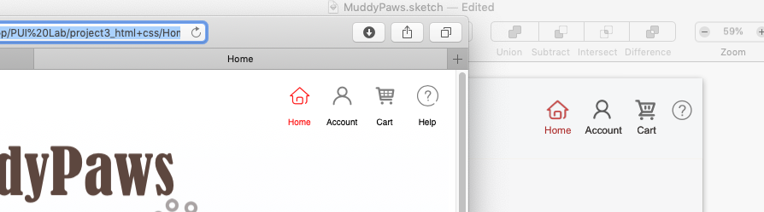

The first user interface bug I noticed immediately was the lack of the help button. I have struggled between whether I should add a “contact” button or a “help” button. Then I thought of what function or message I want this button to convey, I decided to use help button. I want users to have an obvious place to go when they have questions regardless of what problems they run into. The problems can be something require customer service, and it can also be some technical issue reports. In the future design, the help page should have the contact information on the top and then frequent-asked questions below the contact information, so users don’t have to categorize their problems before choosing a button to click.

1. #6 Recognition rather than recall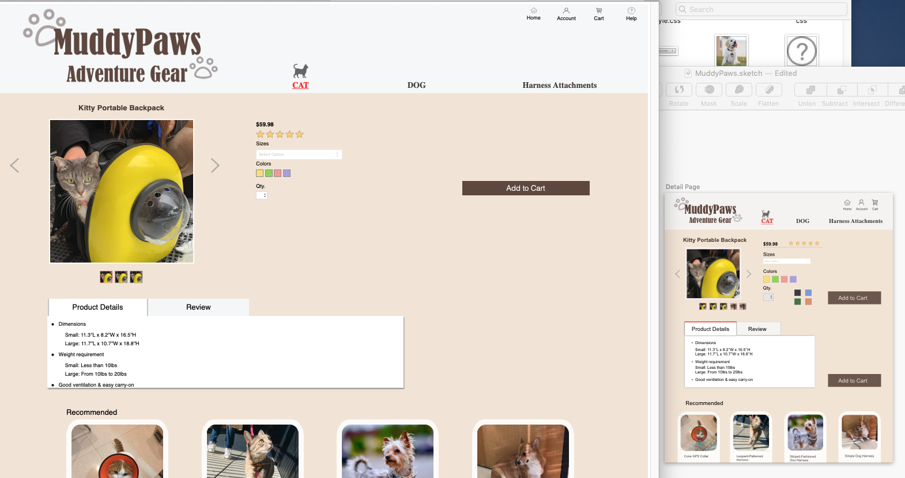

The second user interface bug I encountered was on my detailed product page. The proportion of my original design did not allow the “Add to Cart” button to show above the fold. Users had to scroll down a little to see the button, which did not minimize the user’s memory load by making objects, actions and options visible. Then I adjusted the position of the “Add to Cart” button to make it available to the users without scrolling.

1. #Aesthetic and minimalist design

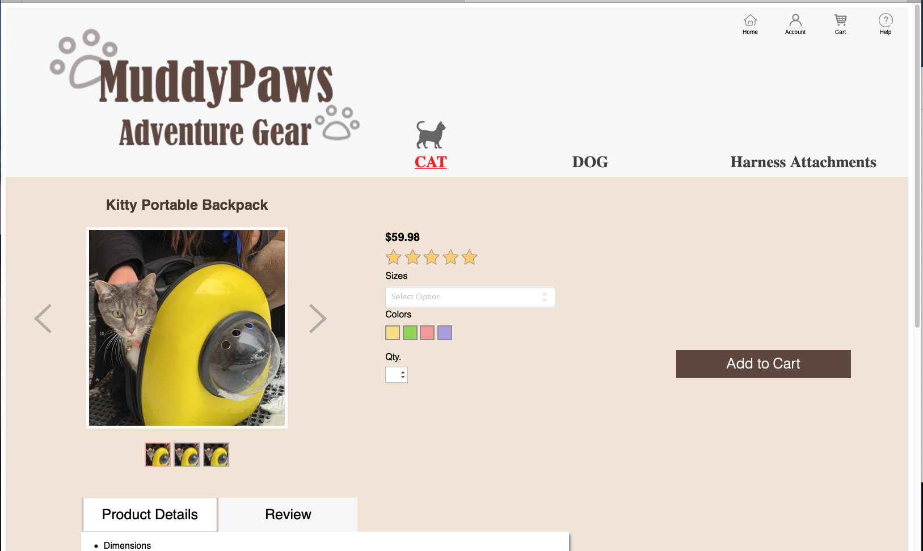

There was another bug on the detailed product page. I had two “Add to Cart” buttons. At first, I thought it would be useful to have one on the upper half of the page, the other on the lower half of the page. However, after I prototyped it in HTML, I found my page was not too long. The second button was not needed.

**Challenges**

The most challenging part of this assignment was the concepts of CSS. I was confused of the concepts of “position” and “display”. When I first learned it, I thought I understood them. However, when it came to the time to apply them, it took me long time to try out. The worse situation was sometimes I did not even know how to phrase the question properly. Thus, during the process of writing the code, I learnt not only how to make things work in CSS, but also how to search for the useful answers online. I was very slow adapting the use of “display” and “position”, so the Home page took me about 6 hours to complete. I think time was an issue to me, too.

The other difficulty I have encountered was debugging. Sometimes I could not locate why the change I made in CSS did not update on the website. There were couple reasons: the div was either incomplete or wrapped around the wrong objects; the code got override by another command. The silliest mistake I made was linked the wrong CSS file because I changed its name and forgot to update. I like to use the built-in developer tool to inspect where the code went wrong. It is very efficient and super helpful.

**Brand Identity**

The brand name is Muddy Paws, so I wanted to use the color theme that is close to mud but not too dark to make it actually looks dirty or gloomy. Thus, I chose light orange as my main theme color. This company specifically focused on outdoor adventure products for cats and dogs, so I wanted to design the color that brought out more energy. My goal for the user is to feel cheerful when shopping on the website. I also wanted to bring a neat feel to the customer. The identity of brand is fun and cheerful, cute, too!