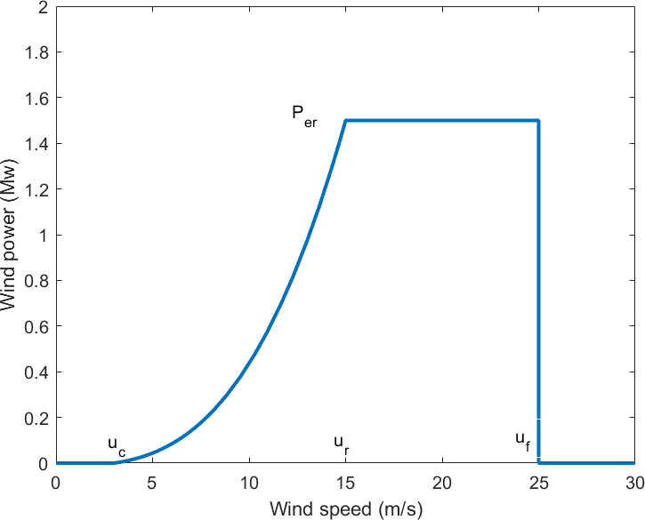

Fig. 3. Wind speed - wind power conversion graph

aforementioned criteria may be condensed into the piece-wise function shown below:

0 , if *u*(*t*) ≤ *uc*

*m*

*P*

(*t*) =

*c*

*c*

*r*

1. *Wind power model*

*Per* (*u*3*−u*3(*t*))

*u*3*−u*3

*< u*(*t*) ≤ *u*

*Per* , if *ur < u*(*t*) ≤ *uf*

0 , if *uf* ≤ *u*(*t*)

, if *u*

*c*

*r*

(3)

The electrical output power of wind turbine systems is gen- erated by the mechanical power extracted from the available wind energy by the wind turbine blades. Using aerodynamic theory, the mechanical power extracted by a wind turbine from

[15] is determined as follows:

According to equation (3), the problem of wind energy gener- ation may be analysed using the parameters of the anticipated wind speed and the actual wind turbine employed. In com- bination with equation (1), the following expression may be used to forecast wind speed:

*P* = 1 *ρAu*3(*t*)*C* (*θ, λ*) (1)

*u*(*t*) = *W* (*NWP* (*t* − 1)*, . . . , NWP* (*t* − *m*)*,*

(4)

*m* 2 *p*

*u*(*t* − 1)*, . . . , u*(*t* − *n*))

where *Pm* is the mechanical power taken by a wind turbine, *ρ* is the density of air, *A* is the swept area of the blades, and *u* is the wind speed. *Cp*(*θ, λ*) represents the proportion of available wind energy produced by a wind turbine. *θ* is the pitch angle of the blade, whereas *λ* is the tip speed ratio. Assuming a constant rotational speed and disregarding the percentage, the electrical power output of a wind turbine may be calculated as follows:

where *W* (*NWP, u*) is the predicted function for wind speed. *NWP* is the NWP data of the last *m* hours. *n* is the last *n* hours of the wind speed.

1. *PV model*

Akhbari et al [16] expressed the DC power provided by a solar PV source as:

*Pm* =

1 *ρAu*3(*t*) (2)

2

*Pdc*(*t*) = *Ieff* (*t*)*ηgAs* (5)

where *Ieff* (*t*) represents the incident efficient radiance

Thus, the corresponding output curves from wind speed to power generation are as Fig.3, where *ur* represents the rated wind speed, *uc* represents the cut-in speed (when the electrical power output rises above zero and power generation begins), and *uf* represents the furling wind speed (when the turbine is shut down to prevent structural damage). *Per* is the rated power with a 1.5Mw value. As illustrated in the picture, it is assumed that the output power increases between *uc* and *ur* and then remains constant between *ur* and *uf* . All other conditions result in the emission of 0 power. Consequently, the

(*Wm−*2), *ηg* represents the solar PV source efficiency and *As* represents the solar PV source effective surface area (*m*2). The efficiency of solar PV sources is affected by ambient tem-

perature, temperature loss coefficient, and nominal operating cell temperature, according to [17]. Because the power of solar energy and solar incident efficient radiance are linearly related in the equation above, the key to forecasting solar energy output is to estimate *Ieff* (*t*).