Xuexian Xie (001674636)

**Program Structures & Algorithms**

**Spring 2021**

**Assignment No. 2**

* **Task**

Use Insertion Sort to measure the running time of random array, partial-ordered array, reverse-array and ascending array.

* **Output**

* **Relationship Conclusion:**

Normal Order array perform the best and reverse-order array perform the worst.

* **Evidence to support the conclusion:**

I added a trendline and I found out the power function is the most fit function for this plot.

* **Graphical representation:**

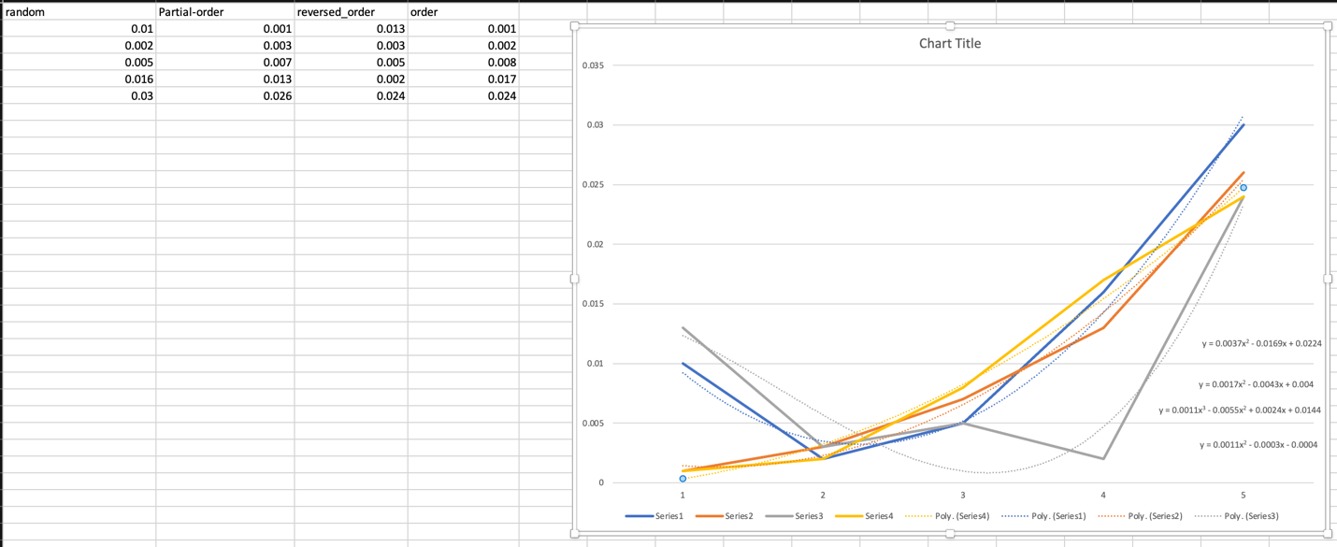

* **Unit tests result:**

