Xuexian Xie (001674636)

**Program Structures & Algorithms**

**Spring 2021**

**Assignment No. 4**

* **Task:**
* For weighted quick union, store the depth rather than the size.
* For weighted quick union with path compression, do two loops, so that all intermediate nodes point to the root, not just the alternates.

For both of these, code the alternative and benchmark it against the implementation in the repository. You have all of that available from a previous assignment.

* **Output:**

* **Relationship Conclusion:**

The weighted quick union with path compression is faster than the weighted quick union without path compression.

* **Evidence to support the conclusion:**

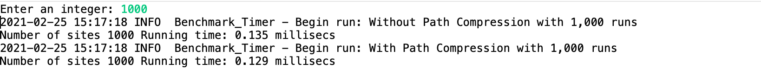

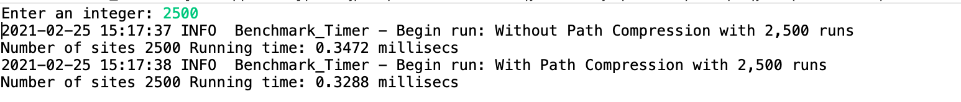

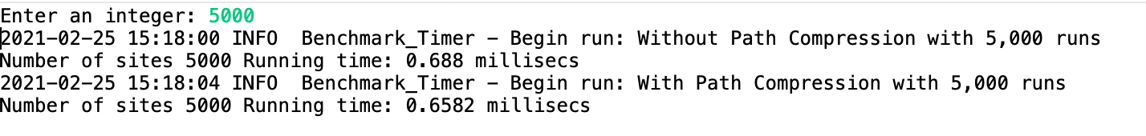



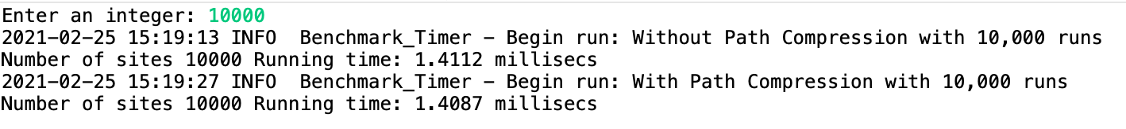

* **Unit tests result:**

