**Introduction**

The STEM industry is always concerned with its diversity problem. Silicon Valley is the place with the largest influence of Information industry. This project intended to show the diversity information of Silicon Valley by demonstrating the difference of gender, race and job category. The target audience of the visualization project is public audience who can easily understand the visualization.

**Design**

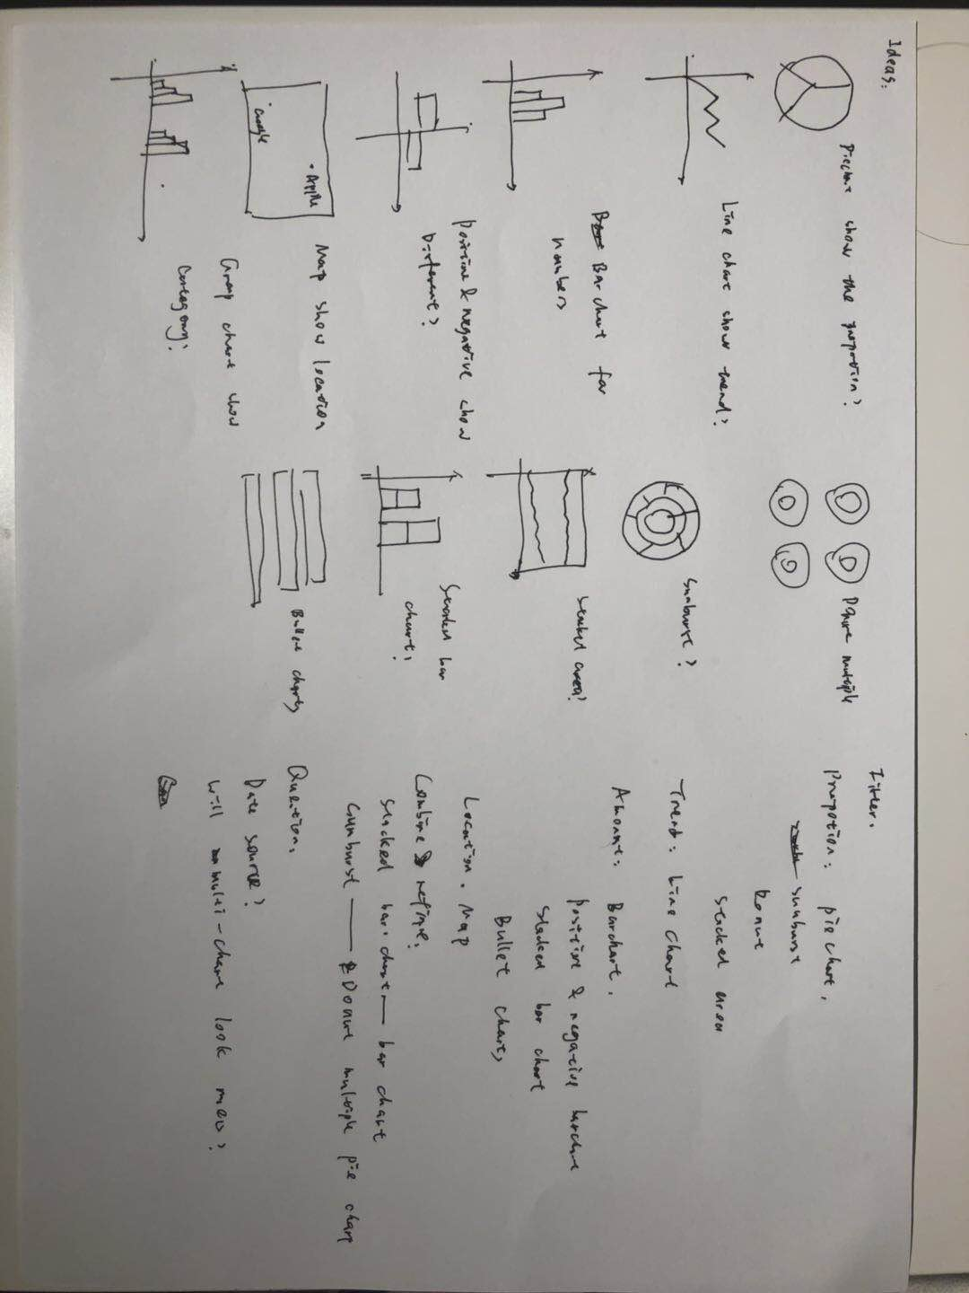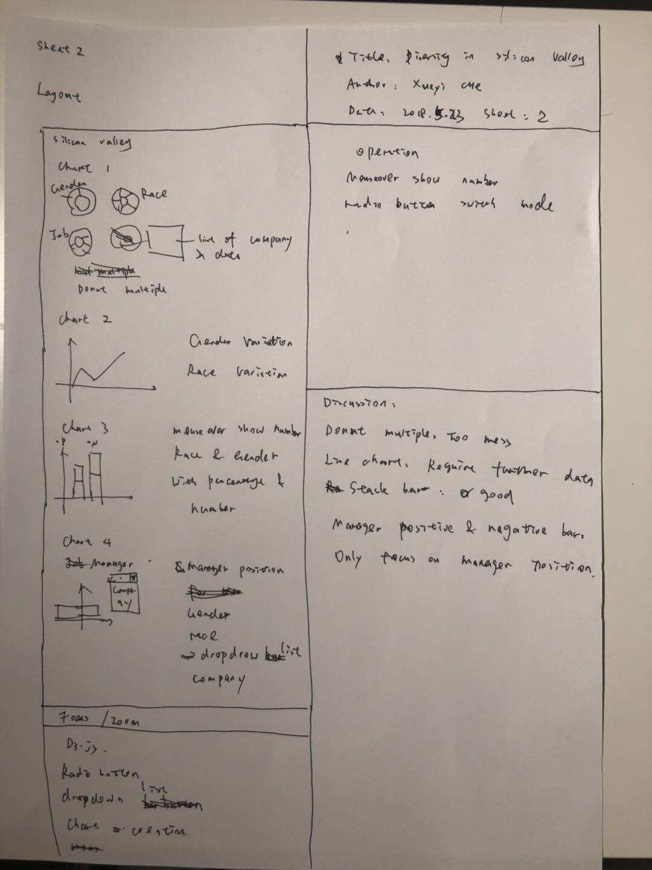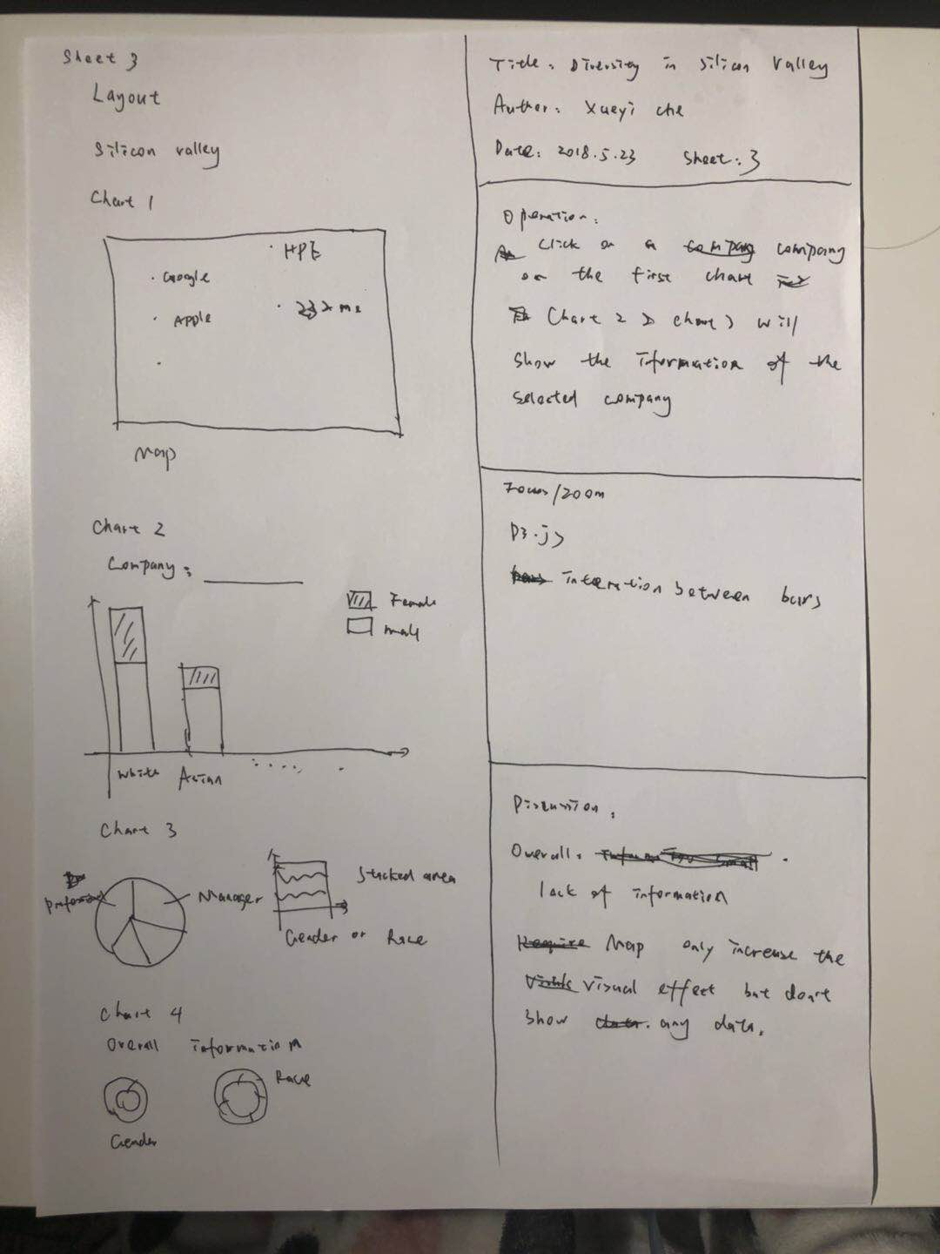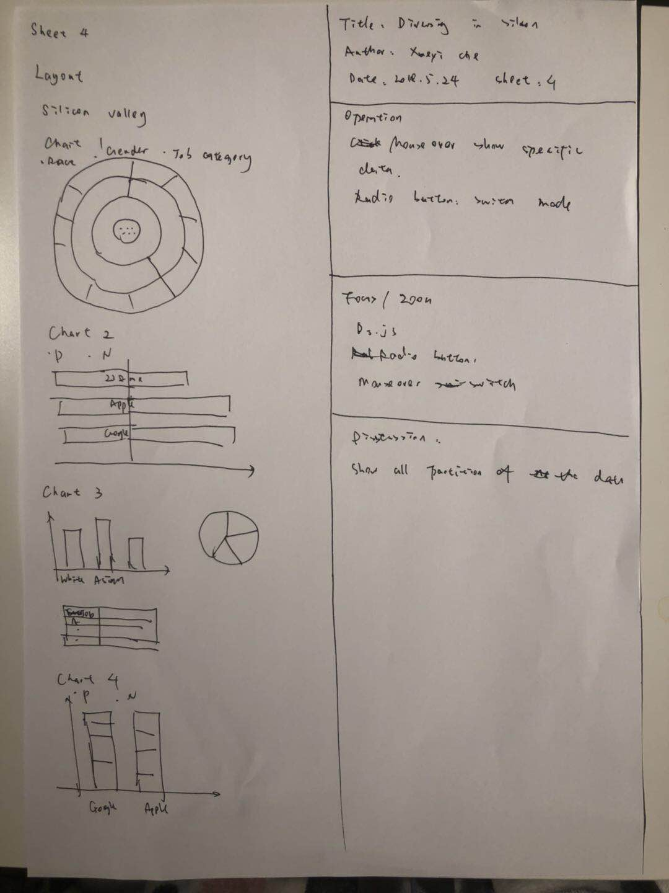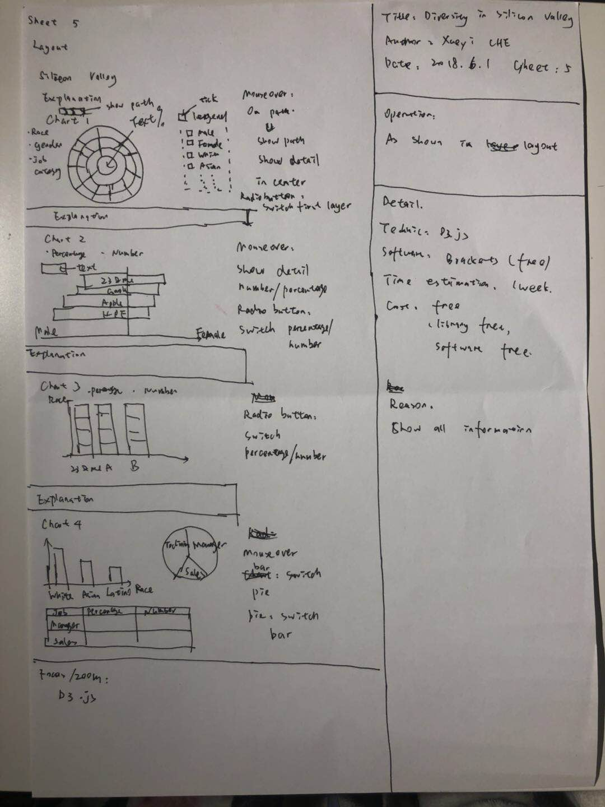

**Reason to choose the final design**

Sunburst can show the information clearly with partition. Positive and negative chart can contrast different attribute. Stacked bar chart indicate the race distribution clearly. The dashboard can demonstrate the relationship between race and job category. Overall, these four charts include all the information in dataset and explore the main idea the visualization want to do.

**Implementation**

The implementation uses the d3.js library. D3.js allows great control over the visualization which can demonstrate large quantity of data in one chart by mouse operation, which makes the visualization more clear.

**User guide**

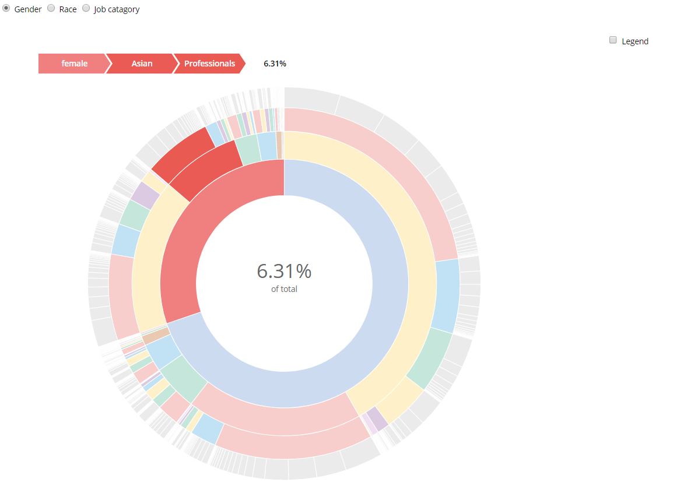

Figure 1: Chart1

The first chart is a summarize chart which demonstrate the overall information. The data set is based on the whole dataset using a sunburst chart.

User can switch the first layer by clicking the radio button. The option can be gender, race and job category. The first layer show the distribution of the selected category, the second layer show the distribution of the new category based on the first category. For example, if the first category is gender, the first layer would illustrate the proportion of the each gender in Silicon Valley, the second layer race would illustrate the proportion of each race of each gender. User can put mouse over the partition to see the exact proportion of people with specific gender, race, category and company. By clicking the toggle box in sidebar, users can see the color allocation for each category. The legend above the chart can show the specific path of the current mouse selection.

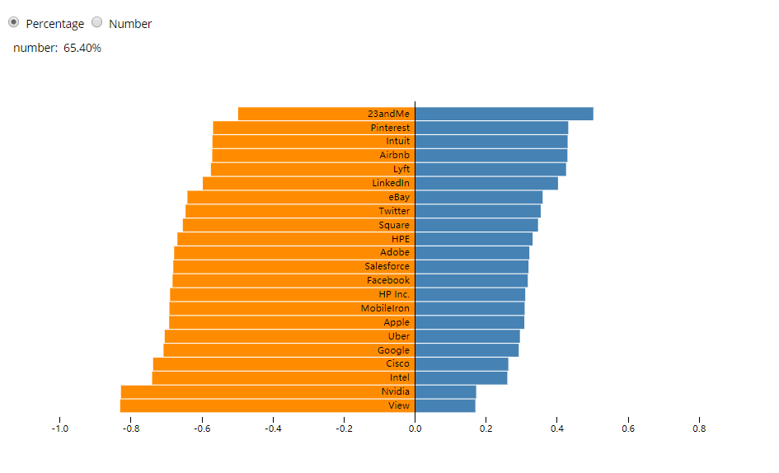

Figure 2: chart2

The second chart is a positive and negative bar chart for gender distribution of each company. The positive part show the proportion of female employee of the company and the negative part is for male employee.

User can switch the demonstration mode by clicking the radio button. There are two mode which are percentage and specific number. The data is sorted by the percentage of female employee. By move the mouse over the rectangular, the specific number or percentage would shown in the upper-left of the chart.

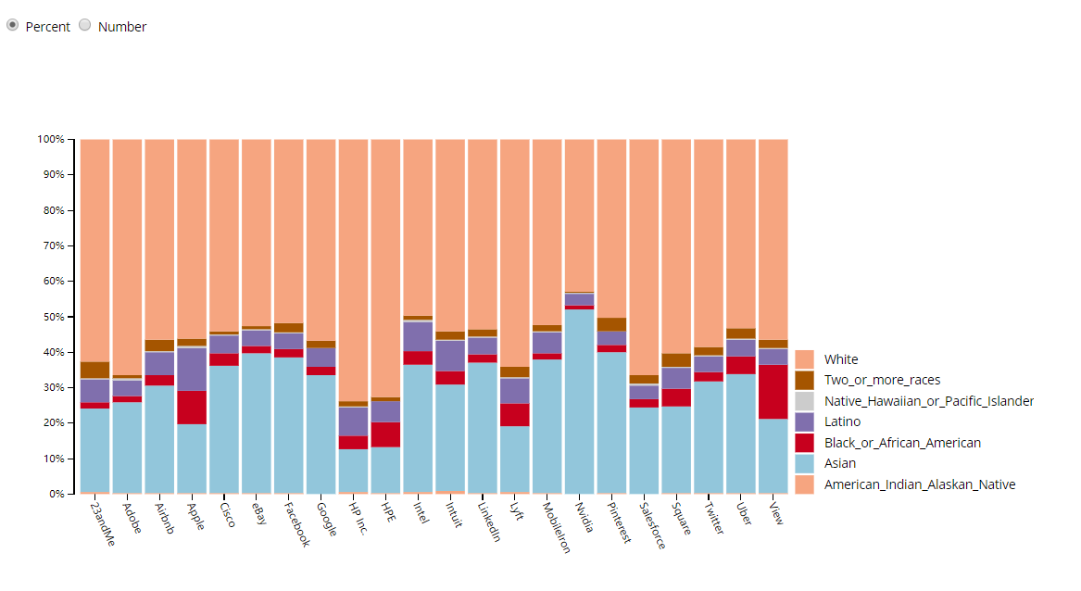

Figure 3: third chart

The third chart is a stacked bar chart for race distribution of each company.

User can switch the demonstration mode by clicking the radio button. There are two mode which are percentage and specific number.

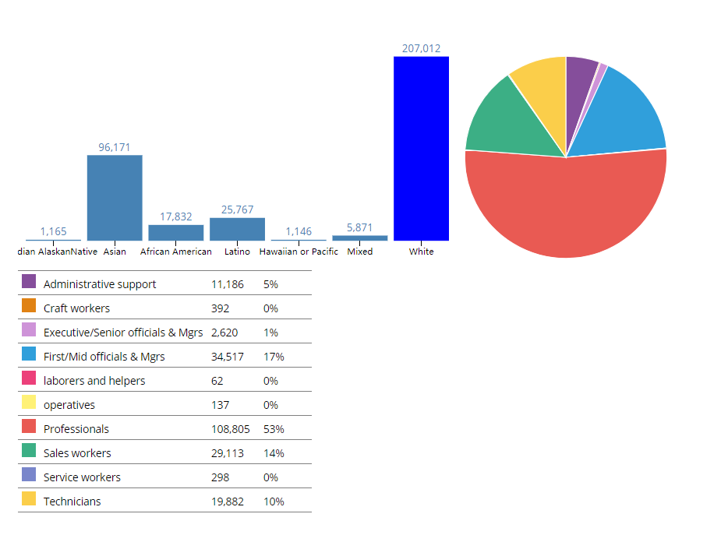

Figure 4: fourth chart

The fourth chart is a combination of bar chart and pie chart which aim to show the relationship between race and job category.

The bar chart show the overall race distribution and the pie chart shows the job category distribution.

User can move the mouse over the bar chart, the pie chart would switch to the job category distribution of the specific race as the user move the mouse on. The number and percentage of job category of the specific race would demonstrate in the table below.

Moreover, user can also move the mouse over the pie chart, the bar chart would switch to the race distribution of the specific job category as the user move the mouse on.

**Conclusion**

The visualization project shows the diversity of the Silicon Valley by four charts: sunburst chart, positive and negative bar chart, stacked bar chart and dashboard. The d3.js library is used to demonstration.

The dataset has 3010 dataset.

I’ve learnt how to build chart by using d3.js, basic javascript operation, advanced data processing by using excel and R language. I also learn some knowledge about html and css.

If I have more time to do the project, I would further improve the chart with better outlook, and let user do more operations which would illustrate more information in the chart.