1 activity consists of 4 fragments;

**android:theme="@style/Theme.AppCompat.Light.NoActionBar"**

**android:onclick=”addThreeFor”**

**setText**

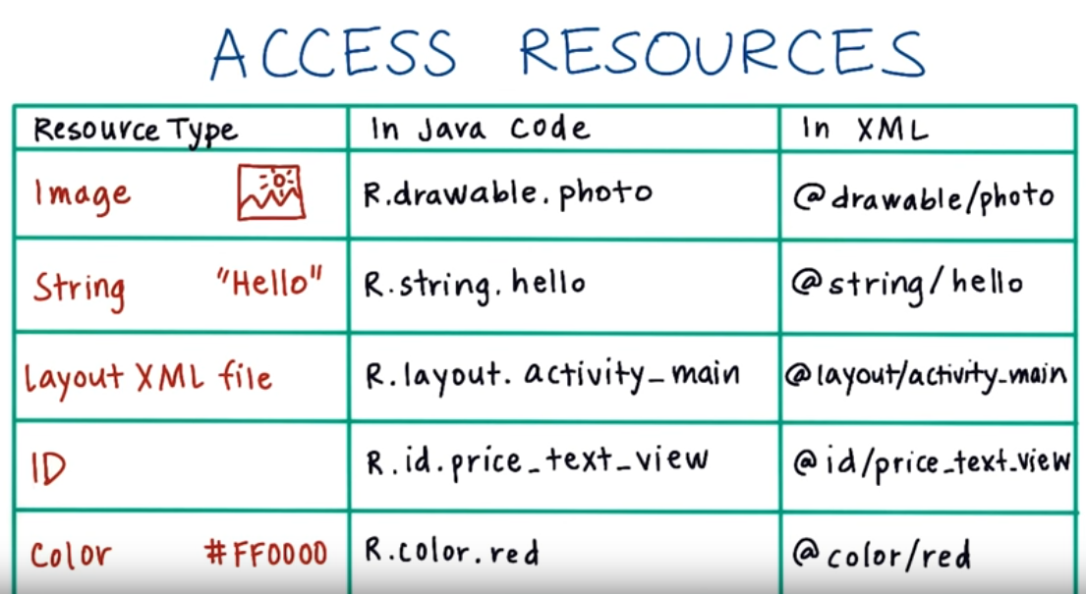

TextView: setText(..);

Navigation drawer

TextView textview = new TextView(this);

Textview.setText(“SW”);

setContentView(textview); findViewById

setVisibility(View.GONE);

TextView o = (TextView)findViewById(R.id.order_summary);

<**android.support.design.widget.FloatingActionButton  
 android:id="@+id/fab"  
 android:layout_width="wrap_content"  
 android:layout_height="wrap_content"  
 android:layout_gravity="bottom|end"  
 android:layout_margin="@dimen/fab_margin"  
 app:srcCompat="@android:drawable/ic_dialog_email"** />

**@style/ThemeOverlay.AppCompat.Dark**









<**style name="AppTheme.NoActionBar"**>  
 <**item name="windowActionBar"**>false</**item**>  
 <**item name="windowNoTitle"**>true</**item**>  
</**style**>

<**item name="colorPrimary"**>@color/colorPrimary</**item**>  
<**item name="colorPrimaryDark"**>@color/colorPrimaryDark</**item**>  
<**item name="colorAccent"**>@color/colorAccent</**item**>



*// for (Legislators_data legi : legislators_by_state) {  
// Log.v("state", legi.state_name);  
// }  
// Log.v("length of senate ", "is " + legislators_senate.size());  
// Log.v("length of house ", "is " + legislators_house.size());  
// for (Legislators_data l : legislators_senate) {  
// Log.v("last name", l.last_name);  
// }*

*// fragmentManager.beginTransaction().replace(R.id.content_frame, new AboutMe()).commit();*

|  |  |
| --- | --- |
|  | **From fragment to activty:**  ((YourActivityClassName)getActivity()).yourPublicMethod();  **From activity to fragment:**  FragmentManager fm = getSupportFragmentManager();  //if you added fragment via layout xml  YourFragmentClass fragment = (YourFragmentClass)fm.findFragmentById(R.id.your_fragment_id);  fragment.yourPublicMethod(); |



*<!--android:layout_centerVertical="true"-->  
<!--android:layout_marginLeft="@dimen/activity_horizontal_margin"-->  
<!--android:layout_marginStart="@dimen/activity_horizontal_margin"-->  
<!--android:layout_toEndOf="@+id/imageView"-->*

**tools:ignore="HardcodedText"**

**android:layout_alignParentLeft="true"**

**android:layout_alignParentStart="true"**

**android:paddingBottom="@dimen/activity_vertical_margin"  
android:paddingLeft="@dimen/activity_horizontal_margin"  
android:paddingRight="@dimen/activity_horizontal_margin"  
android:paddingTop="@dimen/activity_vertical_margin"**

// try to remove listView;

listView = (ListView) findViewById(R.id.***myListView***);  
side_index_bar = (LinearLayout)findViewById(R.id.***side_index***);  
listView.removeAllViewsInLayout();  
side_index_bar.removeAllViewsInLayout();

<**resources**>  
  
 *<!-- Base application theme. -->* <**style name="AppTheme" parent="Theme.AppCompat.Light.NoActionBar"**>  
 *<!-- Customize your theme here. -->* <**item name="colorPrimary"**>@color/colorPrimary</**item**>  
 <**item name="colorPrimaryDark"**>@color/colorPrimaryDark</**item**>  
 <**item name="colorAccent"**>@color/colorAccent</**item**>  
  
 </**style**>  
 <**style name="DetailTheme" parent="Theme.AppCompat.Light.DarkActionBar"**>  
 *<!-- Customize your theme here. -->* <**item name="colorBackground"**>@color/colorPrimary</**item**>  
 </**style**>  
  
  
 <**style name="AppTheme.AppBarOverlay" parent="ThemeOverlay.AppCompat.Dark.ActionBar"** />  
  
 <**style name="AppTheme.PopupOverlay" parent="ThemeOverlay.AppCompat.Light"** />  
  
</**resources**>

@Override  
**public boolean** onOptionsItemSelected(MenuItem item) {  
 **switch** (item.getItemId()) {  
 **case** android.R.id.***home***:  
 **this**.finish();  
 **return true**;  
 }  
 **return super**.onOptionsItemSelected(item);  
}

**android:theme = "@style/DetailTheme"**

**android:onClick="sendMessage"**

<**android.support.v4.view.ViewPager  
 android:id="@+id/viewPager"  
 android:layout_width="match_parent"  
 android:layout_height="match_parent"**>  
 <**android.support.design.widget.TabLayout  
 android:layout_width="match_parent"  
 android:layout_height="wrap_content"  
 android:id="@+id/tabLayout"  
 app:tabMode="fixed"  
 app:tabGravity="fill"**/>  
</**android.support.v4.view.ViewPager**>

<**LinearLayout  
 android:id="@+id/side_index"  
 android:layout_marginTop = "60dp"  
 android:layout_width="50dp"  
 android:layout_height="fill_parent"  
 android:background="#c3c3c3"  
 android:gravity="center_horizontal"  
 android:orientation="vertical"  
 android:layout_alignParentRight="true"**>  
</**LinearLayout**>

Me

,\"b\":\"true\"





1. When first loaded, check to see if this item is in the list :

Empty star ___NOT;

Full star ___ YES;

1. When click, full 🡪 empty: remove the item from the list;

When click empty 🡪 full: add this item to the list;

ETags --- Unix <i> Node for each servers;

**Q5: What is a common way to work around the cross-domain restriction of**

**XMLHttpRequest()?**

**A5: Use a proxy –OR- CORS**

ImageView fbImage = (ImageView)findViewById(R.id.***fb***);  
**if** (**this_legi**.**facebook_id** != **null**) {  
 fbImage.setOnClickListener(**new** View.OnClickListener() {  
 @Override  
 **public void** onClick(View view) {  
 Intent intent = **new** Intent();  
 intent.setAction(Intent.***ACTION_VIEW***);  
 intent.addCategory(Intent.***CATEGORY_BROWSABLE***);  
 intent.setData(Uri.*parse*(**"www.facebook.com"** + **this_legi**.**facebook_id**));  
 startActivity(intent);  
 }  
 });  
}

**package** com.wangxuhui.navigationdrawer;  
  
  
**public class** Date {  
 **int year**;  
 **int month**;  
 **int day**;  
  
 **public** Date(String input) {  
 String[] array = input.split(**"-"**);  
 **this**.**year** = Integer.*parseInt*(array[0]);  
 **this**.**month** = Integer.*parseInt*(array[1]);  
 **this**.**day** = Integer.*parseInt*(array[2]);  
 }  
 **public int** dateValue() {  
 **int** value = **this**.**day** + **this**.**month** * 30 + **this**.**year** * 30 * 12;  
 **return** value;  
 }  
 **public** String toString() {  
 String[] months = {**"Jan"**, **"Feb"**, **"Mar"**, **"Apr"**, **"May"**, **"Jun"**, **"Jul"**, **"Aug"**, **"Sep"**, **"Oct"**, **"Nov"**, **"Dec"**};  
 **return** months[**this**.**month** - 1] + **" "** + **this**.**day** + **", "** + **this**.**year**;  
 }  
}

<**LinearLayout  
 android:layout_width="match_parent"  
 android:layout_height="wrap_content"  
 android:orientation="horizontal"  
 android:layout_marginTop="30dp"**>  
 <**TextView  
 android:layout_width="0dp"  
 android:layout_weight="1"  
 android:layout_height="20dp"  
 android:textStyle="bold"  
 android:text="End Term:"  
 android:layout_gravity="left"**/>  
 <**TextView  
 android:id="@+id/legi_term_end"  
 android:layout_width="wrap_content"  
 android:layout_height="20dp"  
 android:text="name"**/>  
</**LinearLayout**>



