Autocomplete = “on”;

<datalist><option>…<datalist>

<progress value = “ “, max = “”, position = “”></progress>

<meter value/min/max/high/low/optimum></meter>

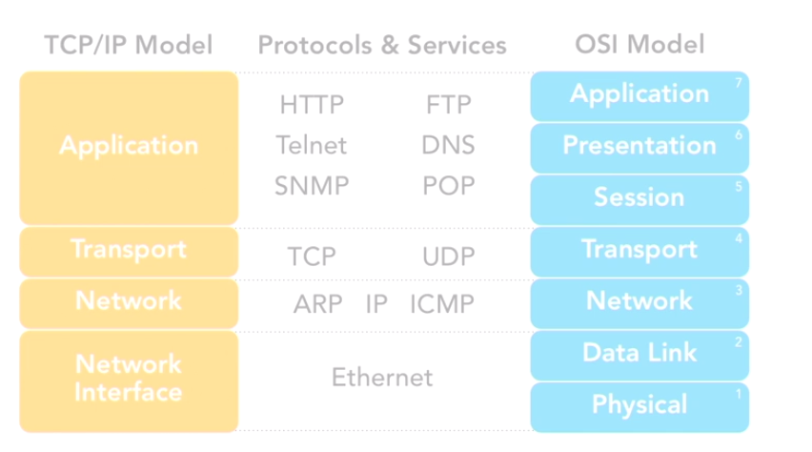

Array funcitions: count(), max(), min();sort(); rsort(); print_r();

In_array(14, $numbers);

Is_bool();is_float(); is_null(); isset();

empty(); // empty: "", null, 0, 0.0, "0", false, array()

gettype($var);

settype($var, “integer”); //in-place

(integer) $var; // NOT changing $var’s type;

Define(“max_length”, 980) ; // constants

var_dump();

htmlspecialchars(…);

htmlentities(…);

include();

require(); // fatal error if cannot load the file(different from include());

include_once();

require_once();

header(“HTTP /1.1 404 Not Found”);

headers are sent before page;

headers_list();

**Location:** path; // redirect; make a new get request

(php type juggling):

string vs. null: converts null to “”;

Boolean vs. other: converts other to Boolean;

number vs. other : converts other to number;

empty(); //

Multitline:

/(.*)/**s**

**@media screen and (max-device-width: 480px)**

**<link rel = “stylesheet” type = “text/css” media = “screen and (max-width: 570px)” href = “index.css”/>**

**<meta name=”viewport” content=”width=320”>**

**<link rel = “stylesheet” href=”main.css” type = “text/css” media=”screen”>**

**@media [not| only] screen and (…) {**