6-5-2021

Beñat, Jon, Abde and Mikel.

bOSST-GARREN TALDEA

Ubuntu SERVER

Index

Ethernet configuration: 2

Installing apache: 5

Installing php: 6

Installing mariadb: 7

Installing Webmin: 8

# Ethernet configuration:

Firstly, we should be sure about how many Ethernet adapters the server has. This picture shows the command typed in order to know it. ls /sys/class/net/

Of course, before we do any change in the configuration, we should create a copy of the configuration file to root. We added the extension as .org in order to do not have any kind of error. cp /etc/netplan/00-installer-config.yaml /root/00-installer-config.yaml.org

After that, we could change the entire configuration, so now we are going to move into the file. nano –c / etc/netplan/00-installer-config.yaml

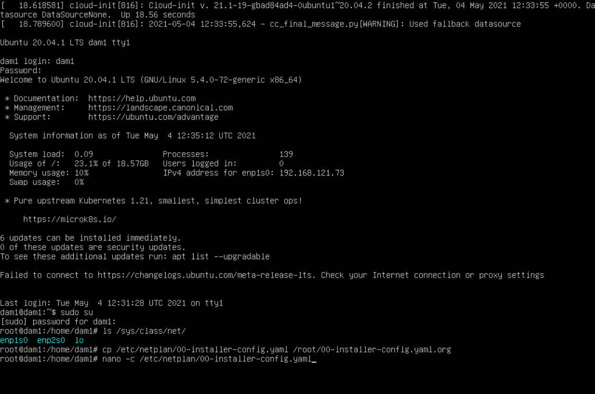

In this case, we should add the Ethernet, which does not appear in the file. BE CAREFUL! YOU MUST BE AWARE OF THE SPACES NECESARY TO TYPE THE IPS. Depending on the type of ip, you should type these different options:

* Addresses: [the ip]
* Gateway4: [the gateway’s ip]
* Nameserver:

Addresses: [dns’s ip]

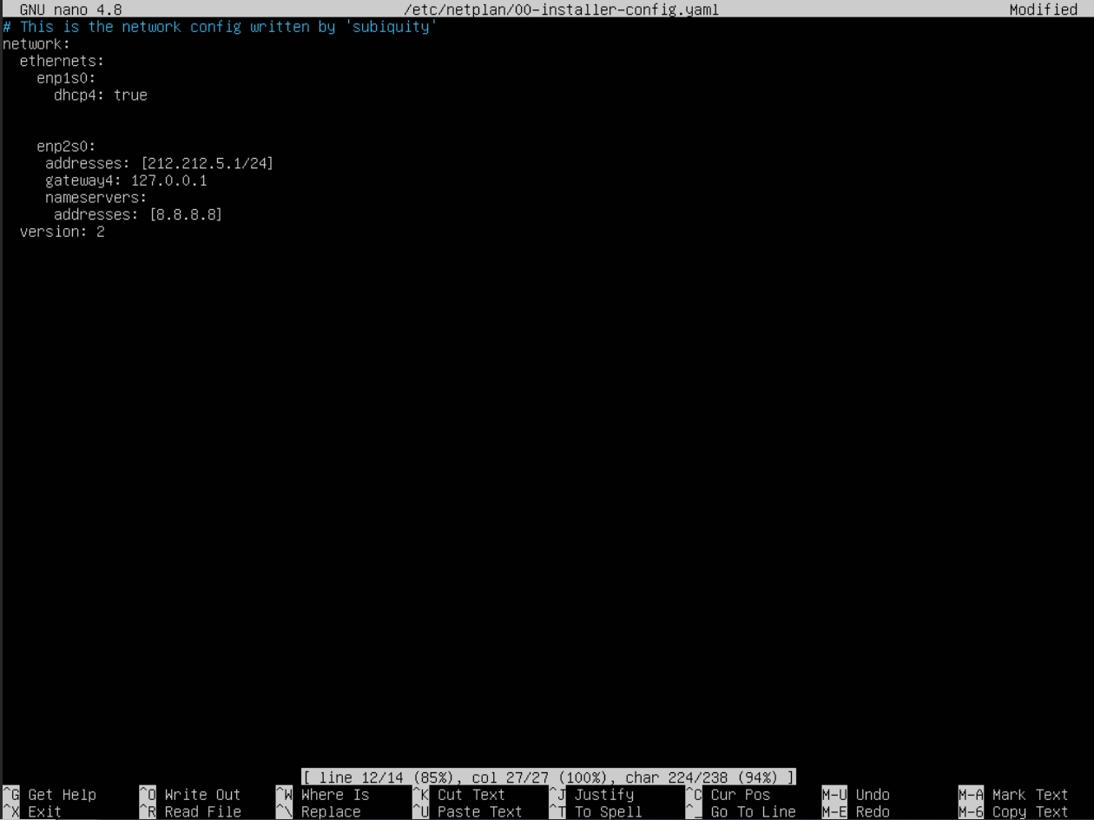

Once we have finished we have to type ctrl + o to save and ctrl + x to exit. As a result, our config file is ready to be used. To apply the changes we have to type the following command. Netplan apply

If you want to check If the changes are applied, type this command: ifconfig

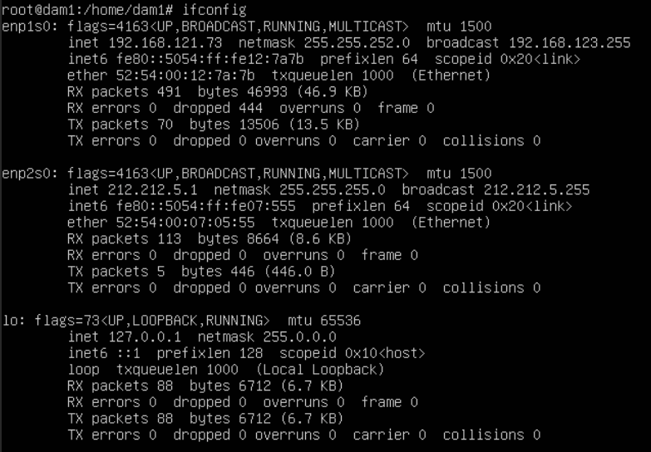

# Installing apache:

First, we should be sure of opening the ports 80, 443 and ssh. This are the ports that apache used in order to run. To open these ports, we should type these commands: ufw allow 80, ufw allow 443 and ufw allow ssh.

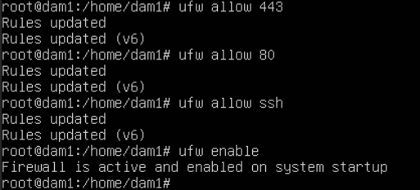

Now we have to type apt install apache2.

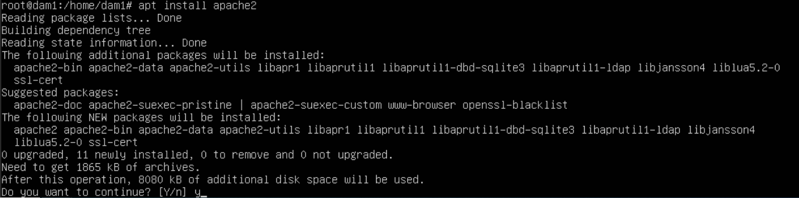

Once it has finished the installation, we are going to type systemctl apache2 status.

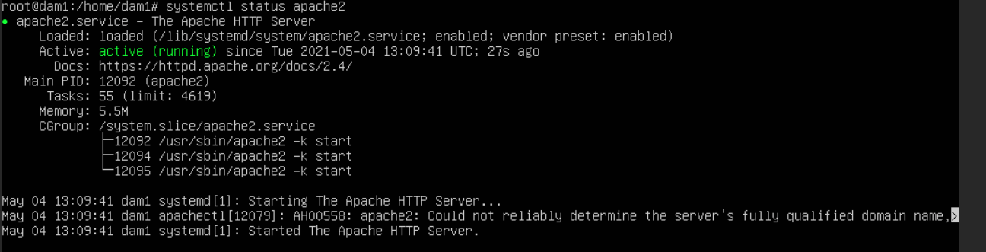

# Installing php:

It is true that our web server is working, but if we are going to use php code, we must install the php plugin. Due to that, we have to type apt install php7.4 php7.4-mysql php-common php7.4-cli php7.4-json php7.4-common php7.4-apache libapache2.

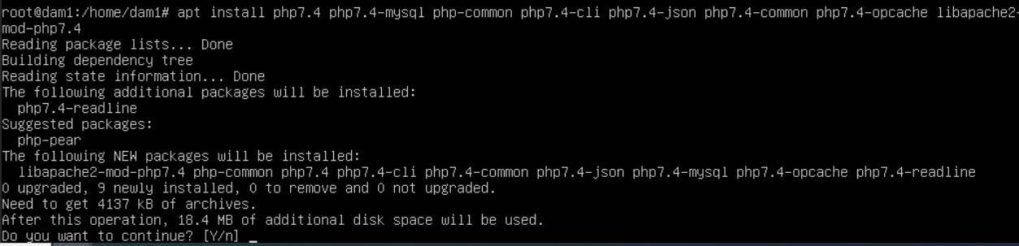

Let’s see the php version.

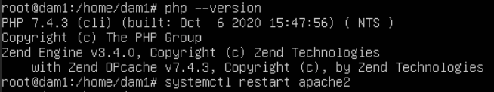

# Installing mariadb:

Now we are going to install mariadb due to the connection between our application and a database. In order to install mariadb we have to type apt install mariadb-client mariadb-server.

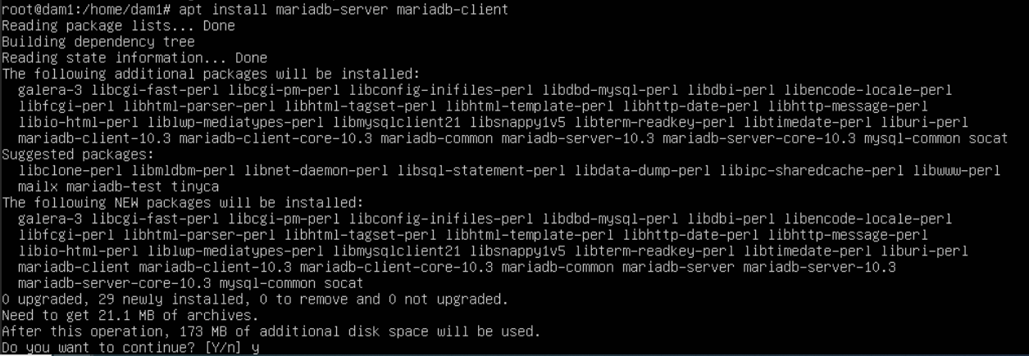

After it has installed, if you want to see the mariadb status you should type systemctl mariadb status.

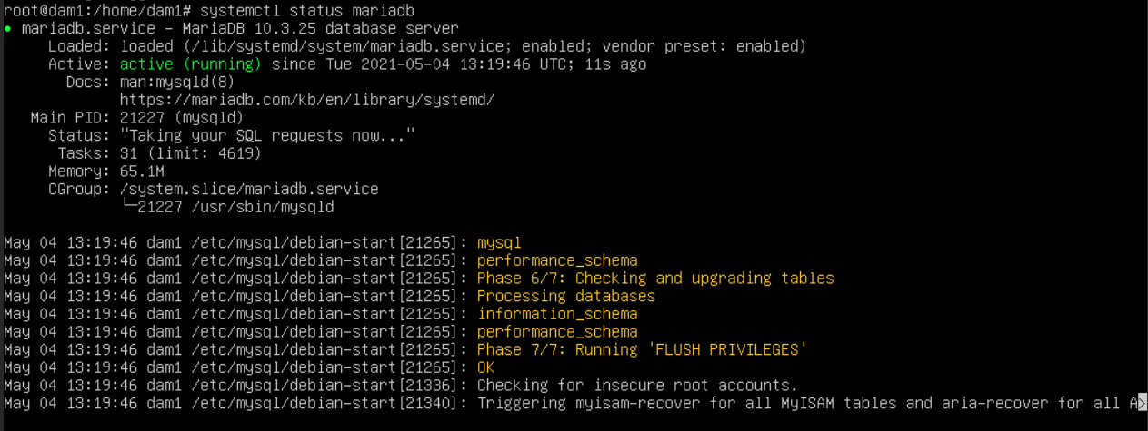

# Installing Webmin:

Before we install webmin, we have to add some repositories in order to be able to install it correctly. First of all we have to install the wget option.

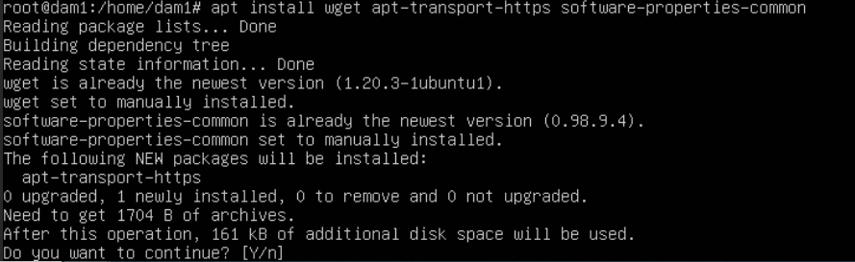

After that, we are going to add the webmin repository into our repository using wget.

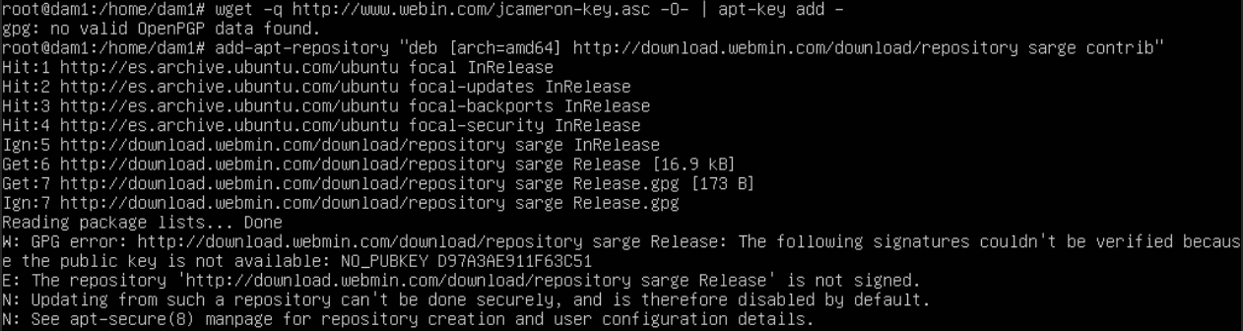

Finally, we can install webmin now. Moreover, we have to open the port 10000 as well.

