Four pods are running, service and deployment stats are normal
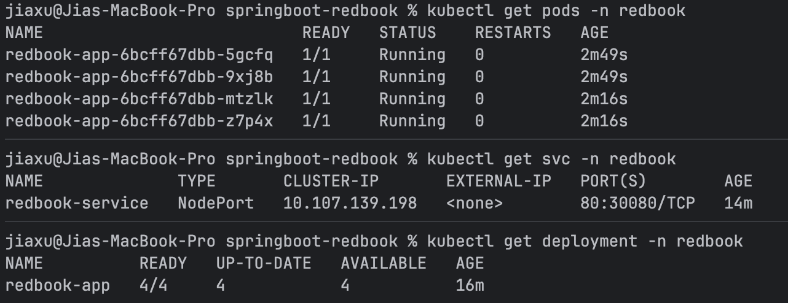
Logs of one of the pods are transmitting heartbeat
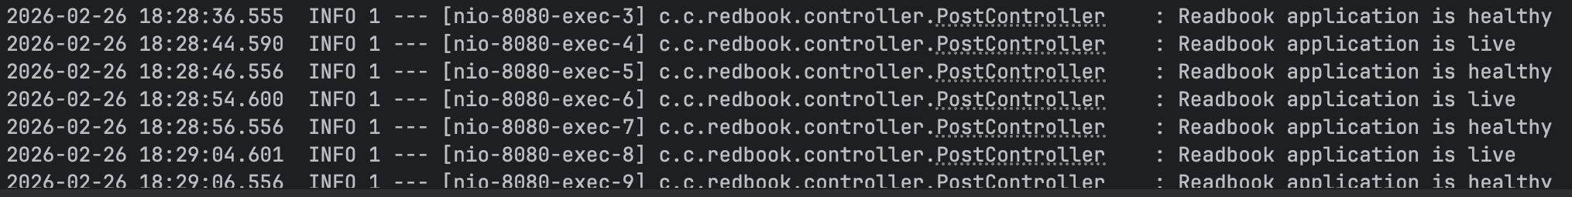

Access to application
Forward port: kubectl port-forward svc/redbook-service -n redbook 8080:80
Postman receives a good response.
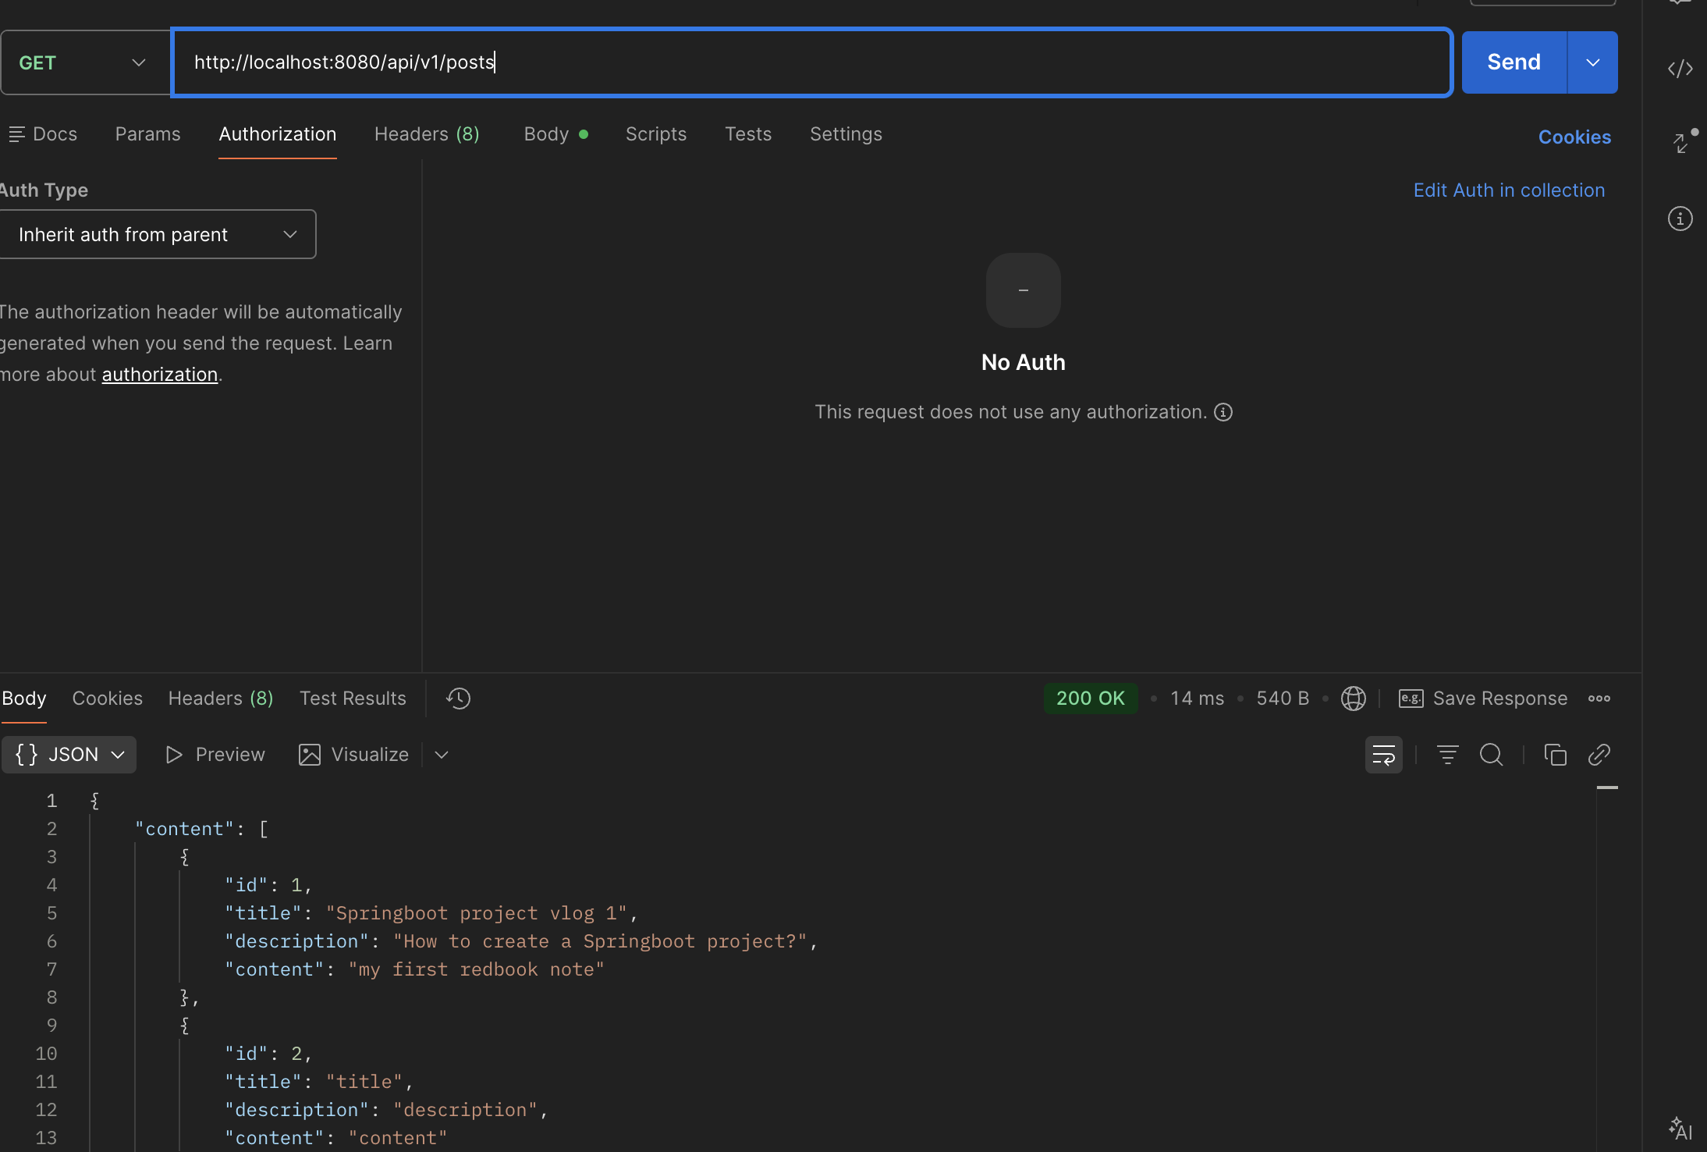
Monitor endpoints work
