10.1
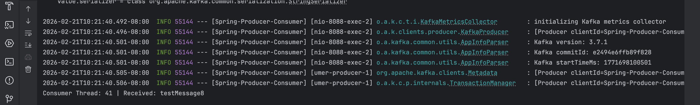

- consumer service prints on terminal
- total lag on consumer group is 0, proving that the latest log has been committed
10.2
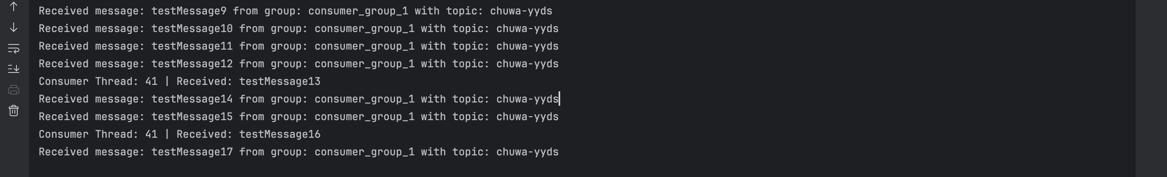
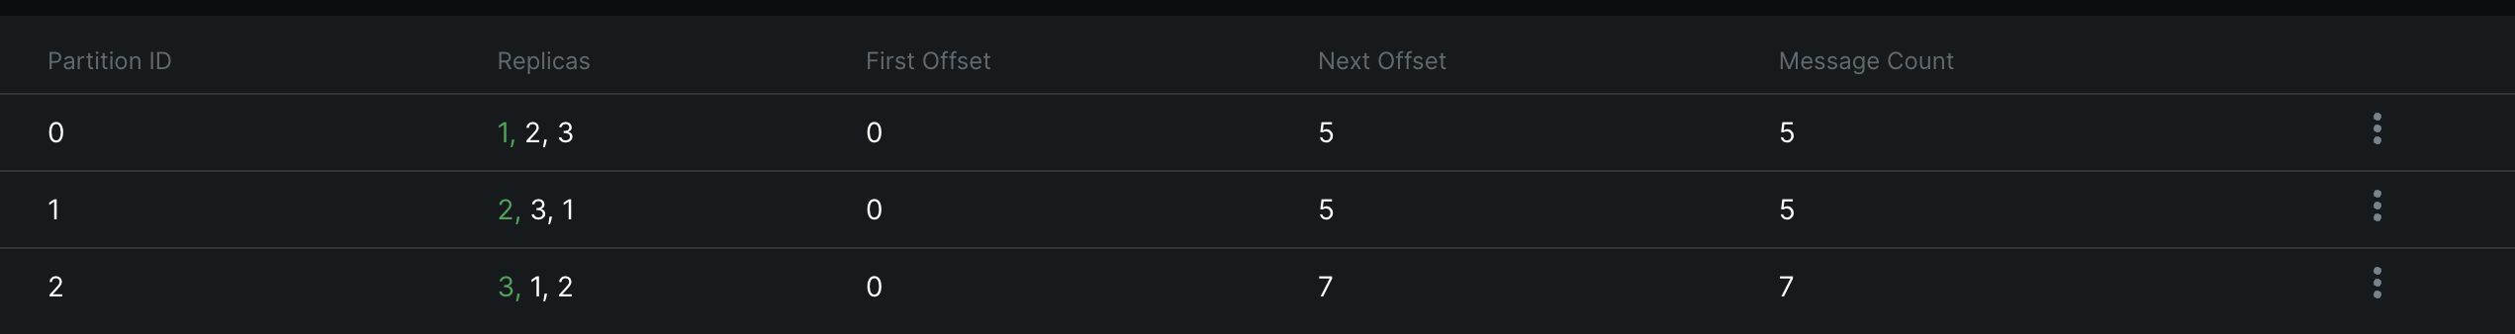
- thread 41 has not received
- only three consumers are active although there are six consumers
10.3
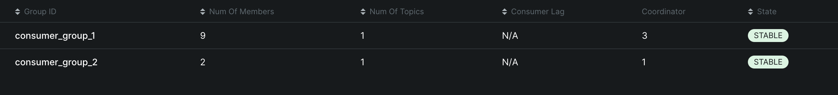

10.4
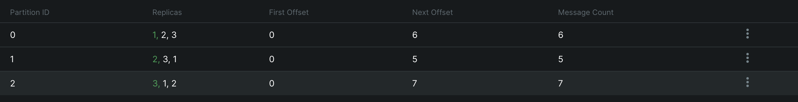
- test17, partition 2, offset 6; test 18, partition 0, offset 5
- in consumers, partition 2 next offset 7; partition 0 next offset 6

10.5 Delivery guarantees
a. At-Least-Once. Default. Stop server the offset won’t increase. If server restarts, message is delivered again.
b. At-Most-Once. Fast but risk. Consumer commits offset immediately when it receives messages, even before code runs. Code change:
props.put(ConsumerConfig.ENABLE_AUTO_COMMIT_CONFIG, "true"); props.put(ConsumerConfig.AUTO_COMMIT_INTERVAL_MS_CONFIG, "100"); // Commit almost instantly
c. Exactly-Once. This ensures that even if a message is retried, the end result happens only once. In spring boot, we need to make it transactional.
@Bean
public ConcurrentKafkaListenerContainerFactory<String, String> kafkaListenerContainerFactory() {
ConcurrentKafkaListenerContainerFactory<String, String> factory = new ConcurrentKafkaListenerContainerFactory<>();
factory.setConsumerFactory(consumerFactory());

// This makes the consumer part of a transaction
factory.getContainerProperties().setAckMode(ContainerProperties.AckMode.MANUAL_IMMEDIATE);
return factory;
}

10.6
Adde custom partitioner to filter word “priority”. It should go to partition 0.

