Screenshots
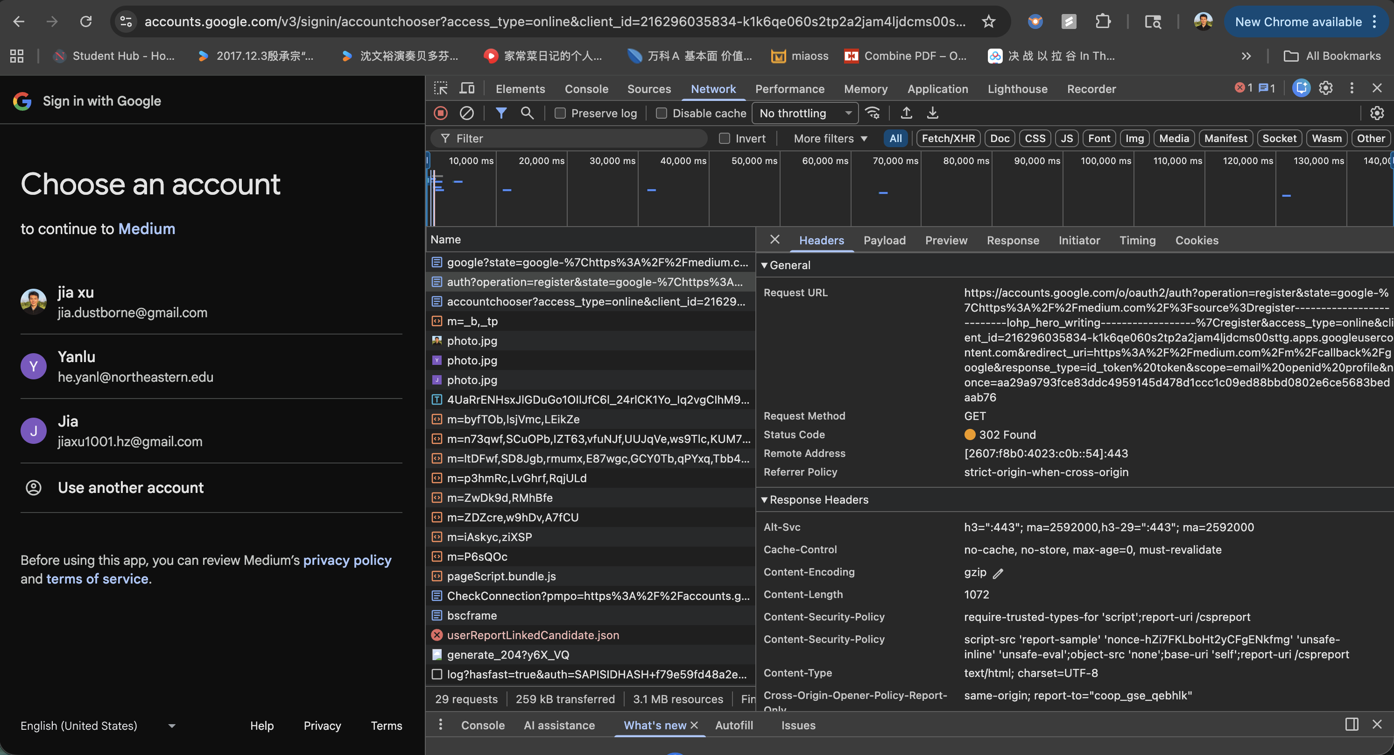

Step-by-Step SSO Flow
- Initiation: You click the "Continue with Google" button. The website redirects your browser to Google's OAuth 2.0 endpoint.
- Authentication: Google asks for your credentials (email/password) or uses your existing session.
- Consent: You agree to share specific info (e.g., email, name).
- Redirection (The Code Exchange): Google redirects you back to the website with a temporary Authorization Code.
- Token Exchange: The website's server takes that code and exchanges it with Google for an ID Token (containing your identity) and an Access Token.

1. The Invisible Handshake (Back-Channel)
In a secure implementation (like Pinterest or Canva), the website doesn't want your browser to ever touch the "Access Token" or "Refresh Token" if it can help it.
- What you see: Google sends your browser back to the website with a short-lived code in the URL.
- What you DON'T see: The website's server takes that code, adds its own secret (the client_secret), and makes a direct POST request to https://oauth2.googleapis.com/token.
- Why it's hidden: Since this is a server-to-server call, it never passes through your browser's Network tab. This prevents malicious browser extensions or scripts (XSS) from stealing the master tokens.
- 2. The Final Result: The JWT
- Once the website’s server has confirmed your identity with Google, it creates its own Session Cookie or JWT (JSON Web Token) to "remember" you.

