The DARPA trans-formative applications
project is an implementation of the ideas
found in the 2003 book “Power to the
Edge” by Alberts and ?
We have established a working version of
Ammo and have demonstrated its
capability to provide a programming
interface to several application areas.
This project is the summary of the work
done to support a sustainment officer in
installing, and validating a network
(Michael James). There is also a MIC
project investigating the design of
networks using the mechanisms

Overview

Project overview rather than a deep dive
●
Project is growing
 Need
 Mechanisms
 Configuration
 Validation
 Status
Ammo is a vigorous project with a two
year history which started as a Summer
internship project.
Situational Analysis


Before you can have a mutex you need
messages
Before you can have reliable systems using message
passing you need to have message passing. Ammo
provides a distributed data store which is kept up to
date via opportunistic message passing.

Let's first consider the problem of the network
sustainment officer.
When a region is first entered the network connectivity
is limited to those serial radios typically used for
voice communications. However, we have
demonstrated that those radios can be effectively
used to communication team location using TDMA,
time division multiple access.
* We have recently implemented and demonstrated
this. We are reviewing the results of that test.

As the number of nodes increase a mesh network can
be formed. An example of this is OSRL (we don't
presently have a channel for this).

The Optimized Link State Routing Protocol (OLSR) is
an IP routing protocol optimized for mobile ad-hoc
networks. (or like OLPC)

The IP layer is established by wireless access points and
routers.
- We have a channel for this using UDP multicast.

Gateway connections via TCP add reliable delivery.
- We have a channel for TCP with several encodings

Gateway to gateway traffic is faster an more reliable.
Caching is used extensively.
- This is presently implemented, Jonathan Williams

Quality Evolves

In reality you will have all situations simultaneously.
The problem is that the network is built quickly, used
extensively, and disassembled. So there is no time to
tune the network. It has to be sufficient for the
project needs immediately. We need to provide tools
to people who will design the network.

The following set of applications are presented
to illustrate a typical set of network objectives
They demonstrate different types of information
and its corresponding dissemination
Consider the case of tsunami in Japan, or
hurricane in Haiti. The infrastructure of
the country is decimated, including
information networks, cell towers,
electrical grids, ...
In addition many people are injured and
in need of prompt medical attention.
Providing shelter, water and food to the
uninjured is also critical. Speed is
essential so speculative decisions are
warrented.
TDMA
(dynamic)
latency
CSMA
TDMA
(static)
participants
This application is concerned with knowing where your
friends are are and where the obstacles and targets
are located. The only equipment available may be
two-way radios and smart phones.

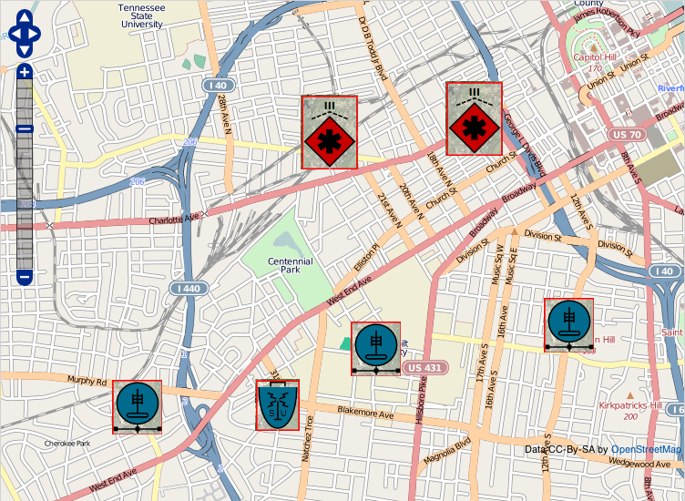
Characterized by regularly repeated location updates
by everyone in the team. This is well suited for
TDMA, where each participant gets a unique time
slice (or slot).
First priority is to get patrols out to find the problem
areas. Any provision for collaboration between
rescue works will be helpful.
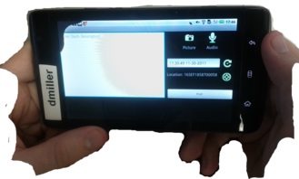
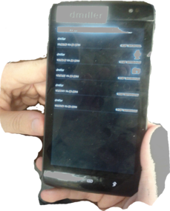
The aid workers can communicate via voice. It will
also be important to be able to send data over the
same communication channels. There is a need for
providing ad-hoc messages between workers.
- multiple senders
- various receivers
- soft deliver times
Average channel clearing rate
Burst size
During their patrols the aid workers will find situations
about which they will need to report. These
constitute patrol reports.
Regardless of the type of communication these event
triggered messages will need to supersede the
periodic messages from each worker. This illustrates
the need to have a channel which overlays the time
triggered protocol used for publishing locations.
The network sustainment officer, in anticipation of this
situation, needs to decide how the scarce bandwidth
can be partitioned so as to reduce the possibility of
losing messages.
We have demonstrated that the simulator can provide
this type of information. The time that it takes to
clear an overloaded system is an important metric.
Ideally the number of bytes to send divided by the
total channel capacity gives a base line to compare
the rate that the channel is emptied.
Medical evacuations provide a unique example due to
the requirement for high reliability, verification of receipt and response, and high priority. In this area
more rigor is warranted
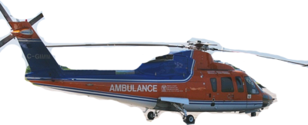
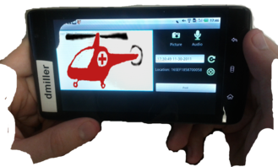
Consider the needs of the medics. They can use live
streaming video.
Frames can be lost, only the most current frame is
important.
- Invitations are sent.
Video is only sent if there are participants.
Again the other message types are superseded as
designed by the sustainment officer.
It is also important to check on the status of messages
independent of the applications using or generating.
Message and system status.

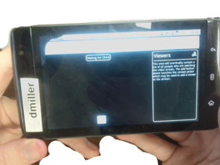
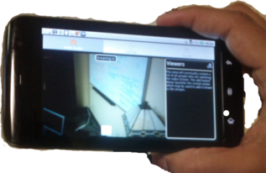
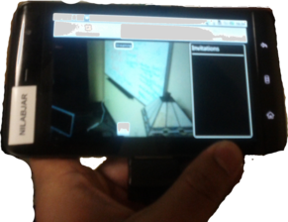

Architecture

 Android (iPhone)
 Gateway
 Interfaces generate from contracts
● data contracts (GME)
● protocol buffers (Google)
● JSON
● custom encoding (Application)
Ammo components are network nodes
this include mobile smart phones and
dedicated gateways. Currently
development is Android only, due to
service implementation limitations.

To assist application developers we provide code
generation to access the distributed data store.
RPC is problematic.
Mobile Device
Application
Content Provider
Dispatcher
Distributor
Channel Management
Channel
Gateway
Mechanisms

Distribution policy
● ● Channel routing rule
● Priority
●

Topic
Other quality of service attributes
Hardware deployment
● Dell Streak
● Windows 7
● RedHat 6
These are the elements which the
sustainment officer has at his disposal.

We start with the physically constrained network.
These constraints may be imposed by hardware,
terrain, weather or any number of other thins. This is
outside the scope of the current presentation. There
are members of the team who are addressing such
concerns as they arise. The origin of this class
project has it roots in using simple voice radios for
data communication.
S2
G1
* → G2
* → G3
* → G4
S2
G2
G3
G4
* → G1,G2
* → G1
* → G5
*→G1,G3,G5
G5
H3
H1
H2
H4
P1
- → G2,G4

The network gets structure by introducing rules which
govern how policy decisions are shared. This is
meta data which is the first level of policy rules.
These are presumed to be statically specified during
provisioning.
S1
G1
T1 → G2
T1 → G3
S2
Post T1
G3
G2

G4
T1 →G1
T1 →H2
T1 → G2
G5
H3
H1
P1
H2
T1 →G4
Interest T1
H4
The shape of the routing patterns are emergent
behavior which results from :
- physical configuration and environment
- routing policy
- application
- operator situation

S1
G1
T1 → G3
S2
Post T1
G3
G2
G4
T1 →G1
T1 →H2
T1 → G2
G5
H3
H1
P1
H2
T1 →G4
Interest T1

If there is some failure in the network the information
should still get through. The ability of the network to
deliver messages should degrade gracefully.
Configuration
Topic
Identifed
Channels
Selected
expire
Generally Ammo provides two
mechanisms to allow the network to be
configured:
- named data (Van Jacobson)
- channel selection
For each of these there are quality of
service properties. Example would be
message priority and expiration time.
The message priority gives a partial
ordering while the expiration time
indicates when the information no
longer has significant value.

inactive
Channel
activation
failed
active
pending
sent
expire
Request
queuing
sent
queued
expire
told
expire
Request
repaired
lost
bad
bad
expire
delivered
expire
expire
Many of the elements in Ammo may be modeled with
a discrete event model. Here we have the
distribution mechanism. This lends itself to
simulation with discrete event simulators such as ns-
3 or CPN-tools
In particular this model shows how requests would be
dispatched over a single channel.
Request Dimensions
past : future
gross : specific
produce : consume

Simulate
Publish
Retrieve

Retrieve

Subscribe+
Subscribe

The types of requests can be grouped in several ways:
- data type I am interested in : data types I originate
and own
- information from the past | information which may
come in the future
- providing varying degrees of specificity and filtering

Propositional Formula
(gateway x (multicast + (serial x terse)))
Short Circuit Conjunctive Normal Form (SCCNF)
(gateway) x (multicast + serial) x (multicast + terse)
The procedure begins with any formula of classical
first-order logic:
- Put the formula into negative normal form, bring the
negation operator to the literals
- Standardize variables into a global namespace
- Skolemize – replace existential variables with Skolem
constants or functions, from the outside inward.
- Discard universal quantifiers, as they are implicit
- Put the formula into conjunctive normal form
Although I created this independently, I have found it is
closely related to “clausal normal form” which is the
foundation of languages such as Prolog.
begins with any formula of prepositional first-order logic.
public DistributorState multiplexRequest(AmmoService that, RequestSerializer serializer) {

if (this.policy == null) { // no matching routing topic
ChannelDisposal actualCondition = that.checkChannel(DistributorPolicy.DEFAULT);
if(actualCondition == ChannelDisposal.QUEUED) {
actualCondition = serializer.act(that,Encoding.getDefault(),DistributorPolicy.DEFAULT);
}
this.put(DistributorPolicy.DEFAULT, actualCondition);
return this;
}
this.total(true);

for (final DistributorPolicy.Clause clause : this.policy.clauses) {
boolean clauseSuccess = false;

for (DistributorPolicy.Literal literal : clause.literals) {
final String term = literal.term;
final boolean goalCondition = literal.condition;
final ChannelDisposal priorCondition = (this.containsKey(term)) ? this.get(term) : ChannelDisposal.PENDING;
if (priorCondition.goalReached(goalCondition)) { clauseSuccess = true; break; }
}
if (clauseSuccess) continue;

for (DistributorPolicy.Literal literal : clause.literals) {
final String term = literal.term;
final boolean goalCondition = literal.condition;
final ChannelDisposal priorCondition = (this.containsKey(term)) ? this.get(term) : ChannelDisposal.PENDING;

ChannelDisposal actualCondition;
switch (priorCondition) {
case PENDING:
actualCondition = that.checkChannel(term);
if(actualCondition == ChannelDisposal.QUEUED) {
actualCondition = serializer.act(that,literal.encoding, term);
}
this.put(term, actualCondition);
break;
default:
actualCondition = priorCondition;
}
if (actualCondition.goalReached(goalCondition)) { clauseSuccess = true; break; }
}
this.and(clauseSuccess);
}
return this;
}
into negation normal form, bring
erators to the literals
riables, where variable are in a

The code for multiplexing the CNF rules.
Content Sensitive Routing : Prefix Matching

<?xml version="1.0"?>

<policy>
<topic type="">
<description>Sample.</description>
<routing priority="normal" category="postal">
<clause>
<literal term="gateway" condition="success" encoding="json" />
<literal term="multicast" condition="success" />
</clause>
</routing>
<routing priority="high" category="subscribe">
<clause>
<literal term="gateway" condition="success" />
</clause>
</routing>
</topic>

<topic type="urn:trial:dummy/">
<routing priority="normal">
<clause>
<literal term="multicast" condition="false" encoding="json" />
<literal term="serial" condition="true" encoding="terse" />
</clause>
<clause>
<literal term="gateway" condition="true" encoding="json" />
<literal term="serial" condition="false" encoding="terse" />
</clause>
</routing>
</topic>

</policy>

Here we see a simple example containing a few prefix
topics and the corresponding first order logic
functions.

Some nodes are white (no values) others have values
(black).
The performance is similar to hash maps, O(k), but
with the added advantage of prefix matching. Of
course the constants are bigger. Careful
implementations can reduce these constance
considerably, the best using bursting to do so.
It is possible that one of the routing protocols, such as
Cord, could be modified to accommodate prefix
matching, but that is beyond the scope of this
project.
<configuration>

<appender name="STDOUT"
class="ch.qos.logback.core.ConsoleAppender">
<encoder>
<pattern>%d{HH:mm:ss.SSS} [%thread] %-5level %logger{36} - %msg%n</pattern>
</encoder>
</appender>

<appender name="LOAD_RECORDER"
class="ch.qos.logback.core.FileAppender">
<encoder>
<pattern>%d{HH:mm:ss.SSS} [%thread] %-5level %logger{36} - %msg%n</pattern>
</encoder>
</appender>

<root level="debug">
<appender-ref ref="STDOUT" />
</root>
</configuration>

http://logback.qos.ch/manual/configuration.html
During provisioning the network officer can schedule
the recording of empirical data during runtime via a
logging framework.
http://logback.qos.ch/manual/configuration.html
NS-3 : Discrete Event Simulation

Reviewed and corrected bugs in TDMA-MAC
model
The PetriNet is a discrete event modelling
language, NS-3 is a discrete event
network simulator.
We selected NS-3.
- Installed
- Built
- Worked through tutorial
Began work on serial modules for
channel and net-device.
We also debugged the TDMA-MAC
module, which is under development.

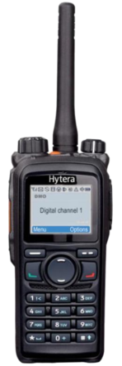
We have implemented this configuration and
demonstrated it with 16 rado/phone nodes.

Explain the NS-3 components
- Application
- Node
- Network Device
- Channel
Application
NS3 vs. NS2
 simulation scripts: OTcl vs. C++/Python
 Modularity of components
 Scalability of simulations

Integration/reuse of externally developed code
and software utilities
 Emulation
 Tracing and statistics
 Validation
. The ns-3 project is designing a follow-on successor
to the popular ns-2 simulator. ns-3 is a rewrite of
the core of the simulator
Architecture
 
●
●
Internet-node library

●
Node library

●
Simulator library

●
Core library
Device library
Core library
--debugging,callbacks,smart pointer,unit tests...
Simulator library
--time objects, schedulers, and events
Node library
--defines abstract base classes, such as nodes,
channels, and network devices
Internet-node library
--Internet-related models (IP and transport
protocols)
Device library (Specific devices such as Ethernet)
Logging

seven levels of log message
--NS_LOG_ERROR
--NS_LOG_WARN
--NS_LOG_DEBUG
--NS_LOG_INFO
--NS_LOG_FUNCTION
--NS_LOG_LOGIC
--NS_LOG_ALL


Script code
--LogComponentEnable("UdpEchoClientApplication", LOG_LEVEL_INFO);
Command Line
--export 'NS_LOG=UdpEchoClientApplication=level_all|prefix_func|
prefix_time'
seven levels of log message
--NS_LOG_ERROR,NS_LOG_WARN
--NS_LOG_DEBUG
--NS_LOG_INFO — Log informational messages
about program progress;
--NS_LOG_FUNCTION — Log a message
describing each function called;
--NS_LOG_LOGIC – Log messages describing
logical flow within a function;
--NS_LOG_ALL
two ways to get the logging information
●
Tracing
 Tracing is for post-processing
 ASCII-Tracing
 PCAP-Tracing

How to build a NS3 model
●
Key simulation objects Node,NetDevice,Channel
Topology
CommandLine cmd;
cmd.AddValue("nPackets","Number of packets to echo",nPackets);
cmd.Parse(argc,argv);

LogComponentEnable ("UdpEchoClientApplication", LOG_LEVEL_INFO);
LogComponentEnable ("UdpEchoServerApplication", LOG_LEVEL_INFO);
NS_LOG_INFO("Creating Topology");

NodeContainer nodes;
nodes.Create (2);

NS_LOG_INFO("Define p2p Helper");
PointToPointHelper pointToPoint;
pointToPoint.SetDeviceAttribute ("DataRate", StringValue ("5Mbps"));

NetDeviceContainer devices;
devices = pointToPoint.Install (nodes);

InternetStackHelper stack;
stack.Install (nodes);

Ipv4AddressHelper address;
address.SetBase ("10.1.1.0", "255.255.255.0");

Ipv4InterfaceContainer interfaces = address.Assign (devices);

UdpEchoServerHelper echoServer (9);

ApplicationContainer serverApps = echoServer.Install (nodes.Get (1));
serverApps.Start (Seconds (1.0));
serverApps.Stop (Seconds (10.0));
We use helper and containers to build the network
topology
During runtime, we configure the helper with
command line.
DataRates, workloads,number of nodes
Helper:NetDeviceHelper, ApplicationHelper
Network Design Validation



Project Status

Simulation for serial channel
● ● Model for ns3 netdevice – in progress
● Model for ns3 applications – existing applications
●

Model for ns3 channel – in progress
Review and debug TDMA-MAC – complete
Speculative reliability
●

External posting with qualification
Augmenting logging with checkpointing
The simulation of the system using ns3 is
ongoing. It will make use of models
developed for provisioning the system
[Michael James] to generate models for
the simulator.
Conclusion

Small systems can use mutual exclusion
●

Although deadlock can be eliminated, partial
ordering can introduce unacceptable latency
Large systems need speculative evaluation
As illustrated in [Nightingale] speculative evaluation
can improve latency at the expense of unnecessary
computation.
Systems with a social aspect are frequently
speculative, for example market based economies
are speculative. Command based economies can
be more efficient but they suffer from slower
progress.
We just completed a test where our system running
over serial radios worked well while a similar system
over wireless routers with mutual exclusion did not.
The current version of Ammo provides minimal
guarantees. Future version will enhance these
guarantees and provide information at various
scales, scopes and to other external players.
Attribution and Acknowledgements
 DARPA for funding and management
 Sandeep Neema – Primary Investigator
 Application development teams and developers
 Demetri Miller – prototype, user interface
 Michael James – channels and provision model
 Jonathon Williams – gateway and architecture
 James Edmonson – testing framework
 Xujie Si – simulations with ns3
 Fred Eisele – prototype, architecture, core, sdk
Mary Maeda – DARPA Project Manager
In addition many application developers
who make use of the sdk and without
whom nobody would care about the
middleware.
Doug Hackworth – messaging, contacts
Nilabja Roy – video-streaming, stress test
Matt Shea – video-streaming prototype
Aterrasys – chat, tracking
Ecleo – location

