**题目一：**

**下载并用pandas导入sz50.xlsx的所有股票，索引设置为datetime，将所有股票的keys打印出来。**

**输出如下：**

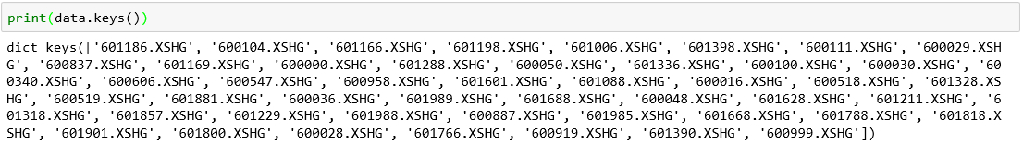

import pandas as pd

Stock=pd.read_excel(‘sz50.xlsx’,sheetname=None,index_col=’datetime’)

print(Stock.Keys())

**题目二：**

**读取data里的600036这只股票的DataFrame,将其收盘价转换成用Numpy的Array格式，并用talib计算10日均线值，返回ndarray的最后五个值**

**输出如下：**



import pandas as pd

import numpy as np

Data=pd.read_excel(‘sz50.xlsx’,sheetname=600036.XSHG,index_col=’datetime’)

NP_Data=np.array(Data.close.values)

import talib as ta

MAarray=ta.MA(Data.close.values,10)

print(MAarray.tail())

**题目三：**

**将MA的ndarray数据转换成Series格式，并将价格和MA值用Matplotlib展示出来**

**输出如下：**

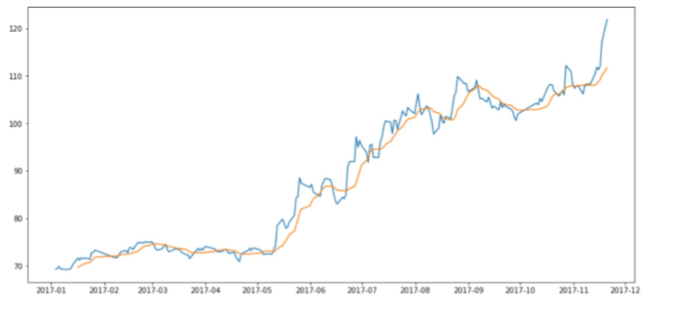

import pandas as pd

import talib as ta

Data=pd.read_excel(‘sz50.xlsx’,sheetname=600036.XSHG,index_col=’datetime’)

MAarray=ta.MA(Data.close.values,10)

Sma=pd.Series(MAarray,index=Data.index)

import matplotlib.pyplot as plt

plt.figure(figsize=(15, 7))

plt.plot(Data,c=’b’)

plt.plot(Sma,c=’r’)

plt.show()

**题目四：**

**用talib计算50只股票的周期为5的ROCR100，生成Dataframe，并将前5只股票的 ROCR100（参数timeperiod=20）用一张图显示出来。**

**输出如下：**

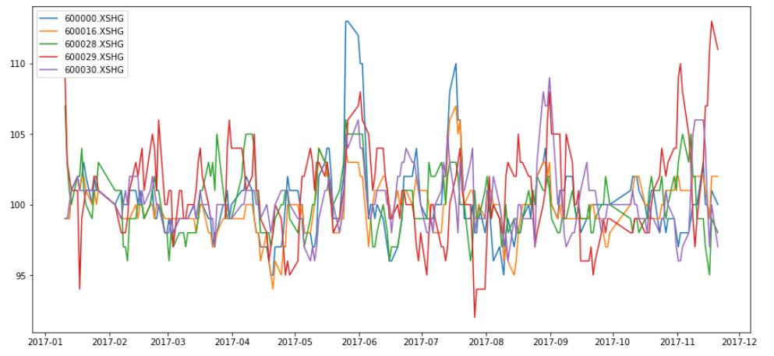

import pandas as pd

import numpy as np

import talib as tb

from talib import abstract

import matplotlib.pyplot as plt

pool=[‘600000.XSHG’,‘600016.XSHG’,‘600028.XSHG’,‘600029.XSHG’,‘600030.XSHG’]

PN=pd.Panel({name:pd.read_excel(‘sz50.xlsx’,sheetname=i,index_col=’datetime’) for name,i in pool})

MOM=Pd.DataFrame(

{name:ta.abstract.ROCR100(value,timeperiod=20) for name,value in PN.minor_xs(‘close’).iteritems()},Index=PN.minor_xs(‘close’).index)

plt.figure(figsize(15,7))

Plt.plot(MOM)

plt.legend=(MOM.columns)

Plt.show()

**题目五：**

**用Panel来计算50只股票的MACD并且输出MACD的Panel的MultiIndex格式**

**输出如下：**

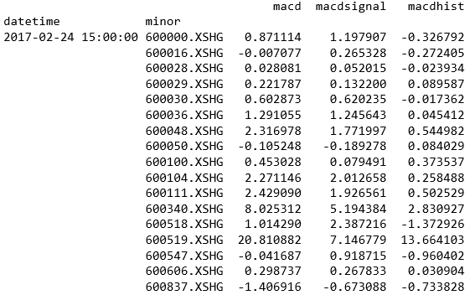

from talib import abstract as ta

import pandas as pd

Stock=pd.read_excel(‘sz50.xlsx’,sheetname=None,index_col=’datetime’)

Data={name:pd.read_excel(‘sz50.xlsx’,sheetname=name,index_col=’datetime’) for name in Stock.keys()}

PN=pd.Panel(Data)

dfMACD=pn.Panel({name:ta.MACD(value) for name,value in PN.iteritems()})

pnMACD=dfMACD.transpose(2,1,0).to_frame()

print(pnMACD)