**Pol Bosch**

**Creatividad 1, Aspasia**

BRAINSTORMING

**GAMIFYING GOOGLE MAPS, GPS usable but only for the path and near sides, DISCOVERING THE WORLD, Fog of War*, GTA map like, Unlocking new areas, Pokemon Go PokeStops, Landmarks, Achievements and Leveling Up, Percentage for the Zones, Start in Barcelona, go world wide, Freemium??? Partnering with Shops and restaurants and government in order to promote visits to certain places, incentivize with discounts or offers in such places, maybe exchangeable with internal currency, character customization, Events, Theatre, Concerts, Meeting new people, sharing photos, art, street art, polls for new points of interest. Maybe paying for points of interest. Tiers for premium POI, Tinder??, Security, dangerous zones, consciousness, AI. PETS unlocked by different areas like typical. Skins for different cultures, and places. HIKING, WEATHER,**

/////////////////////////////////////////////////////////////////////////////////////////

**Having a meal buddy that reacts to what you order, so you can eat better?**

**GAMIFYING GLOVO, I already have a document with the detailed product that I did at uni.**

<https://polhcsob.wixsite.com/my-site/meal-buddy>

Problema / Solució

Identifiquem un problema específic i generem solucions creatives i innovadores per a abordar-lo.

1. Identificació del problema.

**Promote Local Markets and long queues (that require a ticket).**

2. Investigació.

**There’s Markets like “La Boqueria or El mercat d’hostafrancs” that could use a system to handle the queues better.**

3. Generació d’idees.

A**n App that could let you start queueing when entering a Market, Map of the market, could work on supermarkets, and Malls, Pre order the food/products so you just have to get them.**

4. Avaluació i selecció d’idees.

**App to promote local markets and ease the queues for ordering with a map of the internal route you should take to visit all the shops you are queued in.**

4x4x4

1. Cadascú escriu 4 idees en un paper.

**Spotify Party, Enhance conectivity in huge events, Tinder for music bands,**

2. En parelles es creen 4 idees a partir de les anteriors. **(My partner was: Zhenishai)**

**App that enhance conectivity in huge events by partnering with mobile companies, Tinder for music bands, Artist Material Sharing (like wallapop but artist oriented), Artist Platform (For beginners to ask to professionals).**

3. En grups de 4 es crearan 4 idees basades en les anteriors. **My group was Leidy, Zhenishai, Cristóbal y Luis.**

**Child Psycology App, ONG project App, Tinder for finding a Music Band, Traveling Itinerary App, Artists Wallapop/Reddit.**

**My preferred idea is the Gamification of Google Maps in a Fog of War* Pokemon Go style.**

**\*Fog of War Example:**

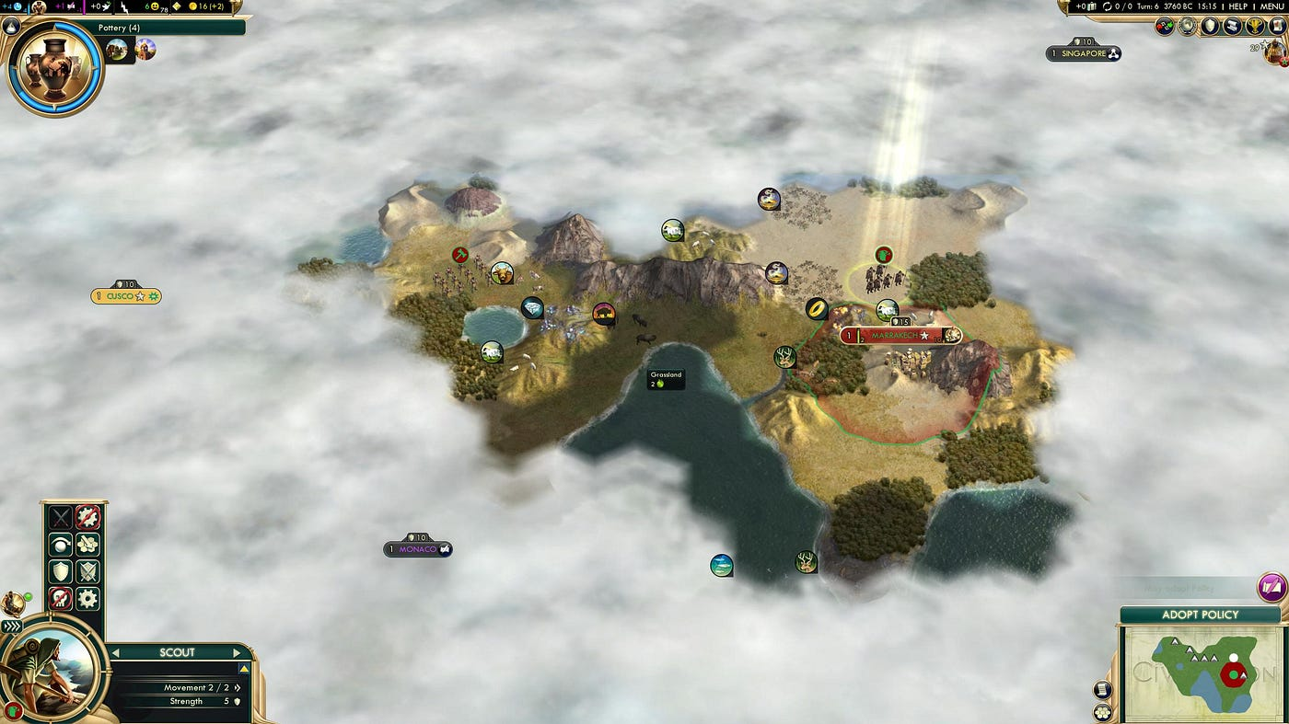

Elevator Pitch

o com explicar la teva idea en 2 minuts.

1. Qui és la teva audiència?

2. Què soluciona el teu producte/servei a la teva audiència?

3. Què és i com funciona?

4. Qui som?

5. Què necessitem?

6. Final emocional