Project 2: Google Map API

Xulun Huang

**Product Mission Statement:**

Our mission is to elevate the dining experience through a real-time, intuitive mapping solution for restaurant discovery. We understand the challenge of choosing the right place to eat amidst an overwhelming array of options. By visually differentiating restaurants based on their price levels, we remove the uncertainty and provide immediate, tailored suggestions for dining. Whether you are navigating your familiar local scene or exploring a new location, our platform, powered by advanced geolocation technology and up-to-date information, enables you to make confident dining choices effortlessly. In doing so, we aim to enrich your dining experiences and, by extension, your daily life.

**User Stories:**

**1. Immediate Location-Based Suggestions**

**Story:**

"As a frequent diner, I want the app to quickly show nearby restaurants when I open it."

**Acceptance Criteria:**

The app uses geolocation to display nearby restaurants upon launch.

**2. Color-Coded Budget Indicators**

**Story:**

"As a budget-conscious user, I want restaurants color-coded by price, so I can make a quick budget-aligned choice."

**Acceptance Criteria:**

Restaurants are marked in Red, Blue, or Green based on their price level.

**3. Custom Location Search**

**Story:**

"As a planner, I want to set a custom location on the map to find restaurants in a future destination."

**Acceptance Criteria:**

Users can click on a location to set it as custom and see nearby restaurants.

**4. Quick Restaurant Info**

**Story:**

"As a user, I want to tap a restaurant marker to see its name, to easily remember interesting places."

**Acceptance Criteria:**

Clicking on a marker displays the restaurant's name in a small info window.

**5. Easy-to-Understand Legend**

**Story:**

"As a user, I want a simple legend to understand the marker colors, so I'm clear on what each color means."

**Acceptance Criteria:**

A legend is visible that explains the color codes for price levels.

**MVP:**

**Core Features:**

**1. Geolocation-Based Restaurant Display**

**Functionality**: As soon as the app is opened, it uses the user's geolocation to display nearby restaurants on a map.

**Implementation**: Utilize Google Maps API for geolocation and restaurant data.

**2. Color-Coded Restaurant Markers**

**Functionality**: Markers for the restaurants will be color-coded based on their price level.

**Implementation**: Integrate Google Maps API to obtain restaurant price data and display markers in Red, Blue, or Green.

**3. Custom Location Option**

**Functionality**: Users can click on a map location to set it as custom, and the map will show restaurants around that area.

**Implementation**: Use Google Maps API for mapping and updating the restaurant list based on custom locations.

**4. Information Windows**

**Functionality**: Clicking on a restaurant marker opens a small information window that shows the restaurant's name.

**Implementation**: Utilize the Google Maps API to create interactive markers that can display information.

**5. Simple Legend**

**Functionality**: A legend will be displayed on the map interface to explain the color codes for the restaurant markers.

**Implementation**: A static legend explaining the color codes will be embedded on the map UI.

**Technical Stack:**

**Frontend**: HTML, CSS, and JavaScript for UI.

**Backend**: None needed for MVP.

**APIs**: Google Maps and Google Places API for geolocation and restaurant data.

**Success Metrics:**

**User Engagement**: Measured by the number of times the app is opened and used for searches.

**User Satisfaction**: Gauged through user reviews and feedback.

**Accuracy of Information**: Cross-referenced with manual checks to ensure restaurant and pricing data are accurate.

**Result:**

I have made a website implementing the MVPs listed above with html and Google Map APIs. Here are some screen shots of the website showing the final results.

The initialized map is shown below: 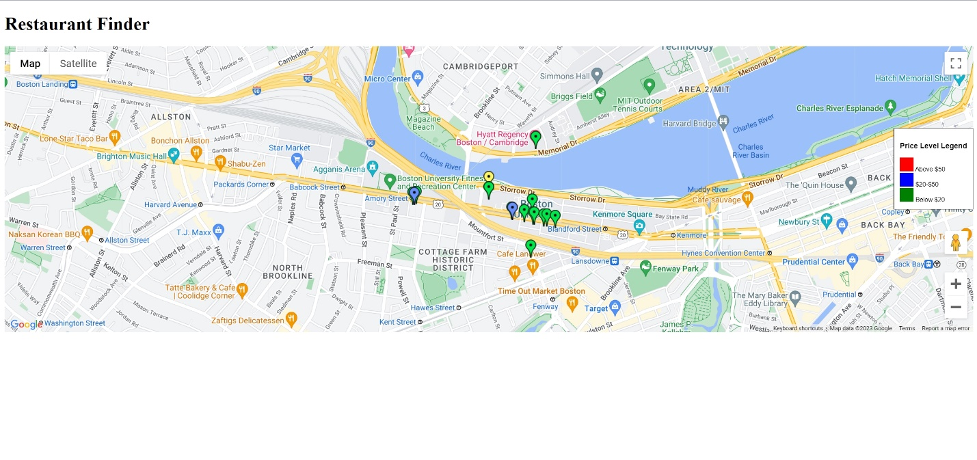

As we can see the yellow marker shows my current position, which is on BU campus. Then the blue and green markers show the restaurants nearby (since there’s no restaurant too expensive here so no marker is red). To the right there is a legend showing what different colors correspond to different price ranges.

Now I want to see the results displayed at a different location other than where I am, I just place a marker there on the map, which is shown below:

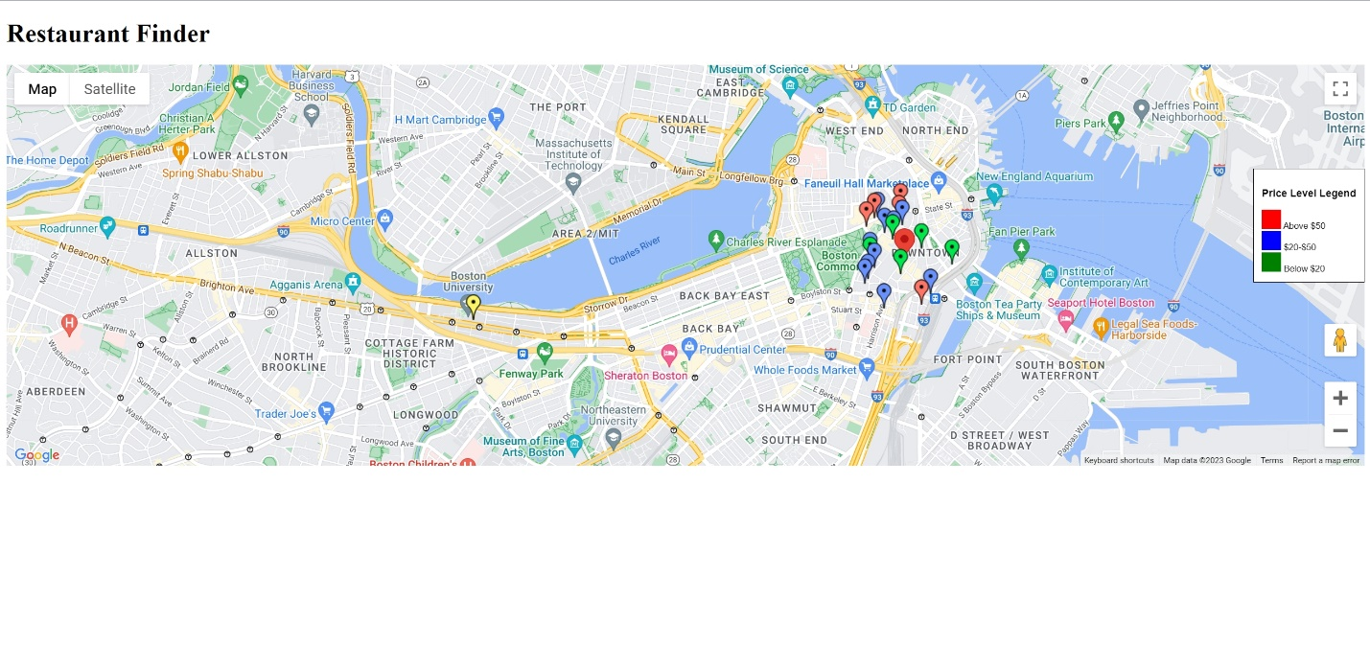

As you can see here, I place a marker in the downtown area of Boston, and restaurants nearby show up, including some expensive ones shown in red markers. In the meantime, restaurant markers around the yellow marker which is where I am disappear for a clean design.

**Conclusion:**

In closing, Restaurant Finder is your go-to guide for finding the perfect dining spot. With the MVP, I am offering essential features that allow you to find restaurants based on your location and budget, all in real-time. The immediate goal is to simplify your dining experience and gather your feedback for continuous improvement. With a balanced blend of technology and user-centric design, it’s exciting to launch a service that elevates your dining journey, both locally and beyond.