Lab 1 output:
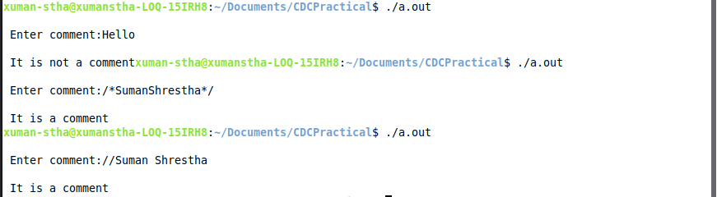

Lab 2 Output:
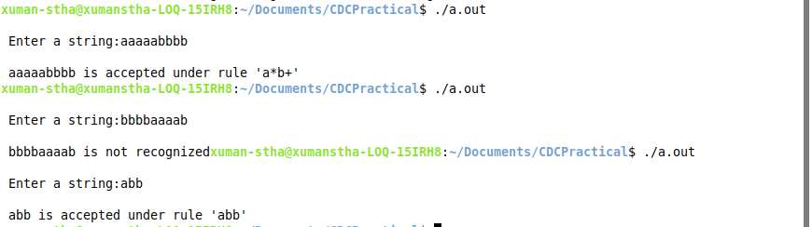

Lab 3 Output:
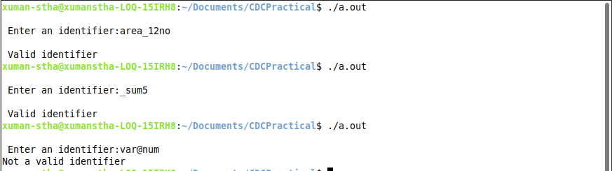

Lab 4 Output:

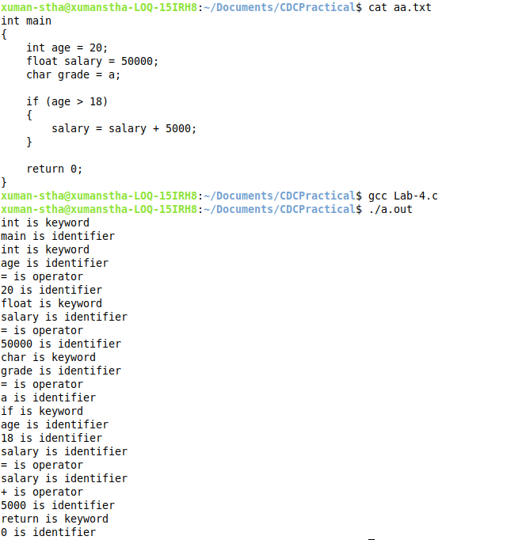

Lab 5 Output:

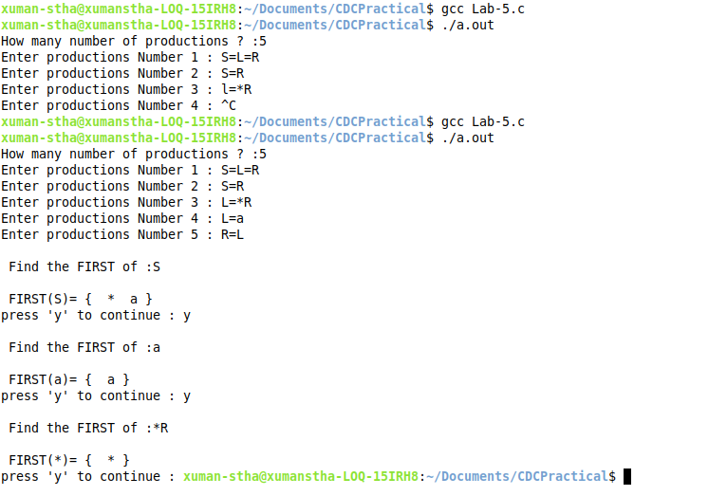

Lab 6 Output:

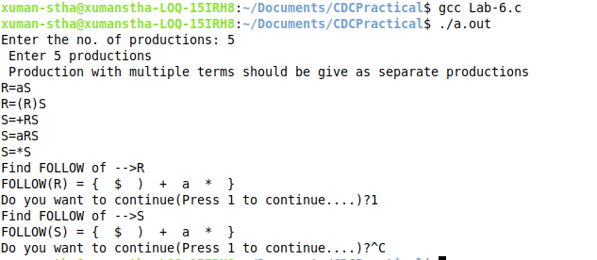

Lab 7 Output:
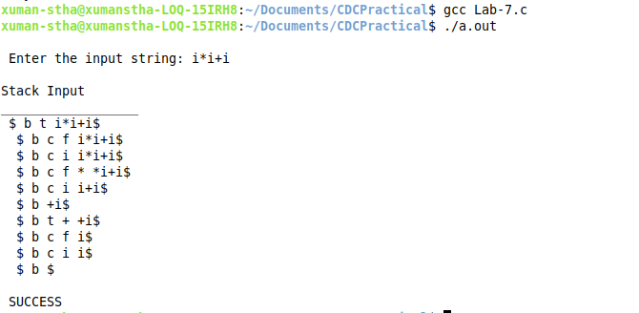

Lab 8 Output:
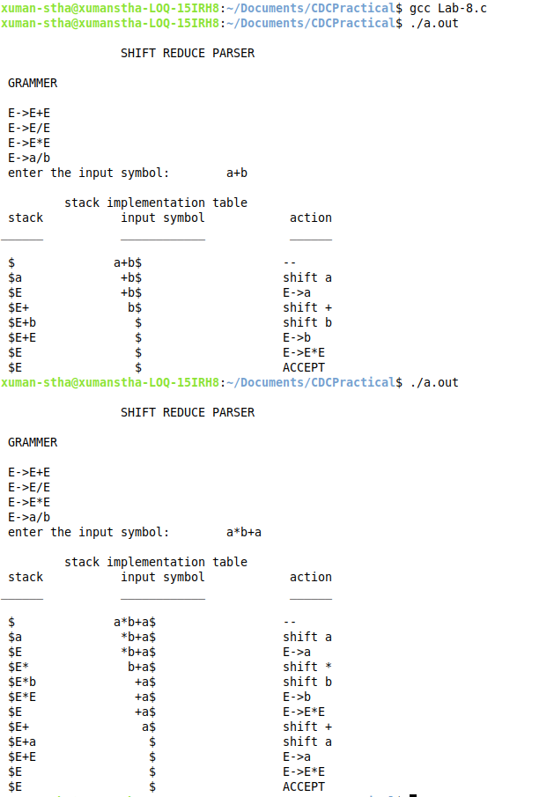
Lab 9 Output:
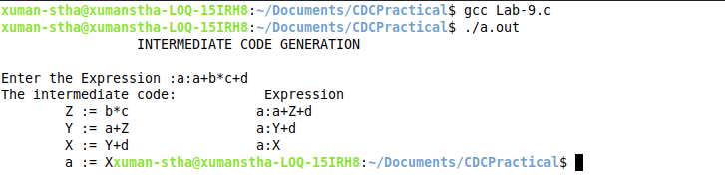

Lab 10 Output:
