Report

First off all, linux is an operating system just like Windows, iOS, and Mac OS. A [Linux](https://www.redhat.com/en/topics/linux) distribution, or distro, is an installable operating system built from the [Linux kernel](https://www.redhat.com/en/topics/linux/what-is-the-linux-kernel), supporting user programs, repositories and libraries. Because [the Linux operating system is open sourced](https://www.redhat.com/en/topics/linux/what-is-linux) and released under the [GNU General Public License](https://www.gnu.org/licenses/licenses.html) , anyone can run, study, modify, and redistribute the source code, or even sell copies of their modified code. Choosing the right Linux distribution depends on your use case and tool requirements. Certain Linux distros work better for different purposes. Some distros are designed as linux desktop environments while others are designed to support backend IT systems.

From my view, I have chosen the fedora because The Fedora Operating System is Linux distribution it is always rolling out with the latest software, driver updates, and Linux features. Linux users enjoy top good security thanks to the Linux kernel underlying every distro but Fedora developers have gone further to embed advanced security features within the distro via the Security-Enhanced Linux module.

* Fedora OS is a very reliable and stable operating system.
* It enhances the security in this operating system.
* It offers many graphical tools.
* This operating system updates automatically.
* This OS supports many file formats.
* It also offers many education software. Let’s talk about how I install it on my computer. I just need : Virtual Box- This software can running Windows, Linux, Mac   
  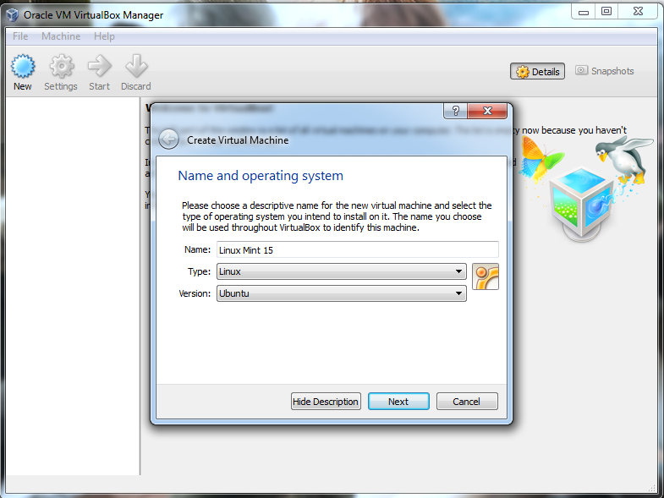

**- Select Type: Linux.  
- Select Version: Fedora**

**Step 2: Select the Amount of RAM**

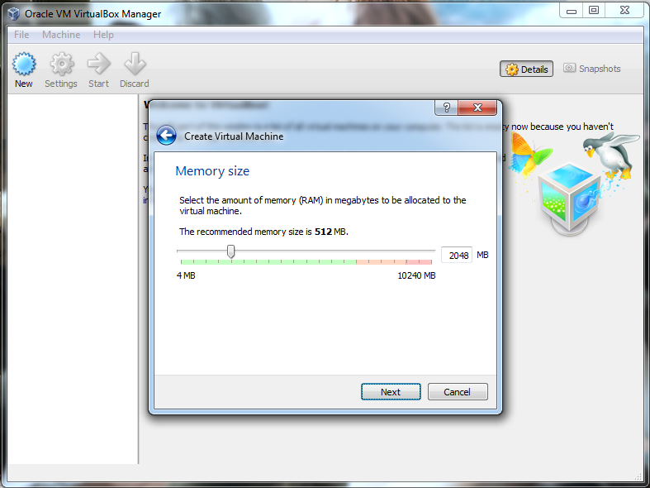

## Step 3: Hard Disk Setting

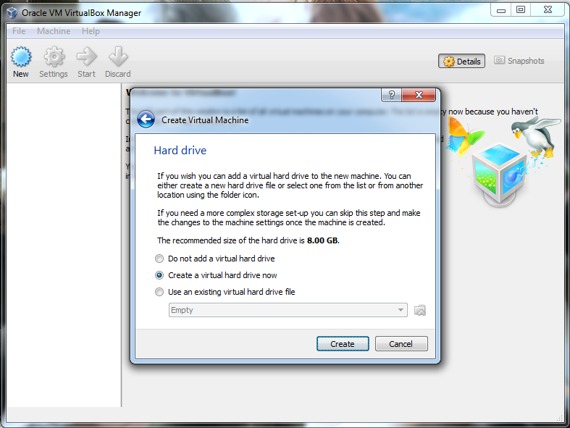

## Step 4: Choose Linux ISO File (which I have already download Fedora Iso )

## 

Then now we will talk about how to install PostgreSQL on Fedora 36 Linux using the command line terminal and some basic configuration and setup tips.

sudo dnf update –refresh

sudo dnf install <http://apt.postgresql.org/pub/repos/yum/reporpms/F-36-x86_64/pgdg-fedora-repo-latest.noarch.rpm>

sudo dnf install postgresql14-server postgresql14-docs –y

sudo dnf install postgresql14-devel –y

sudo dnf install postgresql14-libs postgresql14-odbc postgresql14-plperl postgresql14-plpython3 postgresql14-pltcl postgresql14-tcl postgresql14-contrib postgresql14-llvmjit

sudo /usr/pgsql-14/bin/postgresql-14-setup initdb

They were sequences which are used for installing the PostgreSQL