**Computer Vision – Homework #1**

**Feature Detection / Extraction**

### Question 1

**(a) Harris corner detection on checkerboard image**

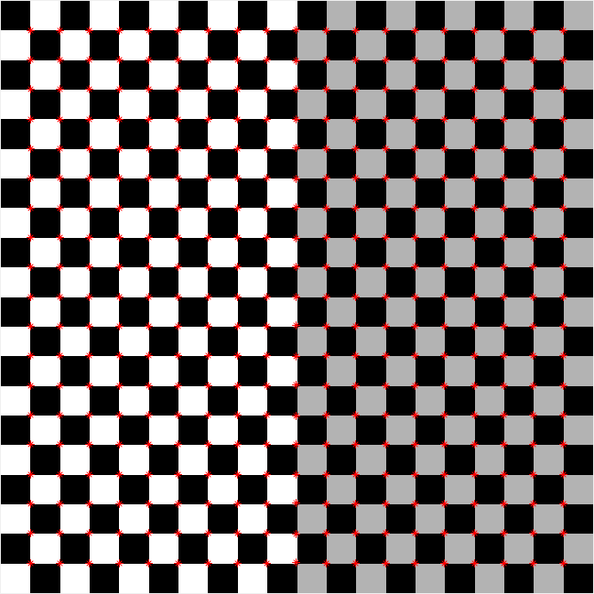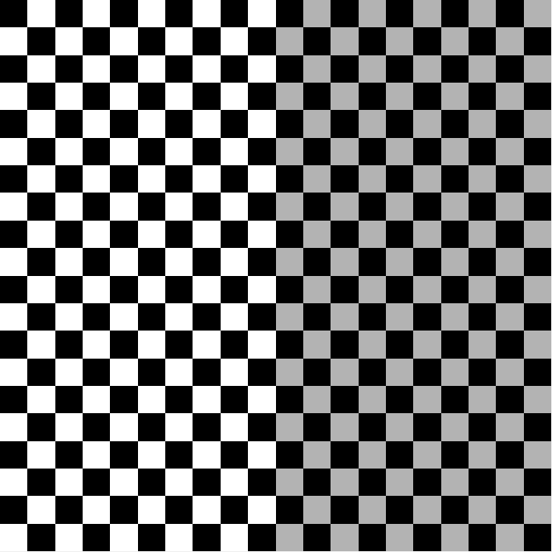

**（a） (b)**

Figure 1: (a) A 1000X 1000 synthetic checkerboard image. (b) Corners detected and marked with red dots.

**(b) Harris corner detection on images of different view point**

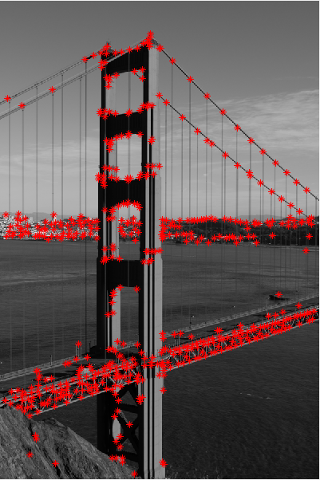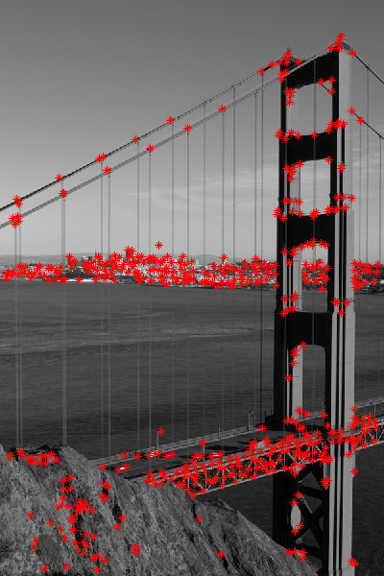

**（a） (b)**

Figure 2: (a) Corner detection result on the “goldengate-02.png“ image. (b) Corner detection result on the “goldengate-03.png“ image.

The extracted corners around the common regions from both images are repeatable. That repeatability is very important. Those repeated corner pointers can be used as features when matching features from different images. Besides, if we know the geometric parameters of the view point of different, we can take advantage of this repeatability to locate the same region shown in the different areas, and calculate the distance from view point to that region.

### Question 2

**(a) Extract FAST keypoints from images**

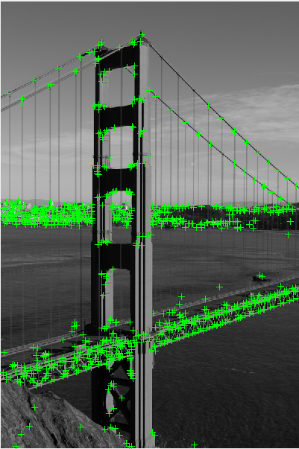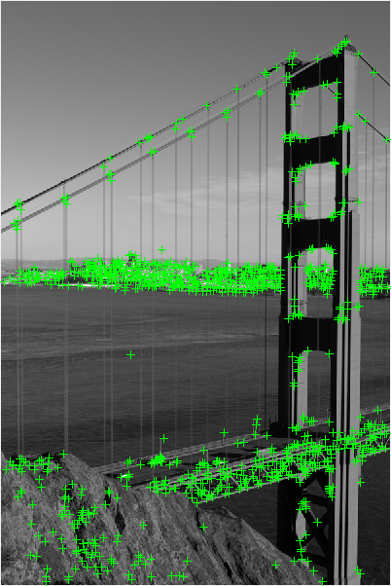

**（a） (b)**

Figure 3: (a) FAST keypoints from “goldengate-02.png“ image. (b) FAST keypoints from “goldengate-03.png“ image.

FAST keypoints are repeatable under viewpoint variation.

**(b) Extract SURF keypoints from images**

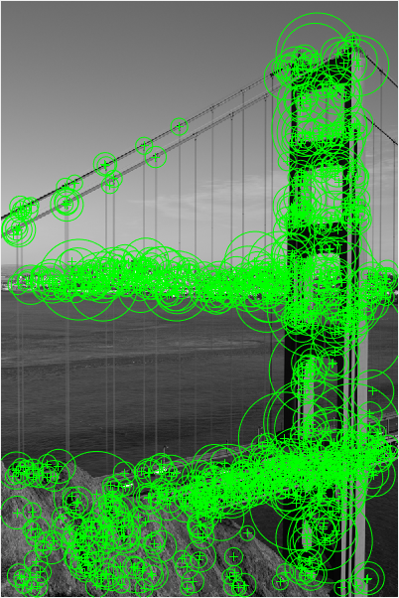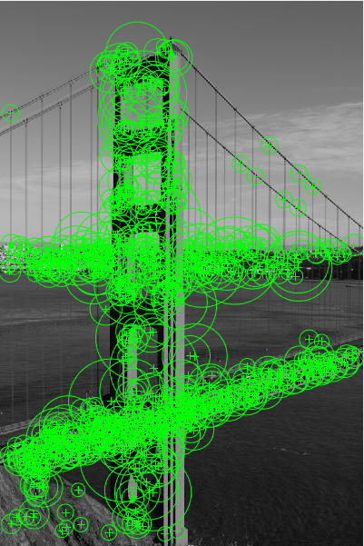

**（a） (b)**

Figure 4: (a) SURF keypoints from “goldengate-02.png“ image. (b) SURF keypoints from “goldengate-03.png“ image.

SURF keypoints are repeatable under viewpoint variation.

### Question 3

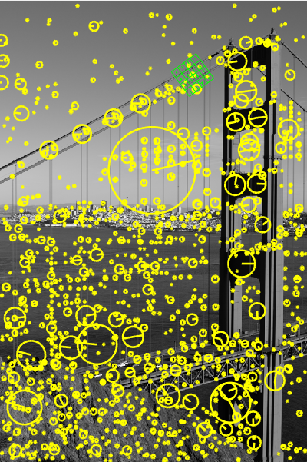

Figure 5: SIFT keypoint detection result on the “goldengate-02.png“ image. A feature frame at sub-pixel location (X, Y) = (377,145:6) is also shown.

### Question 4

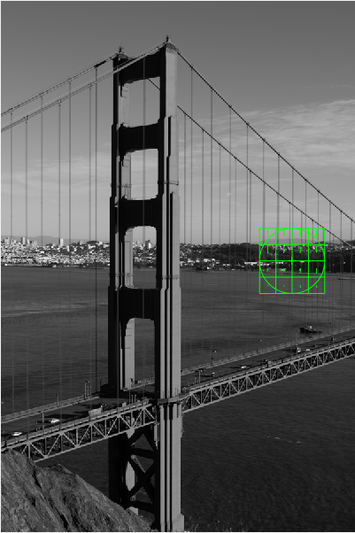

Figure 6: A SURF keypoint and SIFT feature frame result on the “goldengate-03.png“. The feature frame is located at pixel (X, Y) = (494,441).

The SIFT feature frame at (494,441) covers exactly the interest region of the detected SURF keypoint.