**Computer Vision – Homework #3**

**Image Formation & 3D Reconstruction**

### Question 1

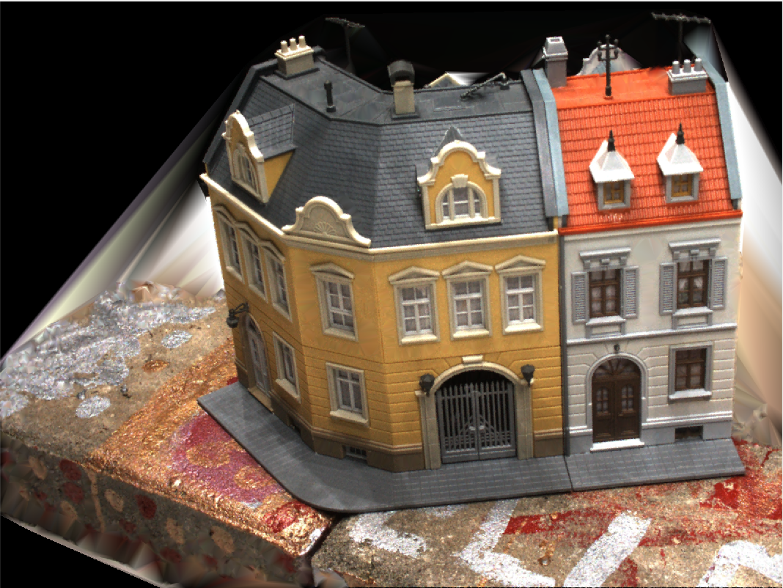

Figure 1. Image captured by first camera

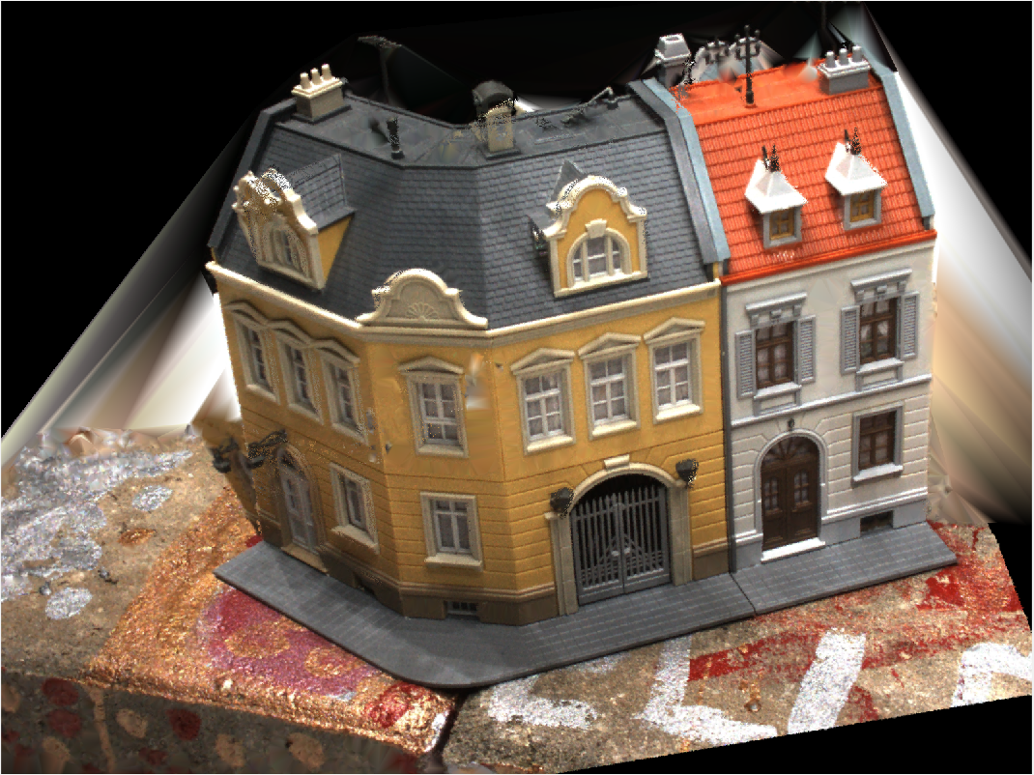

Figure 2. Image captured by second camera

### Question 2

**(a) A point-epipolar line pair**

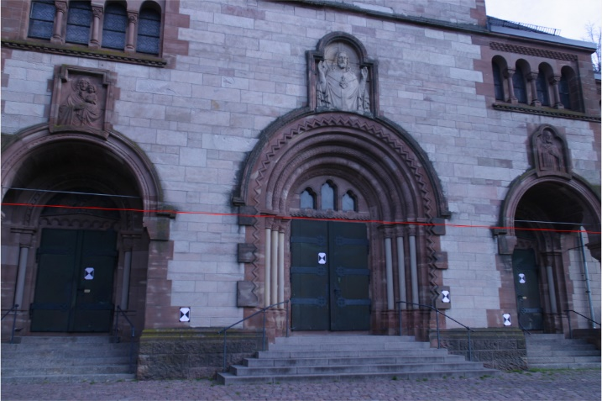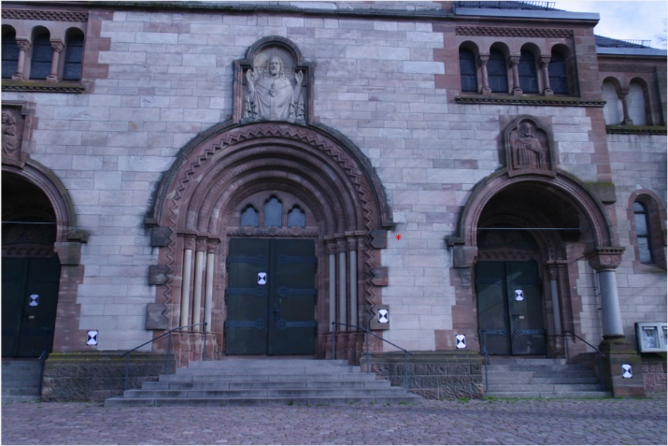

Fig 3. A point-epipolar line pair obtained using the essential matrix

**(b) An epipolar line pair**

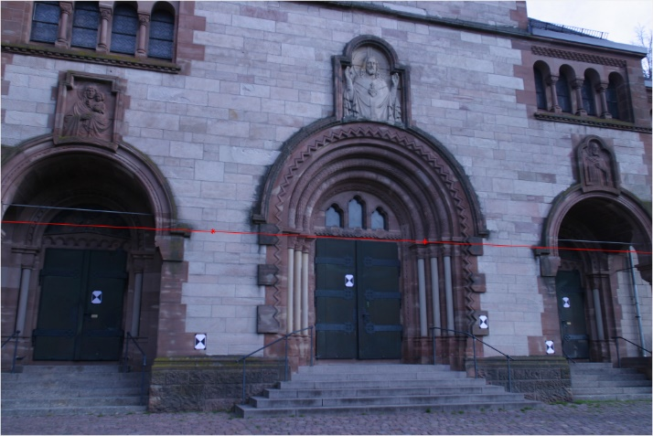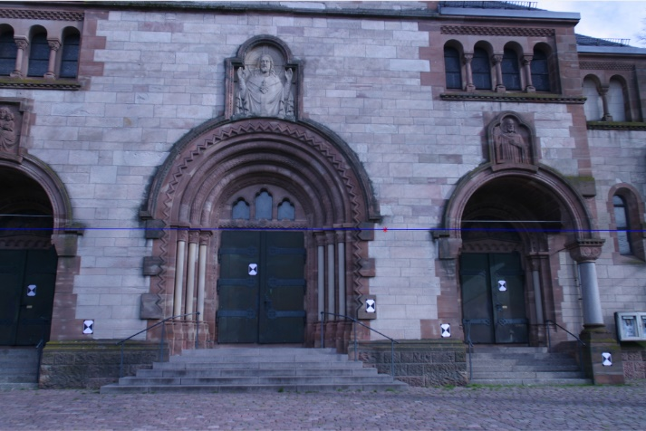

Fig 4. An epipolar line pair obtained using the essential matrix

**(c) 3D reconstruction result**

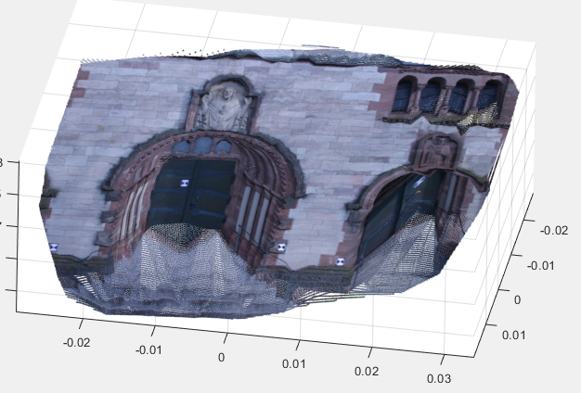

Fig 5. 3D reconstruction result

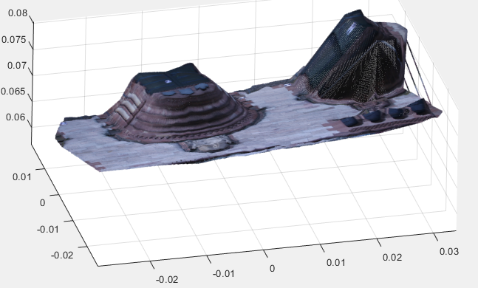

Fig 6. 3D reconstruction result

**(d) Possible causes of the gaps of regions obtained in the 3D reconstruction**

1. The grid is sampled down to get a faster computational time, in this case, only 1/16 information was preserved, When the grid(in pixel) was reprojected back to world coordinate, the missing information may lead to the void.

2. In this approach, I just solve for pho and used that pho to calculate the world coordinate. It`s not accurate enough, some pixels may be reprojected to wrong world coordinate so that the void is left.