Installation

This document assumes that you’ve already installed an Oracle database with APEX installation upgraded.

# Jenkins

First install .NET 3.5. It’s very important to install the 3.5 version. You can find it over here: <https://www.microsoft.com/nl-be/download/details.aspx?id=21>

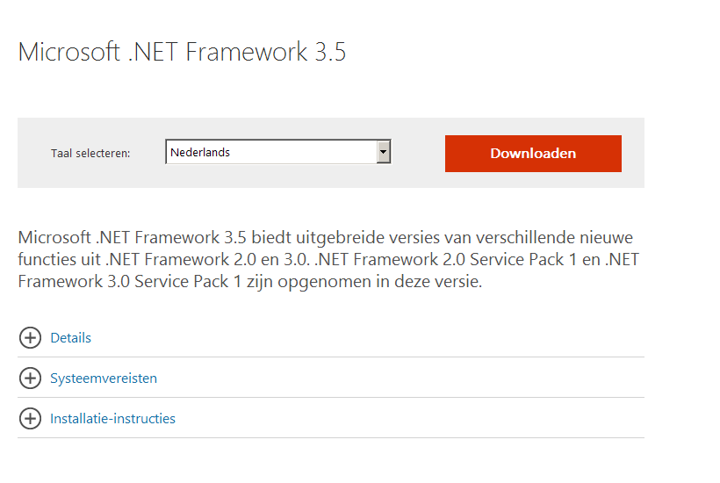

Pick download and choose **no thanks and continue** in the next option to continue.  
Execute the file

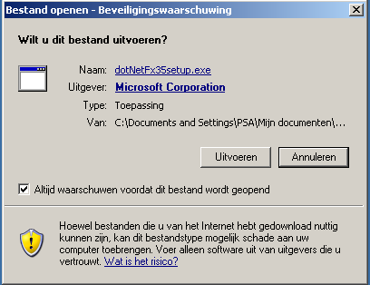

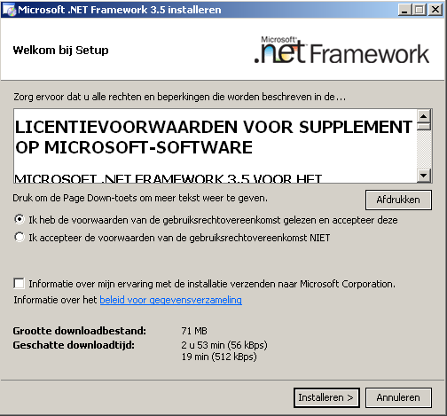

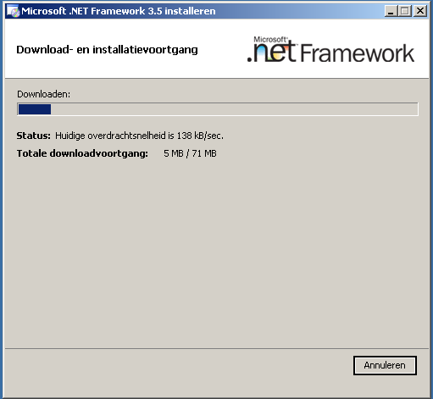

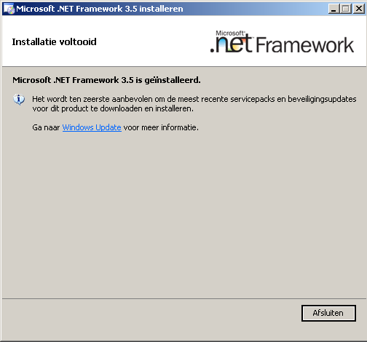

Click close and start the installation of Jenkinst

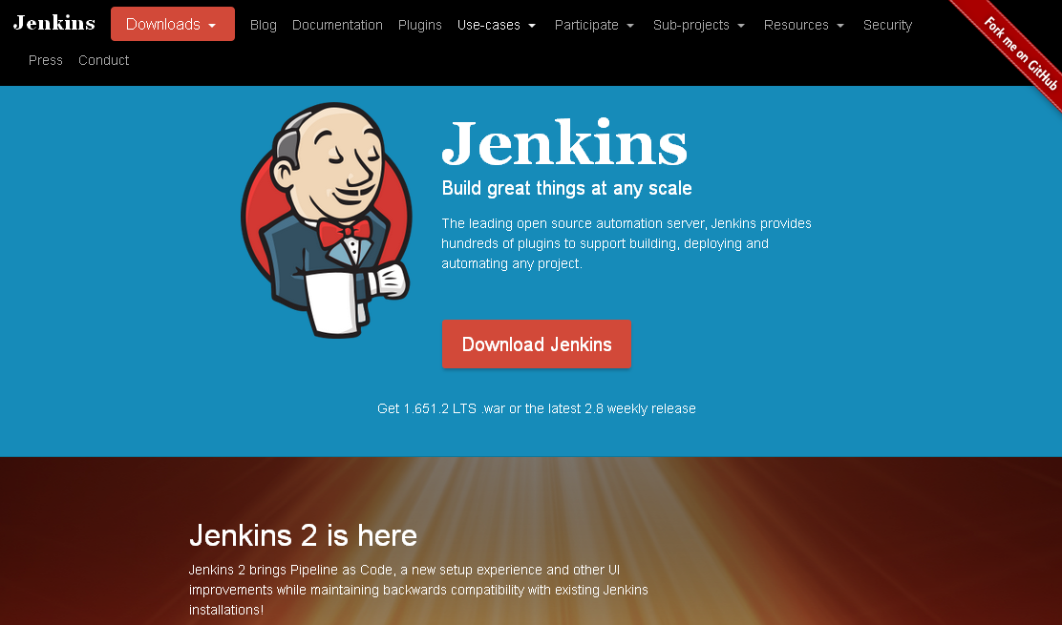

Use the windows version under LTS release

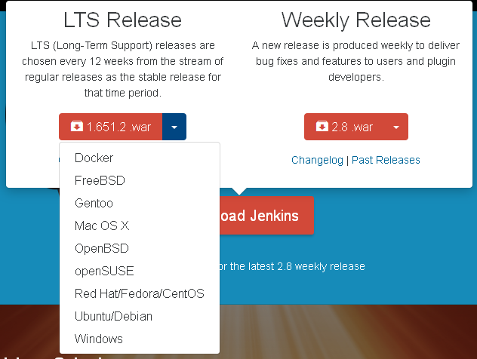

Save and unpack the zip. Run the msi installer.

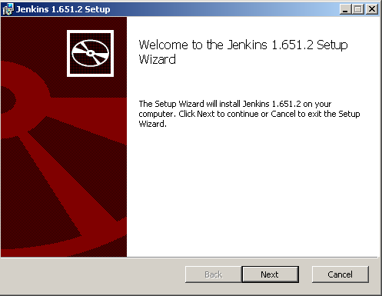

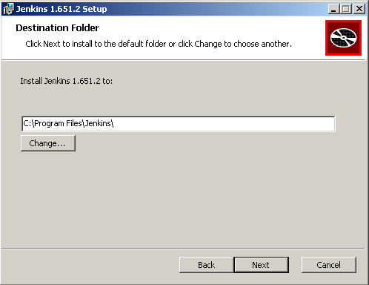

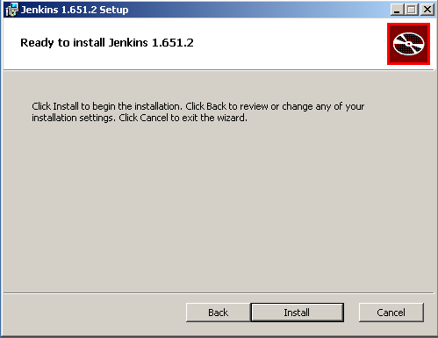

Click install. Jenkins will be installed in the program files folder.

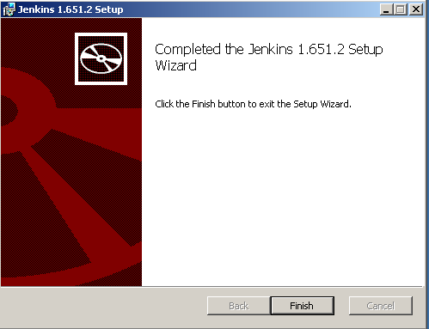

Jenkins should now be booting

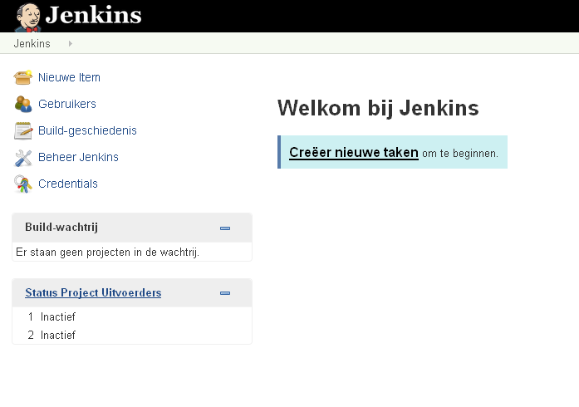

# Changing the port of Jenkins

Open the Jenkins.xml in c:\Program Files\Jenkins in wordpad

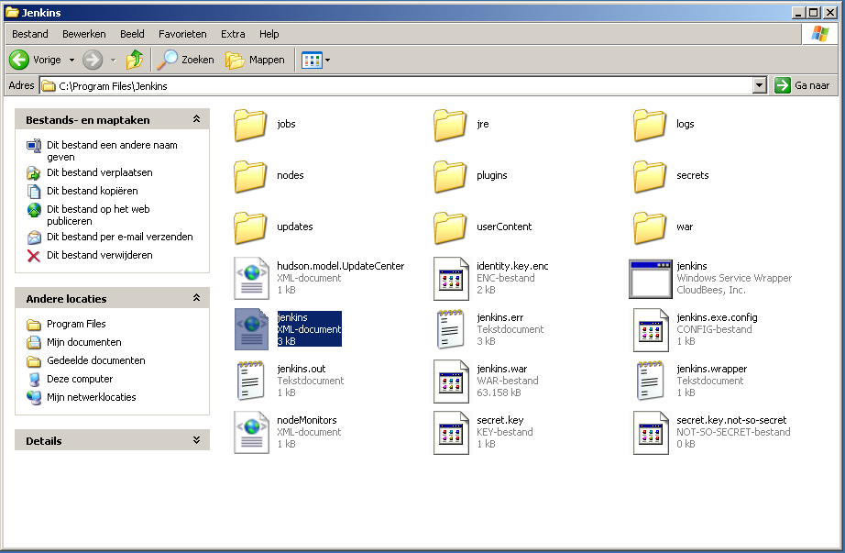

Find httpPort in the document and change it

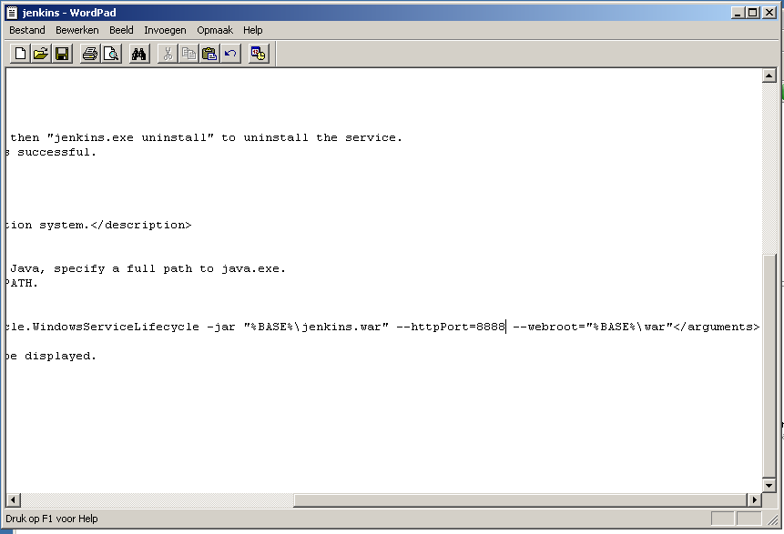

Reboot the pc to make the changes active.

User Manual

# The idea of building sql in a Continuous delivery process

So first things first, what exactly is continuous delivery

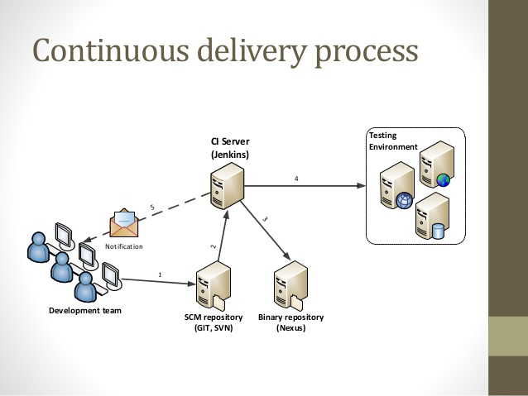

As we see in the picture above, we have a development team that pushes changes to a SCM repository. Our CI server, in our case Jenkins, is listening on these remote changes and can trigger a build. We package this build with a tool called Jenkins and deploy it to our development street.

# Configuring your PC

Installation of maven: Maven is our build tool.   
Follow the instructions: <https://maven.apache.org/install.html>  
Test maven with mvn –version in a command prompt or terminal

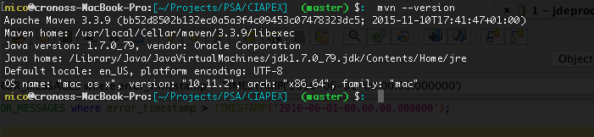

Because Oracle is not providing it’s jdbc driver by default in the maven repository we must install it manually. Download [ojdbc6-11.1.0.7.0.jar](https://maven-eu.nuxeo.org/nexus/content/groups/public/com/oracle/ojdbc6/11.1.0.7.0/ojdbc6-11.1.0.7.0.jar)

Install it with this command:

mvn install:install-file -DgroupId=com.oracle -DartifactId=ojdbc6 -Dversion=11.1.0.7 -Dpackaging=jar -Dfile=ojdbc6-11.1.0.7.0.jar -DgeneratePom=true

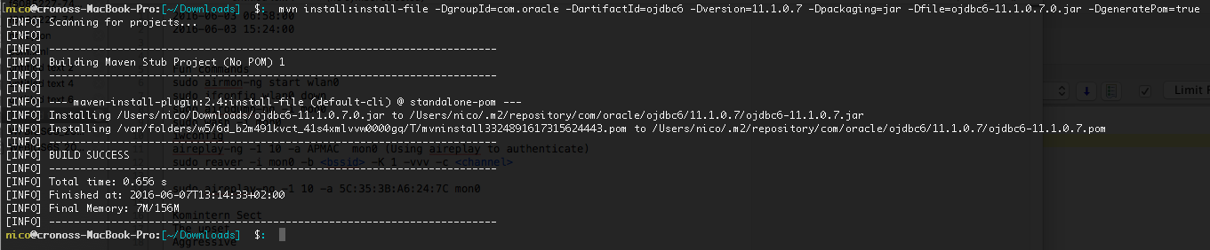

# First build of sample application

Create a folder structure within a sampleproject folder:  
-src/main/resources  
-src/main/sql  
-src/main/plsql

Create the initial pom:

# Installing APEX application

# Installing supporting objects