Algorithm Design and Analysis

Lab 1 Analysis of Algorithms (submit your lab answers to your tutor)

Learning Outcomes
- Understand how to measure the real execution time of a C++ code segment
- Implement algorithms based on pseudocodes
- Compute and compare the complexities of some basic algorithms

1. As discussed in Lecture 1, arrayMax(A, n) is an algorithm to find the largest number in an array A of n integers. The complexity of arrayMax(A, n) is O(n).

Algorithm arrayMax(A, n)
Input: An array A storing n ≥ 1 integers
Output: The maximum element in A
currentMax ← A[0];
for i←1 to n-1 do
if currentMax < A[i] then
currentMax ← A[i]
return currentMax

(a) (15 min) A C++ implementation of arrayMax function is listed below. C++ chrono library is used to measure the duration of executing arrayMax. Compile and run the program. Make sure your compiler is configured to support C++17 (Code::Blocks > Settings > Compiler).

filename: lab01q01a.cpp
#include <iostream>
#include <chrono>
#include <cstdlib>
using namespace std;

int arrayMax (int A[], int n) {
int currentMax = A[0];
for (int i=1; i <= n-1; i++) {
if (A[i] > currentMax)
currentMax = A[i];
}
return currentMax;
}

template <typename T>
void printArray (T A[], int n) {
for (int i = 0; i < n; i++)
cout << A[i] << " ";
cout << endl;
}

int main() {
const int n = 500;
srand (time(0)); // Init random number generator.
int* A = new int[n];
for (int i = 0; i < n; i++)
A[i] = rand() % RAND_MAX; // generate randon number range 0-32767.

cout << "Array A:\n";
printArray (A, n);

auto start = chrono::system_clock::now();
int currentMax = arrayMax (A, n);
auto end = chrono::system_clock::now();
chrono::duration<double> duration = end - start;

cout << "The maximum integer in A is "
<< currentMax << endl;
cout << "Duration: " << duration.count() << "s\n";

delete [] A;
}

(b) (5 min) Try re-run the program with bigger array size such as 10 million and 100 million. Comment out the printArray function to save running time. Notice the duration. It does not increase much. This is normal for an algorithm with time complexity of O(n).

2. partialSum(A,S,n) is an algorithm to find the partial sums of an array of n integers.

Algorithm partialSum (A,S,n)
Input: An array A storing n≥1 integers
Output: An array S storing the partial sums of A.
S[0] ← A[0]
for i←1 to n-1 do
S[i] ← A[0]
for j←1 to i do
S[i]← S[i] + A[j]

(a) (10 min) Based on the partialSum algorithm above, fill up the S[i] column in the table below.

i | A[i] | S[i] after the inner "for" loop executed
0 | 11 | 11
1 | 23 | 34
2 | 5 | 39
3 | 27 | 66
4 | 33 | 99
5 | 1 | 100
6 | 45 | 145
7 | 18 | 163

(b) (10 min) Count the number of primitive operations of each step in partialSum. What is the time complexity of partialSum?

Algorithm | Number of primitive operations
S[0] ← A[0] | 1
for i←1 to n-1 do | 2n
S[i] ← A[0]] | n-1
for j←1 to i do | n(n-1)/2
S[i] ← S[i] + A[j] | n(n-1)
T(n) | 3n + n(n-1)/2 + n(n-1)

(c) (20 min) Implement the above algorithm in C++. You may use the following code.
#include <iostream>
// 1. Add chrono library.
#include <chrono>
#include <cstddef>
#include <print>
using namespace std;

// 2. Add partialSum function.

template <typename T> void partialSum(const T A[], T S[], const size_t &N) {
S[0] = A[0];
for (size_t i = 1; i < N; i++) {
S[i] = A[0];
for (size_t j = 1; j <= i; j++)
S[i] = S[i] + A[j];
}
}

template <typename T>
void printArray (T A[], int n) {
for (int i = 0; i < n; i++)
cout << A[i] << " ";
cout << endl;
}

int main() {
const int n = 8;
int* A = new int[n] {11, 23, 5, 27, 33, 1, 45, 18};
int* S = new int[n];
// 3. Take start time.
const auto start = std::chrono::steady_clock::now();
// 4. Call partialSum.
partialSum(A, S, n);
// 5. Take end time.
const auto end = std::chrono::steady_clock::now();
// 6. Calculate duration.

cout << "A:\n";
printArray (A, n);
cout << "Partial sum S:\n";
printArray (S, n);

// 7. Display duration.
std::println("{}", duration.count());

delete [] A;
delete [] S;
}

(d) (10 min) Re-run the partialSum function with the following array size and record its duration in the first row (try the first few array sizes in the lab). Comment out the printArray function to save running time. You may have to increase the random number if 32767 is not big enough to be representative.

Array size n | 10k | 50k | 100k | 250k | 500k | 750k | 1m | 5m | 10m
2(c) partialSum duration (s) | 0.495936s | 12.3889s | 49.5489s | 309.682s | 1403.73s | 3350.33s | 6746.46s | Do at home | Do at home
2(f) Improved partialSum duration (s) | 0.00016956s | 0.000903687s | 0.000945809s | 0.00230435s | 0.00379715s | 0.00566937s | 0.00775255s | 0.03915s | 0.0755943s

(e) (15 min) The partialSum algorithm could be improved to O(n) complexity time. Write the improved partialSum algorithm in the table below.

Algorithm | Number of primitive operations
ps ← 0 | 1
for i←0 to n-1 do | 2n+2
ps ← ps + A[i] | n
S[i] ← ps | n
T(n) | 4n+3

(f) (15 min) Implement the improved partialSum in C++.

#include <chrono>
#include <cstddef>
#include <print>
// 1. Add chrono library.

// 2. Add partialSum function.
template <typename T> void partialSum(const T A[], T S[], const size_t &N) {
T ps = 0;
for (size_t i = 0; i < N; i++) {
ps += A[i];
S[i] = ps;
}
}

template <typename T> void printArray(const T A[], const size_t &N) {
for (size_t i = 0; i < N; i++)
std::print("{} ", A[i]);
std::println();
}

int main() {
constexpr size_t N = 8;
const int *const A = new int[N]{11, 23, 5, 27, 33, 1, 45, 18};
int *const S = new int[N];

// 3. Take start time.

auto start = std::chrono::steady_clock::now();

// 4. Call partialSum.

partialSum(A, S, N);

// 5. Take end time.

auto end = std::chrono::steady_clock::now();

// 6. Calculate duration.

auto duration = end - start;

std::println("A:");
printArray(A, N);
std::println("Partial sum S:");
printArray(S, N);

// 7. Display duration.

std::println("{}", duration);

delete[] A;
delete[] S;

return 0;
}

(g) (10 min) Re-run the improved partialSum function with the array size specified in 2(d). Record its duration in the second row.

(h) (10 min) Based on the durations obtained in 2(d), plot a graph with Duration vs Array size. The original algorithm should produce a quadratic line while the improved algorithm should produce a linear line.

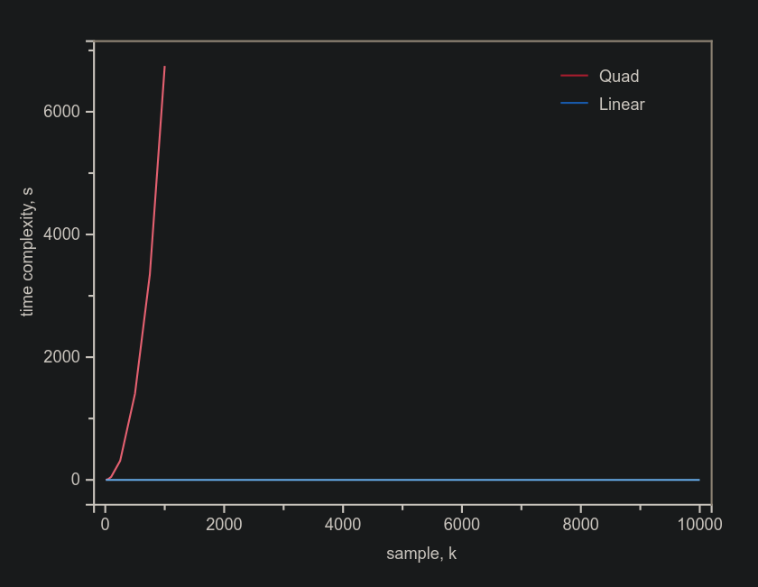
Unable to finish the quadratic function, due to huge sample size and time complexity.

