Homework4

Xunzhi Li

**1 Data**

we split 90% raw dataset as training set.

It’s a 610 x 9724 matrix.

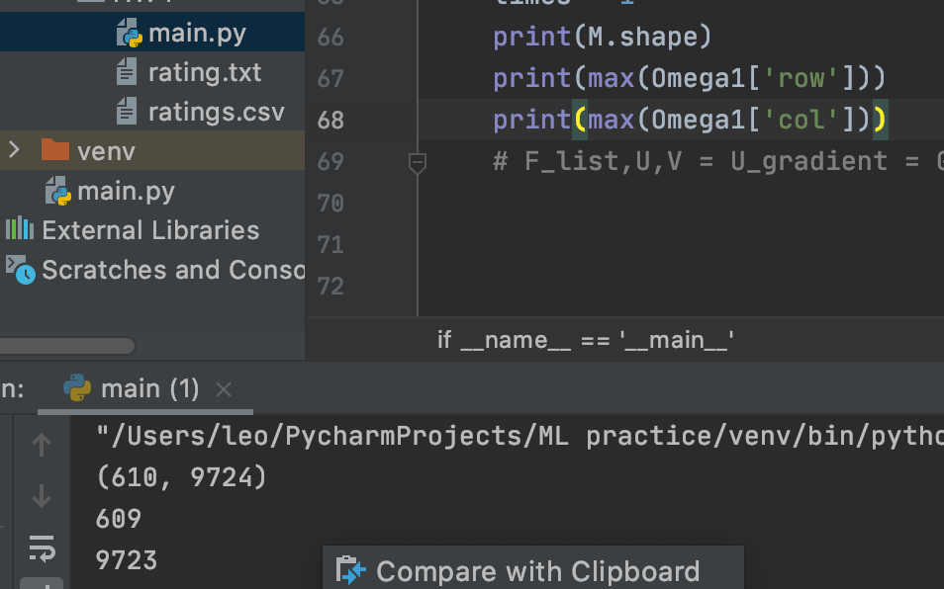

**2 Learning**

1) gradient :

2) we choose learning rate as 0.1

detains are in my .py file.

3)

My conclusion is if λ =1 ,Gradient Descent works good. Normally, we only need 5 times iterations and F(U,V) can reach its lowest point.

**3.Evaluation**

1. RMSE for λ =1 : 152.85007182892136

2.

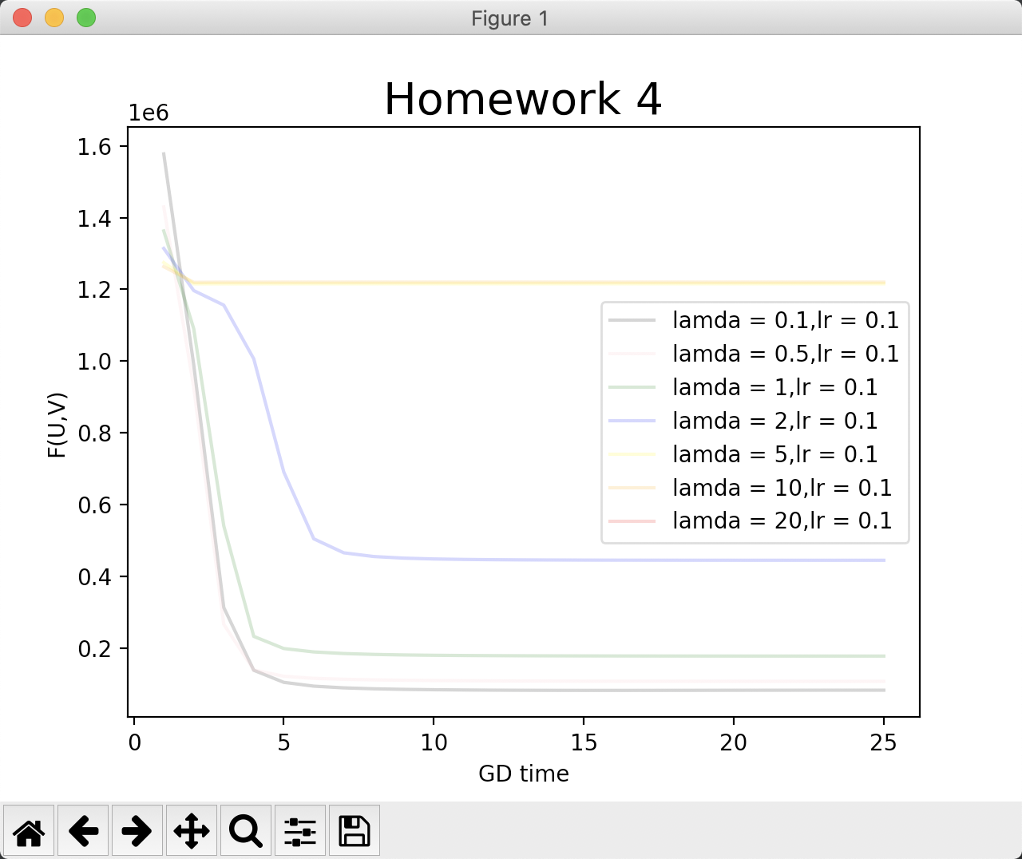

For GD and λ , Conclusion is :

These two Norm(F) terms are to prevent overfitting U and V (user_matrix and movie_matrix). So, if λ is too small(0.001,0.1,0.5,1) GD would perform unbelievable perfect.

However, if λ= 2,it works not good. If =5 or even bigger , it performs terrible .

As for RMSE and λ :

RMSE for λ as 0.1, 0.5, 1, 2, 5 , 10, 20 =

However, I have no idea for even bigger λ, my program throw out “RuntimeWarning” warning. So I didn’t process the program based on λ = 50, 100, 500, 1000 and even the smallest 10−6. I think maybe my computer is too old .

My finding is ,RMSE’s value decreases in the beginning (λ <=0.5) then increases while λ arises (>=0.5 <=5), but it remains stable after λ=5. So when λ = 0.5, I get the best result.