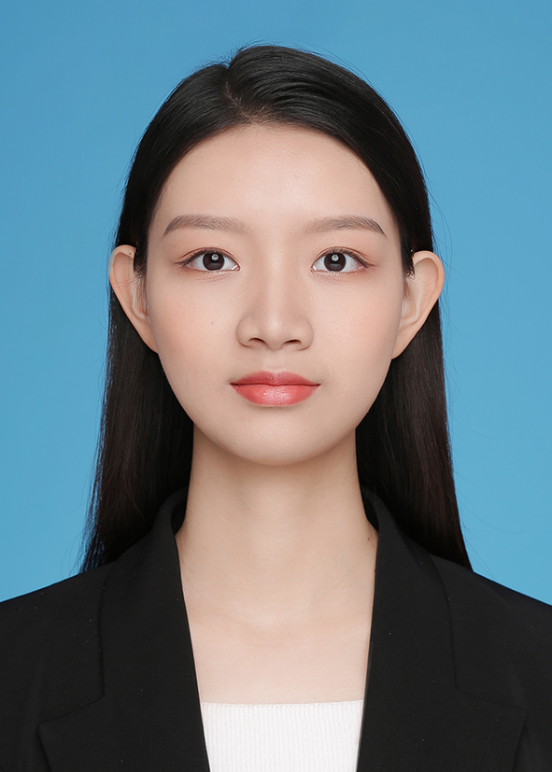
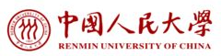
Xuran ZENG
TEL：+86 15102022205
E-mail：xuran_zeng@ruc.edu.cn

Education Background
Aug.2017-Present Undergraduate, Finance, Renmin University of China
Aug.2019-Aug.2020 Undergraduate, Start-up, Kedge Business School
GPA：3.97/4.0

Internship Experience
Apr2019-Jun,2019 Baidu Finance Quant
Responsible for exploring the application value of Baidu search engine data in the financial economy. From the papers using Google data, we use empirical research on the value of search engine data in predicting (correcting) economic data, analyzing economic trends as characteristic indicators, and predicting stock returns.
Sep2019-Aug,2019 PwC Audit
Follow the project team to check the voucher, complete part of the voucher test, prepare the account schedule, the subject draft, and assist in proofreading the audit report and the notes to the report. Assist the project team to complete the annual audit of GAC Mitsubishi Motors Co., Ltd. (single) and participate in the special audit of GAC Fenglv, Honda China and Honda Technology.

Academic Activities & Students Activities
April,2019 – Present Financial Big Data Laboratory, RUC Research Assistant
Follow the tutors Professor Wang Hefei and Professor Lin Chengyu, and study financial portals in US and in China and P2P lending models and risks.
May,2018-Present Youth Volunteers Association President
During the period of employment, 59 regular daily volunteer activities such as summer education and nursing homes were organized, 775 people participated in the social volunteer service organized by the association; 69 members of the association were coordinated.
Nov,2017-Present ‘Mingde Zhongfa’Talent Growth Support Program of RUC member
‘Mingde Zhongfa’ is an outstanding student training program established by Renmin University of China. Conduct personal tutor research, social practice, and international exchanges. During the period, I wrote a total of 3 research reports and won 2 honors at the University level and above.

Awards & Honors
1、National Scholarship（1%），11/2018
2、Social Work and Volunteer Service Scholarship，11/2018
3、Outstanding team of summer social practice for capital college students in 2018，11/2018
4、Undergraduate Innovation Experiment Program，04/2019
5、Second Prize of the 20th "Innovation Cup" Student Extracurricular Academic Science and Technology Competition Entrepreneurship Project of Renmin University of China，04/2018

