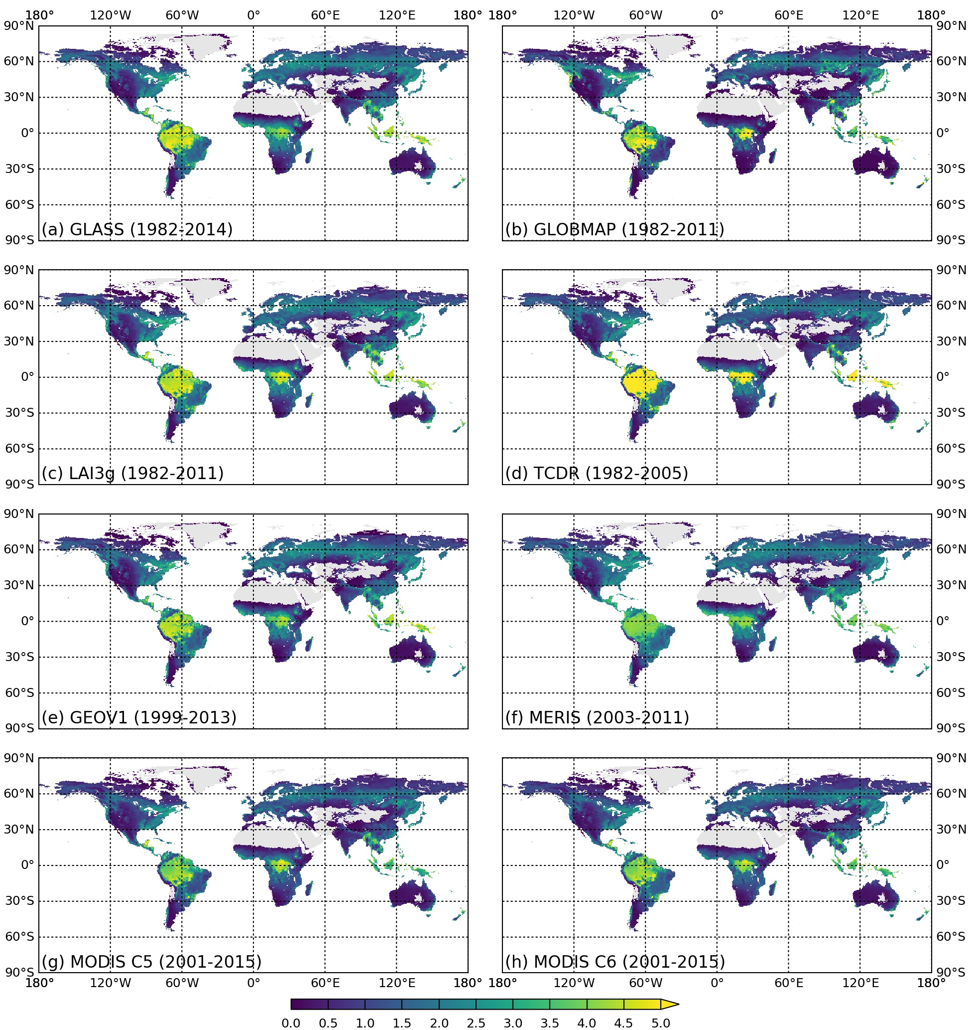

Fig. S1. Multi-year averaged growing season mean LAI from TCDR, GLASS, GLOBMAP, LAI3g, GEOV1, MERIS, MODIS C5, and MODIS C6 products.

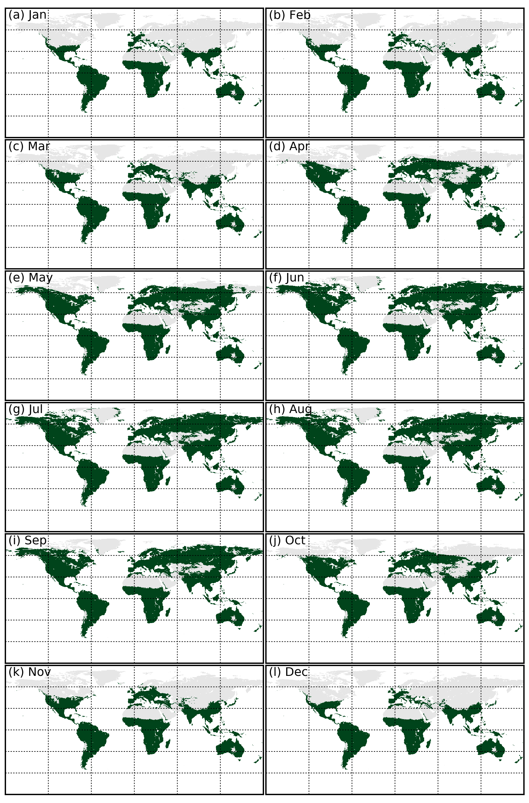

Fig. S2. Pixels identified as growing season, with the definition of multi-year averaged monthly-mean temperature larger than 0°C. Unvegetated regions have been excluded.

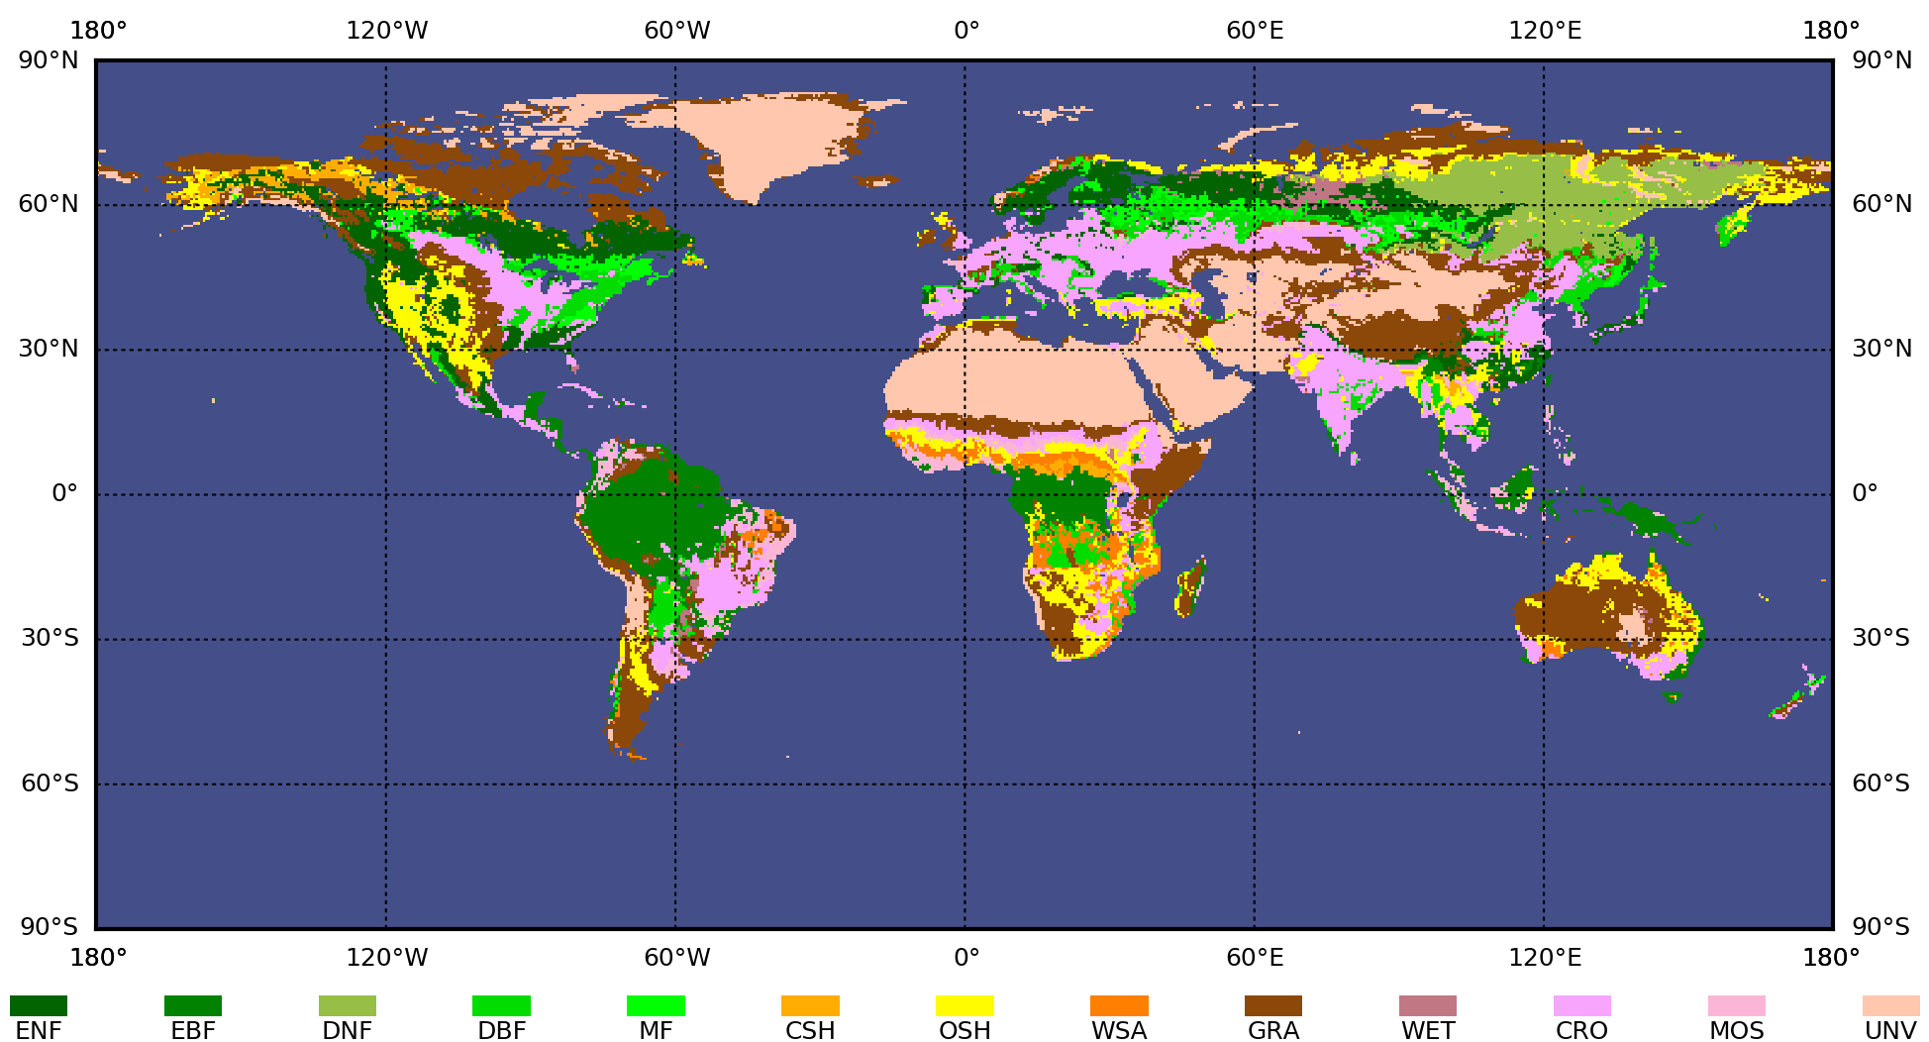

Fig. S3. Global land cover type map used in this study. ENF: Evergreen Needleleaf Forest. EBF: Evergreen Broadleaf Forest. DNF: Deciduous Needleleaf Forest. DBF: Deciduous Broadleaf Forest. MF: Mixed Forest. CSH: Closed SHrubland. OSH: Opened SHrubland. WSA: Woody SAvana. GRA: GRAssland. WET: WETland. CRO: CROpland. MOS: Mosaic of cropland and natural vegetation. UNV: Unvegetated land.

