Urban land use and land cover classification
目录
3.2 Case Study: Landsat Image-Housing Data Integration for ULC Classification in Indianapolis 2
3.2.1 Study Area 2
Figure3.1 Study area—Marion County,Indiana 3
3.2.2 Datasets Used 3
Figure3.2 Landsat ETM+ image(bands 4,5,and 3as red,green and blue, respectively)of Indianapolis acquired on June 22,2000. 4
3.2.3 Methodology 5
Figure3.3 Strategies of LULC classification by incorporating zoning and housing datasets for improving classification performance 5
Figure 3.4 Housing density distribution at Census block, Marion County, Indiana, in 2000. 6
Figure 3.5 Centroids of Census block. 7
In the Pre-Classification Stage 7
Figure 3.6 Housing surface generated by IDW interpolation. 8
Figure 3.7 Rasterized housing density. 9
During the Classification 9
In the Post-Classification Stage 9
Figure3.8 Examples of typical land use. 10
Table 3.1 Definitions of LULC 11
Table3.2 Decision Rules Developed for Postsorting 11
3.2.4 Accuracy Assessment 11
3.3 Classification Result by Using Housing Data at the Pre-Classification Stage 12
Table3.3 Separability Cell-Array for Six ETM+ Bands Using Transformed Divergence (Best Average Separability:1957.1 with Combination1,2,3,4,5,6) 13
Figure 3.9 LULC classification image based on integration of housing and the ETM+ image at the pre-classification stage. 14
3.4 Classification Result by Integrating Housing Data during the Classification 14
Figure 3.10 LULC map based on integration of housing sur face into the ETM+image as an additional layer (during the classiﬁ cation). 15
Table3.5 Separability Cell-Array for ETM/Housing Surface Using Transformed Divergence (Best Average Separability: 1983.69 with Combination 1, 2, 3, 4, 5, 6, 7) 15
3.5 Classification Result by Using Housing Data at the Post-Classification Stage 15
Figure 3.11 LULC map based on integration of housing data at the post-classiﬁcation stage. 16
3.6 Summary 16

3.2 Case Study: Landsat Image-Housing Data Integration for LULC Classification in Indianapolis
（案例研究：Landsat影像与住房数据融合用于印第安纳波利斯的土地利用/土地覆盖分类）
The objectives of this case study is to improve urban LULC classification accuracy by incorporating ancillary data (specifically census data) and Landsat imagery at different classification stages and to develop a suitable procedure for effective integration of these two types of data.（本研究的目标是：通过在不同的分类阶段将辅助数据（特别是人口普查数据）与Landsat影像结合使用，提高城市土地利用/土地覆盖分类精度，并进而提出一种能有效综合应用这两类数据的操作流程。）

3.2.1 Study Area
（研究区）
The study area is located at 39°46'N and 86°09'W, Marion County (the city proper of Indianapolis), Indiana (Fig. 3.1). According to the U.S. Census Bureau, the county has a total area of 1044 km², including 1026 km² of land and 18 km² of water. The average annual temperature is 11.7°C, with the highest temperature of 24.6°C in July and the lowest temperature of -1.9°C in January. 研究区位于印第安纳州的马里恩县（译者注：印第安纳波利斯市是印第安纳州最大城市也是州首府所在地，隶属于马里恩县，行政上市县政府合一，印第安纳波利斯市占据了马里恩县内的绝大部分地区，县里还另有8个独立的市镇），经纬度位置为北纬39°46′、西经86°09′（图3.1）。根据美国人口普查局数据，马里恩县的总面积为1044平方千米，包括1026平方千米的陆地面积和18平方千米的水域面积。年平均气温11.7°C，最高气温24.6°C，出现在七月；最低气温-1.9°C，出现在一月。Annual precipitation is evenly distributed throughout the year, and average annual rainfall is 1021 mm, with the least amount of precipitation occurring in February. 全年降水量分布均匀，年平均降水量是1021 mm，最少降水量出现在二月。It is the core of the Indianapolis metropolitan area. The county seat—Indianapolis—was called “plain city” because of its flat topography (elevation ranges from 218 to 276 m above sea level), which provides the possibility of expansion in all directions. 研究区位于印第安纳波利斯市大都会区的核心区域。县府所在地——印第安纳波利斯市由于其平坦的地形（海拔高度范围在218 m到276 m之间），被称为“平原城市”，这样的地形为城市向四周扩展提供了可能。In recent decades, the city has been experiencing areal expansion through encroachment on agricultural land and other nonurban land owing to population increases and economic growth (the population of Marion County increased by approximately 7.9 percent from 1990 to 2000).近几十年来，由于人口的增长和经济的发展（从1990年到2000年，马里恩县的人口增加了约7.9%），通过占用农业用地和其他非城市用地，印第安纳波利斯市实现了土地面积的扩张。
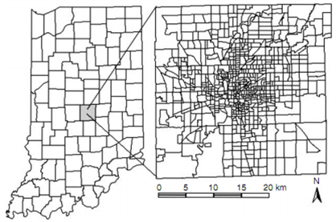

Figure3.1 Study area—Marion County, Indiana
图3.1 研究区—印第安纳州马里恩县

According to the 2000 Census, there were 860,454 people with a density of 838/km². There were 387,183 housing units at an average density of 377/km². With its large population, Indianapolis ranks as the twelfth largest city in the United States.根据2000年人口普查，印第安纳波利斯市总人口为860,454人，人口密度为838人/平方千米；住房单元总数为387,183套，平均密度为每平方千米377套。由于人口众多，印第安纳波利斯位列美国第12大城市。In 1999, the median household income in the county was $40,421, and the per capita income was $21,789, with 11.40 percent of the population and 8.7 percent of families below the poverty line. 1999年，马里恩县居民家庭收入中值为40,421美元，户均收入21,789美元，有11.40%的人口和8.7%的家庭处在贫困线以下。
Indianapolis has the highest concentration of major employers and manufacturing, professional, technical, and educational services in the state. With its moderate climate, rich history, excellent education, and abundant social services, arts, leisure, and recreation, Indianapolis was named as one of America’s “Best Places to Live and Work” (Employment Reviews, August 1996). In 1996, it ranked fifth on the list of the 30 best cities for small business by Entrepreneur magazine, and it was one of the top 10 metropolitan areas in the nation for business success in a 1996 study by Cognetics, a research firm in Cambridge, Massachusetts.印第安纳波利斯拥有全州最密集的大型公司企业及制造业、职业技术和教育服务机构。由于具有温和的气候，悠久的历史，良好的教育体系和丰富的社会服务资源以及繁荣的艺术和娱乐休闲业，印第安纳波利斯被称为美国“最适宜居住和工作的地方”之一（出自《职业评论》1996年8月刊）。1996年，印第安纳波利斯还被《企业家》杂志评为全美30个最适合小型企业发展城市的第五名，同年，一项由马萨诸塞州坎布里奇市一家名为Cognetics的调查公司主持的研究表明，印第安纳波利斯还是全美十大最有利于商业成功的大都会之一。

3.2.2 Datasets Used
使用的数据
The primary data sources used in this research are Census 2000 data and Landsat Enhanced Thematic Mapping Plus (ETM+) images (Fig. 3.2). The Landsat 7 ETM+ image (L1G product of path 21, row 32) used in this study was acquired on June 22, 2000, under clear-sky conditions. 本研究的主要数据源包括2000年人口普查数据和Landsat ETM+影像。Landsat 7 ETM+影像（属L1G产品，轨道号：21列32行）的成像日期是2000年6月22日，天气晴朗无云。The data were converted radiometrically to at-sensor reflectance using an image-based correction method (Markham and Barker, 1987). Although the L1G ETM+ data were corrected geometrically, the geometric accuracy was not high enough for combining them with other high-resolution datasets. Hence the image was further rectified to a common Universal Transverse Mercator (UTM) coordinate system based on 1:24,000 scale topographic maps. A root-mean-square error of less than 0.5 pixels was obtained in the rectification.采用基于影像的校正方法（Markham and Barker, 1987）对该影像进行了辐射校正，形成星上反射率影像。尽管ETM+的L1G数据产品已进行过几何校正，但其几何精度并不够高，不足以将其与其他高空间分辨率数据集联合使用。因此，采用1:24,000比例尺地形图将其校正到通用横轴墨卡托（UTM）坐标系统中，几何校正结果均方根误差小于0.5个像元。
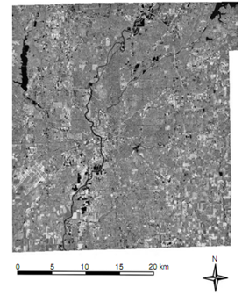

Figure3.2 Landsat ETM+ image(bands 3,2,and 1as red,green and blue, respectively)of Indianapolis acquired on June 22,2000.
图3.2 2000年6月22日的印第安纳波利斯Landsat ETM+影像
（波段3，2，1分别对应于红，绿，蓝波段）
Census 2000 data from the U.S. Bureau of the Census include (1) tabular data stored in Summary File 1, which contains information about the population, families, households and housing unit, etc. and (2) spatial data called topologically integrated geographic encoding and referencing (TIGER) data that contains data representing the position and boundaries of legal and statistical entities.
来自于美国人口普查局的2000年人口普查数据包括：（1）储存在“总结文档1”（Summary File 1）中的表格数据包含人口、家庭、住房等信息，（2）名为拓扑综合地理编码和参考的空间数据（包括代表这个地区的合法和统计的实体位置和边界）。These two types of data are linked by Census geographic entity code. The U.S. Census has a hierarchical structure consisting of 10 basic levels: United States, region, division, state, county, county subdivision, place, Census tract, block group, and block.这两种类型的数据（表格数据和人口数据）都与人口地理实体编码结合。美国人口普查共分为10个等级结构，分别是全国、区域、地区、州、郡、郡分支、地方、人口地带、街区群、街区。For population estimation, the block-group level was selected as the work level, whereas the block level was used as the work level for classification. 为了进行人口估计，街区群被选为工作的主要层次，而街区被选为分类的层次。Other ancillary data used in this research included (1) aerial photographs taken in the summer 2003 that were downloaded from the Indiana Spatial Data Portal and (2) GIS zoning data that were created by an Indianapolis and Marion County GIS team with the state plane coordinate system. All data, including housing, population, aerial photograph, zoning, and ETM+ images, were georegistered to UTM coordinates before data integration. 在这个研究中用到的其他辅助数据包括2003年夏天下载的印第安纳波利斯洲和Marion郡的GIS团队应用stateplane坐标系统的投影空间和GIS规划数据（下载于印第安纳空间数据门户2003年夏）。所有的数据包括住房、人口、航空相片、规划及ETM+影像，在融合之前都统一校正到UTM坐标系统中。

3.2.3Methodology
方法
Landsat ETM+ image, zoning, and Census housing data were combined for use in LULC classification in this research. The strategy of the LULC classification procedure is illustrated in Fig. 3.3. Zoning and housing data were used in different stages of image classification (e.g., pre-classification, during classification, and post classification) to identify a suitable procedure for improving LULC classification accuracy.在本研究中结合Landsat7的ETM+影像、规划数据、人口住房数据用于LULC分类。图3.3中阐释了LULC分类的方法。用规划数据、人口住房数据在图像分类的不同阶段（分类前、分类时、分类后）来鉴别一种提高LULC分类精度的合适算法。
Housing information was extracted from the Census data at block level, and housing density (Fig. 3.4) was calculated by dividing housing units by block area. In order to incorporate housing information into the Landsat ETM+ image, housing data must be converted to raster format. Two methods are often used to this conversion. One method is to conduct rasterization, and the other is to generate a housing surface by using spatial interpolation algorithms. In this study, the centroids of blocks (Fig. 3.5) were identified with the aid of ArcGIS, and then inverse-distance-weighting (IDW) interpolation was used to generate a housing surface. 从街区水平提取住房信息，住房密度是将住房单位除以街区面积。为了将住房信息结合到Landsat 7 ETM+影像中，住房数据必须转换成栅格形式。经常用两种方法来转换。一种方法是（直接）栅格化，另一种方法是通过空间内插算法产生一个住房趋势面。在本研究中，用ArcGIS软件来鉴别街区的质心，之后使用IDW内插方法来产生一个住房密度趋势面。

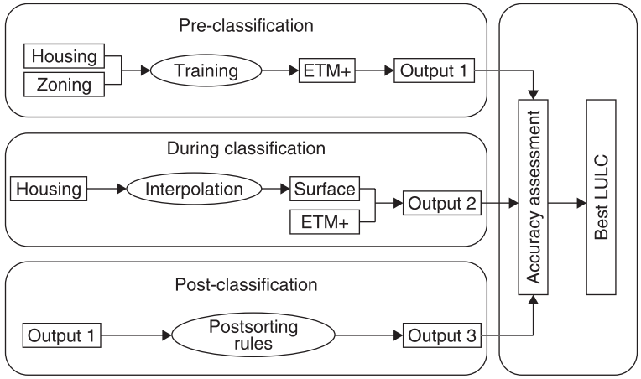

Figure3.3 Strategies of LULC classification by incorporating zoning and housing datasets for improving classification performance
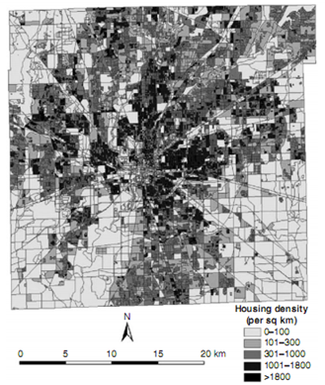

Figure 3.4 Housing density distribution at Census block, Marion County, Indiana, in 2000.

The smooth and continuous housing surface derived from the centroids of blocks using IDW (Fig. 3.6) enabled conversion of spatial data from irregular zonal units (blocks) into regular units (surface cells or pixels) that had a similar format as the ETM+ image. One important characteristic of this model is that it preserves the total housing units (Mesev, 1998). In contrast, the rasterized housing density (Fig. 3.7) was not continuous; cell values were the same within a block, but it preserved most of the original housing density of the blocks. Both were integrated with the ETM+ image as extra layers by stacking them on Landsat ETM+ six bands for further classification.光滑且连续的住房密度趋势面通过使用反距离内插把街区质心的空间数据从不规则的带状单元转换成一种拥有与ETM+影像格式相似的规则的单元（表面栅格或像素）。这个模型有一个重要特征，它会包会保护整体的住房单元。然而，栅格化的住房密度并不是连续的，格网的值与街区相似，但其保护了大多数的原始的街区住房密度。二者与ETM+第6波段叠合得到的作为额外图层与ETM+影像共为一个整体，用于更深层次的分类。
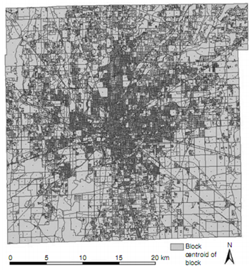

Figure 3.5 Centroids of Census block.

In the Pre-Classification Stage
在分类前阶段
A traditional supervised classification (specifically, the maximum-likelihood classifier) was used to classify the ETM+ image using its light-reflective bands. Before implementing image classification, selection of good-quality training samples is critical. In this research, housing density, zoning data, and high spatial-resolution aerial photographs were used to assist the identification of training samples of different urban LULC classes.
The ETM+ image was classified initially into 11 classes (i.e., commercial, transportation, industrial, water, low-density residential, medium-density residential, high-density residential, grass, crop land, fallow, and forest). Figure 3.8 provides examples of typical LULC data appearing on the aerial photograph. The 11 classes then were merged to 8 classes by combining commercial, transportation, and industrial as urban and combining crop and fallow as agricultural land.传统的监督分类，特别是最大似然分类法，是利用ETM+的光谱波段去划分ETM+影像的。在实施影像分类之前，选择高质量的训练区样本是关键性的。在这个研究中，房屋密度、分区数据和高空间分辨率航空影像被用来协助鉴定不同城市土地利用和土地覆盖类别的训练区样本。ETM+影像在起初是被分类为11类的，被分为商业用地、交通运输用地、工业用地、水体、低密度住宅区、中密度住宅区、高密度住宅区、草地、作物用地、休耕地和森林。在图3.8中提供了出现在航天影像中土地利用和土地覆盖类型的例子。通过合并商业用地、交通运输用地和工业用地作为城市区和将作物地和休耕地合并为农业用地然后将11种类别合并成8类。
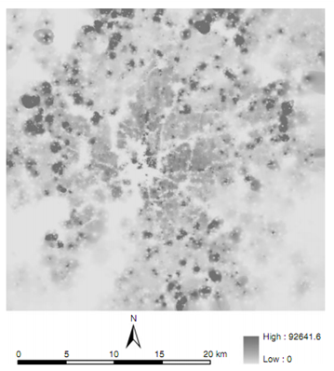

Figure 3.6 Housing surface generated by IDW interpolation.
For residential density, there are no agreed-on standards for what constitutes high, medium, and low density. A high density in Indianapolis might be medium or even low density in Shanghai. Therefore, in this study, the criteria for separating different densities of residential lands were adopted based on housing density and zoning data. For example, residential lands having housing units of more than 1300 per square kilometer were assigned as high-density residential areas, those having housing units of fewer than 400 per square kilometer were assigned as low-density residential areas, and those having housing units between 400 and 1300 per square kilometer were assigned as medium-density residential areas. Table 3.1 gives the definitions for these eight classes. This classification result was used as a base map for the post-classification sorting.对于居住地密度而言，什么是高密度，中密度和低密度并没有一个统一的标准。在印第安纳州的高密度，可能到了上海就是属于中密度，甚至是低密度了。因此，在本次研究中，居住地的密度划分标准是以房屋密度和分区数据为基础的。比如说，对于住宅用地，每平方公里超过了1300户那么就被认定是高密度的住宅区，而那些每平方公里上的户数在400-1300则被认为是中密度住宅区；少于400户的，就被认为是低密度住宅区。表3.1给出了八种类的具体定义，这个分类结果是作为分类后处理归类排序的底图。
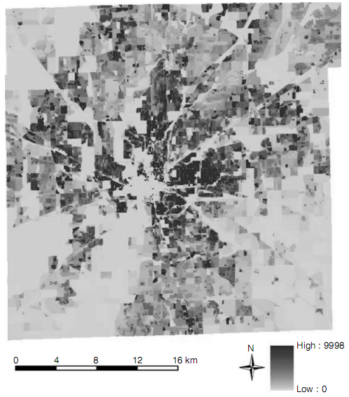

Figure 3.7 Rasterized housing density.

During the Classification
在分类期间
In this stage, the housing dataset was incorporated as an extra layer into the ETM+ image. Two housing data layers—rasterized housing density and housing surface—were combined with the ETM+ image as additional channels for image classification. Supervised classification with the maximum likelihood algorithm then was used to classify the combined image. 在这个阶段，住房数据集被合并作为额外层数到ETM+影像中。两个住房数据层——栅格化住房密度和住房趋势面——与ETM+影像结合作为影像分类的另外的通道。使用最大似然法的监督的分类然后被用于分类合并的影像。

In the Post-Classification Stage
在分类后阶段
Because of similar spectral characteristics in certain LULC types, such as between high-density residential and commercial areas and between low-density residential and forest areas, urban LULC classification is often difficult based on spectral signatures (Lu and Weng, 2004). Thus, in this research, housing density was used to correct the pixels that were misclassified during the classification procedure.
Based on the housing density distribution at the block level, the following rules indicated in Table 3.2 were developed. Finally, for convenience, grass, crop land, and forest areas were merged into a new group called vegetation. By applying the rules shown in the table, the problematic pixels could be merged into the categories most appropriate for this research.因为在某些土地利用和土地覆盖（LULC）类别中具有相似的光谱特征，例如在高密度住宅区与商业用地之间、低密度住宅区与林区之间，基于光谱特征的城市土地利用和土地覆盖（LULC）分类常常是困难的（陆和翁，2004）。因此，在本研究中，用住房密度来改正在分类过程中被错误分类的象元。表3.2列出了基于街区（block）水平的住宅密度分布规则。最后，为了便于草地、庄稼地以及林区被合并成一个叫“植被”（vegetation）的新的类别，通过采用表中所述的规则，存疑像元就可以被合并到本研究中最合适的类别中去。
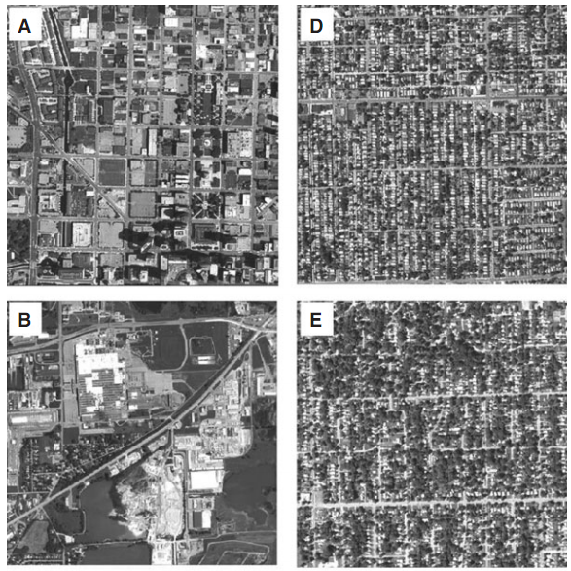
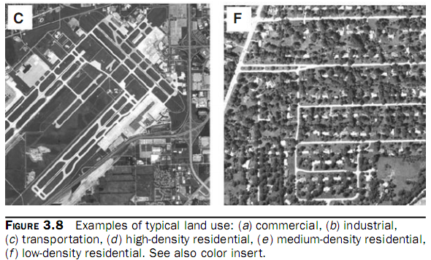

Figure3.8 Examples of typical land use.

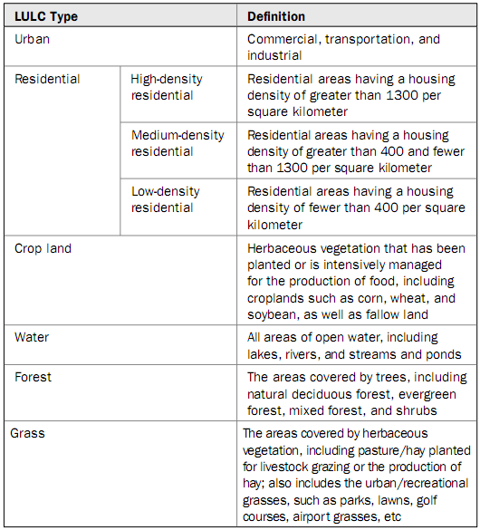

Table 3.1 Definitions of LULC
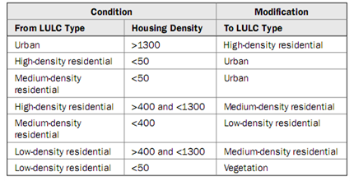

Table3.2 Decision Rules Developed for Postsorting

3.2.4 Accuracy Assessment
精度评价
In LULC classification, accuracy assessment of the classification results is often required (Foody, 2002). Many approaches, such as overall accuracy, producer’s accuracy, user’s accuracy, and kappa coefficient, have been used for evaluating classification accuracy. Their meanings and calculations have been described extensively in the literature (Congalton, 1991; Congalton and Mead, 1983; Hudson and Ramm, 1987; Smits et al., 1999). In reality, the most frequently used method for quantitatively analyzing LULC classification accuracy may be the error matrix, and thus it was used in this study. The accuracy assessment for the three classification images was conducted with a randomly sampling method. Fifty samples for each LULC type were selected. The reference data were collected from high-spatial-resolution aerial photographs. Overall accuracy, producer’s accuracy, user’s accuracy, and kappa statistic were calculated based on the error matrices.在土地利用土地覆盖分类中,分类结果的精度评价是必需的。很多方法被用于评价分类精度，像总体精度，生产者精度，使用者精度和KAPPA系数。它们的意义和计算公式在这些文章（(Congalton, 1991; Congalton and Mead, 1983; Hudson and Ramm, 1987; Smits et al., 1999)）中已经被广泛地的描述。事实上，在定量化地分析土地利用与土地覆盖分类精度中最经常使用的方法就是误差矩阵，也因此它被用于本案例中。三幅分类影像的精度评价是用随机取样的方法。每个土地利用与土地覆盖类型选择50个样本点。参考数据是从高空间分辨率的航空影像中获取的。整体精度，生产者精度，使用者精度和KAPPA统计值是基于误差矩阵来计算的。

3.3Classification Result by Using Housing Data at the Pre-Classification Stage
在分类前使用住房数据的分类结果
Supervised classification using maximum likelihood classification was performed with all six ETM+ reflective bands. Training samples were selected with the assistance of housing-density and zoning GIS data, as well as aerial photographs. Owing to high variability within the same LULC types, training samples were selected to be as detailed as possible. For example, transportation, central business district (CBD), and industrial classes vary considerably in spectral response, although they were classified as one class in the final result. Therefore, training samples were selected separately based on different types of urban land use. A similar situation happened with agricultural lands (lands planted with crops and lands lying fallow).
Because of the spectral confusion problem, the image was classified initially into 11 categories. The cell-array table of separabilities (Table 3.3) indicated that separability between vegetation types (crop land and forest), between residential intensity levels, between high-density residential and transportation areas, and between low-density residential and grass / crop areas was very low owing to the spectral similarity of these features, which may result in poor classification accuracy.
Figure 3.9 shows the classification image, in which the 11 categories were merged to 8 LULC classes (i.e., water, urban, high-density residential, medium-density residential, low-density residential, forest, grass, and crop land). On this image, some obvious errors were found. For example, the commercial area in the northwest (a) was mixed with the medium-density residential area. Medium-density residential area also invades into the airport (b) and industrial areas (c). 使用最大似然分类法的监督分类需要使用到ETM+的6个反射波段。训练样本的选择是借助住房密度数据和区域GIS数据，例如航拍影像。由于同个土地利用/土地覆被类中的高变化性，选择的训练样本也必须尽可能的详细。例如，虽然交通运输用地、中心商业区、工业用地最后被划分为了同一类，但它们在光谱反应中变动相当大。因此，训练样本的选择要基于不同类型的城市土地利用类型分开选择。农业用地（种植庄稼的土地和休耕地）的样本选择也是这样相似的情况。因为光谱混淆的原因，影像起初被分为了11类。网格矩阵的分离度表（表3.3）所示的就是植被类型（庄稼地和林地）、不同的住宅密度区之间的分离度，高密度住宅区与交通用地、低密度住宅地与草地、庄稼地的分离度都很低，因为他们的光谱特征都很相似，这也将导致分类精度的降低。图3.9显示出了由11类合并为8类（即水体、城市用地。高密度住宅区、中密度住宅区。低密度住宅区、林地、草地和庄稼地）后的分类影像。在这幅影像上，发现了一些明显的错误。例如，在西北方向的商业区被混淆为中密度住宅区；中密度住宅区则融入到机场和工业用地。

However, medium-density residential areas supposed to appear in areas adjacent to high-density residential areas were classified as low-density residential areas (d). Table 3.4 shows the classification accuracy based on the eight LULC types. An overall accuracy of 70.5 percent and a kappa value of 0.6629 were achieved. The accuracies of the residential types were the lowest. Confusion occurred between urban and high-density residential areas; between high-density residential and medium-density residential areas; between medium-density residential and low-density residential areas; between low-density residential, grass, and forest areas; and between grass and crop land areas. These confusions were the major factors contributing to the low accuracy of image classification. Mixed pixels, such as mixtures of impervious surface, forest, and grass in the low-density residential areas, were another factor for low classification accuracy. Selecting training samples for low-density residential land was difficult even with the assistance of zoning and housing data.然而，被认为应邻近高密度居住区的中等密度居住区却被分类为低密度居住区（d）。表3.4显示了基于八种土地利用土地覆盖类型的分类精度。总体精度为70.5%，kappa值为0.6629。居住类型的分类精度最低。在城市与高密度居住区；高密度居住区与中等密度居住区；中等密度居住区与低密度居住区；低密度居住区，草地与森林地区；草地与庄稼地之间容易产生混淆。这些混淆是导致影像分类低精度的主要原因。混合像元，例如混入不透水面，森林和草地的低密度居住区，是另一个导致分类精度低的原因。即使有分区数据和住房数据的协助，选择低密度居住区的训练样本依然很困难。
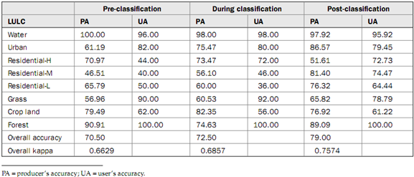

Table3.3 Separability Cell-Array for Six ETM+ Bands Using Transformed Divergence (Best Average Separability:1957.1 with Combination1,2,3,4,5,6)

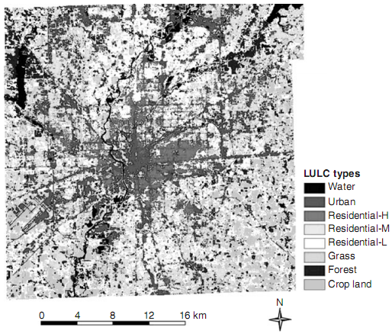

Figure 3.9 LULC classification image based on integration of housing and the ETM+ image at the pre-classification stage.

3.4 Classification Result by Integrating Housing Data during the Classification
在分类过程中集成住房数据的结果
Ancillary data also can be used as extra channels by combining them with remotely sensed data. In this study, rasterized housing density and a housing surface developed with the IDW interpolator were integrated into the ETM+ image as additional layers. A supervised classification was applied to classify the combined dataset. It was found that incorporation of rasterized housing density failed to identify some LULC classes, such as forest, crop, and grass. The integration of housing surface layer with the ETM+ image did improve the average separability to a certain degree (separability value from 1957 to 1984).
A comparison of Table 3.3 with Table 3.5 indicates that the separability between any pair of LULC types mentioned in the last section was increased. Table 3.4 shows that the accuracies of high-density residential and medium-density residential were improved, but the accuracies of low-density residential, urban, and crop land decreased. Both overall accuracy and the kappa value increased, although not significantly. Figure 3.10 shows the classified image based on the during-classification approach.将辅助数据与遥感数据结合起来还可以作为一个额外的通道。在本研究中，栅格化的住房密度及用IDW插值获得的住房表面将被整合到ETM+影像中作为一个附加图层。监督分类将被应用于合成数据集的分类。我们发现融合了栅格住房密度的数据不能辨别一些城市土地利用土地覆被类别，如林地、庄稼地和草地。把住房趋势面图层与ETM+影像进行集成将会使平均分离度提高到一定程度（separability value表示11个类别55个分离度千分值均值，从1957提升至1984），通过表3.3与3.5的比较可以看出，在最后提到的每个分类类型中的分离度都提高了。表3.4表明高密度住宅区和中密度住宅区的分类精度提高了，但是低密度住宅区、城市和庄稼地的精度却降低了。尽管变化不是很显著，但全局精度与Kappa值都上升了。图3.10展示基于分类过程方法的分类影像。
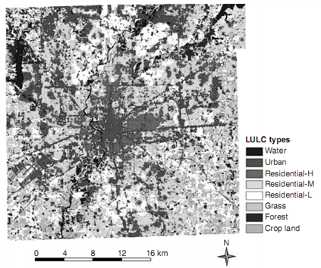

Figure 3.10 LULC map based on integration of housing sur face into the ETM+image as an additional layer (during the classiﬁcation).

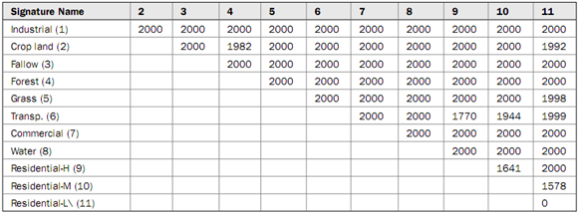

Table3.5 Separability Cell-Array for ETM/Housing Surface Using Transformed Divergence (Best Average Separability: 1983.69 with Combination 1, 2, 3, 4, 5, 6, 7)

3.5Classification Result by Using Housing Data at the Post-Classification Stage
在利用房屋数据进行分类后处理的分类结果
The ancillary data can be used further for postprocessing of the classified images. In this research, the LULC image (see Fig. 3.9) developed from the ETM+ image was used as a base. Postsorting rules were applied to this image to produce a refined LULC image (Fig. 3.11). Because the objective of using these rules was to refine urban and residential land uses, they did not have much impact on water, agricultural land, and forest in terms of accuracy. However, the post-classification sorting had a great impact on the residential and urban areas, as well as grasslands.
Table 3.4 indicated that the overall accuracy and kappa value were increased to 79 percent and 0.7574 respectively, compared with 70.5 percent and 0.6629 before the sorting. The accuracies of residential land areas were improved considerably, but the accuracies of urban areas and grasslands were decreased to varying degrees. Also, the obvious errors mentioned in the pre-classification stage disappeared. A comparison of the three classification schemes indicates that integration of housing data through postsorting is more effective than through adding housing surface as a layer into the dataset to be classified.辅助数据可用于进一步的图像分类后处理。在本研究中，LULC图像（见图3.9）以ETM +影像为基础产生。后处理规则将被用于制作精确的LULC图像（图3.11）。由于使用这些规则的目的是提取城市用地和住宅用地，他们没有过多影响水体，农业用地，森林的分类精度。但是，分类后的整理对居民区和城市地区以及草地有很大的影响。表3.4显示，整体精度和Kappa值分别提高到百分之79和0.7574，较之先前的百分之70.5和0.6629。住宅用地区域的精度有相当大的改善，但城市用地的精度和草地的精度有不同程度的下降。此外，在分类前的阶段提到的明显的错误消除。比较3个分类计划表明，结合房屋数据进行分类后处理比通过把住房数据作为一个图层加入用来分类的数据集的方式更加有效。
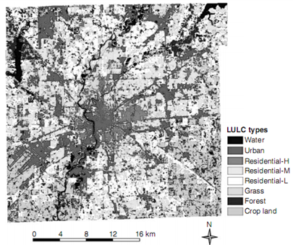

Figure 3.11 LULC map based on integration of housing data at the post-classiﬁcation stage.

3.6 Summary
总结
This chapter examined the role of Census housing data in LULC classification for an urban area through integration with the Landsat ETM+ image at different classification stages based on a case study of Indianapolis. The results indicate that use of housing data in the post-classification stage provides a better result than use of such data during the classification stage as an additional layer. 本章检验了人口住房普查数据在LULC分类中充当的角色。通过基于印第安纳波利斯的研究案例，在不同的分类阶段将城市区域与ETM +遥感影像相结合，结果表明，在分类后阶段使用住房数据比在分类阶段使用这些数据作为一个新增加的图层效果更佳。
In urban areas, an important data source is housing data. However, the use of the housing data has not fully been examined in urban LULC classification. This research examined the use of housing data at different stages of image classification, that is, for assisting in the selection of training sample plots at the pre-classification stage, for combination with the remote sensing image as an extra channel at the during-classification stage, and for modifying the classified image through use of expert rules at the post-classification stage.
在城市地区，一个重要的数据来源是住房数据，可是，在城市土地利用覆盖分类中住房数据并没有充分研究（讨论）。本研究讨论了不同分类阶段住房数据的使用，即，在分类前阶段协助训练样本的选择，在分类过程中，将住房数据与遥感影像融合作为一个外加通道，在分类后阶段运用专家规则来改善分类后的影像。
When housing data were used as an extra channel during the classification procedure, two factors may contribute to their ineffectiveness for improving classification accuracy. One possible factor is the abnormal distribution of housing data in the training samples. Because the assumption of a normal distribution of the training samples was not satisfied, the effectiveness of the maximum likelihood classifier, if employed, may suffer. Another factor is associated with the relatively coarse spatial resolution of the interpolated housing surface image, which was developed from Census data at the block level.
在分类过程中将住房数据作为一个外加通道，两个因子可能导致提高分类精度的低效率。一个可能的因素是住房数据在训练样本的非正态分布，因为假设训练样本是正态分布并不是令人满意的，如果采用最大似然分类器的有效性也会遇到同样的问题。另外一个因素是与内插的住房趋势影像的相对粗糙的空间分辨率有关，住房影像数据是从街区的水平提出的趋势面。

In this study, the control points used for generating housing surface were geometric centers, that is, centroids of the blocks, which often introduced errors when used to represent the source zones. Calculation of the centroid of an area depends on the coordinates of points defining the boundaries of a source zone. If a source zone is simple or symmetric, the centroid would be a good control point, and the estimated value for a grid cell would be more reliable. However, if a zone is irregular and complicated, the location of centroid can be significantly affected, and the interpolation result may be biased.
在本研究中，用来生成住房表面的中心点是几何中心，也就是说，是街区的质心，当用来代表源区域时常常会引入误差。计算一个区域的质心取决于确定源区域边界的点的坐标。如果一个源区域是简单或均匀的，那么它的质心就是一个很好的控制点，栅格的估计值就会更加可靠。可是，如果一个区域是不规则的，复杂的，质心的位置就会受到很大的影响，内插结果也会有偏差。
In reality, Census blocks are often not in regular shapes. The nonuniform distribution of housing units within a block can further complicate the problem. Another important issue is how to select an appropriate spatial interpolation algorithm because different interpolators may influence the final result of LULC classification substantially.事实上，人口街区（Census block）经常不是规则的，一个街区内的住房单元没有规定的分布会进一步使得问题复杂。另一个重要问题是如何选择一个合适的内插算法。因为不同的内插方法会对最后的LULC分类产生很大程度的影响。
Use of housing data in the post-classification stage provided the best results in this research. The deterministic decision rules used to refine the base LULC are critical for their effectiveness; therefore, they need to be developed carefully. In reality, developing the decision rules is a challenge because there are no standard criteria for distinguishing the different residential densities. An analyst needs to carefully check the existing information, such as Census data and historic land use, and information collected by local planning agencies. In this research, decision rules were developed based on housing density distribution with zoning data as a reference, but the break points for housing density seemed to be somewhat difficult to determine. This may have contributed to unsatisfactory improvement in separating the low-density residential class from the others.在后分类阶段采用住房数据产生了最后的结果，用来优化基础LULC的关键性决策规则对于分类的有效性来说是非常重要的。因此必须认真的制定决策规则。实际上，制定这些决定性的规则是一个挑战，因为没有区分不同密度住宅区的统一的标准。必须认真分析已有的信息，如人口数据，历史土地利用情况，还有从当地规划局搜集到的信息，在本研究中，基于住房分布，以区划数据为参考，但是不同密度住房的区别的分界点有点难以决定。因此也导致了优化后的低密度住宅与其他类别的分离度不是很令人满意。
Image classification in urban areas using medium-spatial-resolution (10 to 100 m) data is a challenge task. Although much research has been conducted with different techniques, a comprehensive comparison on which to generate some common guidelines for urban classification is lacking because of the use of different datasets, different image processing procedures, and different complexities of urban landscapes. For this same study area, we have conducted research with different approaches. It is pertinent to make a comparison and to arrive at some general observations.使用中等空间分辨率的数据进行城市地区的影像分类是一个富有挑战性的任务。尽管许多研究使用了不同的技术，但一个关于为城市分类生成一些通用准则的全面对照还是很缺乏的，这是由于不同数据集的使用、不同的影像处理过程以及城市景观的不同复杂性所造成的。对于这个相同的研究区域，我们用不同的方法进行了研究。做一个比较并达到一些总体的观察，这样的结论比较中肯。
Lu and Weng (2005) compared eight different image processing routines to identify suitable remote sensing variables for urban classification for the same study area by using the ETM+ image. Incorporation of spectral signature, texture, and surface temperature was examined, as well as data fusion techniques for combining a higher-spatial-resolution image with lower-spatial-resolution multispectral images. The research indicated that incorporation of texture from lower-spatial-resolution images or of a temperature image cannot improve classification accuracies. However, incorporation of textures derived from a higher-spatial-resolution panchromatic image did improve the classification accuracy. In particular, use of data fusion result and texture image yielded the best classification accuracy. Incorporation of texture and spectral signatures is conventionally assumed to provide better classification results than use of pure spectral signatures (Butusov, 2003; Shaban and Dikshit, 2001). However, the success for incorporating texture images depends on the type of texture measure, the image used to derive textures, and the selection of moving window size (Lu and Weng, 2005).陆和翁利用同一区域的Landsat ETM+影像图，对比八种不同的图像处理程序来辨别出适用用于城市土地分类的遥感变量。通过将光谱特征，纹理和表面温度的集成以及将高分辨率影像与低分辨率的多光谱图像的融合的研究表明集成低分辨率的光谱图像的纹理或一个温度图像不能提高分类的精度。然而集成高分辨率的全色影像的纹理却能能够提高分类的精度。特别是利用融合的结果图和纹理能够产生最好的分类效果。集成纹理和光谱特征的分类正常会比单纯适用光谱特征的效果好，然而集成纹理图像选择的成功的关键在于纹理测度的类型，用于提取纹理特征图像的选取，以及所选择移动窗口的大小的确定。
Owing to the complexity of urban landscapes and the limitations of current sensor technology, per-pixel-based classification approaches have proven to be difficult for urban LULC classification. Recently, subpixel analysis using spectral mixture models, which unmix an image into different fractions, has been demonstrated to improve classification accuracy (Lu and Weng, 2004; Phinn et al., 2002; Rashedet al., 2001).
Spectral unmixing provides a more realistic representation of the true nature of a surface compared with that provided by the assignment of a single dominant class to every pixel by statistical models (Campbell, 2002) and is suitable to solve the mixture problem for medium- or low-spatial-resolution data. Lu and Weng (2004) compared a subpixel-based classification approach with traditional supervised classification in this study area and found that the subpixel-based approach can improve classification accuracy significantly (by 9 percent) compared with the maximum likelihood classifier.由于城市景观的复杂性和现有遥感技术的限制，基于每个像元的分类方法对土地利用和土地覆盖分类是困难的。最近，运用光谱混合模型的亚像元分析，把一个影像分成不同的块，已经被证明能提高分类的精度。与用统计模型将单个占优势的类分配到每一个像元的方法相比，光谱分解法能够更加真实地表现一个表面的本质，而且适合于解决中低分辨率数据的像元混合问题。陆和翁在2004年基于这个研究区，对基于互相关的图像匹配亚像素定位分类方法和传统的监督分类方法进行了比较，结果表明，与最大似然法分类相比，基于互相关的图像匹配亚像素定位分类方法能大大提高分类的精度（提高9%）。

Although the use of textures, data fusion of multiresolution images, and subpixel information improved urban LULC classification accuracies, the separation of different densities of residential areas is still difficult in urban LULC classification. Therefore, in another study in the same study area, Lu and Weng (2006) developed a new approach based on the combined use of impervious surface and population density for urban land use classification. Five urban land use classes (i.e., low-, medium-, high-, and very-high-density residential areas and commercial/industrial/transportation uses) were developed with an overall classification accuracy of 83.78 percent. This research indicates that setting up suitable thresholds for impervious surface and population density for each urban land use category is the key to success with this approach.尽管使用了纹理，多分辨率影像的融合数据，和亚像元信息提高了城市LULC的分类精度，但在城市LULC的分类中区分不同密度住宅区还是很困难。因此，关于同一个地区的另外一个研究中，陆和翁结合不透水表面和人口密度用于城市土里利用分类发明了一种新方法。五个城市土地利用类别（即：低，中，高和极高密度住宅区和商业，工业、交通运输用途）。用这种方法，达到83.78%的总体精度。研究表明为每一个城市土地利用类别设置合适的阈值，（不透水表面和人口密度的阈值）是采用此方法成功的关键。

