《遥感与GIS综合》个人作业四
AI辅助学习课本Chap3、Chap10

一、AI辅助学习过程
本次作业围绕课本Chap 3和Chap 10展开。Chap 3已经在课堂中讲解，作业内主要完成核心内容总结、技术流程图绘制；Chap 10作为自学内容，完成AI辅助中英文互译、核心内容总结、主要流程图绘制、文献推荐和未来改进方向总结。并最终使用AI生成PPT。
具体操作中，本次作业使用Codex进行辅助完成文献部分的中英文互译；文献部分则利用AI辅助在Google学术进行检索和校对，最终使用ChatGPT进行未来改进方向的总结，通过AI生成HTML页面 > HTML页面转图片 > 图片转PPT的方式生成用于汇报的PPT文件。
二、AI辅助中英文互译
1. Chap 10全文中英文对照
10.2 Case Study: Population Estimation Using Landsat ETM+ Imagery 10.2.1 Study Area and Datasets The city of Indianapolis, Indiana, has been chosen to implement this study. A detailed description and a map of the study area can be found in Sec. 3.2.1 of Chap. 3. A landsat 7 ETM+ image (row/path: 32/21) dated June 22, 2000, was used in this research. Atmospheric conditions were clear at the time of image acquisition, and the image was acquired through the U.S. Geological Survey’s (USGS’s) Earth Resource Observation Systems Data Center, which had corrected the radiometric and geometric distortions of the image to a quality level of 1G before delivery. Population data at block group level were obtained from an ESRI Data and Maps CD, which was provided by the ESRI Company, based on a combination of topologically integrated geographic encoding and referencing (TIGER) files and 2000 U.S. Census population data. Because of different coordinate systems used for the Census data and the ETM+ image, the geographic coordinates of the Census data were converted to the Universal Transverse Mercator (UTM) to match with those of the ETM+ image.
10.2 案例研究：使用 Landsat ETM+ 影像进行人口估算 10.2.1 研究区域和数据集。印第安纳州印第安纳波利斯市被选来实施这项研究。研究区域的详细描述和地图可以在第3章3.2.1节中找到。 本研究使用了 2000 年 6 月 22 日的 Landsat 7 ETM+ 影像（行/路径：32/21）。影像获取时大气条件清晰，该影像是通过美国地质调查局 (USGS) 地球资源观测系统数据中心获取的，该数据中心在交付前已将影像的辐射和几何畸变校正至 1G 的质量水平。普查块组尺度的人口数据是从 ESRI 公司提供的 ESRI 数据和地图 CD 中获得的，该 CD 基于拓扑集成地理编码与参照 (TIGER) 文件以及 2000 年美国人口普查人口数据的组合。由于人口普查数据和 ETM+ 影像使用的坐标系不同，人口普查数据的地理坐标已转换为通用横轴墨卡托 (UTM)，以与 ETM+ 影像的地理坐标相匹配。
10.2.2 Methods. Principal Component Analysis Remotely sensed data, such as visible bands in Landsat TM/ETM+ images, are highly correlated between the adjacent spectral bands (Barnsley, 1999). Several techniques have been developed to transform highly correlated bands into an orthogonal subset. PCA is used most commonly. After performing PCA, the original correlated bands are transformed into independent principal components (PCs), of which the first PC contains the largest portion of data variance, and the second PC contains the second largest data variance, and so on. The higher-numbered PCs often appear noisy because they contain very little variance of information (Richards, 1994). In this study, six ETM+ multispectral bands (1 to 5 and 7) were used to perform PCA. The first three PCs were used in population-estimation analysis because they accounted for 99 percent of total variance.
10.2.2 方法。主成分分析 遥感数据，例如 Landsat TM/ETM+ 影像中的可见波段，在相邻光谱波段之间高度相关（Barnsley，1999）。已经开发了几种技术来将高度相关的波段转换为正交子集。PCA是最常用的方法。进行PCA后，原始相关波段被转换为独立的主成分（PC），其中第一个PC包含最大部分的数据方差，第二个PC包含第二大数据方差，依此类推。序号较高的PC通常噪声较大，因为它们包含的信息方差非常小（Richards，1994）。在本研究中，使用六个 ETM+ 多光谱波段（1 至 5 和 7）来执行PCA。前三个 PC用于总体估算分析，因为它们占总方差的 99%。
Vegetation Indices. Many vegetation indices have been developed based on the fact that plants reflect less in visible red light but more in near-infrared radiation than nonvegetated surfaces (Bannari et al., 1995; Jensen, 2000). Thus vegetation indices can enhance or extract some specific features that single spectral bands cannot. In this research, six vegetation indices, namely, the normalized difference vegetation index (NDVI), the soil adjusted vegetation index (SAVI), the renormalized difference vegetation index (RDVI), the transformed NDVI (TNDVI), the simple vegetation index (SVI), and the simple ratio (RVI), were examined to use for population estimation (Table 10.2).
植被指数。许多植被指数的制定都是基于以下事实：植物比非植被地表反射的可见红光较少，但反射的近红外辐射较多（Bannari 等，1995 年；Jensen，2000 年）。因此植被指数可以增强或提取一些单一光谱波段不能提取到的特定特征。本研究采用六种植被指数，即归一化植被指数（NDVI）、土壤调节植被指数（SAVI）、重归一化差值植被指数（RDVI）、转换NDVI（TNDVI）、简单植被指数（SVI）和简单比值（RVI），用于人口估算（表10.2）。
Fraction Images Spectral mixture analysis (SMA) is regarded as a physically based image processing tool that supports repeatable and accurate extraction of quantitative subpixel information (Mustard and Sunshine, 1999; Roberts et al., 1998; Smith et al., 1990). It assumes that the spectrum measured by a sensor is a linear combination of the spectra of all components within the pixel (Adams et al., 1995; Roberts et al., 1998). Because of its effectiveness in handling spectral mixture problems, SMA has been used widely in estimation of vegetation cover (Asner and Lobell, 2000; McGwire et al., 2000; Small, 2001; Smith et al., 1990), in vegetation or land-cover classification and change detection (Adams et al., 1995; Aguiar et al., 1999; Cochrane and Souza, 1998; Lu et al., 2003; Roberts et al., 1998), and in urban studies (Phinn et al., 2002; Rashed et al., 2001; Small, 2001; Wu and Murray, 2003). In this study, SMA was used to develop green-vegetation and impervioussurface fraction images. Endmembers were identified initially from the ETM+ image based on high-resolution aerial photographs. The shade endmember was identified from the areas of clear and deep water, whereas green vegetation was selected from the areas of dense grass and cover crops. Different types of impervious surfaces were selected, from building roofs to highway intersections. An unconstrained least-squares solution was used to decompose the six ETM+ bands (1 through 5 and 7) into three fraction images (e.g., vegetation, impervious surface, and shade). The fractions represent the areal proportions of the endmembers within a pixel. The shade fraction was not used owing to its irrelevance to the population distribution. A detailed description of this procedure can be found in Lu and Weng (2004).
分量影像。光谱混合分析（SMA）被认为是一种基于物理的影像处理工具，支持可重复且准确地提取定量亚像素信息（Mustard 和 Sunshine，1999；Roberts 等，1998；Smith 等，1990）。它假设传感器测量的光谱是像素内所有成分的光谱的线性组合（Adams 等人，1995；Roberts 等人，1998）。由于其在处理光谱混合问题方面的有效性，SMA 已广泛应用于植被覆盖估算（Asner 和 Lobell，2000；McGwire 等，2000；Small，2001；Smith 等，1990）、植被或土地覆盖分类和变化检测（Adams 等，1995；Aguiar 等，1999；Cochrane 和 Souza， 1998；Lu 等人，2003；Roberts 等人，1998）以及城市研究（Phinn 等人，2002；拉希德等人，2001；小，2001；吴和默里，2003）。在本研究中，SMA 用于开发绿色植被和不透水面分量影像。端元最初是根据高分辨率航拍照片从 ETM+ 影像中识别出来的。阴影端元是从清澈和深水的区域中确定的，而绿色植被是从茂密的草和覆盖作物的区域中选择的。选择了不同类型的不透水面，从建筑物屋顶到高速公路交叉口。使用无约束最小二乘解将六个 ETM+ 波段（1 到 5 和 7）分解为三个分量影像（例如植被、不透水面和阴影）。这些分数表示像素内端元的面积比例。由于与人口分布无关，因此未使用阴影分量。该过程的详细描述可以在 Lu 和 Weng (2004) 中找到。
Texture Images Texture often refers to the pattern of intensity of variations in an image. Many texture measures have been developed (Haralick, 1979; Haralick et al., 1973; He and Wang, 1990) and used for land-cover classification (Gong and Howarth, 1992; Marceau et al., 1990; Narasimha Rao et al., 2002; Shaban and Dikshit, 2001). A common texture measure, variance, has been shown to be useful in improving land-cover classification (Shaban and Dikshit, 2001). In this study, variance was developed and used to examine its relationship with population. Landsat ETM+ bands 3 and 7, which correlate strongly with urban features, were used for deriving texture images with window sizes of 3 × 3, 5 × 5, and 7 × 7.
纹理影像。纹理通常是指影像中变化强度的模式。人们已经开发了许多纹理测量方法（Haralick，1979；Haralick 等，1973；He 和 Wang，1990）并用于土地覆盖分类（Gong 和 Howarth，1992；Marceau 等，1990；Narasimha Rao 等，2002；Shaban 和 Dikshit，2001）。一种常见的纹理测量方差已被证明有助于改进土地覆盖分类（Shaban 和 Dikshit，2001 年）。在本研究中，开发了方差并用于检查其与人口的关系。 Landsat ETM+ 波段 3 和 7 与城市特征密切相关，用于导出窗口大小为 3 × 3、5 × 5 和 7 × 7 的纹理影像。
Temperature. A surface-temperature image was extracted from the ETM+ thermal infrared band (band 6). The procedure to develop the surface temperature involves three steps: (1) converting the digital number of ETM+ band 6 into spectral radiance, (2) converting the spectral radiance to at-satellite brightness temperature, which is also called blackbody temperature, and (3) converting the blackbody temperature to land surface temperature. A detailed description of how the temperature image was developed can be found in Weng and colleagues (2004).
温度。从 ETM+ 热红外波段（波段 6）提取表面温度影像。计算表面温度的过程包括三个步骤：（1）将ETM+波段6的数字转换为光谱辐射亮度，（2）将光谱辐射亮度转换为卫星亮度温度，也称为黑体温度，以及（3）将黑体温度转换为陆地表面温度。关于如何开发温度影像的详细描述可以在 Weng 及其同事 (2004) 中找到。
Model Development. Since Census data and ETM+ data have different formats and spatial resolutions, they need to be integrated. With the help of ERDAS IMAGINE, remotely sensed data were aggregated to block-group level. The mean values of selected remote sensing variables at the blockgroup level were computed. The variables include radiances of ETM+ bands, principal components, vegetation indices, green-vegetation and impervious surface fractions, temperatures, and texture indicators. All these data then were exported into SPSS software for correlation and regression analysis. Twenty-five percent of the total block groups (658) in the city were randomly selected. A 2.5 standard deviation was used to identify the outliers. A total of 162 samples was used for developing models with a non-stratified sampling scheme. The population density in Indianapolis was calculated to range from 0 to 7253 persons/km2, whereas most block groups had a population density that ranged from 400 to 3000 persons/km2 (Fig. 10.1). Previous research has indicated that extremely high or low population density is difficult to estimate using remotely sensed data.
模型开发。由于人口普查数据和 ETM+ 数据具有不同的格式和空间分辨率，因此需要将它们集成。在 ERDAS IMAGINE 的帮助下，遥感数据被聚合到普查块组尺度。计算了普查块组尺度选定遥感变量的平均值。变量包括ETM+波段的辐射亮度、主成分、植被指数、绿色植被以及不透水面分数、温度和纹理指标。然后将所有这些数据导出到 SPSS 软件中进行相关和回归分析。随机抽取全市总普查块组（658 个）的 25%。使用 2.5 个标准差来识别异常值。总共使用 162 个样本来开发采用非分层抽样方案的模型。印第安纳波利斯的人口密度计算范围为 0 至 7253 人/平方公里，而大多数普查块组的人口密度范围为 400 至 3000 人/平方公里（图 10.1）。先前的研究表明，使用遥感数据很难估算极高或极低的人口密度。
Hence the population densities of the city were divided into three categories: low (fewer than 400 persons/km2), medium (401 to 3000 persons/km2), and high (more than 3000 persons/km2) based on the data distribution. All block groups in the low- and high-density categories were used for sampling owing to their limited number. For the medium-density category, samples were chosen using a random sampling technique. Table 10.3 summarizes the statistical characteristics of selected samples for different categories. Pearson’s correlation coefficients were computed between population densities and the remote sensing variables. Stepwise regression analysis was further applied to identify suitable variables for developing population-estimation models. The coefficient of determination (R2) was used as an indicator to determine the robustness of a regression model. To improve model performance, various combinations of the remote sensing variables were explored, as well as the transformation of population densities (PD) into natural-logarithm (LPD) and square-root (SPD) forms.
因此，根据数据分布，将城市人口密度分为低（400人/平方公里以下）、中（401至3000人/平方公里）和高（3000人/平方公里以上）三类。由于数量有限，低密度和高密度类别的所有普查块组都被用于抽样。对于中等密度类别，使用随机抽样技术选择样本。表 10.3 总结了不同类别所选样本的统计特征。计算人口密度和遥感变量之间的皮尔逊相关系数。进一步应用逐步回归分析来确定用于开发人口估算模型的合适变量。决定系数（R2）用作确定回归模型稳健性的指标。为了提高模型性能，探索了遥感变量的各种组合，以及将人口密度（PD）转换为自然对数（LPD）和平方根（SPD）形式。
Accuracy Assessment Whenever a model is applied for prediction, there are always discrepancies between true and estimated values, and these are called residuals. It is necessary to validate whether the model fits training-set data, which is called internal validation, or to test its fitness with other data sets that are not used as training sets, which is called external validation (Harvey, 2002a). Relative and absolute error can be computed. For an individual case, the relative error can be expressed as RE = (Pg – Pe)/Pg × 100 (10.2) where Pg and Pe are the reference and estimated values, respectively. The residual (Pg – Pe) for individual cases may be negative or positive, so absolute values of the residuals are used to assess the overall performance of the model; that is, n ∑ REn Overall relative error (RE) = k =1 (10.3) n n ∑ P −P g e，Overall absolute error (AE) = k =1 (10.4) n，where n is the number of block groups used for accuracy assessment. The smaller the RE and AE, the better the models will be. A total of 483 unsampled block groups was used to assess the performance of models in the non-stratified sampling scheme. For the stratified sampling scheme, a total of 521 samples was used for accuracy assessment. A residual map was created based on the best estimation model for geographic analysis of predicted errors.
精度评价。每当应用模型进行预测时，真实值和估算值之间总是存在差异，这些差异称为残差。需要验证模型是否拟合训练集数据，这称为内部验证，或者用未作为训练集的其他数据集来测试其拟合情况，这称为外部验证（Harvey，2002a）。可以计算相对误差和绝对误差。对于个别情况，相对误差可以表示为RE = (Pg – Pe)/Pg × 100 (10.2)。其中 Pg 和 Pe 分别是参考值和估算值。个别情况下的残差 (Pg – Pe) 可能为负值或正值，因此残差的绝对值用于评估模型的整体性能；即 n Σ REn 总体相对误差 (RE) = k =1 (10.3) n n Σ P −P g e，总体绝对误差 (AE) = k =1 (10.4) n，其中n是用于精度评价的普查块组的数量。 RE 和 AE 越小，模型就越好。总共使用 483 个未抽样普查块组来评估非分层抽样方案中模型的性能。对于分层抽样方案，总共使用了 521 个样本进行精度评价。基于最佳估算模型创建残差图，用于预测误差的地理分析。
10.2.3 Result of Population Estimation Based on a Non-Stratified Sampling Method Six groups of remote sensing variables were used to explore their relationship with population parameters, and their correlation coefficients are presented in Table 10.4. Table 10.4 indicates that among the ETM+ spectral bands, band 4 was the most strongly correlated with population density; the transforms of population density into natural-logarithm or square-root forms did not improve the correlation coefficients of single ETM+ bands except for band 5. The principle components, especially PC2, improved the correlation with population parameters when compared with single ETM+ bands. All selected vegetation indices had a significant correlation with population density. The green-vegetation fraction had a better correlation with population density than the impervioussurface fraction. Selected textures, especially band 7 associated with a window size of 7 × 7, were strongly correlated with population density. Among all selected remote sensing variables, temperature was the most correlated variable with population density. Moreover, it was found that vegetation-related variables such as band 4, PC2, vegetation indices, and the green-vegetation fraction all had a negative correlation with population parameters. This is so because for a given area, more vegetation is often related to less built-up area and thus less population. The strong correlations between population parameters and several remote sensing variables imply that a combination of temperature, textures, and spectral responses could be used to improve the population-estimation models. A series of estimation models was developed by performing stepwise regression analysis based on different
10.2.3 基于不分层抽样方法的人口估算结果 采用六组遥感变量探讨其与人口参数的关系，相关系数见表 10.4。表 10.4 表明，在 ETM+ 光谱波段中，波段 4 与人口密度的相关性最强；种群密度转换为自然对数或平方根形式并没有改善除波段 5 之外的单个 ETM+ 波段的相关系数。与单个 ETM+ 波段相比，主成分，特别是 PC2 改善了与种群参数的相关性。所有选定的植被指数与人口密度均具有显着相关性。与不透水面部分相比，绿色植被部分与人口密度具有更好的相关性。选定的纹理，尤其是与 7 × 7 窗口大小相关的带 7，与人口密度密切相关。在所有选定的遥感变量中，温度是与人口密度最相关的变量。此外，我们发现与植被相关的变量，如波段 4、PC2、植被指数和绿色植被比例均与种群参数呈负相关。之所以如此，是因为对于给定区域，更多的植被通常与更少的建成区以及更少的人口有关。种群参数和几个遥感变量之间的强相关性意味着温度、纹理和光谱响应的组合可用于改进种群估算模型。根据不同的情况进行逐步回归分析，建立了一系列的估算模型。
Combinations of remote sensing variables. The predictors and R2 of the regression models developed are presented in Table 10.5. Table 10.5 indicates that any single group of remote sensing variables did not produce a satisfactory R2 except for vegetation indices. Incorporation of vegetation-related variables or use of all variables provided better modeling results. The square-root form of population density improved the regression models, whereas the natural-logarithm form degraded the regression performance, with an exception in the textures. Table 10.6 summarizes the best-performing regression models and associated estimation errors.
遥感变量的组合。表 10.5 列出了所开发的回归模型的预测变量和 R2。表 10.5 表明，除植被指数外，任何一组遥感变量均未产生令人满意的 R2。纳入植被相关变量或使用所有变量可提供更好的建模结果。人口密度的平方根形式改进了回归模型，而自然对数形式降低了回归性能，纹理除外。表 10.6 总结了表现最好的回归模型和相关的估算误差。
Overall, larger R2 values resulted in fewer estimation errors. The regression models using a combination of spectral, texture, and temperature data provided the best estimation results. The R2 value for the best model (model 3) reached 0.83, but the estimation errors were still high. Figure 10.2 shows population-density distribution estimated using this model. The overall relative errors were larger than 123 percent, and the overall absolute errors were greater than 439 persons/km2 (the mean population density is 1470 persons/km2). The extreme low and high population-density block groups were the main sources of error. Low-population-density block groups had a more severe impact on relative errors, whereas high-populationdensity block groups had more impact on absolute errors. These impacts can be illustrated clearly in the scatter plot of the residuals. Figure 10.3 shows the residual distributions of the best model (model 3). It indicates that population in very low-density block groups was overestimated, whereas population in high-density area was greatly underestimated. The high estimation errors imply that no single model worked well for all levels of population density. In order to improve population-estimation results, separating the population density into subcategories such as low, medium, and high densities and developing models for each category become necessary.
总体而言，较大的 R2 值会导致较少的估算误差。使用光谱、纹理和温度数据组合的回归模型提供了最佳的估算结果。最佳模型（模型3）的R2值达到0.83，但估算误差仍然很高。图 10.2 显示了使用该模型估算的人口密度分布。总体相对误差大于123%，总体绝对误差大于439人/平方公里（平均人口密度为1470人/平方公里）。人口密度极低和极高的街区群体是误差的主要来源。低人口密度区普查块组对相对误差的影响更严重，而高人口密度区普查块组对绝对误差的影响更大。这些残差的散点图可以清楚地说明影响。图 10.3 显示了最佳模型（模型 3）的残差分布。这表明极低密度普查块组的人口被高估，而高密度区域的人口被大大低估。高估算误差意味着没有一个模型适用于所有级别的人口密度。为了改善人口估算结果，有必要将人口密度分为低密度、中密度和高密度等子类别，并为每个类别开发模型。
Table 10.7 shows correlation coefficients between population parameters and remote sensing variables in the low-, medium-, and highpopulation-density categories. It is clear that in the low-density category, correlations were not as strong as those in medium- and high-density categories. Similar to the non-stratified scheme, in the medium- and high-density categories, temperature had the strongest positive correlation with population, whereas vegetation-related variables had negative correlations with population. The low correlation between remote sensing variables and population in the low-density category implies that population estimation for these areas was more complicated, and the issue warrants further study.
表10.7给出了低、中、高人口密度类别的人口参数与遥感变量的相关系数。很明显，在低密度类别中，相关性不如中密度和高密度类别中的相关性那么强。与非分层方案类似，在中密度和高密度类别中，温度与人口的正相关性最强，而植被相关变量与人口的负相关性。遥感变量与低密度类人口之间的相关性较低，意味着这些地区的人口估算更为复杂，值得进一步研究。
The R2 values for individual regression models are summarized in Table 10.8. In the low- and high-density categories, the highest R2 were only 0.13 and 0.180, respectively. This indicates that the ETM+ data may not be suitable for population estimation in these categories. In the medium-density category, the combination of vegetation indices or vegetation-related variables and the incorporation of spectral response, textures, and temperature can provide good estimations, especially the latter, when R2 reached as high as 0.87, 0.86, and 0.83 for different forms of dependent variables. Overall, the transforms of population density did not significantly improve the estimation in these categories. Table 10.9 displays the four best models, selected based on R2 and estimation errors. It shows that the results of population estimation for the low-density category using remote sensing variables were not satisfactory owing to high estimation errors. In the mediumdensity category, both models provided very good estimations using vegetation-related independent variables or using a combination of spectral, texture, and temperature variables. The R2 values reached 0.83 and 0.86, respectively, with a relative error of less than 29 percent and an absolute error of less than 384 in both models (compared with a mean value of 1417). Figure 10.4 illustrates estimated populationdensity distribution using the best regression model (model 7) for this category. For the high-density category, the model using temperature as the only independent variable yielded the best estimation result. The relative error was only 11.4 percent, but absolute error reached 429 (compared with a mean value of 3707). Overall, the performance of the estimation models was much improved after stratification of population density into three categories. This finding implies that stratification based on population density is necessary for developing population-estimation models using remotely sensed data. Figure 10.5 shows the distribution of residuals when a combination of models 5, 7, and 8 was applied to predict the population of Indianapolis in 2000. Most underestimations and overestimations were located in the central part of the city. For example, block groups 1, 2, 3, 4, and 5 (marked in Fig. 10.5) with very high population densities were greatly underestimated. These block groups usually had several multistory apartment buildings for residential use. On the other hand, most overestimated block groups were found in the downtown area, where commercial or service uses dominated. For example, the most overestimated block group, block group 3, had a population density of 678 persons/km2, according to the Census data, but the estimated population density reached up to 1884 persons/km2. The second most overestimated area was observed in block group 7, where university and residential uses shared the land.
表 10.8 总结了各个回归模型的 R2 值。在低密度和高密度类别中，最高的 R2 分别仅为 0.13 和 0.180。这表明 ETM+ 数据可能不适合这些类别的人口估算。在中等密度类别中，植被指数或植被相关变量的组合以及光谱响应、纹理和温度的结合可以提供良好的估算，尤其是后者，当不同形式的因变量的 R2 高达 0.87、0.86 和 0.83 时。总体而言，人口密度的变换并没有显着改善这些类别的估算。表 10.9 显示了根据 R2 和估算误差选择的四个最佳模型。结果表明，利用遥感变量对低密度类别进行人口估算，由于估算误差较大，结果并不理想。在中等密度类别中，两种模型都使用与植被相关的自变量或使用光谱、纹理和温度变量的组合提供了非常好的估算。 R2 值分别达到 0.83 和 0.86，两个模型的相对误差均小于 29%，绝对误差均小于 384（与平均值 1417 相比）。图 10.4 说明了使用该类别的最佳回归模型（模型 7）估算的人口密度分布。对于高密度类别，使用温度作为唯一自变量的模型产生了最好的估算结果。相对误差仅为11.4%，但绝对误差达到429（平均值为3707）。总体而言，将人口密度分层为三类后，估算模型的性能得到了很大改善。这一发现意味着基于人口密度的分层对于使用遥感数据开发人口估算模型是必要的。图 10.5 显示了组合模型 5、7 和 8 来预测 2000 年印第安纳波利斯人口时的残差分布。大多数低估和高估都位于城市中心地区。例如，人口密度非常高的普查块组 1、2、3、4 和 5（如图 10.5 所示）被大大低估了。这些街区通常有几栋多层公寓楼供住宅使用。另一方面，大多数被高估的街区群都位于商业或服务用途占主导地位的市中心地区。例如，高估最严重的普查块组3，根据人口普查数据，人口密度为678人/平方公里，但估算的人口密度高达1884人/平方公里。第二个被高估的区域出现在第 7 号街区，那里的大学和住宅用途共享土地。
Based on the models developed for estimating population densities, the population of individual block groups can be calculated, and the total population of the whole city can be summed up. The total population estimates were 832,792 with a relative error of 3.2 percent using the stratified scheme (i.e., combination of models 5, 7, and 8) and 789,756 with a relative error of 8.2 percent using the non-stratified scheme (i.e., model 3). It is concluded that remote sensing techniques can provide reasonably accurate estimation results for the total population and that dividing population density into different categories is more effective than conventional non-stratified methods.
根据人口密度估算模型，可以计算出各个普查块组的人口数量，从而得出整个城市的总人口数。使用分层方案（即模型 5、7 和 8 的组合）估算的总人口为 832,792 人，相对误差为 3.2%；使用非分层方案（即模型 3）估算的总人口为 789,756 人，相对误差为 8.2%。结论是，遥感技术可以为总人口提供相当准确的估算结果，并且将人口密度分为不同类别比传统的非分层方法更有效。
10.3 Discussion. Using remote sensing techniques to estimate population density is still a challenging task in terms of theory and methodology (owing to remotely sensed data per se), the complexity of urban landscapes, and the complexity of population distribution. Remotely sensed data are associated with the characteristics of surface features but not directly related to population counts or population densities. For example, the areas with low population density may be located in industrial/commercial areas or in forest/agricultural areas, but the spectral characteristics of these landscapes are fundamentally different. The areas with high population density generally have a number of multistory apartment buildings. The distribution of these highdensity areas varies greatly with urban spatial structure, which has identified three classic types: concentric zone, sector, and the multiplenuclei city (Wheeler and Muller, 1981). In developed countries, substantial urban growth frequently occurs in suburban areas owing to the redistribution of population and/or decentralization of metropolitan urban functions, whereas in developing countries, urban expansion is more related to rapid population growth and industrialization. In Eastern cities, such as Hong Kong, Singapore, and Shanghai, high population density is often observed in the central part of the city, where high-rise residential buildings coalesce. Optical remotesensing data, however, have not been linked directly to the vertical or internal features of such buildings for digital analysis of population estimation. Remotely sensed data and census data are often collected with different formats and stored with different data structures. The values of any census variable are aggregated totals or mean values for the entire spatial extent of a census unit. In other words, census units are assumed to be homogeneous, no matter what types of variation in land use occur within them. A problem is created when unoccupied areas, such as water, airport, and forest, are given a population in the census. Remote sensing data have finer resolution than census data. When integrating these two types of data, a common method is to aggregate remotely sensed data to an appropriate census level. For example, this research aggregated various remote sensing variables at a block-group level. This aggregation has the potential to result in the same values for different block groups despite their differences in landuse and land-cover types, causing errors for population estimation. Because of the complexity of population distribution, a single model is often difficult to fit all the data. Stratification of population density in this study has proved to be effective in improving estimation results. However, the method of stratifying population based on density may result in spatial discontinuity of the data, and it may be difficult to find suitable thresholds for stratification. The population categories identified here correspond, to some extent, to land-cover categories in urban residential areas in the National Land Cover Database (NLCD) (Vogelman et al., 1998, 2001). Low-intensity residential areas in the NLCD, mostly single-family housing units, relate to the medium-population-density category, whereas high-intensity residential areas, such as apartment complexes and row houses, relate to the high-population-density category. Moreover, given that various factors affect remotely sensed data quality, it is usually difficult to transfer the model developed in one site directly to other sites. Many factors need to be considered, including image acquisition date and time, the atmospheric condition when the image data were acquired, and the characteristics of the urban landscapes under investigation. Model transfer to nearby areas with similar socioeconomic conditions is favorable if these areas are within the same image scene or adjacent scenes in the same path of image acquisition.
10.3 讨论。利用遥感技术估算人口密度在理论和方法上（由于遥感数据本身）、城市景观的复杂性以及人口分布的复杂性，仍然是一个具有挑战性的任务。遥感数据与地表特征相关，但与人口数量或人口密度没有直接关系。例如，人口密度低的区域可能位于工业/商业区或森林/农业区，但这些景观的光谱特征根本不同。人口密度高的地区一般都有不少多层公寓楼。这些高密度区域的分布随城市空间结构的不同而变化很大，形成了三种经典类型：同心城区、扇形区和多核城市（Wheeler and Muller，1981）。在发达国家，由于人口的重新分配和/或大都市城市功能的分散，城市的大幅增长经常发生在郊区，而在发展中国家，城市扩张更多地与人口的快速增长和工业化有关。在香港、新加坡、上海等东部城市，城市中心地区的人口密度很高，高层住宅楼林立。然而，光学遥感数据尚未直接与此类建筑物的垂直或内部特征联系起来，以进行人口估算的数字分析。遥感数据和普查数据通常以不同的格式收集并以不同的数据结构存储。任何人口普查变量的值都是人口普查单位整个空间范围的合计值或平均值。换句话说，人口普查单位被假定为同质的，无论其中土地利用发生何种类型的变化。当人口普查中给出了无人居住的地区（例如水域、机场和森林）的人口时，就会产生问题。遥感数据比普查数据具有更精细的分辨率。整合这两类数据时，常见的方法是将遥感数据聚合到适当的普查水平。例如，这项研究在普查块组尺度聚合了各种遥感变量。尽管土地利用和土地覆盖类型存在差异，但这种聚合有可能导致不同区普查块组产生相同的值，从而导致人口估算错误。由于人口分布的复杂性，单一模型往往难以拟合所有数据。本研究中的人口密度分层已被证明可以有效改善估算结果。然而，基于密度对人口进行分层的方法可能会导致数据的空间不连续性，并且可能难以找到合适的分层阈值。这里确定的人口类别在某种程度上对应于国家土地覆盖数据库（NLCD）中城市居住区的土地覆盖类别（Vogelman 等人，1998 年，2001 年）。 NLCD 中的低密度住宅区（主要是单户住宅单元）属于中等人口密度类别，而高密度住宅区（例如公寓大楼和联排别墅）属于高人口密度类别。此外，由于影响遥感数据质量的因素多种多样，通常很难将一个站点开发的模型直接转移到其他站点。需要考虑许多因素，包括影像获取日期和时间、采集影像数据时的大气条件以及所调查的城市景观的特征。如果这些区域位于同一影像场景或同一影像获取路径中的相邻场景内，则模型转移到具有相似社会经济条件的附近区域是有利的。
10.4 Conclusions. Population-estimation models developed based on the integration of satellite imagery and census data have numerous applications. They can be used to provide information on intra-urban population distribution, which is essential in urban planning, natural-hazard risk assessment, disaster prevention and response, environmental impact assessment, transportation planning, economic decision making, and evaluation of quality of life. They also can be applied to validate urban growth models if the time-series image data become available. This study demonstrates that Landsat ETM+ imagery could be used to provide reasonably accurate population-density estimation by combining various remote sensing-derived variables. Vegetation-related variables were especially effective. Remote sensing-based models were more suitable for estimation of population with medium-density than with low- and high-density areas. The stratification of population density into some categories and development of estimation models for individual categories improved model performance. Although population estimation using remotely sensed data is not straightforward, especially for lowand high- density regions, a major advantage of this approach is that it can provide a timely update of a population database and its spatial distribution, which is impossible by conventional census approaches. More research is needed to improve population estimation through development of suitable models and use of multisource data, such as high spatial-resolution imagery and light detection and ranging (LiDAR) data, which are capable of identifying individual buildings and of measuring the heights of buildings. Comparative analyses of different methods are further suggested; for example, the method based on dwelling counts could be used to estimate population in lowdensity areas using high spatial-resolution remote sensing images. Further studies are warranted by incorporating Elvidge’s radiancecalibrated nighttime lights imagery with original frequency data from satellite imagery because the former has been proven to be effective in estimating low- and high-population extremes (Elvidge et al., 1995, 1997). In addition, dynamic changes in population can be examined if multitemporal remote sensing and census data become available.
10.4 结论。基于卫星影像和人口普查数据整合开发的人口估算模型具有广泛的应用。它们可用于提供有关城市内人口分布的信息，这对于城市规划、自然灾害风险评估、灾害预防和应对、环境影响评估、交通规划、经济决策和生活质量评估至关重要。如果时间序列影像数据可用，它们还可以用于验证城市增长模型。这项研究表明，通过结合各种遥感衍生变量，Landsat ETM+ 影像可用于提供相当准确的人口密度估算。与植被相关的变量尤其有效。基于遥感的模型比低密度和高密度地区更适合估算中等密度的人口。将人口密度分层到某些类别以及针对各个类别开发估算模型提高了模型性能。尽管使用遥感数据进行人口估算并不简单，特别是对于低密度和高密度地区，但这种方法的一个主要优点是它可以提供人口数据库及其空间分布的及时更新，这是传统人口普查方法不可能实现的。需要进行更多研究，通过开发合适的模型和使用多源数据来改进人口估算，例如高空间分辨率影像和光探测和测距（LiDAR）数据，这些数据能够识别单个建筑物并测量建筑物的高度。进一步建议不同方法的比较分析；例如，基于住宅计数的方法可用于利用高空间分辨率遥感影像来估算低密度地区的人口。通过将 Elvidge 的辐射校准夜间灯光影像与卫星影像的原始频率数据相结合，需要进行进一步的研究，因为前者已被证明可以有效地估算低人口和高人口极端情况（Elvidge 等人，1995 年，1997 年）。此外，如果可以获得多时相遥感和人口普查数据，则可以检查人口的动态变化。
2. 专业词汇解释
在阅读Chap 3和Chap 10时，专业词汇不仅需要翻译，还需要结合章节语境理解其作用。以下为本次整理的主要专业词汇术语。
- Land Use and Land Cover (LULC)：土地利用与土地覆盖。土地利用强调人类利用方式，土地覆盖强调地表物理覆盖状态，是Chap 3讨论的核心对象。
- Urban land-use classification：城市土地利用分类。将城市空间划分为居民、商业、工业、交通、绿地等功能类别。
- Landsat ETM+：Landsat增强型专题制图仪。两个章节案例共同使用的多光谱遥感影像来源。
- Ancillary data：辅助数据。除遥感影像外的GIS、人口普查、住房、分区等数据，可提高分类或估算效果。
- Census data：人口普查数据。人口、住房、家庭等统计信息，是Chap 3辅助分类和Chap 10人口估算的重要依据。
- Housing density：住房密度。单位面积住房数量，可帮助区分不同密度的居民区。
- Zoning data：分区数据。城市规划或管理中的用地分区数据，可为城市功能分类提供先验约束。
- TIGER files：TIGER地理编码文件。美国人口普查空间边界和地理编码文件，用于连接统计数据和空间边界。
- Geometric rectification：几何校正。纠正影像几何误差，使遥感影像与地图或矢量边界对齐。
- Universal Transverse Mercator (UTM)：通用横轴墨卡托投影。案例中用于统一遥感影像和GIS数据坐标的投影系统。
- Accuracy assessment：精度评价。用参考数据检验分类或估算结果是否可靠。
- Confusion matrix：混淆矩阵。显示分类结果与参考类别之间的一致和混淆关系。
- Kappa coefficient：Kappa系数。衡量分类结果相对随机一致性的精度指标。
- Population estimation：人口估算。利用遥感和统计变量推断人口数量或空间分布。
- Census block group：人口普查块组。Chap 10中遥感变量与人口数据对齐的统计单元。
- Principal Component Analysis (PCA)：主成分分析。把相关波段转换为少数独立主成分，减少波段冗余。
- Vegetation index：植被指数。利用红光和近红外等波段计算植被覆盖状况的指标。
- NDVI：归一化植被指数。常用植被指数，用于表达植被覆盖强弱。
- SAVI：土壤调节植被指数。在植被稀疏或土壤背景影响明显时比NDVI更稳定。
- Spectral Mixture Analysis (SMA)：光谱混合分析。把一个混合像元分解为多个端元比例。
- Endmember：端元。混合像元分解中的纯地物光谱，如植被、不透水面、阴影。
- Fraction image：分量影像。表示每个像元中某类端元所占比例的影像。
- Impervious surface：不透水面。道路、屋顶等硬化地表，常与城市化和人口密度相关。
- Texture measure：纹理度量。描述影像灰度空间变化，可反映建筑密度和空间复杂性。
- Regression model：回归模型。建立遥感解释变量与人口数量之间的统计关系。
- Residual analysis：残差分析。检查模型估算值与真实人口之间的差异。
- Scale mismatch：尺度不匹配。遥感像元尺度与人口统计单元尺度不一致的问题。
- Dasymetric mapping：分区密度制图。利用辅助数据把统计人口更合理地分配到空间网格。
三、核心内容总结
1. Chap 3：城市土地利用/覆盖分类
Chap 3的重点是城市土地利用（土地覆盖分类）。城市内部的地物类型十分复杂，不同的土地利用类型也可能具有相似的光谱特征，例如：商业区和工业区都可能包含大量屋顶、道路和其他不透水面；同一土地利用类型内部也可能包含草地、树木、建筑和道路等多种覆盖成分。因此，单单依靠遥感影像光谱信息往往难以准确区分城市功能类别。
该章案例将Landsat ETM+影像与人口普查、住房和分区等各方面可用于GIS辅助的数据结合起来，用多源数据弥补单一影像分类的不足。其核心思想是：遥感影像能够提供连续的空间观测数据，GIS和人口普查数据亦能够提供空间边界、住房密度和社会经济语义。通过多源数据融合，能够显著提高城市土地利用分类的精度。
2. Chap 10：基于遥感的人口估算
Chap 10讨论的是利用Landsat ETM+影像进行人口估算。人口本身不能直接从卫星影像中读出，但人口分布与地表特征密切相关，例如：建筑密度较高、不透水面比例较高、纹理结构复杂的区域通常对应较高的人口密度。因此，可以通过一系列的特征提取方法将遥感影像数据转化为人口估算的解释变量。
该章首先使用主成分分析（PCA）来处理多光谱波段，减少波段之间的相关性和冗余信息；随后计算NDVI、SAVI、RDVI、TNDVI、SVI、RVI等各种植被指数，刻画出植被覆盖与非植被地表之间的差异；再通过光谱混合分析（SMA）提取植被、不透水面和阴影等分量影像，以表达混合像元内部的亚像元组成。
纹理特征也是Chap 10的重要内容。城市人口密集区往往具有更复杂的空间结构，单个像元的光谱值不能完全反映这种结构差异，因此纹理方差等指标可以补充地物空间格局信息（这同样对应了Chap 3中“多源数据融合”的思想）。最后，将这些遥感变量在census block group尺度上统计汇总，与人口普查数据建立回归关系，并通过误差和残差分析评价估算结果。
四、主要技术流程图
1. Chap 3 城市LULC分类流程图
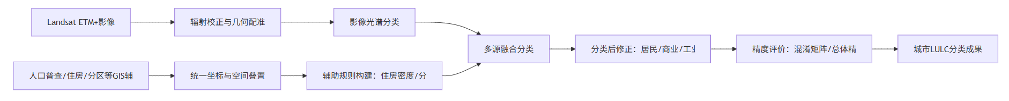
所对应的Mermaid代码：
flowchart LR
A[Landsat ETM+影像] --> B[辐射校正与几何配准]
C[人口普查/住房/分区等GIS辅助数据] --> D[统一坐标与空间叠置]
B --> E[影像光谱分类]
D --> F[辅助规则构建：住房密度/分区约束/参考样本]
E --> G[多源融合分类]
F --> G
G --> H[分类后修正：居民/商业/工业等混淆类别细分]
H --> I[精度评价：混淆矩阵/总体精度/Kappa]
I --> J[城市LULC分类成果]
2. Chap 10 人口估算流程图
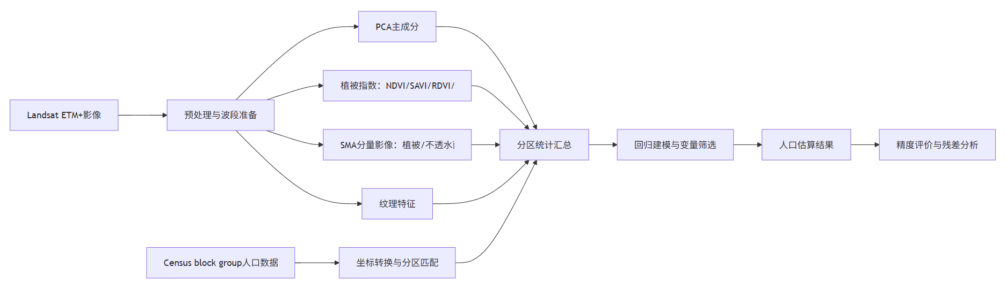
所对应的Mermaid代码：
flowchart LR
A[Landsat ETM+影像] --> B[预处理与波段准备]
C[Census block group人口数据] --> D[坐标转换与分区匹配]
B --> E[PCA主成分]
B --> F[植被指数：NDVI/SAVI/RDVI/RVI]
B --> G[SMA分量影像：植被/不透水面/阴影]
B --> H[纹理特征]
E --> I[分区统计汇总]
F --> I
G --> I
H --> I
D --> I
I --> J[回归建模与变量筛选]
J --> K[人口估算结果]
K --> L[精度评价与残差分析]
五、最新相关文献及重要文献推荐
1. 最新相关文献
[1] Yang R., Zhong Y., Su Y., et al. Multi-E2E: An end-to-end urban land-use mapping framework integrating high-resolution remote sensing images and multi-source geographical data（Multi-E2E：融合高分辨率遥感影像与多源地理数据的端到端城市土地利用制图框架）[J]. Remote Sensing of Environment, 2025. DOI: 10.1016/j.rse.2025.114966. 推荐理由：最新城市土地利用制图框架，直接对应Chap 3的多源融合思想。
[2] Xiong S., Zhang X., Wang H., et al. Mapping the first dataset of global urban land uses with Sentinel-2 imagery and POI prompt（利用Sentinel-2影像和POI提示制图首个全球城市土地利用数据集）[J]. Remote Sensing of Environment, 2025. DOI: 10.1016/j.rse.2025.114824. 推荐理由：用Sentinel-2和POI prompt构建全球10m城市土地利用数据集，适合写研究进展。
[3] Shi S., Liu Y., Li D., Zhong Y. Multi-temporal high-resolution urban land-use mapping and change analysis based on a deep geospatial-temporal adaptation network（基于深度地理时空适应网络的多时相高分辨率城市土地利用制图与变化分析）[J]. Remote Sensing of Environment, 2025. DOI: 10.1016/j.rse.2025.114912. 推荐理由：强调多时相城市土地利用更新和变化检测，是Chap 3流程的时间序列扩展。
[4] Advaith C. A., Agrawal S., Kumar V., et al. Deep Learning Based Land Use Land Cover Classification On Multi-Sensor Remote Sensing Data（基于多传感器遥感数据的深度学习土地利用/土地覆盖分类）[J]. ISPRS Annals, 2025. DOI: 10.5194/isprs-annals-X-5-W2-2025-7-2025. 推荐理由：结合光学、SAR、DEM和GHSL，体现多传感器融合趋势。
[5] Li Z., Chen B., Wu S., Su M., Chen J. M., Xu B. Deep learning for urban land use category classification: A review and experimental assessment（面向城市土地利用类别分类的深度学习：综述与实验评估）[J]. Remote Sensing of Environment, 2024, 311:114290. DOI: 10.1016/j.rse.2024.114290. 推荐理由：综述和实验评估城市土地利用深度学习方法，适合做文献入口。
[6] Hao M., Dong X., Jiang D., et al. Land-use classification based on high-resolution remote sensing imagery and deep learning models（基于高分辨率遥感影像和深度学习模型的土地利用分类）[J]. PLOS ONE, 2024, 19(4):e0300473. DOI: 10.1371/journal.pone.0300473. 推荐理由：比较FCN、SegNet、U-Net、Swin-UNet等模型，适合方法选择参考。
[7] Feng P., Ma Z., Yan J., et al. High-resolution population mapping by fusing remote sensing and social sensing data considering the spatial scale mismatch issue（考虑空间尺度不匹配的遥感与社会感知数据融合高分辨率人口制图）[J]. International Journal of Digital Earth, 2025, 18(1). DOI: 10.1080/17538947.2025.2479863. 推荐理由：直接回应Chap 10中的尺度匹配和人口空间化问题。
[8] Authors listed on journal page Local-global dual attention network (LGANet) for population estimation using remote sensing imagery（用于遥感影像人口估算的局部-全局双注意力网络（LGANet））[J]. Resources, Environment and Sustainability, 2023, 14:100136. DOI: 10.1016/j.resenv.2023.100136. 推荐理由：用注意力网络和夜间灯光辅助人口估算，可与Chap 10传统回归对比。
这些最新文献说明，当前城市土地利用分类和人口估算已经从传统影像分类、回归建模，逐渐发展到多源地理数据融合、深度学习、时序更新和高分辨率人口空间化。其中Multi-E2E、PPUL-Net、ANITA等研究与Chap 3的多源融合思想联系密切；高分辨率人口制图和LGANet等研究则与Chap 10的人口估算主题直接相关。
2. 重要基础文献
[1] Lu D., Weng Q. Urban classification using full spectral information of Landsat ETM+ imagery in Marion County, Indiana（利用Landsat ETM+影像全光谱信息进行印第安纳州Marion县城市分类）[J]. Photogrammetric Engineering & Remote Sensing, 2006, 72(11):1275-1284. DOI: 10.14358/PERS.72.11.1275. 推荐理由：与Chap 3案例区域和方法背景高度相关。
[2] Lu D., Weng Q. Use of impervious surface in urban land-use classification（不透水面在城市土地利用分类中的应用）[J]. Remote Sensing of Environment, 2006, 102(1-2):146-160. DOI: 10.1016/j.rse.2006.02.010. 推荐理由：说明不透水面在城市土地利用分类中的重要性。
[3] Huete A. R. A soil-adjusted vegetation index (SAVI)（土壤调节植被指数（SAVI））[J]. Remote Sensing of Environment, 1988, 25(3):295-309. DOI: 10.1016/0034-4257(88)90106-X. 推荐理由：Chap 10植被指数部分的重要基础文献。
[4] Stevens F. R., Gaughan A. E., Linard C., Tatem A. J. Disaggregating Census Data for Population Mapping Using Random Forests with Remotely-Sensed and Ancillary Data（利用遥感与辅助数据的随机森林方法分解人口普查数据进行人口制图）[J]. PLOS ONE, 2015, 10(2):e0107042. DOI: 10.1371/journal.pone.0107042. 推荐理由：人口空间化的经典机器学习方法，连接遥感和辅助数据。
[5] Tatem A. J. WorldPop, open data for spatial demography（WorldPop：面向空间人口学的开放数据）[J]. Scientific Data, 2017, 4:170004. DOI: 10.1038/sdata.2017.4. 推荐理由：重要人口栅格数据和空间人口学资源。
基础文献主要用于连接课本内容和研究前沿。Lu and Weng的研究与城市LULC分类、不透水面应用和课程案例关系密切；Huete提出的SAVI是Chap 10植被指数部分的重要基础；WorldPop和人口空间化相关研究则为遥感人口估算提供了更广泛的背景。
六、未来改进和拓展方向
1. 多源遥感-GIS人口空间化。可将Sentinel-2、夜间灯光、POI、道路、建筑轮廓和统计人口结合起来，研究街道或社区尺度的人口分布。
2. 城市LULC自动更新。可利用多时相遥感影像、OSM路网和深度迁移学习，构建年度城市土地利用变化图。
3. 可解释城市功能区识别。可在高分影像、POI和建筑形态基础上引入SHAP或注意力可视化，解释分类结果背后的变量贡献。
4. 人口估算不确定性表达。可通过空间交叉验证、误差传播或贝叶斯模型，给出人口估算结果的置信区间和误差地图。
5. 中国城市本地化应用。可结合中国统计年鉴、社区边界、建筑物数据和高分辨率影像，探索适合中国城市管理的人口估算和土地利用分类方法。
七、AI使用中遇到的问题及解决办法
1. 专业词汇不能只做字面翻译
例如land use和land cover在中文中容易合并理解，但二者含义不同；impervious surface也不能只翻译成“不透水面”，还需要说明其与城市化和人口密度的关系。因此术语部分采用中英文机器翻译、AI解释相结合的方式整理。
2. 文献推荐需要核验
AI可以快速给出文献线索，但题名、年份和DOI可能存在错误。其生成的文件还需要手动在谷歌学术、中国知网等平台进行核验对照。
3. 使用Agent时大模型可能会偷懒
大模型在汇总内容时可能采用尽量简单的方式，例如直接复用已有的“翻译参考”文件，而不是自己进行一次翻译。需要明确对大模型的行为作出限制，不允许其使用本地的部分文件。
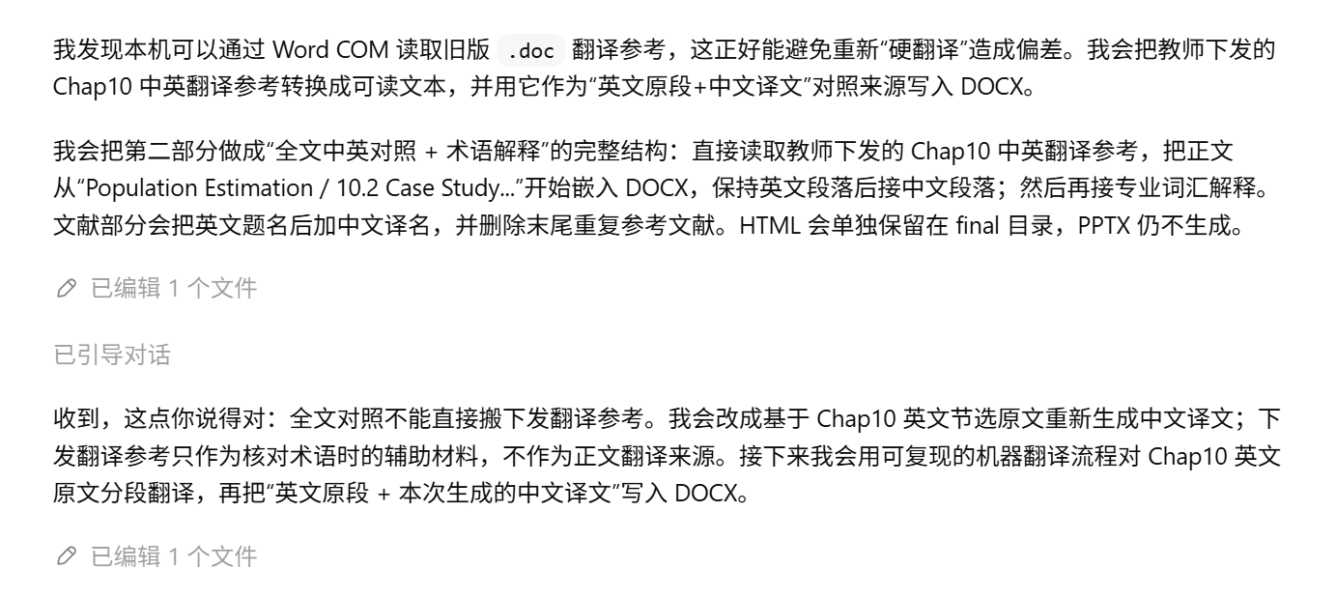
限制其自行翻译后，通用型AI依然无法有效提取出论文的正文内容，会将表格、图片内容等数据也作为正文一并翻译，这一处需要进行人工修改或者可以尝试换用专门针对文献阅读、翻译而训练出的大模型。如图所示，这是不期望翻译的内容被AI错误纳入了翻译范围。行业内已有大量相关模型，例如百度的PaddleOCR、深度求索的DeepSeek-VL、谷歌的Tesseract-OCR等，都为这类应用场景提供了相对成熟的方案，不过在本次作业中没有使用到。
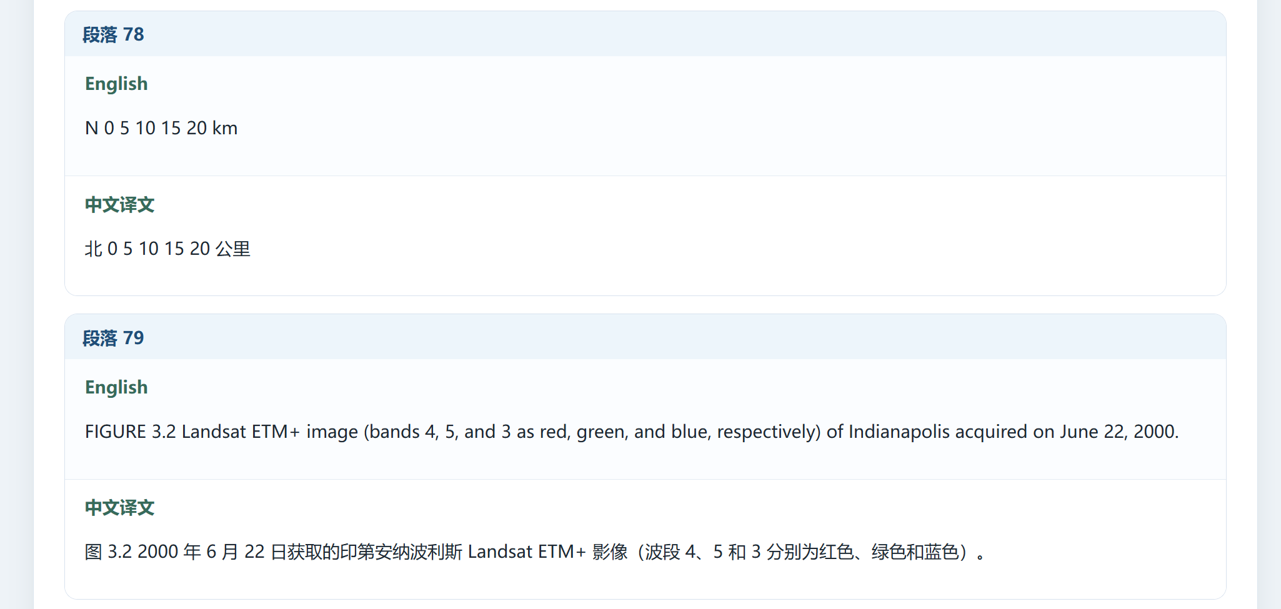
4. 使用Agent时大模型无法有效生成PPT
大模型在汇总内容生成PPT时不会考虑调用已有的Skill、在默认情况下也不会考虑去网络上搜索成熟的方案，而ChatGPT本身生成出的PPT过于简单、展示效果较差。需要明确生成PPT的替代方案，例如GPT生成出的网页质量相对较高，便可以采用HTML > 图片 > PPT的方式来变相实现更加精美的PPT。这一方法的优点在于生成出的内容精美且对大模型友好可控，缺陷在于生成出的PPT本身无法编辑，只能编辑HTML，生成出的内容不好控制页数。在下图示例中，AI生成出了一份高达56页的HTML，这显然不是对于汇报所需的任务量。因此，再次尝试使用专业的软件（ChatGPT for PowerPoint）进行生成。
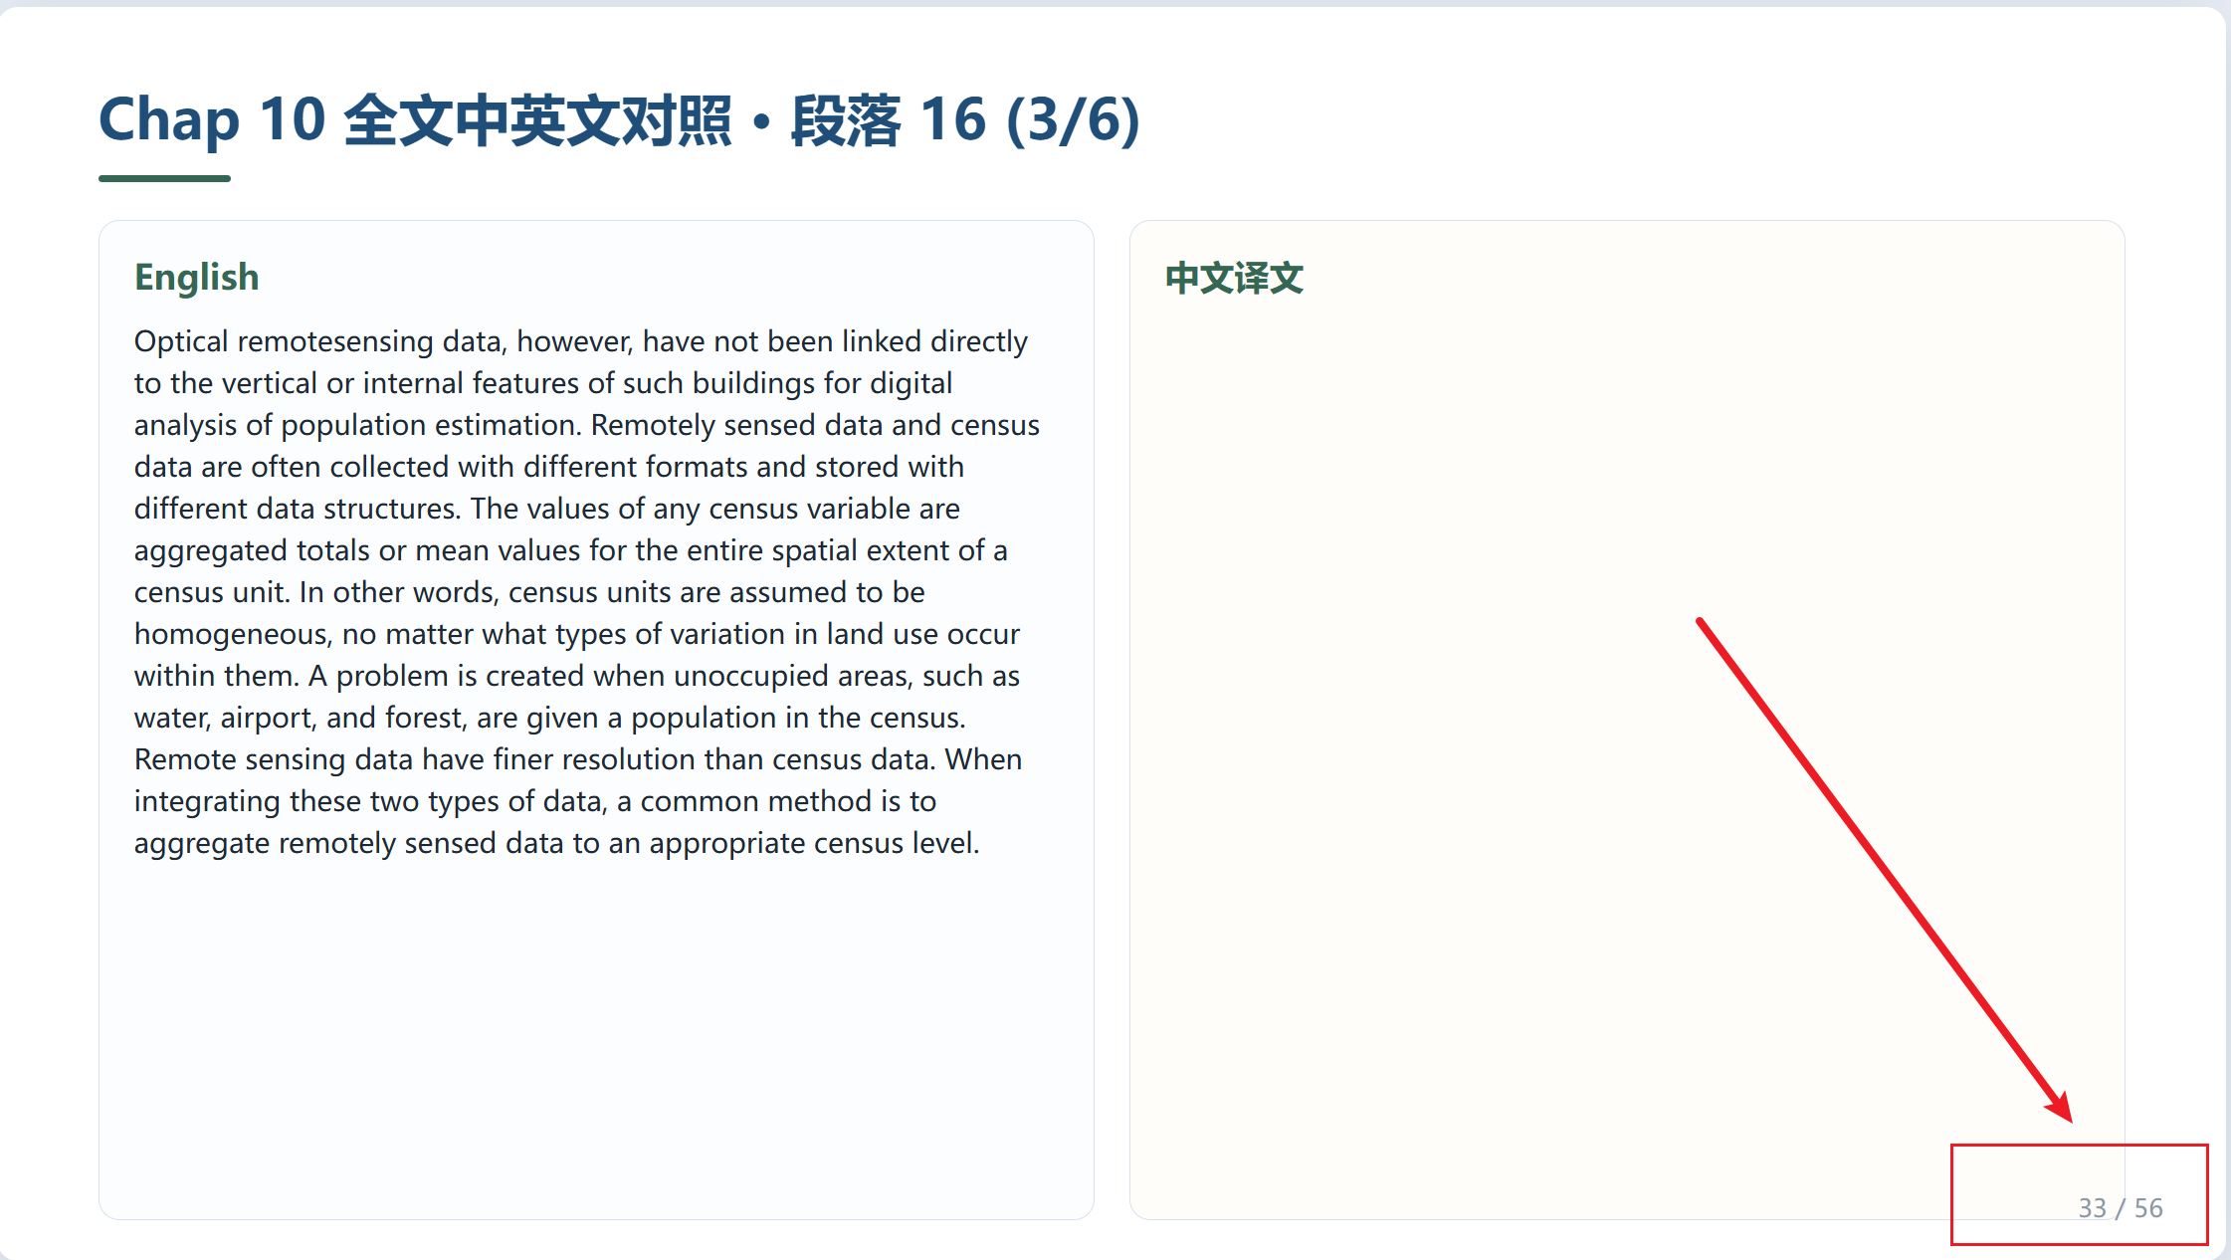
对于Word文档和PPT文件这类本质上由XML生成的结构数据，大模型还无法直接生成出效果优秀的文件，还需要人工进行二次核验和润色，这是AI应用领域绕不开的一环。目前而言，此类问题只能在输入时尽量使用JSON、Markdown等结构化语言，并要求AI同样输出结构化语言，再由人工生成和精确调整输出的文件。AI无法理解人类对于“美”的概念。
八、心得和小结
通过本次作业可以看出，AI工具适合用于辅助阅读、术语解释、流程梳理和文献检索，但最终内容仍然需要回到课本材料和可验证文献，由人工进行核验和确认工作。Chap 3体现了遥感影像和GIS辅助数据融合在城市LULC分类中的作用；Chap 10则进一步说明遥感变量可以通过PCA、植被指数、SMA和纹理特征等方式转化为人口估算模型中的解释变量。
总体来看，遥感与GIS综合的关键在于多源数据融合。遥感提供连续空间观测，GIS提供边界、属性和社会经济语义，两者结合后才能更好地服务城市土地利用分类、人口估算和城市管理。后续如果继续拓展，可以围绕多源遥感-GIS融合的人口空间化或城市LULC自动更新开展研究。

