Operating Systems
The three main pieces of an OS are:
- Kernel – The core part of the OS that manages CPU, memory, and devices.
- System Libraries – Provide standard routines that applications use to interact with the kernel.
- System Utilities / User Interface – Programs or interfaces (like shells or GUIs) that help users interact with the system.
The main services an OS provides are:
- Manages execution of programs
- Controls and allocates memory
- Manages input and output devices
- Manages files
- Facilitates networking
The three key conceptual responsibilities of an OS:
- Virtualisation – Make each application think it has the computer to itself.
- Concurrency – Handle many things happening at once.
- Persistence – Keep data safe even after a crash or shutdown.
A computer’s structure is as follows: [ Applications ] → [ Libraries & Utilities ] → [ Operating System ] → [ Hardware ]
The OS control tables that are used to keep track of everything are:
- Memory Tables – Tracks which parts of memory are used or free.
- I/O Tables – Track which processes are using which devices.
- File Tables – Store info about open files, file permissions, and access status.
- Process Tables – Link to the process’s process image and PCB (the actual code, data, stack, etc. in memory).

Processes
Process States
dispatch
.-----------.
admit / v release
(new)------>(ready) (running)------->(exit)
^ ^ / |
event| '---------' | event wait
occurs| timeout |
(blocked)←----------+
Process Interrupts
When the interrupt fires, the OS preempts the current process, regains control, and can make scheduling decisions.
- Hardware timer interrupt is configured to fire at regular intervals
- Traps (Internal Events): System calls, Errors, Page faults.
- Interrupts (External Events): Keyboard input, Disk completion, Timer interrupts.
Process Termination
- HALT Instruction
- User Action
- Fault or Error
- Parent Process Terminates
  - Depends on the system – some UNIX systems allow orphans (which are adopted by init).
UNIX Process Creation
This system call causes the OS (in kernel mode) to:
- Allocate a slot in the process table.
- Assign a PID to the new child process.
- Copy the parent’s process image (code, stack, heap, etc.).
- Update file counters to reflect shared open files.
- Place the child into the Ready state.
- Return values: Parent gets child’s PID. Child gets 0.
parent resumes
.----------------> (wait) -------->
/ ^
fork() |
\ |
'----> exec() ---> exit()
child
This ^ diagram shows this pattern:
- fork() → creates a child.
- In the child, call exec()→ replaces the child’s memory with a new program.
- Meanwhile, the parent calls wait() → it pauses until the child finishes.
- After child’s exit(), the parent resumes.
Process Control Block
Attribute | Description
Identifier | Unique Process ID (PID)
State | Current status (Running, Waiting, Ready, etc.)
Priority | Helps decide the order of execution
Program Counter | Keeps track of the next instruction to execute
Memory Pointers | Where in memory the code and data are located
Context Data | Register values, stack pointers, etc. (saved when switching between processes)
I/O Status Info | Info about files/devices being used
Accounting Info | CPU time used, memory used, etc., often for monitoring or billing

Process Image
Component | Description
User Program | The actual executable code
User Data | Modifiable variables and dynamic data
Stack | Holds function calls, return addresses, local variables
Process Control Block (PCB) | The metadata (aka attributes) of the process

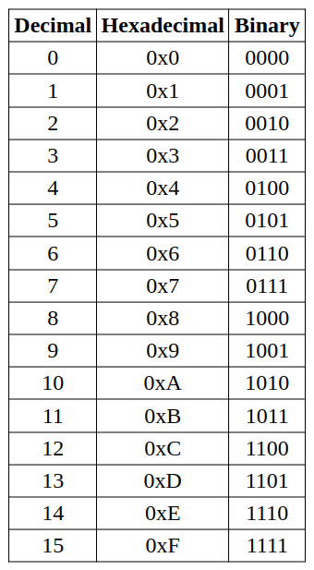
Calculations
From | Equals | To
1 second (s) | = 1,000 | milliseconds (ms)
1 millisecond (ms) | = 1,000 | microseconds (µs)
1 microsecond (µs) | = 1,000 | nanoseconds (ns)

Term | Meaning
Turnaround Time (TAT) | Total time a process spends in system
Waiting Time (WT) | Time spent waiting in the ready queue
Average TAT | Average completion delay
Average WT | Average waiting delay
Finish Time F[i]: time when process i completes.
Turnaround Time TAT[i] = F[i] − Arrival[i]
Waiting Time WT[i] = TAT[i] − Burst[i]
Response Time RT[i] = FirstStart[i] − Arrival[i] (useful esp. for RR/SRT)

RAID (Redundant Array of Independent Disks)
A storage method that combines multiple disks into one logical unit for speed, reliability, or both.
- Striping: Split data across disks → faster (parallel reads/writes)
- Mirroring: Duplicate data → safer
- Parity: Add extra info to rebuild lost data
- Writing to disks can operate in parallel
Level | Description | Pros | Cons | Min Disks
RAID 0 | Striping only | Very fast | No fault tolerance | 2
RAID 1 | Mirroring | Very safe | Doubles storage use | 2
RAID 4 | Striping + 1 parity disk | Good balance | Parity disk bottleneck | 3
RAID 5 | Striping + distributed parity | Fast & fault-tolerant | Slower writes | 3
RAID 6 | Double parity | Survives 2 disk failures | Slower writes | 4
RAID 10 | Mirroring + striping | Fast & safe | Expensive | 4

Crash-Consistency Problem
Cause: Crash during update → on-disk structures inconsistent.
Goal: Ensure valid structures even after crash.

Linux File Systems
ext2 - Based on UNIX FFS.
- No journaling → uses fsck after crash.
Ext3 - Adds journaling, 3 modes:
- Data mode → log data + metadata (safest, slowest).
- Ordered → write data before metadata (default, balanced).
- Writeback → log metadata only (fastest, riskiest).
- HTree indexing → fast large-directory lookups.
Ext4 - Uses extents (contiguous block ranges).
- Supports huge files/volumes (up to exabytes).
Performance features:
- Multi-block allocation
- Pre-allocation
- Delayed allocation (less fragmentation)
Data (Journal) Mode
How it works:
- File data and metadata are both written to the journal.
- Journal is committed to disk.
- Then both data and metadata are written to the main file system.
✓ Maximum data integrity, no risk of corrupted or old data after a crash.
✓ Ensures filesystem and file contents are always consistent.
✗ Slowest mode (double writes: once to journal, once to disk).
✗ Higher I/O overhead.
Ordered Mode
How it works:
- File data is written to disk before journaling metadata.
- Only metadata changes are written to the journal.
- Journal is committed, then metadata is written to the file system.
✓ Good balance between safety and performance.
✓ Prevents old/stale data appearing after a crash.
✗ Slightly slower than writeback due to ordering enforcement.
✗ Still doesn’t journal actual data (metadata only).
Write back Mode
How it works:
- File data blocks are written to disk at any time (no ordering).
- Metadata changes are written to the journal.
- After journal commit, metadata is written to the filesystem.
✓ Fastest performance - minimal journaling overhead.
✓ Good for temporary/non-critical data.
✗ Least reliable - metadata may point to old/corrupted data after crash.
✗ File contents may not match metadata.

CPU Scheduling Summary
Non-Preemptive
FCFS (First-Come-First-Served)
- FIFO order; runs until completion.
✓ Simple to implement.
✗ Short jobs wait behind long ones (convoy effect).
✗ Favors CPU-bound; I/O-bound suffer.
SJF (Shortest Job First / Shortest Process Next)
- Picks job with shortest burst time.
✓ Lowest avg. waiting & turnaround times.
✗ Starvation for long jobs.
✗ Needs prediction of burst time.
Preemptive
SRT (Shortest Remaining Time)
- Preemptive SJF: always runs process with least time left.
✓ Improves turnaround.
✗ Starvation risk for long jobs.
RR (Round Robin)
- Uses time slice (quantum) for fairness.
✓ Good response time; all get CPU regularly.
✗ Too small q → high context-switch overhead.
✗ Too large q → behaves like FCFS.
MLFQ (Multilevel Feedback Queue)
- Multiple queues with different priorities.
- Rules:
  - Run highest-priority queue first.
  - Same-priority → Round Robin.
  - New jobs start at top priority; demoted if they use full slice.
✓ Adapts to both short (interactive) & long (CPU-bound) jobs.
✗ Starvation of low-priority jobs.
- Fix: periodic priority boost to top queue.

Memory Management
Paging
- Physical memory → fixed-size frames.
- Logical memory → same-size pages.
- Page Table: maps page → frame.
→ Processes can be non-contiguous in RAM.
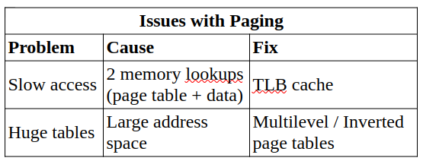
Address translation:
Virtual addr = [Page # | Offset]
- Page size = 2^{x} → Offset = x bits
- Page number = virtual address − x
Physical addr = [Frame # | Offset]
- Extract page # from virtual address.
- Lookup frame # in page table.
- Combine frame + offset → physical address.
✓ No external fragmentation.
✓ Easy sharing (PTEs can map same frame).
✗ Internal fragmentation inside pages.
Policy | Rule / Order Behavior | Strength | Weakness
FCFS (FIFO) | Replace the oldest loaded page; order fixed by arrival — does not move when a page is re-referenced. | Simple, easy to implement. | May evict frequently used pages (Belady’s anomaly); ignores actual usage.
LRU (Least Recently Used) | Replace page not used for the longest time; order updates on every access (most recent moves to front). | Closely models real access patterns; usually good performance. | Requires tracking or timestamps → costly in hardware.
LFU (Least Frequently Used) | Replace the page with the lowest access count; order based on total use frequency. | Works well for repeated access patterns. | Slow to adapt to phase changes; old pages may linger.

Locks
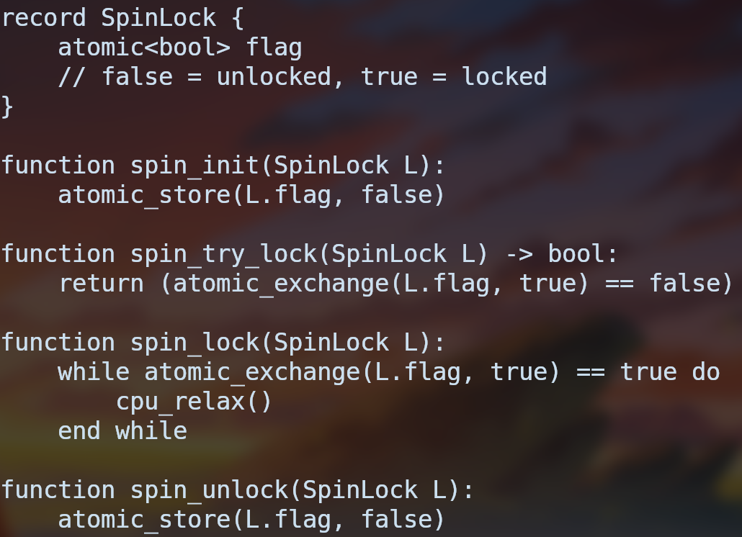
Spin Lock Advantages
- Works best when critical sections are very short and contention is low.
- Efficient on multicore systems - a thread can spin on one core while another releases the lock soon.
- Overhead is minimal when the lock is held only briefly.
Spin Lock Disadvantages
- Busy-waiting wastes CPU cycles; disastrous on a single core if the holder is preempted.
- No fairness: some threads may spin forever (starvation).
- Not for long – never hold a spin lock during I/O or sleeps.
- Priority inversion: low-priority thread can block high-priority ones indefinitely.
Deadlock
All four must hold:
- Mutual exclusion – resource can’t be shared simultaneously.
- Hold and wait – a thread holds one resource while waiting for another.
- No preemption – you can’t forcibly take a resource away.
- Circular wait – there’s a cycle of threads each waiting on the next.
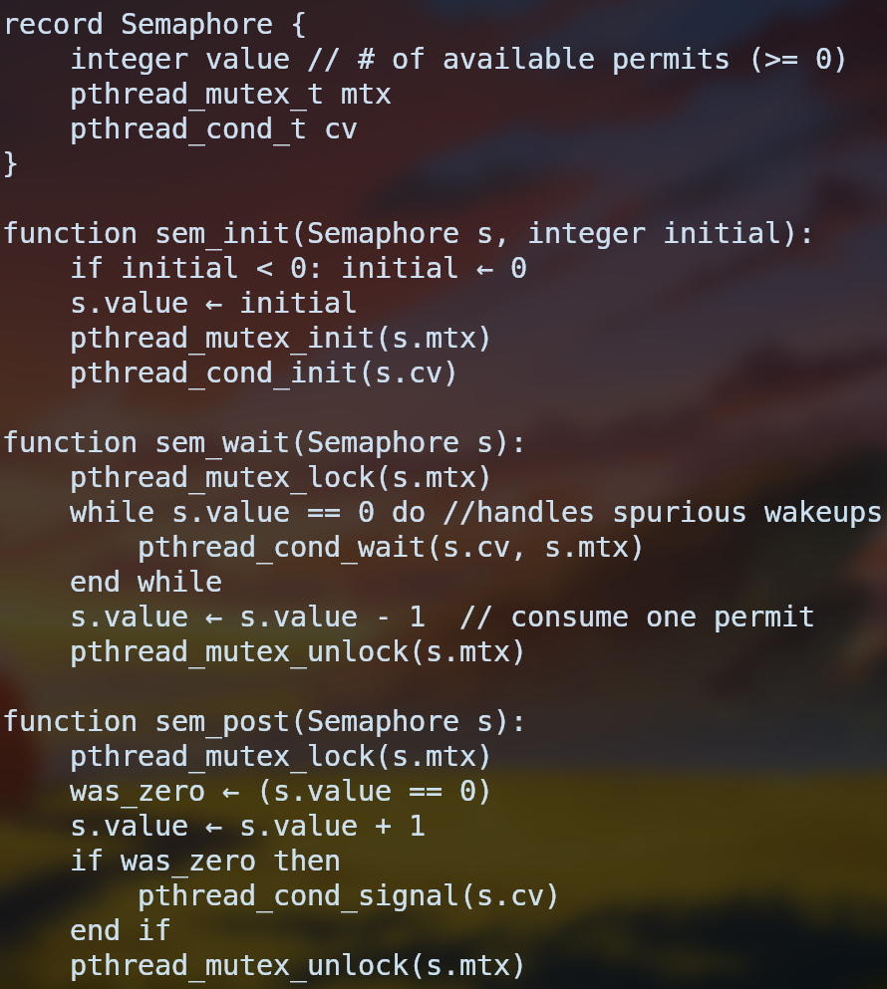
Semaphore
Counting semaphore → value initialised > 1
Binary semaphore (mutex) → value initialised == 1

Schedulers
O(1) Scheduler (Pre-2.6.23)
Concept: Two arrays → active & expired, each with per-priority queues. CPU always runs highest-priority task in active. When active empty → swap arrays.
Goal: Prevent starvation (every task eventually runs).
Priority ranges:
- 0–99 → Real-time tasks (longer time slices, e.g. 200 ms)
- 100–139 → Normal/background (shorter, e.g. 10 ms)
Dynamic priority:
Interactive (sleeping) tasks get a bonus → better responsiveness.
Bitmap search:
Each priority = 1 bit; CPU picks first set bit → O(1) selection.
Issue: Complex tuning; replaced by CFS.

Completely Fair Scheduler (CFS, ≥ 2.6.23)
Goal: Fair CPU sharing; better interactive response.
Core ideas:
- Each task gets CPU time proportional to weight (based on nice value).
- Tracks virtual runtime (vruntime) = CPU used ÷ weight.
- Task with lowest vruntime runs next.
Implementation:
- Red-black tree ordered by vruntime.
- Insert/delete: O(log N)
- Pick next: O(1) (leftmost node)
Default window: 48 ms (sched_latency)
→ N tasks each get ≈ 48 / N ms (≥ 6 ms min slice)
Formulae:
time_slice = (task_weight / total_weight) * sched_latency
vruntime += (weight0 / task_weight) * actual_runtime
Priority Inversion
Definition: High-priority task waits on low-priority one holding a lock. Medium-priority tasks preempt the low one → high-priority starved.
Fix → Priority Inheritance:
Low-priority holder temporarily inherits the high priority → finishes quickly and releases resource.
Famous case: NASA Mars Pathfinder.

Recovery Approaches
fsck (File System Checker)
Scans disk → finds & fixes contradictions.
Slow: checks whole disk.
Restores consistency, not necessarily correct data.
Journaling (Write-Ahead Logging)
Record intended changes in journal before applying.
On crash: Replay committed, skip incomplete.
Much faster recovery.
Metadata Journaling
Only logs metadata (not user data).
Faster, used in ext3/ext4.
Optimizations
Batching: Combine multiple changes.
Circular Log: Reuse journal space after checkpoint.

ZFS (Zettabyte File System)
Motivation
Fix ext limitations:
No manual partitions (pooled storage)
Avoid fsck/journaling delays
Detect & heal corruption
Key Features
Pooled Storage: Shared free space, no fixed partitions.
Copy-on-Write (CoW):
Never overwrite in place.
Write to new blocks, then atomically swap pointers.
Always consistent — no journal needed.
Snapshots
Fast, space-efficient copies.
Keep old versions → instant recovery.
Checksumming (Merkle Tree)
Each block’s checksum stored in parent block.
Detects silent corruption.
Self-healing: Fixes corrupted data using redundancy.

Issues with Paging
Problem | Cause | Fix
Slow access | 2 memory lookups (page table + data) | TLB cache
Huge tables | Large address space | Multilevel / Inverted page tables

