**A simple computer architecture**

Data and information pass between the blocks as electrical signals

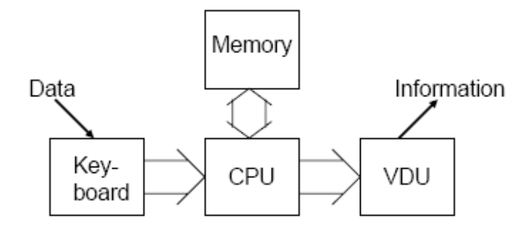

但如果加入的设备变多，CPU将会有很多与其他设备的连接，这会产生很多问题

**The Bus Architecture**

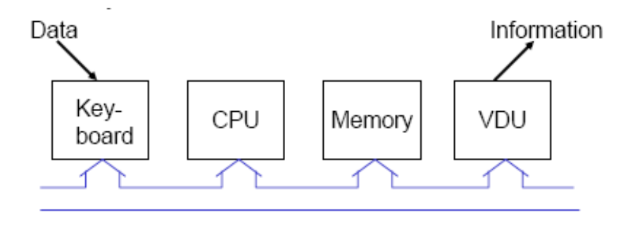

所有设备仅有一条到BUS的连接

BUS是电子连接的集合

normally 8, 16, 32 or 64 individual wires

32 bits of data and information can pass along a 32 bit bus at the same time

**Controlling the BUS**

为了信号不碰撞，同一时间只能有一台设备发送信息

The CPU controls all movements on the bus using **special wires** to activate devices and to synchronize the sending and receiving devices.

These special connections are known as the control bus and they are completely **independent of the bus along which data is passed**

**Address Bus**

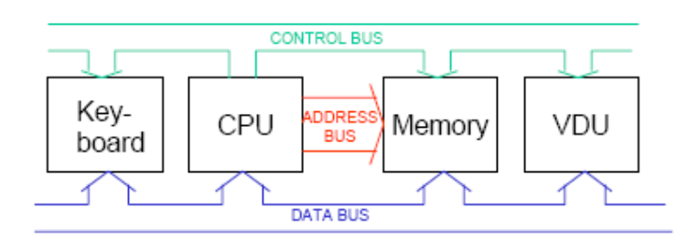

The address bus is used by the CPU to determine **which location in memory** is sending or receiving data

**Some Definition**

A byte is equal to 8 bits

A kilobyte is equal to 1024 bytes (1024 = 2^10)

A megabyte (MB) is equal to 1024 kilobytes(2^20)

A gigabyte (GB) is equal to 1024 megabytes(2^30)

**Simple CPU**

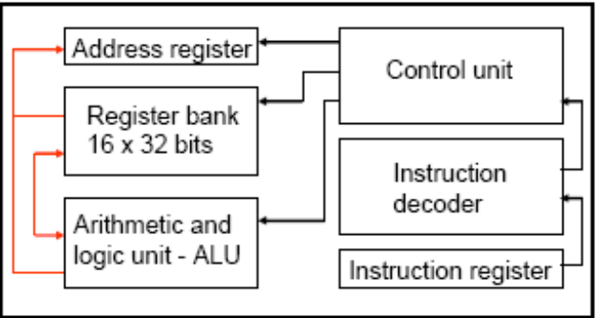

The **data bus** is connected to both the **instruction register and the register bank.**

The **control bus** is connected to the **control unit.**

**Address bus** is connected to the **address register**

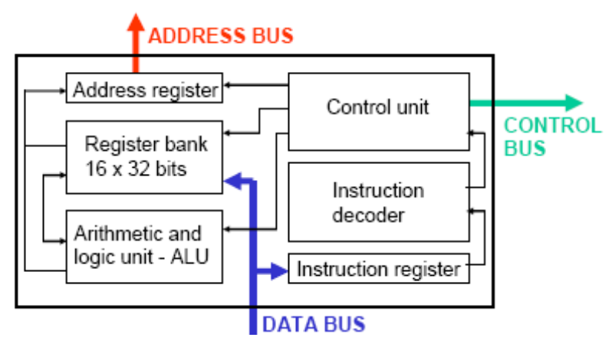

**r15 is the**

**‘program counter’.**