Problem: The "Diamond Lattice" Pattern Generator
You are tasked with creating a highly customizable pattern generator in Python. The program must generate a repeating lattice of "Diamond X" shapes. This will require a deep understanding of nested loops and coordinate manipulation.
Part 1: The Basic "Diamond X" Shape
First, you need to be able to draw a single, symmetrical "Diamond X". This shape is controlled by a size parameter.
- size: An integer that defines the radius of the 'X' from its center. The total grid for a single 'X' will be (size * 2 - 1) rows tall and (size * 2 - 1) columns wide.
For example, a size = 4 'X' would look like this (a 7x7 grid):

Next, you need to implement a thickness parameter. This makes the lines of the 'X' thicker. The thickness is defined as the number of asterisk "layers" drawn around the central lines.
- thickness: An integer (>= 1). A thickness of 1 is the single line from Part 1. A thickness of 2 adds a layer of asterisks on both sides of the central lines, creating a 3-character wide band.
For example, a size = 4, thickness = 2 'X' would look like this:
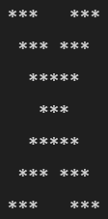
This is the most challenging part. You need to repeat the "Diamond X" shape in a grid, making them connect seamlessly to form a lattice.
- repeat_horizontal: How many times the 'X' pattern repeats side-by-side.
- repeat_vertical: How many times the 'X' pattern repeats top-to-bottom.
The key challenge is that the shapes must connect. The bottom point of an 'X' must merge with the top point of the 'X' below it. The right points must merge with the left points of the 'X' beside it.
For example, size = 3, thickness = 1, repeat_horizontal = 3, repeat_vertical = 2 would produce a single, large, connected pattern:
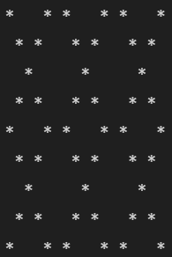

Your Task
Write a Python script that takes four integer inputs: size, thickness, repeat_vertical, and repeat_horizontal. The script must then print the corresponding Diamond Lattice pattern to the console.
Constraints:
- size >= 2
- thickness >= 1
- repeat_vertical >= 1
- repeat_horizontal >= 1
- You must use nested loops. An efficient solution will likely require at least three nested loops.
Full Example
Input:
- size = 4
- thickness = 2
- repeat_vertical = 2
- repeat_horizontal = 2
Expected Output:
