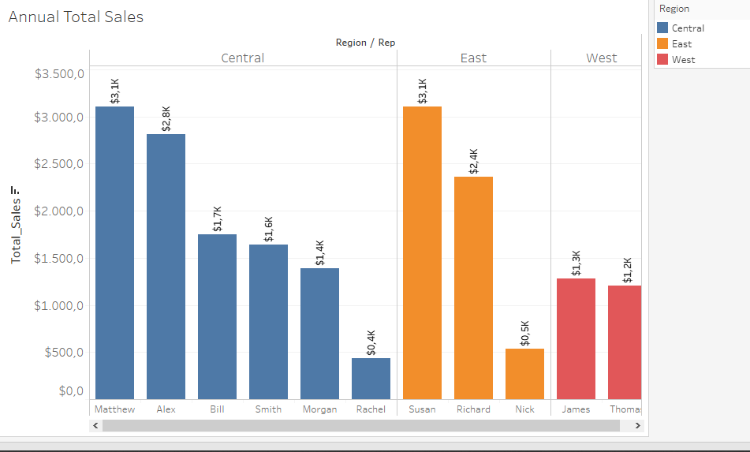

Insight 🡪

* Matthew is the best employee with the biggest total sales on Central region
* Susan is the best employee with the biggest total sales on East Region Followed By Richard And Nick
* On East Region James is the best Employee followed by thomas with the difference approximately 0.1K
* As we Know This is Annual Total sales ,Rachel and Nick have small total sales 🡪 this could be either they are sicks,lazy,or they are having problems finding customers,no information related to,it’s just assumption.Matthew and Susan Should be considered having additional salary more than others employees .
* Employees with 1.5K total_sales Also need to be considered having additional salary ,below it should be considered to be fired,or gave them warnings.
* From the Regions Above we can have an information 🡪 Center Region having More People 🡪 Probability to make a new customers is quietly High ,therefore we need to focus on Center Region in order to gathering more Customers . Followed by East ( We need to know Where the East is / the country ) but from this bar we know that this company is not really focusing on east & West Regions , my assumptions is that it could be this is a “new company” on these regions ,Not much people stay on these regions , thus making sense if they are only few people worked on here,maybe they are tried to gather more informations about the customers ( their minds ,habits ) also the employees that match with the habits and mind in this region so that they can get more money ,lol .but that was the truth , if we can manage our employee minds and habits match with these people on every single regions then the reward will be big .
* We know from the bar , a few employees having bad annual total_salaries.Many things can be happen
  + Their habits & minds doesn’t match with the most customers
  + Their Self Management are bad
  + Most People Hate your products
  + They don’t want new Products replace the old Ones
  + Criminal Records?
  + Employees got Robbeb?
  + Employees is Absolutely Don’t give a fuck with the company 🡨 Well Most Employees Did,as I did now .