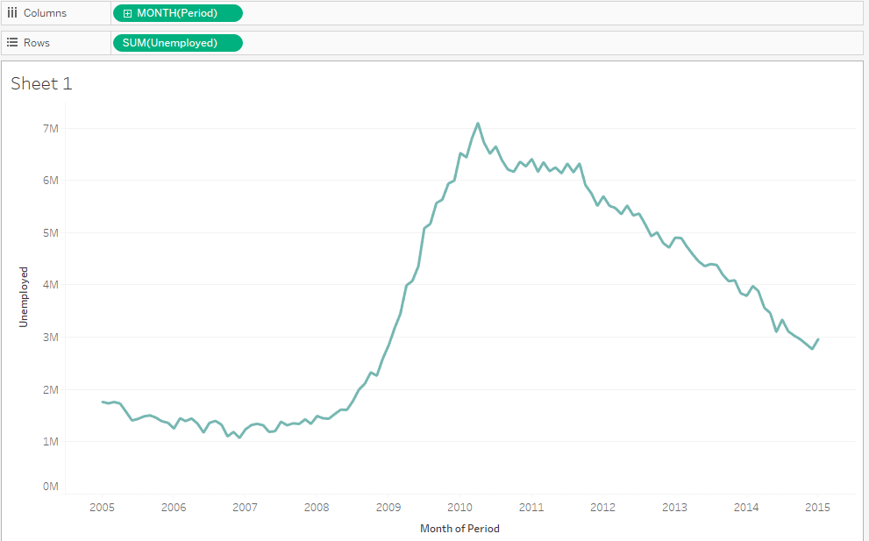

From the line plot above , we can say there’s a significance raise on unemployed person ,started from 2008 to 2010 ,this is caused by interesing facts

* During 2008 Financial crisis Happened (Big Disasters)
  + Started on march 2008 where the crisis Began
    - The amount of unemployed raising very significance
    - Even tho there’s a new open job,still the plots going up
* While the crisis is being repaired,new open jobs opened for unemployed ,but despite that,this could be something happens on 2009
  + 1. Startup get Bankrupts
  + 2. Migrate?
  + 3. Insurance?
  + 4. Swine ful pandmeic
    - Yep this is could be the biggest variable that affected the unemployment jobs on 2009
    - On USA , First Case was detected on 15 april 2009
      * That’s cause the unemployment Raised Very Significance after the april 2009 ,lol.
* While The Pandemic is Still Spearding across USA country , also things happened very bad on 2010
  + Yuan Getting Overpowerd
  + gLobal Warming
  + Google Became target of Cyber attacks
  + The Pandemics Can be controlled Until approximately on june 2010
    - Make sense , the unemployment getting reduced while the timeline keeps going.
      * People working normally again
      * Normal Activities can be doing again
      * And for some reason USA financial getting better
      * Every Stores reopened
      * New Startup Coming up..

Thus , The biggest variables that affecting Unemployement is the financial problems followed by the Pandemics, LOL. Now,let’s examine new Graph

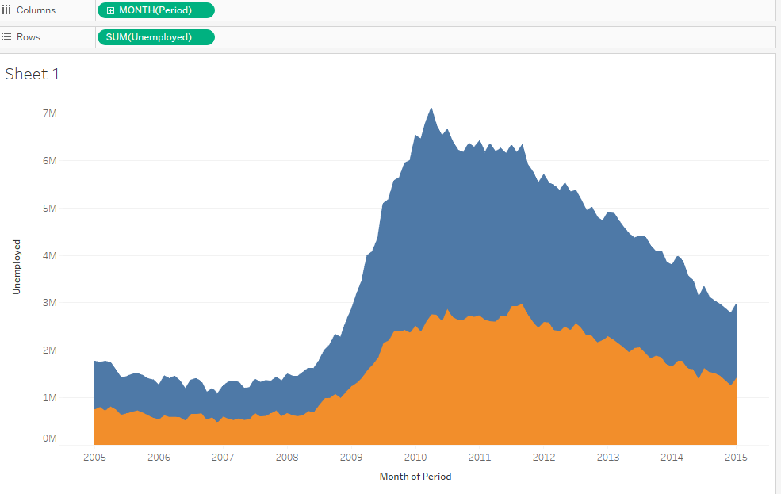

Blue area represent Men

Orange area Represent Women

From this area plot, we can make conclusion

* Men worked more than women,well that’s already a tradition
* Also it’s raised cuz the financial problems and pandemic ,so yeah that what we got here
* Maybe some women don’t want to work anymore,we’ll see the age of women ,to make it clear

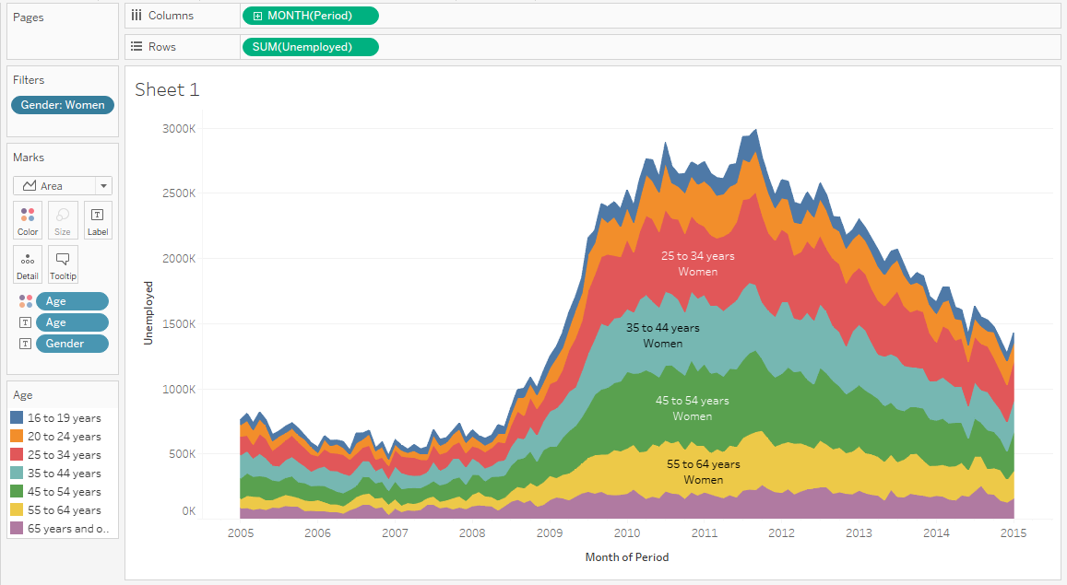

* The Person psychology,Mental,financial problems, Will affect all of these range of age
* And the job market dominated by person around age 25 – 54 ,Cuz from the average 25 – 54 Years old women tend to work than chilled out.
* And since person getting older,they ‘d like to retire..

So for men?? You get the Idea …