# **Epidemiology Report on SARS-COV-2 West Bengal, India**

-By Ashutosh Saxena & Shantanu Mehra

SIR Model: -

The **SIR Model** is one of the simplest compartmental models, and many models are derivatives of this basic form. The model consists of three compartments: **S** for the number of Susceptible, **I** for the number of Infectious, and **R** for the number of Recovered or deceased (or immune) individuals.

Variables Used: -

**N: -**  Total population

**S(t): - Number** of people susceptible on day t

**I(t): -  N**umber of people infected on day t

**R(t): - N**umber of people recovered on day t

**β: - E**xpected amount of people an infected person infects per day

**D: - N**umber of days an infected person has and can spread the disease

**γ: - T**he proportion of infected recovering per day (γ = 1/D)

**R₀: -  T**he total number of people an infected person infects (R₀ = β / γ)

L: - Days after the start of outbreak, lockdown was imposed

Equations & Initial Variables Used:



$Ro=\frac{N*\ln\left(\frac{S2}{S1}\right)}{\left(∆I+ ∆S\right)}$

$\frac{dS}{dt}= -β*I*\frac{S}{N}$

$\frac{dI}{dt}= β*I*\frac{S}{N}- γ*I$

$\frac{dR}{dt}= γ*I$

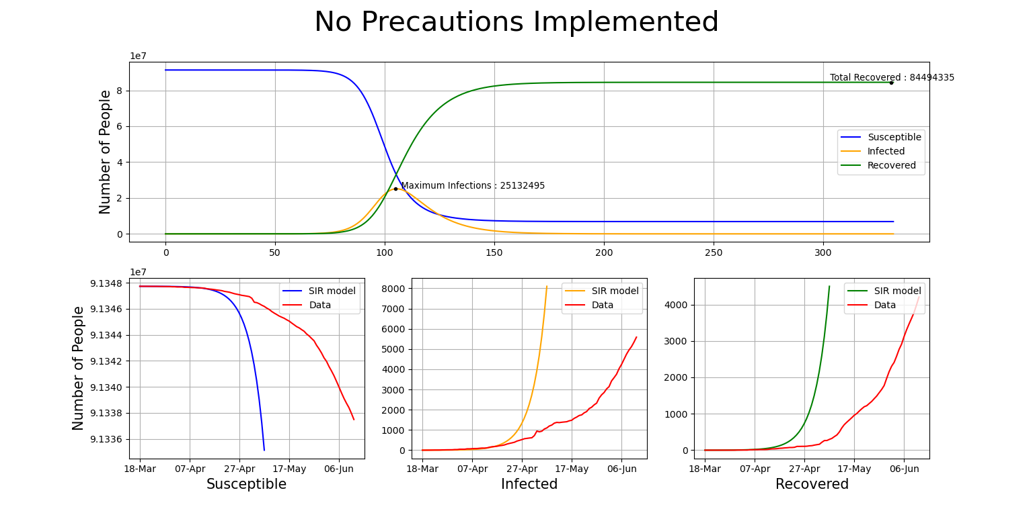**Figure-1**

**The High Inaccuracy observed here in the model is due to the fact that the model here uses R₀ = 2.79 which we have taken as basic reproductive number for SARS-COV-2**

**(source =** <https://academic.oup.com/jtm/article/27/2/taaa021/5735319>**) i.e. if NO precautions were implemented by government and any preventive measures such as social distancing were not adhered to ,similar situation may have been observed.**

Predictions in accordance with SIR Model (Actual observed values may be in vicinity**): -

* Highest Number of Infected that may be Observed = **25,132,495** on 105th day from the start of Epidemic.
* Total Number of Recovered that may be Observed = **84,494,335** at the end of the Epidemic
* Duration of Epidemic = **433 days**

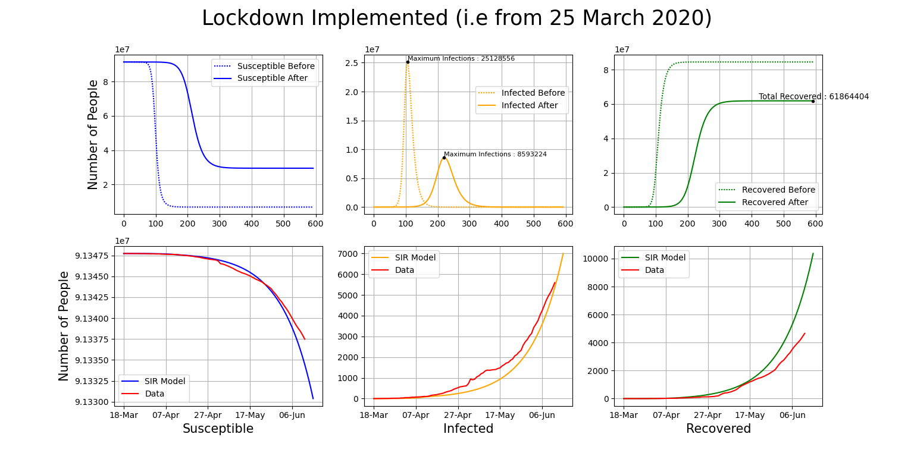**Figure-2**

**Implementation of lockdown has significantly brought down the numbers of max infected, but a downside being the predicted duration of epidemic has increased considerably from 433 to 592 days.**

**The R₀ = 1.669787 for fitting the data is calculated using the following equation**

$Ro=\frac{N*\ln\left(\frac{S2}{S1}\right)}{\left(∆I+ ∆S\right)}$ at each day and averaging over the time period.

Predictions in accordance with SIR Model (Actual observed values may be in vicinity**): -

* Highest Number of Infected to be Observed = **8,593,224** on 220th day of the Epidemic
* Total Number of Recovered to be Observed = **61,864,404** at the end of the Epidemic
* Duration of Epidemic = **592 days**
* **16,535,332**‬ number of infections may be avoided during the entire duration of epidemic, if the pace of spread of virus remains the same.

Limitations of the model: -

* Over-Simplified
* Assumes that individual characteristics of immunity, susceptibility, and ability to recover, are essentially the same for all members of the population.
* It is assumed that the transmission rate remains constant throughout the period of pandemic.
* Assumes recovered individual has become immune to epidemic.